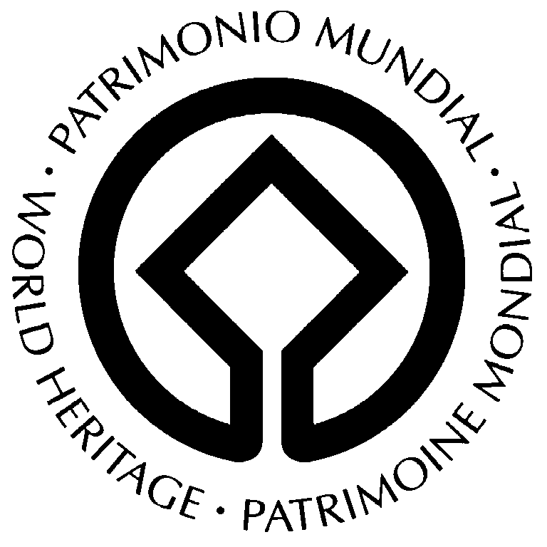


PROVISIONAL AGENDA

UNESCO SUB-REGIONAL WORKSHOP
ON THE SERIAL WORLD HERITAGE NOMINATION
OF THE SILK ROADS

2-5 June 2008
Xi’an, China

Background and Workshop Objectives

As an immediate follow-up to the recommendations of the Asia-Pacific Periodic Report and at the request of the concerned countries, the World Heritage Centre has been assisting Central Asian countries and China in developing a methodological approach for the preparation of a serial World Heritage nomination for cultural heritage properties along the Silk Roads.

Supported by the Netherlands Funds-In-Trust, UNESCO expert missions were carried out in August 2003 and July 2004 to the Chinese section of the Silk Roads in order to advance work towards its possible World Heritage nomination. Following consultations with China’s State Administration of Cultural Heritage, a thematic approach for cultural heritage identification was adopted for the Chinese section of the Silk Roads (land routes).

In November 2005, during a Sub-regional Workshop for 2003 Periodic Report follow-up took place in Almaty, Kazakhstan, representatives from Kazakhstan, Kyrgyzstan, Tajikistan, Turkmenistan and Uzbekistan adopted an Action Plan which gave highest priority to the Serial Nomination for the “Central Asian Silk Roads”. A Regional Workshop on Periodic Report follow-up for North-East and South-East Asia, which took place at Malacca, Malaysia in December 2005 also identified the Silk Roads as a potential theme for serial and transnational World Heritage nomination in Asia.

In August 2006, financed through the Netherlands Funds-In-Trust, a UNESCO Stakeholders Consultation Workshop on the Silk Roads World Heritage nomination was organized in Turfan, Xinjiang, China. This Workshop was attended by some 50 participants from Central Asian countries, China and UNESCO. It also provided the opportunity for the work being undertaken in China on a potential Silk Roads World Heritage nomination to be officially presented to representatives from Central Asia countries.

In October 2006, a UNESCO Sub-regional Workshop on the World Heritage Serial Nomination for Central Asian Silk Roads was organized in Samarkand, Uzbekistan. The meeting agreed upon a general strategy framework and action plan in order to proceed with the Silk Roads World Heritage nomination(s) in both Central Asia and in China. In this context, a Concept Document and strategic approach for the serial nomination was developed by a group of international experts, with support from ICOMOS, for consultation with the participating States Parties.

In April 2007, representatives of the Central Asian countries (Kazakhstan, Kyrgyzstan, Tajikistan and Uzbekistan) and China met in Dushanbe, Tajikistan, to review the proposed Concept Paper and strategic approach for the serial World Heritage nomination and to develop a practical work plan for the next three to four years and recommendations for action/s both by UNESCO and the States Parties involved. The document entitled “A Concept for the Serial Nomination of the Silk Roads in Central Asia and China” was adopted at the meeting and the English, Chinese and Russian versions were circulated amongst the authorities of the participating countries.

In October 2007, the participating countries further requested the World Heritage Centre to present this Concept Document to the 32nd session of the World Heritage Committee, which will take place from 2 to 10 July 2008 in Quebec, Canada.

It should be noted that, the preparation and groundwork on the serial and trans-boundary World Heritage nomination of the Silk Roads is at present being undertaken at the request and initiative of the six States Parties currently involved – the People’s Republic of China and the Republics of Kazakhstan, Kyrgyzstan, Tajikistan, Turkmenistan and Uzbekistan. At the same time, it is being understood that the network of routes to which the name “Silk Roads” has been applied further extended South into the Indian subcontinent and west to the Mediterranean, and that this initial preparatory work currently concentrated in China and Central Asia will provide a paradigm for the eventual identification and inscription of sites all along the entire land route, and even the Steppe and the Maritime routes, that could involve many other countries.

The present workshop will bring together the relevant authorities of each State Party in Central Asia (Kazakhstan, Kyrgyzstan, Tajikistan, Turkmenistan and Uzbekistan) and China, representatives from Afghanistan, Iran, Italy, Japan and Mongolia as well as international experts from UNESCO and ICOMOS. The objectives of the workshop are to:

- Review actions taken by the participating States Parties in implementing the Recommendation put forward in the Concept Document.

- Encourage and support current actions by China and the Central Asian countries in completing the preparations, with their own countries, Tentative Lists of cultural heritage sites along the Silk Roads for a serial and transnation World Heritage nomination

- Present and harmonize national Tentative Lists for the serial World Heritage nomination by agreeing on the categories of individual sites that will be considered for inclusion.

- Select specific routes that will be considered to make up the first serial World Heritage nomination;

- Update the timetable, develop and agree on the workplan for preparing serial World Heritage nomination(s);

- Prepare and agree upon on the statement of Outstanding Universal Value for the Silk Roads sites, identifying the criteria for inscription and assessing the conditions of authenticity and integrity.

- Prepare a guiding document on the management of the serial and transnational World Heritage nomination of the Silk Roads.

PROVISIONAL PROGRAMME

sunday, 1 June

Arrival of international participants at Xi’an-Xianyang International Airport

monday, 2 June

08:30-09:30 | Registration of participants
Plenary Session I | Opening Ceremony  Chairperson: Mr GU Yucai, Director-General, Department for the Protection of Monuments and Sites, SACH
09:30-10:30 | Welcome speech by the Director-General of China’s State Administration of Cultural Heritage or his representative;  Welcome speech by the representative of Shaanxi Provincial Government;  Opening speech by Mr Francesco Bandarin, Director of UNESCO World Heritage  Speech by the representative from the Chinese National Commission for UNESCO
10:30-10:45 | Introduction of the participants
10:45-11:00 | Tea/coffee break
Plenary Session II | Introduction
11:00-11:30 | Introduction to objectives of the workshop and adoption of the programme  Mr JING Feng, Asia and the Pacific Section, UNESCO World Heritage Centre
11:30-12:00 | Presentation on the progress of the serial and transnational World Heritage nomination of the Silk Roads in China and Central Asia (consultation meetings, adoption of the Concept Document)  Mrs Susan DENYER, ICOMOS & Mrs Elena KOROSH, UNESCO Regional Expert and/or Mr GUO Zhan, Vice President of ICOMOS
12:00-12:30 | ICOMOS observations and suggestions on the serial and transnational WH nomination of the Silk Roads  Mrs Susan DENYER, ICOMOS
12:30-14:00 | Lunch
Plenary Session III | Presentation by Country representatives  Chairperson: M Francesco Bandarin & Mr JING Feng, UNESCO
 | Each State Party will make a presentation on the preparation of the Silk Roads nomination and progress made in implementing the Action Plan adopted in the Concept Document: national Tentative Lists preparation, selection of specific routes for World Heritage nomination, draft World Heritage nomination (if available) etc.
14:00-14:30 | Kazakhstan
14:30-15:00 | Kyrgyzstan
15:00-15:30 | Tajikistan
15:30-16:00 | Turkmenistan
16:00-16:20 | Coffee/tea break
16:20-16:50 | Uzbekistan
16:50-17:20 | China
17:20-17:35 | Afghanistan
17:35-17:50 | Iran
17:50-18:05 | Japan
18:05-18:30 | Discussions on the formulation of a Coordination Group to advise on the harmonization of Silk Roads Tentative Lists and WH nomination.

tuesday, 3 June

08:00-09:00 | Breakfast
Plenary Session IV | Procedures on the presentation of Silk Roads sites on the national Tentative Lists (agreement on the categories of individual sites that will be considered for inclusion)  Chairperson: Mrs Susan DENYER, ICOMOS & Mr Yuri Peshkov, UNESCO
09:00-09:15 | Introduction of Silk Roads Tentative List submission Format and serial nomination procedure: Mr JING Feng, UNESCO World Heritage Centre
09:15-10:00 | Discussion on the preliminary selection of specific routes/sites that will be considered to make up the first serial World Heritage nomination with an agreed list of sites by category.
10:00-11:00 | Discussion on the preparation of the serial World Heritage document: preparing and agree upon on statement of Outstanding Universal Value for Silk Roads sites, identifying the criteria for inscription and assessing the conditions of authenticity and integrity.
11:00-12:30 | Updating of the timetable and development of a workplan for preparing serial World Heritage nomination.
12:30-14:00 | Lunch
Plenary Work | Preparation of the Silk Roads World Heritage Serial Nomination  Chairperson: Mr GUO Zhan and Ms Beatrice Kaldun, UNESCO Beijing
14:00-18:30 | The participants will focus on the Format for the nomination of properties for inscription on the World Heritage List to discuss in detail to agree upon (1) the justification for inscription of Silk Roads and the basic criteria applicable to the entire eventual Silk Roads WH nomination; (2) the state of conservation of the selected sites; and (3) protection and management of the selected sites including the management system in force; (4) elaboration and formulation of a management mechanism for the serial Silk Roads cultural heritage sites; (5) Coordination on the preservation of the serial Silk Roads sites with the establishment of an efficient management mechanism and (6) preparation of a guiding document on the management of the serial and transnational World Heritage nomination.
19:00-20:30 | Dinner

wednesday, 4 June

08:00-09:00 | Breakfast
field visit to Silk Roads Cultural Heritage Sites in xi’an

thrusday, 5 June

field visit to Silk Roads Cultural heritage Sites in xi’an
Closing ceremony to adopt conclusion and recommendations of the Workshop

Afternoon: Departure from Xi’an City (in accordance with each participant’s travel schedule)

