World Heritage 32 COM
Distribution Limited WHC-08/32.COM/INF.1
Paris, 17 March 2008
Original: English/French
UNITED NATIONS EDUCATIONAL, SCIENTIFIC
AND CULTURAL ORGANIZATION
CONVENTION CONCERNING THE PROTECTION OF
THE WORLD CULTURAL AND NATURAL HERITAGE
WORLD HERITAGE COMMITTEE

Thirty second Session

Quebec City, Canada
2 – 10 July 2008

GENERAL INFORMATION

For complete information on the 32nd session, please visit the following Web site:

www.Canada2008.ca

This Web site has links to the necessary information regarding registration forms, visa requirements, travel advice and recommended accommodation, and tourist information.

TABLE OF CONTENTS

1. Purpose 4
2. Session Organizers 4
3. Participants and Registration 5
3.1 Participants 5
3.2 Registration 5
4. Accommodation 6
5. Passport, Visa and Other Travel Information 7
5.1 Information About Travelling to Canada 7
5.2 Passport Requirements 7
5.3 Visa Requirements 7
5.4 Applying for a Visa 7
5.5 Other Transit Visas 8
5.6 Transport Canada Security Requirements 8
5.7 Entering Canada 9
5.8 Booking Your Flight 9
5.9 Airport Arrivals and Departures 9
5.10 Medical Insurance 10
6. Meeting Venue 10
6.1 Meeting Venue 10
6.2 Getting to the Meeting Venue 10
6.3 Meeting Check-in Desk 11
6.4 Security Pass 11
6.5 Lost and Found 11
6.6 Participants’ Lounge 11
6.7 Meal Breaks 11
6.8 Medical Services 12
7. Destination Information: Quebec City, Canada 12
7.1 Introduction to Canada 12
7.2 Introduction to Quebec City 13
7.3 Local Transportation 14
7.4 Currency and Exchange 14
7.5 Sales Taxes and Gratuities 15
7.6 Driving in Canada 15
7.7 Electricity Supply 16
7.8 Postal Service 16
7.9 Telephone Service 16
7.10 Smoking Regulations 17
7.11 Time 17
7.12 Weather 16
7.13 Potable Water 17
8. Social Program and related events 17
9. MEDIA 19
9.1 Accreditation is mandatory 19
9.2 Media Registration and Security 19
9.3 Media Centre 19
9.4 Press Conference Room 19
9.5 Official News Releases 20
9.6 Media Access to the 32nd Session 20
10. World Heritage Youth 20
11. Eco-friendly Meeting 21
12. For Further Information 22
APPENDIX – A Registration Form 23
APPENDIX – B Recommended Hotels 30
APPENDIX – C List of Countries and Territories Whose Citizens Require A Visa ………………………………………………………………………………………… 37
APPENDIX – D Map of Dowtown Quebec City 40
APPENDIX – E Complimentary Tours 41
APPENDIX – F Optional Post-Session Excursions 47
APPENDIX – G Media Accredition Application Form 48

1. PURPOSE
The World Heritage Committee consists of representatives from 21 of the States Parties to the Convention Concerning the Protection of the World Cultural and Natural Heritage, elected by the General Assembly of States Parties to the Convention.

The current composition of the Committee is: Australia, Bahrain, Barbados, Brazil, Canada, China, Cuba, Egypt, Israel, Jordan, Kenya, Madagascar, Mauritius, Morocco, Nigeria, Peru, Republic of Korea, Spain, Sweden, Tunisia and the United States of America.

The essential functions of the Committee are:

- to identify, on the basis of nominations submitted by States Parties, cultural and natural properties of Outstanding Universal Value which are to be protected under the Convention and to inscribe those properties on the World Heritage List;
- to monitor the state of conservation of properties inscribed on the World Heritage List, in liaison with the States Parties; decide which properties included in the World Heritage List are to be inscribed on or removed from the List of World Heritage in Danger; decide whether a property may be deleted from the World Heritage List; and
- to examine requests for International Assistance from the World Heritage Fund.

The 32nd Session of the World Heritage Committee will be held in Quebec City, Canada, from 2 to 10 July 2008. All relevant information is available on the meeting’s Web site at: www.Canada2008.ca

2. SESSION ORGANIZERS
The 32nd session is being organized by the Parks Canada Agency on behalf of the Government of Canada. Contact details are:

Address: 32nd Session of the World Heritage Committee
Parks Canada25 Eddy Street, 5th Floor (25-5-W)
Gatineau, Quebec Canada
K1A 0M5
Tel: 1-819-997-0506
Fax: 1-819-953-4909
E-mail: Canada2008@pc.gc.ca

Project Director: Robert Moreau
Tel: 1-819-994-4929
Fax: 1-819-953-4909
E-mail: Robert.Moreau@pc.gc.ca

General Enquiries: Véronique Veillette
Tel: 1-819-997-0506
Fax: 1-819-953-4909
E-mail: Veronique.Veillette@pc.gc.ca

Media: Joanne Huppé
Tel: 1-819-953-8699
Fax: 1-819-953-5523
E-mail: Joanne.Huppe@pc.gc.ca

Lise Rochette
Tel: 1-418-648-4539
Fax: 1-418-648-5561
E-mail: Lise.Rochette@pc.gc.ca

3. Participants and Registration
  - Participants

The primary participants of the 32nd Session of the World Heritage Committee will be the 21 members of the Committee.

States Parties to the World Heritage Convention that are not members of the Committee may send representatives to the session as observers.

Non-States Parties to the Convention that are Member States of UNESCO or of the United Nations may also be permitted by the Committee, upon written request, to attend the sessions of the Committee as observers.

Representatives of the International Centre for the Study of the Preservation and Restoration of Cultural Property (ICCROM), the International Council on Monuments and Sites (ICOMOS), and the World Conservation Union (IUCN) will attend in an advisory capacity.

The United Nations and organizations of the United Nations system, as well as other international governmental and non-governmental organizations, permanent observer missions to UNESCO and non-profit-making institutions having activities in the fields covered by the Convention, upon written request, may be authorized to participate in the sessions of the Committee as observers.

  - Registration

All delegates and those who wish to attend the 32nd session as observers are strongly advised to register as soon as possible and no later than 31 May 2008. Doing so will provide the session organizers sufficient time for the orderly processing of information and prevent any inconvenience to participants. Please register on line on the meeting’s Web site at: www.Canada2008.ca

If you cannot register on line, please use the registration form in Appendix – A and return it by fax to: 1-819-953-4909 or by mail to: 32nd Session of the World Heritage Committee, Parks Canada, 25 Eddy Street, 5th Floor (25-5-W), Gatineau, Quebec, Canada, K1A 0M5.

Please note that all participants at the 32nd session (delegates and observers) must be accredited or approved by the UNESCO World Heritage Centre. Registration will therefore take place in two steps. First, the registration form must be completed and submitted for review (on line, by fax or by mail) by all those who wish to attend the 32nd session. Once accreditation or approval has been given, applicants will be notified of the confirmation of their registration and provided with a personal access code. This code will be needed to complete other arrangements such as booking your accommodation, registering for any events to be held during the session, and for organizing any optional post-session excursions. For those who cannot use the on-line registration, the session organizers will provide assistance in order to help complete arrangements for the 32nd session. Please communicate with the session organizers identified in section 2 of this document.

The session organizers will continue to process registrations and/or modifications made to existing registrations after 31 May 2008. However, it will not be possible to guarantee smooth processing of late registrations, and reserved hotel accommodation may no longer be available.

It is of the utmost importance that registered participants inform session organizers of any subsequent changes made to their travel arrangements. Doing so will help ensure that logistical arrangements are executed in a smooth fashion.

4. Accommodation
For the convenience of session participants, and in recognition of the fact that July is part of the busy tourist season in Quebec City, session organizers have set aside up to 750 hotel rooms at eight different hotels in downtown Quebec City for the duration of the meeting. All of the recommended hotels are located within a 5 to 25-minute walk from the Québec City Convention Centre. Special rates have been negotiated for session participants. To book a room at one of these hotels, session participants must first complete their registration. To learn more about the recommended hotels, including room rates, see Appendix – B.

Session participants are responsible for booking their own hotel room and for covering all costs incurred during their stay. A credit card will be required to reserve a room.

Please note that the numbers of rooms reserved at the eight hotels are limited. Session participants will be alerted when a particular hotel has reached its

capacity within the reserved block. Participants should then proceed to another choice.

For assistance regarding accommodation, please contact the session organizers identified in section 2 of this document.

5. Passport, Visa and Other Travel Information
  - Information About Travelling to Canada

The Citizenship and Immigration Canada Web site at http://www.cic.gc.ca provides helpful information for international visitors travelling to Canada. The site covers details about entry requirements such as who needs a visa and how to apply for one. Countries whose citizens are exempt from requiring a visa are listed. The grounds upon which a person may be considered inadmissible to enter Canada are also discussed. Finally, the procedures that visitors will encounter at points of entry into Canada are reviewed. It is strongly recommended that session participants examine this site prior to making arrangements for their trip to Canada.

  - Passport Requirements

All international visitors to Canada must carry a passport that is valid for the entire duration of their stay in Canada.

  - Visa Requirements

Generally, all travellers to Canada require a Temporary Resident Visa (TRV) to visit or transit through Canada. Specific exemptions exist to this requirement. It is advisable to consult Citizenship and Immigration Canada or the nearest Canadian mission abroad for more information regarding TRV requirements.

If a visa is required, it is the responsibility of session participants to obtain one before travelling. Failing to do so may result in the inability to board your flight to Canada. For the list of countries and territories whose citizens require a visa, please see Appendix – C. For further information, please see the Citizenship and Immigration Canada Web site at: http://www.cic.gc.ca/english/visit/visas.asp

  - Applying for a Visa

According to Canadian law, visas are not issued at airports or at other points of entry to the country. They are issued exclusively at Canadian embassies and consulates. Session participants must apply therefore for a visa in their country. If there is no Canadian embassy or consulate in their country, they must apply for a visa at the Canadian embassy that covers their country. Session participants should contact the Canadian mission or consulate in their country to request information concerning visas and other formalities for entry into Canada.

For further information on how to apply for a visa, please consult the following Web site:

http://www.cic.gc.ca/english/visit/apply-how.asp

For further information on the location of Canadian embassies and consulates, please consult the following Web site:

http://www.dfait-maeci.gc.ca/world/embassies/menu-en.asp

Please note that session participants will require their letter of invitation when applying for a visa. The $75 (Canadian) application fee should be waived for all participants to the 32nd Session of the World Heritage Committee.

A visa application for Canada may take up to two months or more to process and may require leaving your passport with the immigration service or agent in order to complete the process. It may take even more time if it is determined that you require a medical examination as part of the application process. Please allow sufficient time before your departure to obtain your visa. It is recommended that you undertake the process as soon as possible.

  - Other Transit Visas

If you travel to Canada via another country such as the United States, or if you are planning a stopover elsewhere, you must familiarize yourself with the entry requirements of these countries. Please check with your travel consultant about the need for transit visas for all countries you may be travelling through on your way to Canada.

5.6 Transport Canada Security Requirements

Canadian law requires that all persons, including VIPs, undergo security screening when travelling by air either to or from Canada. This includes hand-wanding and other required searches. By special request, wanding / screening may be completed in a private room or VIP lounge at airports. However, such arrangements are usually more time consuming than simply going through normal procedures at the passenger-screening checkpoint.

Please note that certain items are prohibited in carry-on baggage on board aircrafts when travelling in Canada. For further information, please consult the following Transport Canada Web site:
http://www.tc.gc.ca/aboutus/travel/travellerinfo.htm#air

5.7 Entering Canada

The Canada Border Services Agency is responsible to ensure that people entering Canada respect Canadian laws. It is authorized to examine people and goods entering the country to determine their admissibility. The goal is to facilitate the entry of legitimate travellers and goods as quickly as possible.

When you arrive in Canada, a border services officer will ask to see your passport and a valid visa, when necessary. Border service officers may also check all passengers and their luggage in order to detect narcotics, firearms, currency, agricultural products and other substances that visitors are not permitted to bring into Canada. You and/or your luggage may be checked in any or all of the following ways:
- Screening by x-ray equipment;
- Detector dogs; and
- Physical search

There are many items and substances that may not be brought into Canada, and others that are restricted and that must be declared. For further information, please visit the following Canada Border Services Agency Web site:
http://www.cbsa.gc.ca/travel-voyage/visitors-eng.html
This Web site covers topics such as the importation of prescription medication, herbal remedies, Canadian and foreign currency, agricultural products, alcohol, tobacco, firearms and much more. The onus is on session participants to inform themselves about these regulations before entering Canada.

  - Booking Your Flight

Upon confirmation of registration, it is advisable that session participants book their flights well in advance since July is part of the high season for tourism in Canada. In particular, Quebec City is celebrating its 400th anniversary in 2008 and an increase in tourism is expected.

  - Airport Arrivals and Departures

The Vancouver International Airport (YVR), the Lester B. Pearson International Airport in Toronto (YYZ) and the Montreal - P. - E. - Trudeau International Airport (YUL) are the main points of entry to Canada for international flights. Travellers transiting through these airports must ensure their connection to Quebec City via a domestic flight.

The Jean Lessage International Airport in Quebec City (YQB) is located approximately 12 kilometres from the Québec City Convention Centre and from the recommended hotels. A reception desk will be available at the Quebec City

airport as of 27 June 2008 to assist participants upon their arrival. Session organizers will also be present at the airport to assist participants at their departure.

Participants are responsible for their own transportation arrangements from and to the Quebec City airport. Taxis are available at the airport and hotels. The fixed rate for a one-way trip is $30 (Canadian).

It is of the utmost importance that you inform the session organizers of your flight details in order for them to be able to assist you. Also, please keep them informed of any subsequent changes you may make to your travel plans.

Some airports in Canada may charge airport departure taxes or airport improvement fees. The costs vary from one airport to another and are usually included in the ticket price. For airports that session participants will most likely use in Canada, the amount will be between $5 to $25 (Canadian).

5.10 Medical Insurance

While first-aid service will be provided for session participants at the convention centre, all other medical services will not be covered. Session participants will be expected to assume the costs of any medical treatments that they receive while in Canada. It is strongly recommended that medical insurance be purchased in your home country to cover you in Canada as well as any other destinations on your journey.

6. Meeting Venue
6.1 Meeting Venue

The 32nd Session of the World Heritage Committee will be held in the Québec City Convention Centre. It is located at 900 René-Lévesque Boulevard East, Quebec City, Canada. For a general overview of the facility, see:
http://www.convention.qc.ca/tiki-index.php?page=HomePage

The convention centre is located in the heart of the city at the center of a vibrant hotel, tourism and business district. Many of the attractions that make Quebec City a special place are within a short walk from the meeting facility.

  - Getting to the Meeting Venue

Hotels that are recommended for the meeting are within a 5 to 25-minute walk of the Québec City Convention Centre. A relatively short distance, shuttle transportation is not required. Please see the attached map of Quebec City’s downtown in Appendix – D.

  - Meeting Check-in Desk

The meeting check-in desk will be set up in the main hall of the Québec City Convention Centre as of 1 July 2008. Every participant must register prior to the beginning of the World Heritage Committee session. An information package regarding the 32nd session will be available at that time. For participants who plan to arrive later in the session, the check-in desk will be open every morning at 8 a.m.

  - Security Pass

Part of the meeting check-in procedure will be to take a photo and to create a personal security ID badge for all of the participants. Please register at your earliest convenience upon arrival to allow sufficient time to complete the badges. Meeting start times cannot be delayed to accommodate late check-ins.

ID badges are not transferable. For security purposes, the pass must be visibly worn at all times to gain entry to the convention centre, to attend meetings, and to participate in other activities. Access to the event will be denied to any individual who is not officially accredited or who uses the ID badge improperly.

6.5 Lost and Found
A lost-and-found service will be provided for session participants. It will be located at the security desk on Level 4 near the René-Lévesque entrance.
  - Participants’ Lounge

A participants’ lounge with an Internet cafe will be provided. Located on Level 3 of the convention centre, the lounge will be equipped with computers (with Internet access) and printing facilities. Technical staff will be on site to assist you.

  - Meal Breaks

For lunch breaks during the 32nd session, participants will be able to purchase light meals such as sandwiches and salads at kiosks made available on Level 4 of the convention centre. Session organizers will endeavour to ensure that the lunch menu suits a variety of dietary requirements.

For evening meals, participants will find that the convention centre and nearby recommended hotels are in the middle of a superb dining district that offers a wide range of culinary experiences. From simple fare to the finest of dining, this area of Quebec City has it all. Recommended hotels will also have cafes and high quality restaurants able to cater to a variety of tastes.

For more information on dinning in Quebec City, please see the following Quebec City Tourism Web site: http://www.quebecregion.com/e/restaurants.asp

  - Medical Services

A first-aid assistant will be available in the convention centre should this service be required by session participants.

There are pharmacies located within 500 to 1000 metres of the convention centre. Please note that a pharmacist in the province of Quebec will be able to fill only those prescriptions that have been written by a doctor who is registered with the College of Physicians of Quebec.

7. Destination Information: Quebec City, Canada
  - Introduction to Canada

Canada is an immense country. It has a total area of 9,984,670 square kilometres. Of this, 9,093,507 square kilometres is land and 891,163 square kilometres is fresh water. Canada is the second largest country in the world.

Climate sculpts this massive landscape through heat, cold, humidity, light and wind. The variety of Canada's landscapes shows the diversity of its climate. Around the Great Lakes and alongside the St. Lawrence River as far downstream as Quebec City, the climate is characterized by relatively warm summers and cool winters, moderated by surrounding water bodies.

Canada's 31,241,030 people are spread out in ten provinces and three territories. While Canada is very diverse in its people, its landscape, its climate and its way of life, Canadians do share many important values. These values guide and influence much of our everyday life. These are values of pride, a belief in equality and diversity, and respect for all individuals in society and institutions that govern us.

The Aboriginal peoples were the first people to live in Canada. Their different spiritual beliefs and cultural traditions have been passed down from generation to generation. There are three main groups of Aboriginal peoples in Canada: the First Nations; the Inuit; and the Métis.

Canada's political system is a democratic constitutional monarchy, composed of the Queen of Canada, who is officially represented by the Governor General, and Parliament. The federal Parliament consists of the Senate (upper chamber), which 105 members are appointed by the Governor General on the recommendation of the Prime Minister, and the House of Commons (lower chamber), with 308 members elected by the citizens. The government originates in the elected House of Commons. After an election, the party with the most elected representatives forms the government. Its leader becomes the Prime Minister who then chooses people (usually members of the House of Commons of his or her party) to head the various government departments under the designation of ministers.

For further information on Canada, please see the following Web site: http://canada.gc.ca/

  - Introduction to Quebec City

Quebec City is the capital of the Canadian province of Quebec. It is the seat of the provincial legislature, the National Assembly of Quebec, and has a population of 528,595. The metropolitan area has a population of 717,600 (2005).

A popular travel destination, Quebec City and its surrounding area welcome over six million tourists every year from all corners of the world. The city is full of attractions and fascinating discoveries for visitors.

Lower Town, home to the first settlers of New France, encompasses the old port district and a host of other treasures. Leading the way to Upper Town are steep, winding roads and stairways with telling names, like Côte de la Montagne (Mountain Road) and Escalier Casse-Cou (Breakneck Stairway). And crowning it all is one the most photographed buildings in the world, the famous Château Frontenac, perched atop towering Cape Diamond.

In Upper Town, the contours of the fortified city are easy to see and explore. Quebec City was founded by the French explorer Samuel de Champlain in 1608. It is the only North American city north of Mexico to have preserved its ramparts, together with the numerous bastions, gates and defensive works which still surround Old Quebec. The Upper Town has remained the religious and administrative centre, with its churches, convents and other monuments like the Dauphine Redoubt and the Citadel. Together with the Lower Town and its ancient districts, it forms an urban ensemble which is one of the best examples of a fortified colonial city. In fact, all it takes is a short stroll to understand why Old Quebec was designated a UNESCO World Heritage Site in 1985.

For further information on Quebec City, please see the Web site of the City of Quebec at:
http://www.ville.quebec.qc.ca/en/exploration/mille_atouts.shtml

For further information on the province of Quebec, please see the following Web site:
http://www.bonjourquebec.com/qc-en/accueil0.html

In 2008, Quebec City is celebrating a major anniversary. Planned events throughout the year will mark the 400th anniversary of the founding of “Kébec” on the shores of the St. Lawrence River by Samuel de Champlain. From 3 to 6 July 2008, four full days of festivities will mark the date of Quebec City’s founding. It will also be the start of the city’s summer festival. To find out more about the 400th celebrations, please see the following Web site:

http://monquebec2008.sympatico.msn.ca/MonQuebec2008/?lang=en-ca

7.3 Local Transportation

Travelling by Foot

Many of Quebec City’s special attractions are within a short walk of the recommended hotels and the convention centre.

Travelling by Bus

The Réseau de transport de la Capitale, Quebec City’s public transporters, offers a city wide, modern, high-quality service. For further information, please see the following Web site: http://www.rtcquebec.ca

Travelling by Taxi, Car Rental, Tourist Shuttle

Taxi services, limousine rentals, car rentals, bus and plane charters, as well as tourist shuttles are all readily available. Your hotel concierge can help you to arrange any of these private transportation requests.

7.4 Currency and Exchange

The currency in Canada is the Canadian dollar, abbreviated to: CAN $. Canada has a decimal currency system with one dollar equalling 100 cents. Banknotes are in denominations of $100, $50, $20, $10 and $5. Coins are in $2 (often called a toonie), $1 (loonie), 25 cents (quarter), 10 cents (dime), 5 cents (nickel) and 1 cent (penny).

The most widely used credit cards (e.g., Visa, MasterCard and American Express) are accepted in most shops, restaurants, cafes and hotels throughout Quebec City. Travelers cheques are usually accepted at major hotels. They can also be cashed at a bank or currency exchange office. Some restaurants and department stores may also accept them.

It is advisable to carry Canadian currency in small denominations. Currency exchange offices are numerous in Quebec City. There are a number of such offices located within 500 to 1000 metres of the convention centre. Airports also offer currency exchange services. Some businesses accept United States dollars, although the exchange rate may be less competitive than at a currency exchange office.

Banks are usually open from 10 a.m. to 3 p.m., Monday through Friday. The daily hours of operation may vary slightly depending on the bank. However, all are usually closed on Saturdays and Sundays. Withdrawals may be made from most automated teller machines (Cirrus, Plus or Interac networks) 24 hours a day, 7 days a week.

The following exchange rate examples were applicable on 29 January 2008:
1 Canadian dollar = 1.001 United States dollars
1 Canadian dollar = 0.678 Euros
1 Canadian dollar = 0.503 Pounds Sterling

Exchange rates are subject to change frequently. For up-to-date information on currency conversion, please see the Bank of Canada Web site at: http://www.bankofcanada.ca/en/rates/converter.html

7.5 Sales Taxes and Gratuities

Two different sales taxes – the provincial Quebec Sales Tax (QST – 8%) and the federal Goods and Services Tax (GST – 5%) – are applied to most goods and services (they are not already included in prices).

In bars, taxis and hair salons, it is customary to leave a gratuity corresponding to 10%-15% of the bill (not including taxes); the gratuity is not included in the bill. At restaurants, it is customary to offer a gratuity corresponding to the total of the QST and GST amounts on the bill, which works out approximately to 13%. Gratuities for bellhops or baggage porters are at the client’s discretion (usually $1 per item).

7.6 Driving in Canada

In Canada, cars are left-hand drive (driven on the right-hand side of the road) with either manual or automatic gear change. By law, all automobile drivers and passengers must wear a seatbelt, and driving while using a cell phone is not permitted.

Unless otherwise posted, there is a speed limit of 100 kilometres an hour on open highways and 50 kilometres an hour on urban roads and in built-up areas. Speed is always reduced in children’s play areas and where road works are taking place.

Visitors in possession of a valid driver’s license from their home country may drive an automobile in Canada for a maximum period of six months. Visitors to Canada do not need an international driver’s license. However, an international driver’s license is strongly recommended if your driver’s license or other documents are written in a language other than English or French.

Although 16 is the minimum age to drive an automobile in Canada, some car rental companies enforce a minimum age of 25, while others may charge higher rates for drivers under the age of 21.

The consumption or presence of alcoholic beverages in a moving automobile is strictly prohibited in Canada. If you are suspected of impaired driving, you will be

required to take a breath test. In the province of Quebec, if the test indicates a blood alcohol level of 80 mg/1,000 ml (0.08) or higher, legal action may be taken.

7.7 Electricity Supply

Canada's electrical supply is 110 Volts and 60 Hertz (cycles per second). Plugs either have two or three prongs. Two-pronged plugs have two flat pins, while three-pronged plugs have two flat pins and one round.

Hotels will not have adapters for guests to use, so it is recommended that you purchase your own if you think you will need them during your stay.

7.8 Postal Service

Post offices are generally open from Monday to Friday from 8:30 a.m. to 5 p.m. There are postal outlets located within 1000 metres of the convention centre. The hotel reception desk may also be able to assist you with postal and courier services.

For more information about Canada’s postal service including the cost of mailing items to international destinations from within Canada, see the following Web site: http://www.canadapost.ca/splash.asp

7.9 Telephone Service

If calling from within Canada:
- For all emergencies, dial: 911
- For directory assistance, dial: 411

There are public telephones located in public areas throughout the convention centre that can be used for both local and international calls.

A local call from a public telephone costs CAN $0.50. Payment may be made using coins or prepaid calling cards (credit card payments are more expensive). For long-distance calls, prepaid calling cards are usually the most cost-effective method.

Depending on the technology used and the service provider, foreign cell phones may or may not work in Canada. However, pre-paid cellular phones are also an option.

To place a call from Canada to an international destination, dial: 011 + country code + (any applicable area code) + local number.

To place a call to Canada from a foreign country dial: (your country’s system access number) + 1 (country code for Canada) + area code (418 for Quebec City) + local seven digit number.

7.10 Smoking Regulations

In Canada, smoking is prohibited in all public buildings (including airports, hotels and the convention centre, etc.). Where smoking is permitted, it is usually in a specially designated area.

Individual hotels may offer their guests the choice of a smoking room. It is necessary to verify this with your hotel. Do take note that heavy cleaning fines are often added to guests’ bills if they smoke in rooms that are designated non-smoking.

7.11 Time

The province of Quebec is in the Eastern time zone of North America, five hours behind Greenwich Mean Time (GMT minus 5). The province of Quebec also primarily uses the 24-hour clock: eg. 4 p.m. = 16:00.

7.12 Weather

Quebec City can be characterized by a humid continental climate. As it is in the northern hemisphere, July falls in the height of summer. Summers are usually hot, with average minimum/maximum temperatures being 13 / 25 °C (55 / 77 °F). Depending on the climate you are accustomed to, it may still be possible to encounter cool evenings, so it is best to bring a windbreaker or light sweater. Rain wear is also recommended.

For further information about the current weather conditions in Quebec City, please see the following Web site: http://www.weatheroffice.gc.ca/city/pages/qc-133_metric_e.html

7.13 Potable Water

It is safe to drink tap water throughout Canada. However, for those who prefer bottled mineral water, it is readily available in various stores and hotels.

8. Social Program and related events
As a registered participant, you are invited to attend the social functions and events that will be held during the 32nd Session of the World Heritage Committee. Please indicate your intention to attend any or all of the functions and events by using the on-line registration (see Step Two). For assistance, please communicate with the session organizers identified in section 2 of this document.

The opening ceremony of the 32nd session will be held at the Québec City Convention Centre (Exhibit Hall) on 2 July 2008. The ceremony will begin at 4 p.m. and will be followed by a reception, dinner and cultural performances. Formal dress is recommended for this event.

From 1 to 10 July 2008, complimentary guided tours of the Historic District of Old Québec World Heritage Site will be offered to session participants and to family members accompanying them. Please register for these tours at the check-in desk located in the main hall of the convention centre.

On 9 July 2008, the following three complimentary tours will be offered to session participants:
- Whale Watching at the Saguenay St. Lawrence Marine Parks;
- Boat Crossing and Tour of Grosse Île and the Irish Memorial National Historic Site of Canada; and
- Visit to the Montmorency Falls and of the Île d’Orléans.

All tours will leave from the Québec City Convention Centre early in the morning and return by the end of the day. Please note that numbers for each tour option are limited. You are therefore encouraged to book early to avoid disappointment. For further information on the complimentary tours, please see Appendix – E.

The closing event for the 32nd session will be held at the Quebec Citadel National Historic Site of Canada on 9 July 2008. The event will begin at 7 p.m. and will include a cocktail, dinner, tours of the historic site and cultural performances. Business casual dress is recommended for this event.

To enable participants at the 32nd session the opportunity to visit some of Canada’s World Heritage Sites, a series of post-session tours is currently being organized. Choosing to take one of these tours is entirely at the discretion of session participants. All costs associated with the excursions will be the responsibility of participants.

The post-session excursions will begin on 11 July 2008. They will include an opportunity to explore some of the management issues of the different World Heritage Sites. The following five tours are being developed:
- Western Canada’s Majestic Natural Heritage;
- Steer North to a Nordic Realm;
- The Rideau Canal: A Triumph of the Human Spirit:
- Newfoundland and Labrador: Great Voyages; and
- Miguasha: Witness to the Evolution of Life on Earth.

For further information on the post-session excursions, please see Appendix – F.

- Media
9.1 Accreditation is mandatory

Aaccreditation is mandatory for reporters and journalists who wish to cover the 32nd Session of the World Heritage Committee. To become accredited, please apply using the on-line application form on the meeting Web site at: www.Canada2008.ca
For those who do not have access to the Internet, please use the media accreditation form in Appendix – G and return it by fax to: 1-819-953-4909 or by mail to: 32nd Session of the World Heritage Committee, Parks Canada, 25 Eddy Street, 5th Floor (25-5-W), Gatineau, Quebec, Canada, K1A 0M5.

9.2 Media Registration and Security

The check-in desk for the 32nd session will be set up in the main hall of the convention centre as of 1 July 2008. A special desk will be marked for media representatives. Please note that your application for accreditation must be received and approved before you present yourself for registration.

Part of the registration procedure will be to take your photo and create your personal accreditation/security pass on site. Accreditation passes are to be worn visibly at all times to gain access to the convention centre and must be presented upon request of security personnel at any time.

Accreditation passes are not transferable. Access to the convention centre will be denied to any individual who uses the pass improperly. Please be advised that security personnel will examine and may test equipment and personal effects carried into the media centre. Allow sufficient time in your schedule to pass the security checks.

9. 3 Media Centre

The media centre will be located in Foyer 4 of the convention centre. You are required to enter the media centre via the René-Lévesque entrance. The media centre will have work stations. Journalists will also have access to the Internet and a fax machine.

9.4 Press Conference Room

The press conference room will also be located in Foyer 4 of the convention centre, immediately adjacent to the media centre. This room will be used for the main news conferences. The final schedule outlining press events will be available upon registration.

  - Official News Releases

Official news releases and photographs of the 32nd Session of the World Heritage Committee will be posted on the meeting Web site. News releases will be posted on the media room page and photographs will be posted in the photo gallery.

  - Media Access to the 32nd Session

The UNESCO World Heritage Centre will have a media team in Quebec City during the 32nd session. It will be responsible for media relations. Daily media briefings related to decisions of the World Heritage Committee will be held. News releases will also be issued during the session.

Please note that UNESCO procedures do not allow media to be present in the meeting room when the World Heritage Committee is in session. Given that media will only be allowed to attend the opening ceremony and press conferences, images of the Committee in session will be provided to the media for their use.

A technical briefing for media representatives will be held prior to the 32nd session in order to review media protocols and the business of the World Heritage Committee. Information on the World Heritage Convention will also be covered. Requests for interviews with members of the World Heritage Committee will be considered.

For media enquiries, please communicate with the session organizers identified in section 2 of this document.

10. World Heritage YoutH
There are youth in the world today who are actively engaged in a wide range of activities relating to heritage conservation. Cultivating and fostering their energy, talent and knowledge are vital to the ongoing sustainability of World Heritage Sites.

The Government of Canada is pleased to include a significant youth component as part of the 32nd Session of the World Heritage Committee taking place in Quebec City. The youth program is being organized with the assistance of the Canadian Commission for UNESCO.

For more than two weeks, a number of young Canadians between the ages of 18 to 25, and other youths from countries representing the geographical regions of UNESCO will come together in Canada to learn about world heritage and the Convention. Working in close association with each other, participants will explore the following themes:

- UNESCO and mechanisms for the implementation of the Convention;
- Common Heritage of Humanity;
- World Heritage and Responsible Tourism;
- World Heritage and the Environment; and
- World Heritage and a Culture of Peace.
In addition, the young participants will undertake a common project while visiting some of Canada's World Heritage Sites and present their findings at the opening ceremony of the 32nd session. The young participants will also play an active role during the World Heritage Committee meeting and will share their experiences with their peers through the Internet.

For further information regarding the youth component at the 32nd session, please communicate with:

Cynthia Lacasse
Junior Program Officer
Youth Canadian Commission for UNESCO
350 Albert Street,
P.O. Box 1047
Ottawa, Ontario
Canada
K1P 5V8

Tel: 1-613-566-4414, Ext. 4550
Fax: 1-613-566-4405
E-mail: Cynthia.Lacasse@unesco.ca

Lise Auger
Project Manager
32nd Session of the World Heritage Committee
Parks Canada25 Eddy Street, 5th Floor, Room 22
Gatineau, Quebec Canada
K1A 0M5

Tel: 1-819-934-117
Fax: 1-819-953-4909
E-mail: Lise.Auger@pc.gc.ca

Web site: http://www.unesco.ca/en/default.aspx

11. Eco-friendly Meeting
The organizers of the 32nd Session of the World Heritage Committee have worked closely with the management of the Québec City Convention Centre to ensure an eco-friendly meeting, thereby minimizing impacts on the environment.

The Québec City Convention Centre prides itself on its high standards of eco-management. It is a green building, renowned for its efficient waste and energy management. Session activities will be carried out in a manner designed to minimize waste disposal, reduce waste production, as well as to promote recycling and composting.

As a participant at the 32nd session, you can help ensure an eco-friendly meeting by adopting the following practices:
- Recycle your waste: bottles, cans, paper, etc.
- Turn off any lights, TV, air conditioner or heaters when you leave your hotel room for the day.
- When printing up materials, make sure to print double-sided versions.
- Bring your own reusable mug, pen and pencil.
- Do your sightseeing by foot or public transport.
- Collect business cards of colleagues and have them e-mail reports and other information rather then collecting printed hand-outs.
- When examining exhibits, take only what information you really require.
- Take advantage of the energy-saving option of not having sheets and towels changed every day at your hotel.
- Make use of the public transportation system.

12. FOR FURTHER INFORMATION
For further information on the World Heritage Committee and on the World Heritage Convention, please see the following Web site: http://whc.unesco.org/en/about/

For further information on Canadian World Heritage Sites and on Canada's Tentative List for World Heritage Sites, please see the following Web site: http://www.pc.gc.ca/progs/spm-whs/index_e.asp

For further information on Parks Canada, please see the following Web site: http://www.pc.gc.ca

For further information on the Canadian Commission for UNESCO, please see the following Web site: http://www.unesco.ca/

For any questions regarding the 32nd Session of the World Heritage Committee, please communicate with the session organizers at:

Canada2008@pc.gc.ca.

APPENDIX – A
Registration Form
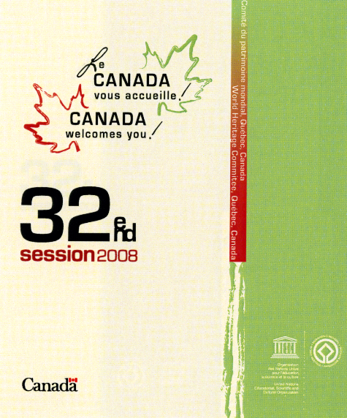

REGISTRATION FORM

32nd Session of the World Heritage Committee
Quebec City, Canada
2 – 10 July 2008

Please complete the registration form and return it by fax to: 1-819-953-4909 or by mail to: 32nd Session of the World Heritage Committee, Parks Canada, 25 Eddy Street, 5th Floor (25-5-W), Gatineau, Quebec, Canada, K1A 0M5. The deadline for applications is 31 May 2008.

1 – Participant Information

I am participating as a Committee member: 
- Please specify the head of your delegation: _____________________________________________________________

I am participating as a representative of an Advisory Body:
 IUCN  ICOMOS  ICCROM

I am participating as representative of a State Party to the meeting: 

I am participating as a member of the UNESCO Secretariat: 

I am participating as a representative of an NGO/IGO invited by the Director-General: 

I am requesting participating as an observer: 
- Please specify: ________________________________________________________________
________________________________________________________________

2 – Personal Information

First Name(s):
______________________________________________________________________

Last / Family Name:
______________________________________________________________________

Please indicate your first name(s) as you would like it to appear on your ID badge, if different from above:
______________________________________________________________________

Please indicate your last / family name as you would like it to appear on your ID badge, if different from above:
______________________________________________________________________

Title (Mr., Mrs., Ms., Dr., Hon., President, Prof.):
______________________________________________________________________

Position:
______________________________________________________________________

Organisation:
______________________________________________________________________

Address:
______________________________________________________________________

City / Town:
______________________________________________________________________

Province / State:
______________________________________________________________________

Postal Code / Zip Code:
______________________________________________________________________

Country:
______________________________________________________________________

Representing Which Country:
______________________________________________________________________

Office Telephone:
______________________________________________________________________

Office Facsimile:
______________________________________________________________________

Mobile Telephone:
______________________________________________________________________

E-mail Address:
______________________________________________________________________

Assistant First Name(s):
______________________________________________________________________

Assistant Last / Family Name:
______________________________________________________________________

Assistant Telephone:
______________________________________________________________________

Assistant E-mail Address:
______________________________________________________________________

3 – Passport and Visa Information

Date of Birth:
______________________________________________________________________________
Place of Birth (Town, Country):
______________________________________________________________________

Nationality:
______________________________________________________________________

Passport Number:
______________________________________________________________________

Issue Date:
______________________________________________________________________

Place of Issue (Town, Country):
______________________________________________________________________

Expiry Date:
______________________________________________________________________

Do you need a visa?
 Yes  No

If you need a visa, please specify the country in which you intend to apply to the Canadian embassy or consulate:
______________________________________________________________________

4 – Travel Companion

Will another person be accompanying you?
 Yes  No

If another person is accompanying you, who is not registering for the meeting, please provide the following information for that person:

First Name(s):
______________________________________________________________________

Last / Family Name:
______________________________________________________________________

Title (Mr., Mrs., Ms., Dr., Hon., President, Prof.):
______________________________________________________________________

Relation to Participant:
______________________________________________________________________

Date of Birth:
______________________________________________________________________

Place of Birth:
______________________________________________________________________

Nationality:
______________________________________________________________________

Passport Number:
______________________________________________________________________

Issue Date:
______________________________________________________________________

Place of Issue (Town, Country):
______________________________________________________________________

Expiry Date:
______________________________________________________________________

5 – Future Communication:

I prefer to be contacted by:

 E-mail  fax  mail

Privacy Statement

All of the personal information you will provide on this registration form will be encrypted and will be treated according to the Privacy Act of Canada. This information will be safeguarded for your protection. The information is being collected for the purpose of enabling session organizers to register you as a participant at the 32nd Session of the World Heritage Committee. It will also help other agencies of the Government of Canada to facilitate your entry into the country.

APPENDIX – B
Recommended Hotels

Please note that you must first be approved as a participant at the 32nd Session of the World Heritage Committee before you can make any accommodation arragemenents. Please communicate with session organizers for further information.

Château Laurier Hotel
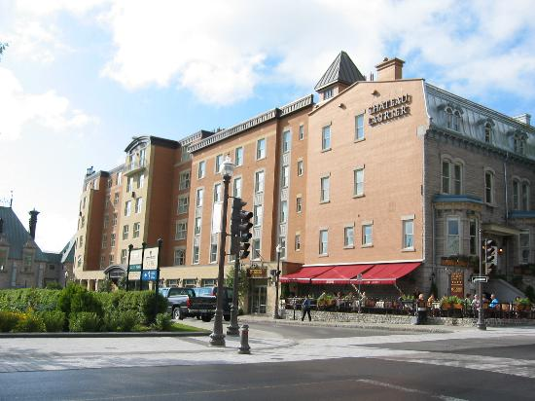
Conveniently located on the Plains of Abraham and only a five-minute walk from Old Quebec, the Château Laurier Hotel offers the tranquility of an inner courtyard and of one of the most prestigious city parks in Canada – all in close proximity to the irresistible charms of Quebec City.

Room Rate: CAN $189*

Distance from the convention centre: 0.5 kilometre

Location:
1220 George-V West Square
Quebec City, Quebec
Canada
G1R 5B8
Telephone: 1-418-522-8108
Fax: 1-418-524-8768
Web site: http://www.hotelchateaulaurier.com/en/laurier/

Guest Amenities:

- Air conditioned
- Breakfast
- Handicapped rooms/facilities
- Fire place
- Health club
- Phone service
- Room service
- Television with cable
- Meal plan - continental
- Safe deposit box
- Tour desk
- Laundry/valet services
- Porters
- Copy service
- Fax
- No smoking rooms/facilities
- Multilingual
- Restaurant
- Safe
- TV
- Fire alarm with light

Clarendon Hotel

Since 1870, the Clarendon Hotel has been an integral part of Old Quebec. It stands proudly across from the gardens beside City Hall in a historic neighbourhood featuring cobblestone streets, decorative gardens and a grove of century-old trees.
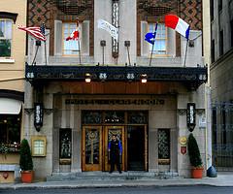

Room Rate: CAN $192*

Distance from the convention centre: 1.2 kilometres

Location:
57 Sainte-Anne Street
Quebec City, Quebec
Canada
G1R 3X4
Telephone: 1-418-692-2480
Fax: 1-418-692-4652
Web site: http://www.dufour.ca/en/dufour_menu/hotels/clarendon_hotel/

Guest Amenities:

Bags brought to your room
- Breakfast served at a table with a view of the Old City
- Health spa
- Bathrobe
- Pressed shirt
- Wireless high-speed Internet connection in each room

Courtyard Marriott Quebec
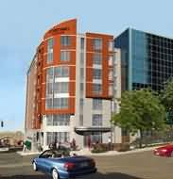
The Courtyard Marriott Quebec is at the heart of Quebec City's Joie de Vivre, just steps away from the world famous Historic District of Old Québec and its top attractions.

Room Rate: CAN $230*

Distance from the convention centre: 0.4 kilometre

Location:
850 D'Youville Place
Quebec City, Quebec
Canada
G1R 3P6
Telephone: 1-418-694-2171
Fax: 1-418-694-4478
Web site: www.marriott-quebec.com

Guest Amenities:
- Work desk and ergonomic char
- Voice mail
- Complementary high-speed Internet access
- Iron and ironing board
- Hair dryer
- Coffee machine and a small fridge

Other services:
A business center is at guests’ disposal as well as an exercise room and whirlpool facilities. Valet parking service, deposit boxes, dry cleaning and guest laundry service are also available.

Delta Quebec
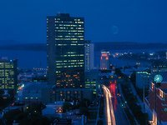
With exceptional views of the Laurentian Mountains and Parliament Hill, the Delta Quebec is located in the heart of North America’s only walled city. The hotel is linked to the Québec City Convention Centre and the boutiques of Quebec Place.

Rooms Rates: CAN $199 - $249*

Distance from the convention centre: 0.4 kilometre

Location:
690 René-Lévesque Boulevard East
Quebec City, Quebec
Canada
G1R 5A8
Telephone: 1-418-647-1717
Fax: 1-418-647-2146
Web site: http://www.deltaquebec.com/english/location.html

Guest Amenities:
- High-speed Internet access - wireless also available ($)
- Data port
- Working desk with ergonomic chair
- Television, cable and choice of in-room movies
- June Jacobs bath products
- Bathrobe
- Iron and ironing board
- Hairdryer
- Voice mail
- Clock radio and alarm
- Dry cleaning service ($)
- Newspaper delivered to your room
- Hotel safety deposit box upon request

Fairmont Le Château Frontenac
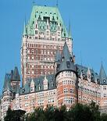

Overlooking the St. Lawrence River, Fairmont Le Château Frontenac is an integral part of the Historic District of Old Québec. This newly restored heritage hotel is within easy walking distance to all of the sites and experiences that Old Quebec has to offer.

Room Rates: CAN $309 - $359*

Distance from the convention centre: 0.9 kilometre

Location:
1 Carrieres Street
Quebec City, Quebec
Canada
G1R 4P5
Telephone: 1-418-692-3861
Fax: 1-418-692-1751
Web site: http://www.fairmont.com/frontenac/
Guest Amenities:
- Air-conditioning with individual climate control
- Alarm clock-radio
- Cable television with in-room pay movies and video games
- Fairmont high-speed Internet connection service through modem (complimentary to Fairmont President's Club members)
- Coffee/tea maker
- Hair dryer
- Iron and ironing board
- Refreshment center
- Telephone equipped with voice-mail and cordless phone
- Windows that open to the outside
- Video check-out

The following amenities may be available in selected guest rooms (please indicate the request in your on-line reservation): bed board, connecting rooms, crib, desk with halogen lamp, fireplace (non-working decorative) in some suites and Signature rooms, rollaway, and whirlpool (in selected rooms, upon availability – CAN $50 per night extra charge).

Loews Le Concorde Hotel
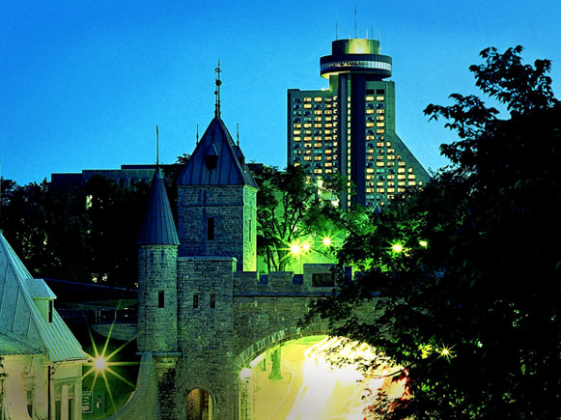
Loews Le Concorde Hotel is near the cobblestone streets of Old Quebec, three blocks from the city walls. This location is also across from Battlefields Park, two blocks from the Parliament buildings and the Capital Observatory, and six blocks from Saint-Jean Street (shopping and dining.) Nearby attractions include the Museum of Fine Arts, the Notre-Dame Cathedral and the Quebec Naval Museum.

Room Rate: CAN $249*

Distance from the convention centre: 0.7 kilometre
Location:
1225 Cours de Général-De Montcalm
Quebec City, Quebec
Canada
G1R 4W6
Telephone: 1-418-647-2222
Fax: 1-418-647-4710
Web site:
http://www.loewshotels.com/en/Hotels/Le-Concorde-Hotel/Overview.aspx?SetLanguage=true

Guest Amenities:
- Health Club, saunas, whirlpool and heated outdoor pool (in season)
- Multilingual staff and full-service concierge
- Uniquely local gift shops
- Two restaurants and lounges: L'Astral, a revolving rooftop restaurant and the Galerie, a lobby restaurant bar (outdoor terrace in season)
- 24-hour room service
- Business workstations
- Wireless high-speed Internet access
- Indoor parking / valet service available

Manoir Victoria Hotel
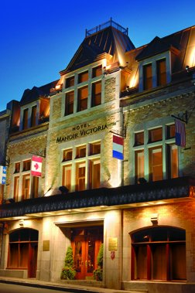
Located in the heart of historic, culturally vibrant, gastronomic and romantic Old Quebec, the Manoir Victoria is a unique four-star European-style hotel.

Room Rate: CAN $245*

Distance from the convention centre: 1.0 kilometre

Location:
44 Côte du Palais
Quebec City, Quebec
Canada
G1R 4H8
Telephone: 1-418-692-1030
Fax: 1-418-692-3822
Web site: http://www.manoir-victoria.com/English/index.html

Guest Amenities:
- Hairdryer
- Ironing board and iron
- Individual digital thermostat
- Color TV with cable, remote control and radio
- Free wi-fi Internet access. Internet lounge also available in lobby
- Alarm clock
- Direct access telephone
- In-room safe (Luxury, Grand Luxury, Distinctive, Suites)
- Voice mail
- Coffee maker
- Minibar ($)
- In-room pay movies
Additional Services (available upon request):
- Rollaway bed ($)
- Crib
- Humidifier
- Bed board

Royal Palace Hotel
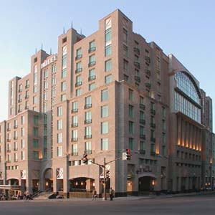
This majestic building is in perfect harmony with the European character of Old Quebec. It is situated across from the Québec City Convention Centre, within a stone's throw of the city's summer festivities.The hotel’s garden gives the impression of being on a tropical island.

Room Rates: CAN $179 - $209*

Distance from the convention centre: 0.4 kilometre

Location:
775 Honoré-Mercier Avenue
Quebec City, Quebec
Canada
G1R 6A5
Telephone : 1-418-694-2000
Fax: 1-418-380-2553
Web site: http://www.hotelsjaro.com/palaceroyal/index-en.aspx

Guest Amenities:
- Modem outlet
- Refrigerator and micro-waves
- Voice mail
- High-speed Internet access
- Iron and ironing board
- Coffee maker
- Hair dryer
- 27" television
- Extra quilts and hypo-allergenic pillows
* Please note that all room rates are subject to a 5 % federal goods and services tax, a 7.5 % provincial sales tax and a 3% accommodation tax.
APPENDIX – C
List of Countries and Territories Whose Citizens Require A Visa To Enter Canada

Please note that the following list is accurate as of 1 March 2008. For up-to-date information, please see the Citizenship and Immigration Web site at: http://www.cic.gc.ca/english/visit/visas.asp

A  Afghanistan  Albania  Algeria  Angola  Argentina  Armenia  Azerbaijan | B  Bahrain  Bangladesh  Belarus  Belize  Benin  Bhutan  Bolivia  Bosnia-Herzegovina  Brazil  Bulgaria  Burkina Faso  Burundi | C  Cambodia  Cameroon  Cape Verde  Central African Rep.  Chad  Chile  China, People’s Rep. of  Colombia  Comoros  Congo, Democratic Rep. of the  Congo, Rep. of the  Costa Rica  Croatia  Cuba | D  Djibouti  Dominica  Dominican Rep.
E  East Timor  Ecuador  Egypt  El Salvador  Equatorial Guinea  Eritrea  Ethiopia | F  Fiji | G  Gabon  Gambia  Georgia  Ghana  Grenada  Guatemala  Guinea  Guinea-Bissau  Guyana | H  Haiti  Honduras
I  India  Indonesia  Iran  Iraq  Israel (only Israeli citizens holding valid Israeli “Travel Document in lieu of National Passport”)  Ivory Coast | J  Jamaica  Jordan | K  Kazakhstan  Kenya  Kiribati  Korea, North  Kuwait  Kyrgyzstan | L  Laos  Lebanon  Lesotho  Liberia  Libya
M  Macao S.A.R.  Macedonia  Madagascar  Malawi  Malaysia  Maldives Islands  Mali  Marshall Islands  Mauritania  Mauritius  Micronesia, Fed. States  Moldova  Mongolia  Montenegro  Morocco  Mozambique  Myanmar (Burma) | N  Nauru  Nepal  Nicaragua  Niger  Nigeria | O  Oman | P  Pakistan  Palau  Palestinian Authority  Panama  Paraguay  Peru  Philippines
Q  Qatar | R  Romania  Russia  Rwanda | S  Sao Tomé e Principe  Saudi Arabia, Kingdom of  Senegal  Serbia  Seychelles  Sierra Leone  Somalia  South Africa  Sri Lanka  Sudan  Surinam  Syria | T  Taiwan  Tajikistan  Tanzania  Thailand  Togo  Tonga  Trinidad and Tobago  Tunisia  Turkey  Turkmenistan  Tuvalu
U  Uganda  Ukraine  United Arab Emirates  Uruguay  Uzbekistan | V  Vanuatu  Venezuela  Vietnam | Y  Yemen | Z  Zambia  Zimbabwe

APPENDIX – d
Map of Downtown Quebec City
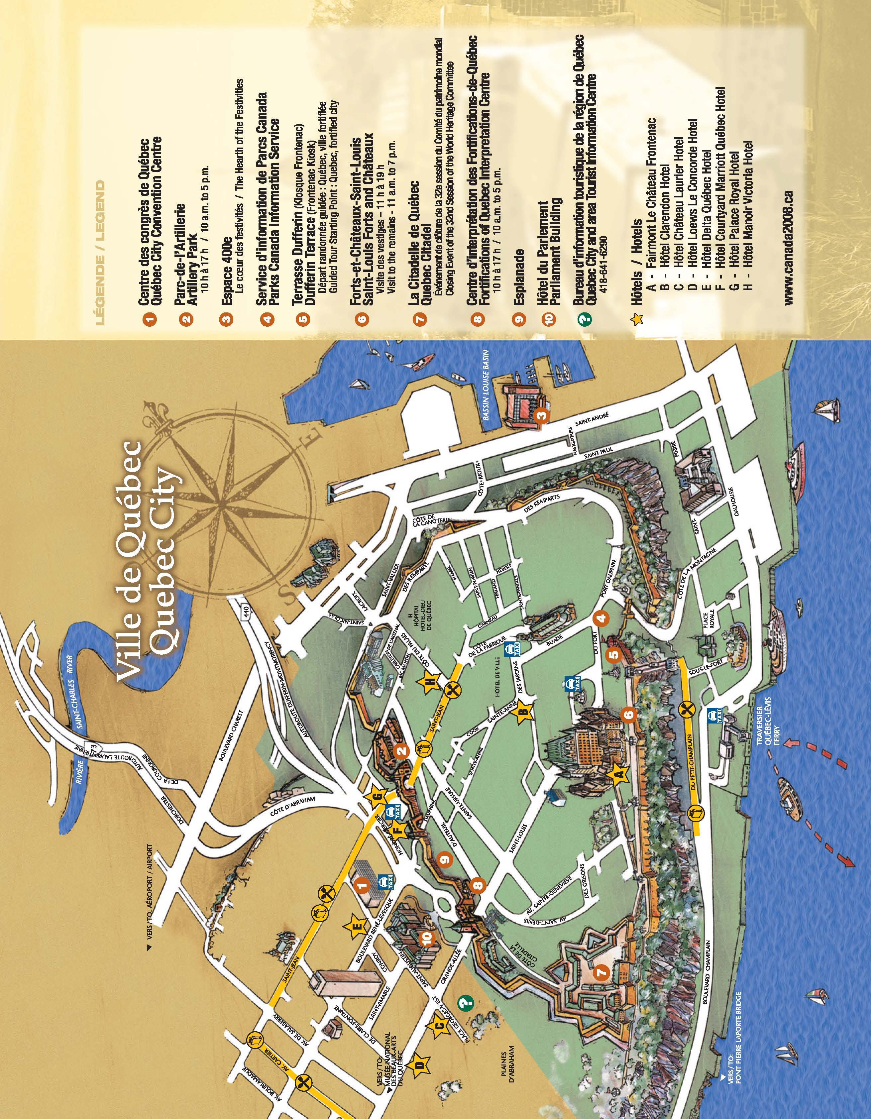
APPENDIX – E

Complimentary Tours

Whale Watching at the Saguenay St Lawrence Marine Park

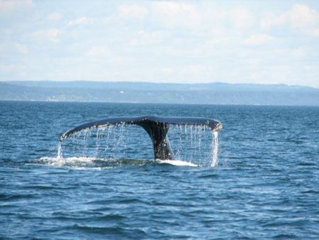
Start Time:
Coach departs from the Québec City Convention Centre at 7 a.m., 9 July 2008.

Dress:
Dress comfortably as the day will be spent walking or sitting in a motor coach or on a boat. If you select this option, be sure to bring some warm clothing because even on a summer’s day, it may be cold when on the water.

Tour Description:
Each year, when the finer weather returns, the little town of Tadoussac becomes the scene of intense activity. Hordes of nature-lovers descend on the region for a chance to observe the many species of marine mammals that gather in its nearby waters. More than 13 species that include blue whales, porpoises, belugas and several kinds of fin whale, spend a little time here where the Saguenay flows into the St Lawrence. The creatures are drawn by the abundance of food. Nothing is more splendid on a summer’s day than a river cruise that will allow you an up-close look at these majestic denizens of the cold oceans. Setting out from Quebec City, buses will pass the Île d’Orléans and the Basilica of Sainte-Anne de Beaupré, bringing passengers to Charlevoix, a region designated as a UNESCO Biosphere Reserve. Typical of Quebec, this entire area will enchant you with splendid vistas where sea and mountains meet. The river route through Charlevoix offers visitors arresting panoramas of picturesque, small rural villages. On the return journey, everyone will bring back fond memories of a wonderful day in the fresh air filled with discoveries of a truly special marine environment.

Details:
- Capacity : 200 people
- Embark at Baie Sainte-Catherine for the three-hour cruise
- Lunch at Tadoussac
- Return to Québec City Convention Centre for 5 p.m.
- Tour guides will be present throughout the day

Boat Crossing and Visit of Grosse Île and the Irish Memorial
National Historic Site of Canada

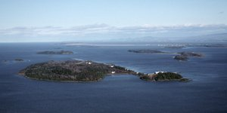
Start Time:
Coach departs from the Québec City Convention Centre at 8 a.m., 9 July 2008.

Dress:
Dress comfortably. The day will be spent walking or sitting in a bus or on a boat. If you select this option, be sure to bring some warm clothing because even on a summer’s day, it may be cold when on the water.

Tour Description:
Located in the middle of the St. Lawrence River, downstream from Quebec City, in the Île aux Grues archipelago, Grosse Île was a quarantine station from 1832 to 1937 for the Port of Quebec. At the time, it was the main point of entry for immigrants to Canada. The history of this location, which has witnessed such noteworthy events as the typhus epidemic in 1847 that killed thousands of Irish immigrants, will touch you with its many stories of human drama, including the exceptional devotion of the facility’s medical staff. Relive the unsettling experiences of immigrants who sailed towards the hope of a better future and the experiences of those who welcomed them.

A guided tour of this historical location will show you the measures established at that time to help the many immigrants who had contagious diseases therefore curbing the spread of epidemics on the continent. During your visit to the island, like the immigrants before you, you will pass through the disinfection building and meet the staff from that era for a simulated medical inspection. A pathway will then lead you to the hotels where the immigrants were housed, and to the Celtic cross, onto the western cemetery and to the Memorial, a monument dedicated to the memory of the immigrants, sailors and station employees who are buried on the island. Lastly, the tourist trolley will take you to the village and hospital sector. A brief stop at the Catholic chapel will give you insight into the daily lives of the islanders at this former quarantine station.

By visiting Grosse Île, you will discover the great human adventure of immigration, then and now. You will also encounter the seascape of the St. Lawrence River, where saltwater and freshwater meet.

Details:
- Capacity: 300 people
- Sail on the St. Lawrence River for two hours
- Lunch on the island
- Return to the Québec City Convention Centre for 5 p.m.
- Tour guides will be present throughout the day
Visit to the Montmorency Falls and of the Île d’Orléans
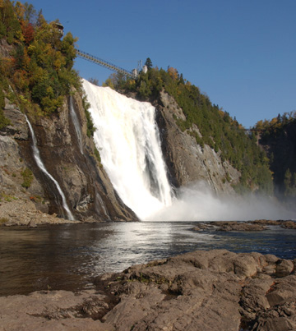
Start Time:
Coach departs from the Québec City Convention Centre at 8 a.m., 9 July 2008.

Dress:
Dress casually for comfort. Your day will be spent either sitting on a bus or walking.

Tour Description:
Located 20 kilometres downstream from Quebec City, Île d’Orléans was nicknamed Minigo (Enchantress) by the area’s first inhabitants and later christened Bacchus Island by explorer Jacques Cartier in 1535 because of its many wild vines. Approximately 30 kilometres long, the island takes its current name from the son of King Francis I, the Duke d’Orléans. Originally, most of the people who colonized the island, which is considered one of the oldest settlements in New France, were from Poitou and Normandy, provinces of western France. Part of their legacy is the mark they left on the many geographical names that still persist in Quebec.

Île d’Orléans hosts many architectural treasures of the past. The tour will acquaint you with the magnificent ancestral homes, historical churches and processional chapels that line the Chemin Royal. The enchanting countryside filled with farms, orchards and sugar bushes, not to mention the fabulous scenic views of the St. Lawrence River, will charm you. A stop at the Mauvide-Genest Manor National Historic Site of Canada, a venerable seigniorial residence, will introduce you to the customs of the former island inhabitants. A stop at a sugar shack will immerse you in one of the most popular and deeply rooted traditions of Quebec culture. Lastly, at a height of 83 metres, Montmorency Falls is sure to be a highpoint of your visit. You will be able to admire this true masterpiece of nature from the various lookouts.

Details:
- Capacity: 300 people
- Visit the Mauvide-Genest Manor National Historic Site of Canada
- A stop at a traditional sugar shack with music and taffy on snow sampling
- A stop at the Montmorency Falls Park
  - Aerial tramway
  - Lookouts / panorama
- Return to the Québec City Convention Centre at 5 p.m.
- Tour guides will be present throughout the day
APPENDIX – F
Optional Post-Session Excursions

Western Canada’s Majestic Natural Heritage
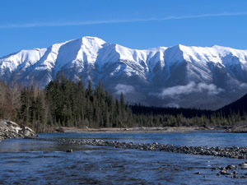
Straddling the British Columbia-Alberta border, the Canadian Rockies offer some of the most awe-inspiring scenery to be seen anywhere in the world. Some of the snow-capped peaks you will see in the distance rise to over 4,000 meters. At their base, as a permanent reminder of the beauty and power of nature, lie extraordinary glacier-carved landscapes. This is a land of emerald lakes, rushing rivers and breathtaking canyons, mighty glaciers, hot springs and forests of many species.

Canadian World Heritage Sites included:
- Head-Smashed-In Buffalo Jump (Alberta)
- Dinosaur Provincial Park (Alberta)
- Canadian Rocky Mountain Parks (Alberta and British Columbia)
- Waterton-Glacier International Peace Park (Alberta)
Steer North to a Nordic Realm
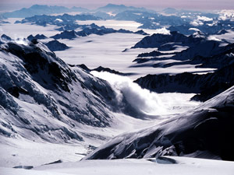
Behold! An empire of mountains and ice! Here, in a vast international preserve, are most of the tallest peaks in North America and the largest icefields outside the polar caps. Half the land mass is permanently draped in snow and ice – the other half fosters forests and tundra and stable populations of eagles, grizzlies and other species often at risk elsewhere. Kluane National Park and Reserve in the Yukon lies in the Canadian portion of a vast, unbroken ecological unit that covers 97,000 square kilometres. It is untouched but for an historic Aboriginal presence.

Canadian World Heritage Site included:
- Kluane/Wrangell - St.Elias/Glacier Bay/Tatshenshini-Alsek (Yukon and British Columbia)

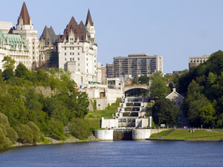
The Rideau Canal: A Triumph of the Human Spirit

The construction of the Rideau Canal and its associated fortifications represents a key event in the struggle between the British Empire and the United States of America for domination of North America. It is thus considered a singular witness to a fascinating period in human history. Built between 1828 and 1832, it stretches 202 kilometres from Ottawa to the Port of Kingston. It is the only canal dating from the great North American canal-building era of the early 19th century that remains operational along its original line with most of its original structures intact, including 47 locks, 74 dams, 33 lockmasters’ houses, 6 defensive outposts, a fort and 4 Martello towers. This excursion will acquaint you with a relatively recent era in which European conflicts had a determinant impact on North American history.

Canadian World Heritage Site included:
- The Rideau Canal (Ontario)

Newfoundland and Labrador: Great Voyages
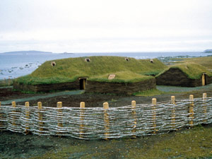
On the shores of the Atlantic, see for yourself the shared history of the European and North American continents. Gros Morne and L’Anse aux Meadows speak to great voyages of both people and the land.

The scenery at Gros Morne ranks among the most spectacular in Eastern Canada: sharp ridges and huge cliffs, coastal bogs and highland tundra, dramatic ocean inlets and lakes. Yet it is not primarily this exceptional natural beauty that has earned the park its place on the World Heritage List, but rather its remarkable geology. The park is considered a textbook illustration of plate tectonics, the now-proven theory that says continent-sized plates of the Earth’s crust have collided and separated repeatedly over geological time. Sedimentary strata in the park preserve fossils of almost every phylum known to exist during that time – a virtual catalogue of evolution.

The remains of the 1,000-year-old Viking colony at L’Anse aux Meadows mark the site of the first-known European settlement in North America. It was here that the Vikings built three timber-and-sod longhouses and five smaller buildings — and here that the first hot iron working in North America took place. Excavation has unearthed the remains of eight buildings and hundreds of Viking artefacts, mostly of wood but also of iron, stone, bronze and bone.

Canadian World Heritage Sites included:
- L'Anse aux Meadows National Historic Site (Newfoundland and Labrador)
- Gros Morne National Park (Newfoundland and Labrador)

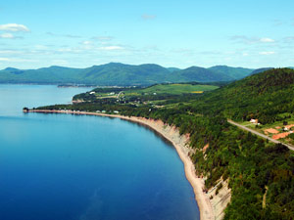
Miguasha: Witness to the Evolution of life on Earth

Fossils of plants and fish that tell the story of life on our planet some 378 million years ago: that is what awaits you in the jewel of nature to be discovered in Miguasha Park. A treasure house of the world’s natural heritage, this Park excites wonder with the condition of its remarkably rich fossil beds and enhances our understanding of a key transition in the evolution of life on Earth.

Canadian World Heritage Site included:
- Miguasha National Park (Quebec)

How To Book A Post-Session Excursion

Details regarding the post-session excursions, including their costs and itineraries, are still being finalized. If you select one of the post-session excursions, session organizers will communicate with you as soon as the detailed information is available.

In the meantime, if you have any questions, please do not hesitate to contact the session organizers.

Contact person:

Véronique Veillette
32nd Session of the World Heritage Committee
Parks Canada
25 Eddy Street, 5th Floor (25-5-W)
Gatineau, Quebec
Canada
K1A 0M5

Tel: 1-819-997-0506
Fax: 1-819-953-4909
E-mail: Canada2008@pc.gc.ca
APPENDIX – G
Media Accreditation Application Form

MEDIA ACCREDITATION APPLICATION FORM

32nd Session of the World Heritage Committee
Quebec City, Canada
2 – 10 July 2008

Please complete the application form and return it by fax to: 1-819-953-4909 or by mail to: 32nd Session of the World Heritage Committee, Parks Canada, 25 Eddy Street, 5th Floor (25-5-W), Gatineau, Quebec, Canada, K1A 0M5. The deadline for applications is 31 May 2008.

Personal Information

First Name(s):
______________________________________________________________________

Last / Family Name:
______________________________________________________________________

Title (Mr., Mrs., Ms., Dr, Hon., President, Prof.):
______________________________________________________________________

Address:
______________________________________________________________________

City / Town:
______________________________________________________________________

Province / State:
______________________________________________________________________

Postal Code / Zip Code:
______________________________________________________________________

Country:
______________________________________________________________________

Office Telephone:
______________________________________________________________________

Office Facsimile:
______________________________________________________________________

Mobile Telephone:
______________________________________________________________________

E-mail Address:
______________________________________________________________________

Date of Birth:
______________________________________________________________________

Place of Birth (Town, Country):
______________________________________________________________________

Nationality:
______________________________________________________________________

Passport Number:
______________________________________________________________________

Issue Date:
______________________________________________________________________

Place of Issue (Town, Country):
______________________________________________________________________

Expiry Date:
______________________________________________________________________

Name of the media organization you represent:
______________________________________________________________________

In which of the following media do you work?
 Print - Please specify:
_________________________________________________
 Radio - Please specify:
________________________________________________
 Television - Please specify:
____________________________________________
 Other - Please specify:
________________________________________________

Please indicate the dates you will require space in the media centre between 2 to 10 July 2008:
______________________________________________________________________

Privacy Statement

All of the personal information you will provide on the accreditation form will be encrypted and will be treated according to the Privacy Act of Canada. This information will be safeguarded for your protection. The information is being collected for the purpose of enabling session organizers to accredit you to cover the 32nd Session of the World Heritage Committee, in accordance with media protocols that are established for the session. It will also help other agencies of the Government of Canada to facilitate your entry into the country.

