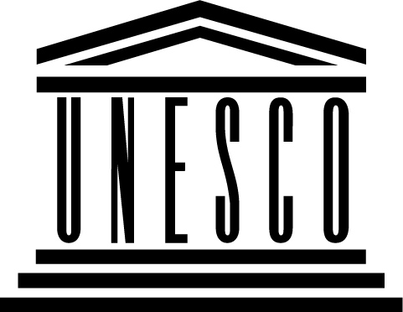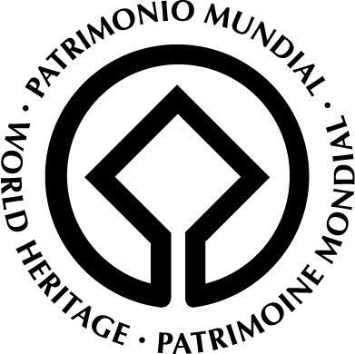

Mid Atlantic Ridge Expert Workshop,
Iceland

Government of Iceland
in cooperation with the
UNESCO World Heritage Centre

15 – 16 January 2007
8.30 – 14.00

Ministry of Education, Science and Culture
Sölvhólsgötu 4

Participants:

UNESCO:
Dr. Mechtild Rössler WHC Paris
Ms.Céline Fuchs WHC Paris

Norway:
Mr. Gaute Sønstebø, Direktoratet for naturforvaltning, Trondheim
Mr. Marko Petersen NWHF Oslo
Mr. Harald Bredesen NWHF Oslo

Iceland:
Sigurður K. Oddsson Thingvellir National Park
Einar E. Sæmundsen Thingvellir National Park
Guðrùn Kristinsdóttir Thingvellir National Park
Ossur Skarphéðinsson Thingvellir Committee
Steingrimur Hermannsson Chair of the Surstey Research Society
Snorri Baldursson Icelandic Institute of Natural History
Sveinn Jakobsson Icelandic Institute of Natural History
Helgi Torfason Icelandic Institute of Natural History

The Icelandic World Heritage Committee:
Ragnheiður H. Þórarinsdóttir Ministry of Education, Science and Culture, chair
Sigurður Á. Þráinsson Ministry for the Environment
Árni Bragason Environment and Food Agency of Iceland
Kristín Huld Sigurðardóttir The Archaeological Heritage Agency of Iceland

