WHC
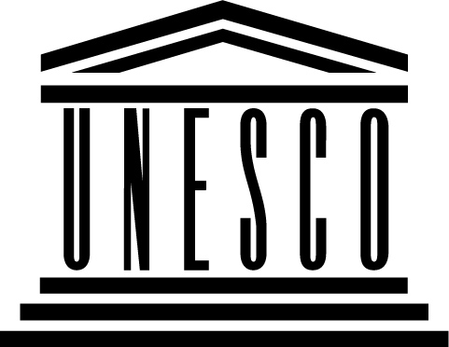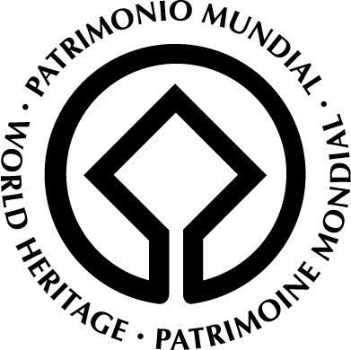
Mid Atlantic Ridge Expert Workshop,
Iceland

Government of Iceland
in cooperation with the
UNESCO World Heritage Centre

16 January 2007
8.30 – 14.00

Ministry of Education, Science and Culture
Sölvhólsgötu 4

Agenda

- Welcome and introduction . Icelandic World Heritage committee

- The World Heritage Convention and serial Trans-Boundary WHL nominations, WHC (Guidelines)

- Surtsey, creation and evolution – The Institute of Natural History, Iceland

- Mid-Atlantic Ridge – Serial nomination

- exchange information on the nature and distribution of Mid Atlantic Ridge heritage (biological, geological, cultural);
- set limits to the Ridge ‘phenomenon’ – the volcanic features associated with mid oceanic spreading in the Atlantic extend beyond the ridge; where should limits be set for practical and scientific reasons ?;
- review the distribution and function (in terms of heritage protected) of existing World Heritage sites on the Ridge;
- identify heritage (biological, geological, cultural) that is potentially of Outstanding Universal Value on the Ridge but currently lies outside WH sites;
- produce a concise report on the above including: review of the issues involved managing such serial sites; the use of serial nominations for capacity building; recommendations for action.

- Discussions

- Conclusion

14.30 – 18.00 Tour to Thingvellir

