Lady from Osogbo
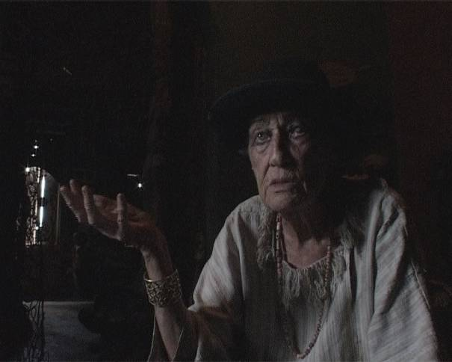
A 77’ documentary film by Pierre Guicheney (2007)
Camera Pierre Guicheney
Sound Malika Lasfar Guicheney
Editing Emmanuel Gérard Cuesta
Consultant François Liège
A CNRS / 24 Images / Pierre Guicheney coproduction

