World Heritage 31 COM
Distribution Limited WHC-07/31.COM/21A
Paris, 10 May 2007
Original: English/French
UNITED NATIONS EDUCATIONAL, SCIENTIFIC
AND CULTURAL ORGANIZATION
CONVENTION CONCERNING THE PROTECTION OF
THE WORLD CULTURAL AND NATURAL HERITAGE
World Heritage Committee
Thirty first Session

Christchurch, New Zealand
23 June – 2 July 2007

Item 21 of the Provisional Agenda: Other business

21A. Cost-benefit analysis of the current summary record and audio recording

SUMMARY

This document presents the results of a cost-benefit analysis of the current written Summary Record and an audio recording of the World Heritage Committee’s proceedings, as requested by Decision 30 COM 13 (Vilnius, 2006).

Draft Decision: 31 COM 21A, see Point II

- BACKGROUND

  - As a result of concerns about the efficiency, cost and transparency of the current Summary Record of its debates, by Decision 30 COM 13 adopted at its 30th session (Vilnius, 2006), the World Heritage Committee requested the World Heritage Centre to undertake a cost benefit analysis of the production of the written Summary Record and an audio verbatim recording for discussion at its 31st session.
  - In preparing the cost-benefit analysis, the following assumptions were applied:
a) the audio recording would be made available as an audio CD/DVD in English and French (and any other languages for which interpretation was provided at the session, as the interpreters are recorded), indexed (Annex 1), and easy to search and use;
b) it would also be accompanied by a short written summary of no more than 50 pages, in order that users without easy access to computers would not be disadvantaged by a switch to audio recordings. This short summary would enable the reader to track the principal points of debate leading to the Committee’s Decision. Such a model is already used by other international organizations such as the International Whaling Commission.
  - The cost-benefit analysis, which used the actual costs of producing the Summary Record of the 28th session of the Committee (Suzhou, 2004) as the baseline, is presented in Options A and B in Table I.
  - The cost-benefit analysis shows that a switch to an audio verbatim recording would result in financial savings in terms of paper consumption, printing, translation and postage.
  - There would also be beneficial opportunity costs related to efficiency because the current written record typically takes one year to finalize, whereas the audio recording could be issued at the same time as the Decisions report, i.e. within one month of the closure of the session (Rule 46 of the Rules of Procedure). Another benefit, although not financially quantifiable, is that an audio verbatim recording provides a perfectly accurate record of what is said. This should be of high value to users and in particular to States Parties.
Table I
Option A : Written record: 28th session of the World Heritage Committee (Suzhou, 2004)
Option B : Audio recording CD/DVD: 28th session of the World Heritage Committee (Suzhou, 2004)

 | ACTIONS | OBSERVATIONS | ESTIMATE OPTION A | ESTIMATE  OPTION B
 | Per diem of a staff member( sound technician) | This mission could be covered by the host country in the framework of the “Statement of Requirements” |  | Per diem: USD 660  Terminal Fares: USD 120
 | Travel (sound technician) Paris-Shanghai-Suzhou | Based on an Economy class flight |  | USD 1,000
 | Overtime (sound technician) | Based on 40 hours  (30€ per hour) |  | USD 1,589
 | Transcription | Note-taking during the meeting | By World Heritage Centre staff members | By World Heritage Centre staff members
 | Reproduction costs for the CD /DVD | US$ 2.38 per copy  (450 copies) |  | USD 1,071
 | Printing of the first Draft Summary Record | Printing at UNESCO Headquarters | Approximately 200 pages: USD 1,119 | Approximately 50 pages: USD 430
 | Postal costs for the dispatch of the first Draft of the Summary Record. | The Draft Summary Record has to be sent for approval to the participant States Parties. The dispatch is by e-mail and postal services. | USD 1,454 | USD 867

 | ACTIONS | OBSERVATIONS | ESTIMATE  OPTION A | ESTIMATE  OPTION B
 | Preparation of the cover page | Cover page prepared by RECTO VERSO in accordance with the editorial directives of UNESCO and the World Heritage Centre. | USD 437 | USD 437
 | Compilation, correction, page-setting of the final version of the Summary Record | A staff member (P2) to update the corrections (2 months full time) / Staff member (P-4) (one month). | By World Heritage Centre staff members at the meeting | By World Heritage Centre staff members at the meeting
 | Reviser (English) | Temporary staff contracted  (P5) | approximately 200 pages: USD 5,033 | approximately 50 pages: USD 2,516
 | Translation | From English to French and vice versa  (USD 51,60 per page) | approximately 200 pages: USD 10,320 | approximately 50 pages: USD 2,580
 | Printing of the final version | Printing at UNESCO Headquarters | approximately 200 pages: USD 1,119 | approximately 50 pages: USD 430
 | Postal costs for the dispatch of the final version of the Summary Record | 1 copy per address based on approximately 450 dispatches to different postal zones. Priority post. | approximately 500 gr: USD 3,973 | approximately 155 gr: USD 2,880
 |  |  | TOTAL:  USD 23,455 | TOTAL:  USD 14,580

II. DRAFT DECISION

Draft Decision: 31 COM 21A

The World Heritage Committee,
- Having examined Document WHC-07/31.COM/21A,
- Recalling Decision 30 COM 13, adopted at its 30th session (Vilnius, 2006),
- Takes note of the cost-benefit analysis presented therein;
- Requests the World Heritage Centre to produce an audio verbatim recording of the proceedings of its sessions, which should be complemented by a short written summary, as of its 32nd session in 2008.
Annex 1

Model: Index of the Audio-recording of the 15th session of the General Assembly of States Parties to the World Heritage Convention (UNESCO, 10-11 October 2005)

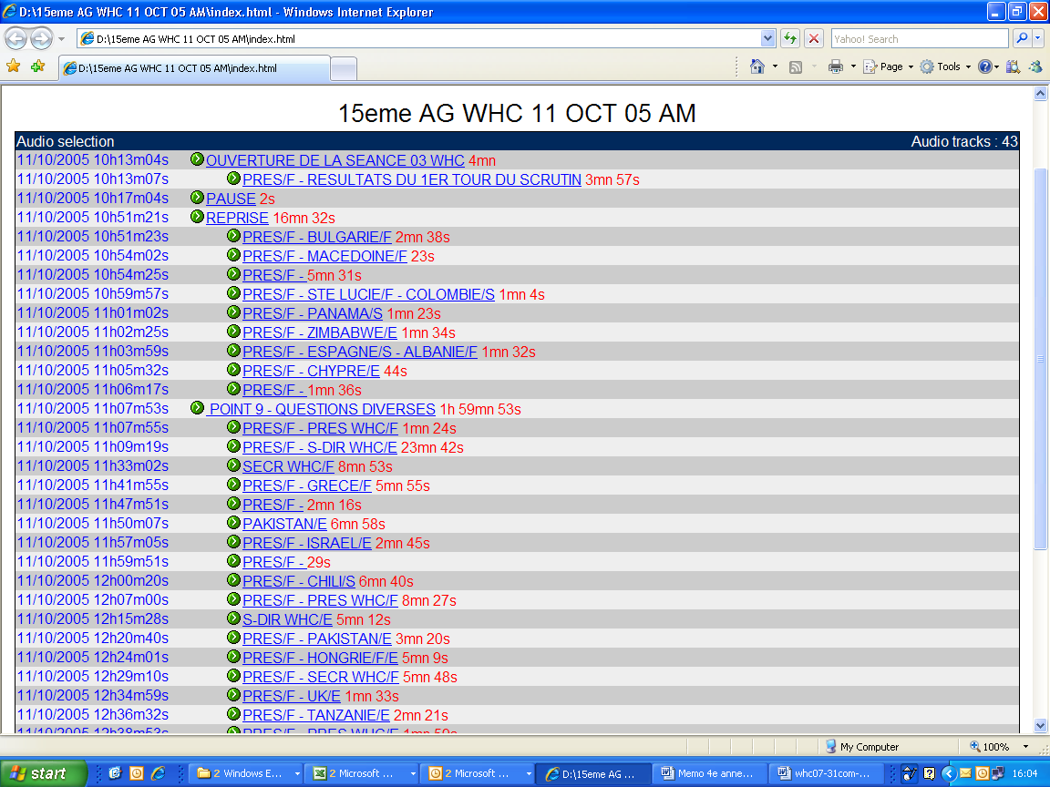
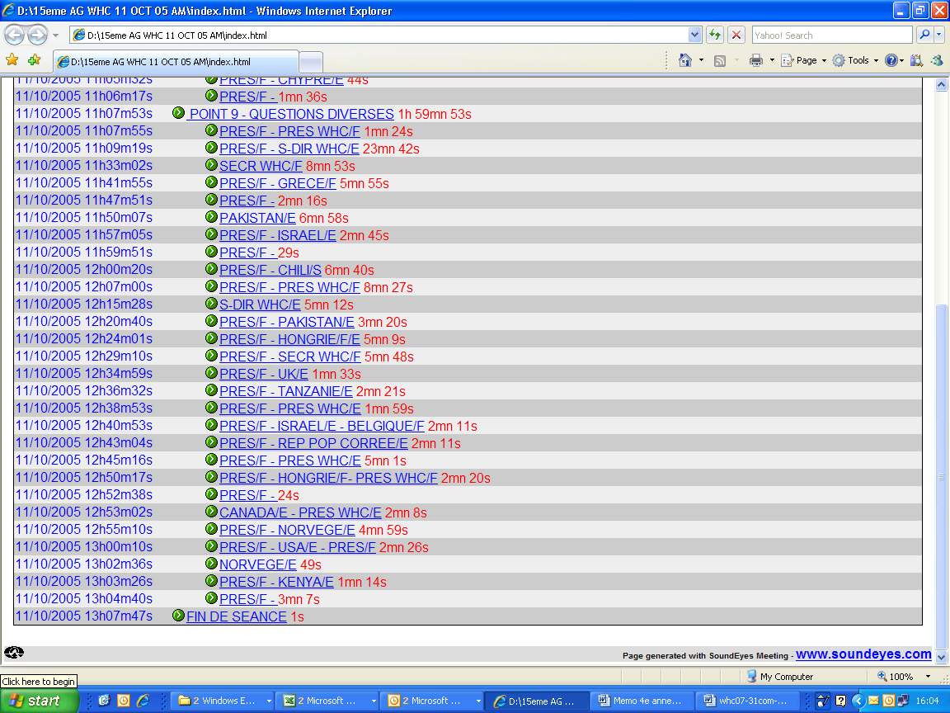

The travel of a sound technician UNESCO staff member would be necessary to ensure an audio recording indexed following the UNESCO format.

