World Heritage 31 COM
Distribution Limited WHC-07/31.COM/11A.2
Paris, 10 May 2007
Original: English/French
UNITED NATIONS EDUCATIONAL, SCIENTIFIC
AND CULTURAL ORGANIZATION
CONVENTION CONCERNING THE PROTECTION OF
THE WORLD CULTURAL AND NATURAL HERITAGE
WORLD HERITAGE COMMITTEE

Thirty first Session

Christchurch, New Zealand
23 June – 2 July 2007

Item 11A of the Provisional Agenda: Follow-up on the Periodic Report for Europe

11A.2 Clarifications of site limits and property sizes by States Parties in response to the Retrospective Inventory

SUMMARY

This document presents the results of the Retrospective Inventory of nomination dossiers of properties inscribed in the European region between 1978 and 1998, conducted in coordination with the European Periodic Reporting Exercise. The document recalls the need for the Inventory and the Committee's decision to endorse it in December 2004 (Decision 7 EXT.COM 7.1). In response to letters written to each State Party following review of the individual dossiers, fifteen States Parties have responded in order to clarify the original intention of their nominations.

A summary of follow-up activities to the Periodic Report for the European Region, presented to the World Heritage Committee at its 30th session (Vilnius, 2006), is contained in document WHC-07/31.COM/11A.1.

Draft Decision: 31.COM 11A.2, see Point IV

Clarifications and Retrospective Inventory

- Origins of the Retrospective Inventory

The Retrospective Inventory, an in-depth examination of the nomination dossiers held by the World Heritage Centre, ICOMOS and IUCN, was initiated in the autumn of 2004. As of March 2007 it had completed work on sites inscribed in Europe (1978-1998) and Arab States (1978-2004), and had started the analysis of African sites (1978-2005). The documentation submitted by European States Parties in the framework of the Periodic Reporting Exercise had also been examined (with the exception of some GIS files for which the relevant software was not available at the World Heritage Centre, but which will be examined before the end of the year).

Four considerations led the World Heritage Centre to establish the Retrospective Inventory:

- For older sites, in most countries, there is no institutional memory at the local and national levels concerning the inscription process of sites. This principle is valid for each region and is a major source of difficulties for the Periodic Reporting process, as shown in the first cycle (2000-2006). It was originally thought that the distribution of CDs containing a scanned version of the relevant nomination materials would assist the States Parties to solve the problem of the lack of institutional memory. Unfortunately, the burning of the CDs was conducted over a very short time frame and undertaken long before the discrepancies between the different nomination archives were understood. No analysis was made of the different nomination versions, very little supplementary material submitted before inscription was included, nor were maps with formats larger than A3; therefore, the CD which were distributed proved to be incomplete. As a consequence, the need of an urgent thorough examination of nomination dossiers, in order to identify authoritative versions of documents and maps, was acknowledged, and the Retrospective Inventory was created in order to (among other functions) accomplish such an analysis;

- For older sites, a complete set of documentation provided by States Parties does not exist in a single repository. In particular, almost all pre-inscription documentation is only kept at the Advisory Bodies archives, while a substantial portion of post-inscription information submitted by States Parties is only available at the World Heritage Centre. This “dispersion” of the documentation concerning each site has led to serious omissions in mission planning, with implications on the full understanding of the state of conservation of sites. The Retrospective Inventory helps to solve this problem, thanks to the elaboration of a consolidated list of all materials concerning each World Heritage Site, clarifying where each document is kept and whether it is available in an electronic version;

- Often, a full awareness of the extent of World Heritage sites is missing. While the general identity of the 830 properties is of course known, the limits of most sites inscribed before 1992 are uncertain. A still-unknown number of properties are "serial" properties, often without identified boundaries. In Europe alone, over 1700 separate serial parcels are included in the more than 400 World Heritage properties, for the most part unmapped. New serial properties are being discovered as a result of the Retrospective Inventory analysis (confirmed serial properties are listed on the web site under the corresponding site name).

- Baseline data (such as boundaries, geographic coordinates, serial components, size of property in hectares, etc.), are essential for reactive monitoring and are equally importantly to prepare and to analyze Periodic Reports on World Heritage properties. Baseline data do not exist in any consistent, easily retrievable form for most World Heritage sites. The Retrospective Inventory is essential to capture such information.

II. Periodic Reporting and Retrospective Inventory

The Retrospective Inventory was begun in parallel with the launching of the Periodic Reporting Exercise in Europe, in order to determine what baseline data existed for the concerned European properties, so that:
- Focal points of State Parties would have the best possible baseline data on which to found their own Section II reports;
- The World Heritage Centre would have valid baseline data against which to review completed Section II reports; and
- Missing geographic information could be identified and requested from States Parties as part of the process.

Letters were sent to Periodic Reporting focal points, Permanent Delegations, National Commissions and national authorities identifying the relevant maps and other geographic information on file and asking for the missing information.

To date, 15 States Parties have responded, either in full or in part, to the requests contained in the Retrospective Inventory letters.

III. Clarifications

The responses of the States Parties to the Retrospective Inventory, whenever providing previously missing geographic information or defining previously uncertain boundaries, are considered "clarifications". They are, in other words, re-statements of the original intention of the States Parties, consistent with the final nomination as presented, the opinion of the Advisory Body and the decision of the Committee at the time of inscription. For the purpose of the Committee's record, and in order to avoid any future misunderstanding, it is important that the Committee "takes note" of such clarifications.

To this end, a working document has been produced for the Committee's consideration at its 31st session, containing all boundary "clarifications" received in response to the Retrospective Inventory (a “Clarification Document” will be issued each year until all outstanding map and boundary issues have been resolved). This document includes a thumbnail record of the new map of the property and some explanatory notes. If the property is serial, a small table lists the serial components and their sizes. This document does not include answers to the Retrospective Inventory when there is no “clarification” provided, i.e. whenever geographic information on the concerned site was already available, boundaries were already clear and the State Party was only requested to submit a map of a better quality than the one submitted with the nomination. Moreover, the “clarification” procedure does not apply whenever site boundaries are clearly defined and States Parties wish to change them. In such a case, procedures for boundary modifications (minor or significant), as defined in the relevant paragraphs of the Operational Guidelines, apply.
The Committee is invited to "take note" of the clarifications provided, thank the States Parties concerned for their action and request European States Parties who have not provided yet an answer to the questions raised within the Retrospective Inventory framework to do so by 1 December 2007 at the latest. This deadline will allow the World Heritage Centre to present all new clarifications to the Committee at its 32nd session in 2008. The Committee is also invited to acknowledge that, whenever site boundaries are not clearly defined, it will not be possible for the World Heritage Centre to examine proposals for boundary modifications.

Note: this document is being printed in black and white, but its electronic version is in colour and is available (document whc07-31com-11A.2e) at the following Web address: http://whc.unesco.org/archive/2007.

IV. Draft Decision: 31 COM 11A.2

The World Heritage Committee,

1. Having examined Document WHC-07/31.COM/11A.2,

2. Takes note of the clarification of property limits provided by the following States Parties in the Europe region in response to the Retrospective Inventory:

- Belgium: La Grand-Place, Brussels;
- Bulgaria: Rock-Hewn Churches of Ivanovo; Thracian Tomb of Sveshtari;
- Italy: Church and Dominican Convent of Santa Maria delle Grazie with “The Last Supper” by Leonardo da Vinci; Historic Centre of Florence; I Sassi di Matera; Historic Centre of Urbino;
- Portugal: Historic Centre of Évora;
- Slovenia: Škocjan Caves;
- Spain: Altamira Cave; Mudejar Architecture of Aragon; Cathedral, Alcázar and Archivo de Indias in Seville; La Lonja de la Seda de Valencia; San Millán Yuso and Suso Monasteries; University and Historic Precinct of Alcalá de Henares.

3. Requests the State Parties in the Europe Region who have not yet answered the questions raised in 2005 in the framework of the Retrospective Inventory to provide all requested clarifications and documentation as soon as possible and by 1 December 2007 at the latest;

4. Acknowledges that the World Heritage Centre and the Advisory Bodies will not be able to examine proposals for boundary modifications for properties located in the Europe Region whenever current boundaries are unclear. The same principle applies to sites located within other Regions;

5. Thanks the States Parties concerned for their efforts to improve the credibility of the World Heritage List.

Clarifications of Site limits and Property sizes by States Parties

BELGIUM

Property | La Grand-Place, Brussels
Identification | BE-857
Date(s) of inscription | 1998
Area of the inscribed property | 1.4806 ha
Area of the buffer zone | 20.9334 ha
Date of receipt of the clarification | 06/02/2007

Technical Summary:
The State Party has provided a clear map of the site, displaying the boundaries of the inscribed property and its buffer zone. The surface in hectares of the inscribed property and its buffer zone has also been indicated.

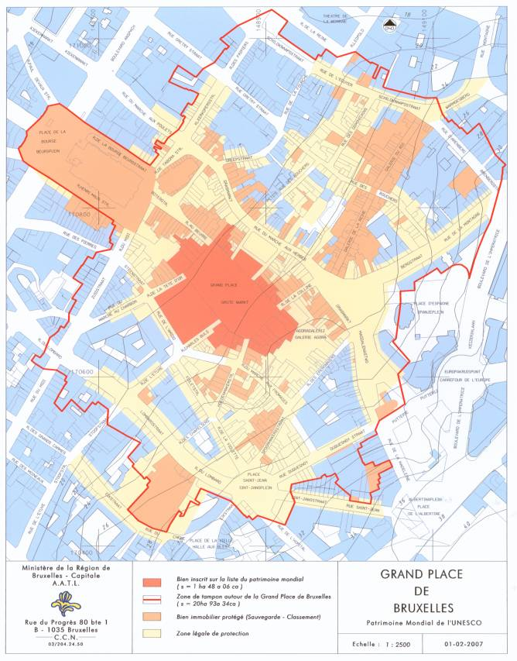

BULGARIA

Property | Rock-Hewn Churches of Ivanovo
Identification | BG-45
Date(s) of inscription | 1979
Area of the inscribed property | 171.8 ha
Date of receipt of the clarification | 21/12/2005

Technical Summary:
The State Party has provided a clear vector map of the site, displaying the boundaries of the inscribed property. The surface in hectares of the inscribed property has also been indicated.

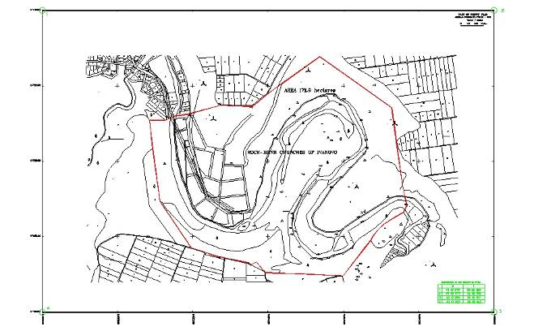

Property | Thracian Tomb of Sveshtari
Identification | BG-359
Date(s) of inscription | 1985
Area of the inscribed property | Not provided
Date of receipt of the clarification | 21/12/2005

Technical Summary:
The State Party has provided a clear vector map of the site, displaying the boundaries of the inscribed property. The surface in hectares of the inscribed property has not been indicated.

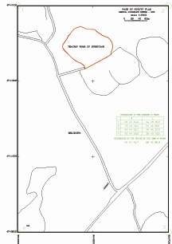

ITALY

Property | Church and Dominican Convent of Santa Maria delle Grazie with "The Last Supper” by Leonardo Da Vinci
Identification | IT-93
Date(s) of inscription | 1980
Area of the inscribed property | Not provided
Date of receipt of the clarification | 30/01/2006

Technical Summary:
The State Party has provided a clear map and an aerial photograph of the site, which display the boundaries of the inscribed property. The surface in hectares of the inscribed property has not been indicated.

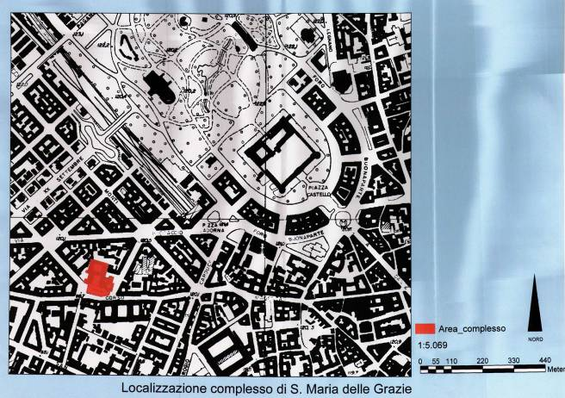
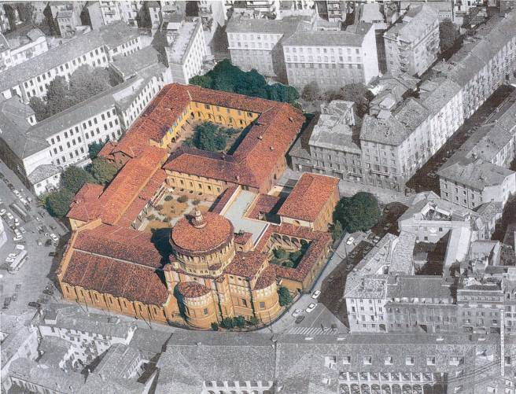

Property | Historic Centre of Florence
Identification | IT-174
Date(s) of inscription | 1982
Area of the inscribed property | 505 ha
Date of receipt of the clarification | 30/01/2006

Technical Summary:
The State Party has provided GIS files and a clear map of the site, displaying the boundaries of the inscribed property. The surface in hectares of the inscribed property has also been indicated.

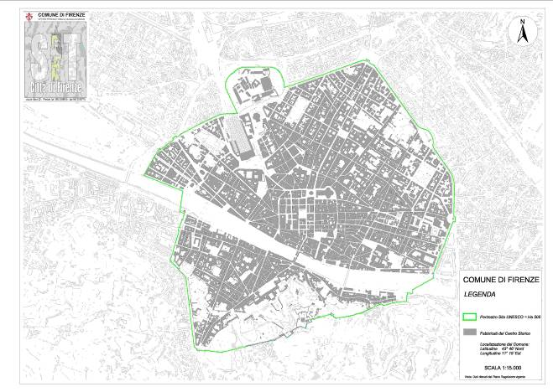

Property | I Sassi di Matera
Identification | IT-670
Date(s) of inscription | 1993
Area of the inscribed property | 1016 ha
Area of the buffer zone | 4365 ha
Date of receipt of the clarification | 30/01/2006

Technical Summary:
The State Party has provided a clear map of the site, displaying the boundaries of the inscribed property and its buffer zone. The surface in hectares of the inscribed property and its buffer zone has also been indicated.

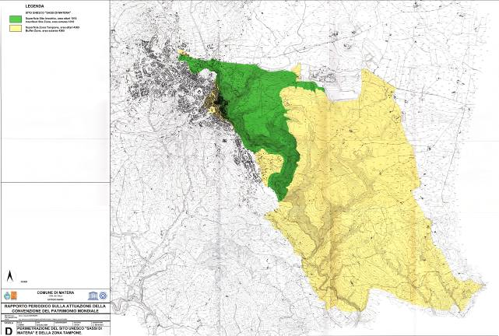

Property | Historic Centre of Urbino
Identification | IT-828
Date(s) of inscription | 1998
Area of the inscribed property | 29.23 ha
Area of the buffer zone | 3608.5 ha
Date of receipt of the clarification | 20/02/2006

Technical Summary:
The State Party has provided clear maps of the site, displaying the boundaries of the inscribed property and its buffer zone. The surface in hectares of the inscribed property and its buffer zone has also been indicated.

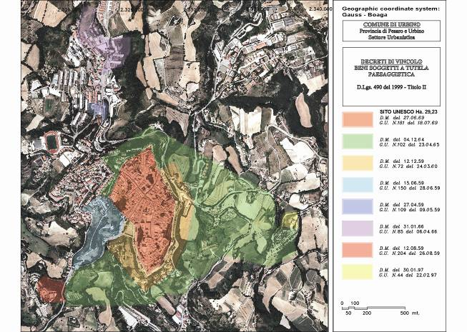
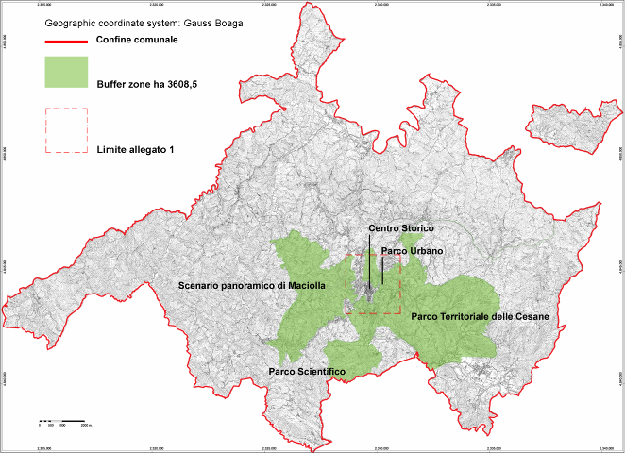

PORTUGAL

Property | Historic Centre of Évora
Identification | PT-361
Date(s) of inscription | 1986
Area of the inscribed property | 100,35 ha
Date of receipt of the clarification | 02/02/2006

Technical Summary:
The State Party has provided a clear map of the site, displaying the boundaries of the inscribed property; the map also displays the buffer zone existing at the national level, which should be presented to the Committee for review in the future. The surface in hectares of the inscribed property has also been indicated.

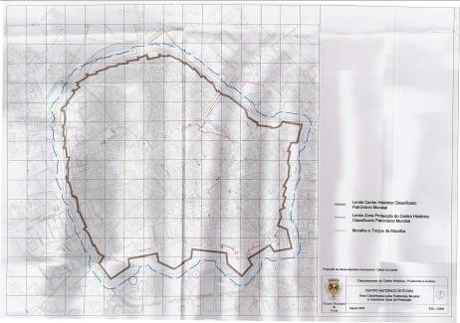

SLOVENIA

Property | Škocjan Caves
Identification | SI-390
Date(s) of inscription | 1986
Area of the inscribed property | 413 ha
Date of receipt of the clarification | 26/10/2006

Technical Summary:
At the time of its 10th session in 1986, the World Heritage Committee "noted that the area inscribed on the World Heritage List included the underground chamber of the Hanke Canal extending in the direction of Druskovec". No map was submitted to the Secretariat to reflect this modification to the original nomination. In discussions with the representative of the Ministry of the Environment in September 2006, it was mentioned that a corrected map had been submitted by the State Party to IUCN. This was later confirmed. In October 2006 a map was submitted, showing clearly the boundaries of the World Heritage property including the underground chamber of the Hanke Canal extending in the direction of Druskovec. This map is consistent with the opinion of IUCN and with the decision of the Committee. A buffer zone exists at the national level. The State Party has also indicated the surface in hectares of the inscribed property.

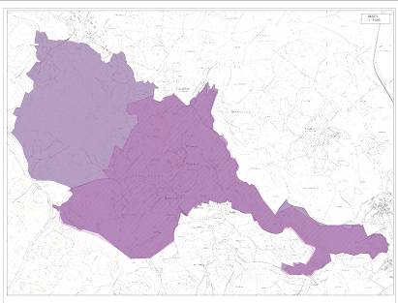

SPAIN

Property | Altamira Cave
Identification | ES-310
Date(s) of inscription | 1985
Area of the inscribed property | Not provided
Area of the buffer zone | 16 ha
Date of receipt of the clarification | 01/02/2007

Technical Summary:
The State Party has provided a clear map of the site, displaying the boundaries of the inscribed property and its buffer zone. The surface in hectares of the buffer zone of the site has been indicated, but the size of the inscribed property has not been provided.

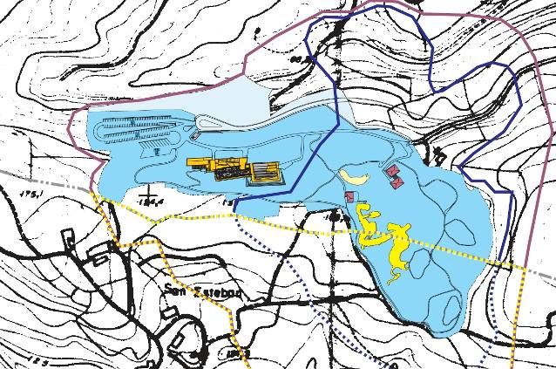

Property | Mudejar Architecture of Aragon
Identification | ES-378bis
Date(s) of inscription | 1986-2001
Area of the nscribed property | 4.251 ha
Area of the buffer zone | 27.2935 ha
Date of receipt of the clarification | 01/02/2007

Technical Summary:
This is a serial site composed of ten elements: four inscribed in 1986 and six added in 2001. While the boundaries of the six elements inscribed in 2001 were clearly defined and the surface in hectares of each component was known, the delimitation and the surface of the four elements inscribed in 1986 was unclear. The State Party has provided clear maps displaying the boundaries and the buffer zone of each component of the property and has indicated the surface in hectares of each site element and its buffer zone.

Serial ID | Name | Area | Buffer zone
378-001 | Torre, techumbre y cimborrio de la catedral de Santa María de Mediavilla | (2482m²)  0.2482 ha | (19921m²)  1.9921 ha
378-002 | Torre e iglesia de San Pedro | (1396m²)  0.1396 ha | (11594m²)  11.594
378-003 | Torre de la iglesia de San Martín | (85m²)  0.0085 ha | (17804m²)  1.7804 ha
378-004 | Torre de la iglesia del Salvador | (94m²)  0.0094 ha | (6321m²)  0.6321 ha

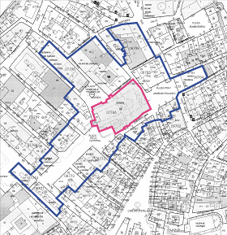 | 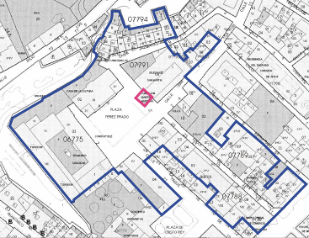
Torre, techumbre y cimborrio de la catedral de Santa María de Mediavilla (378-001) | Torre e iglesia de San Pedro (378-002)
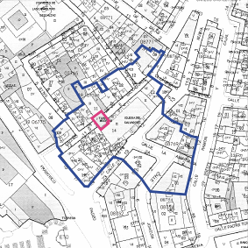 | 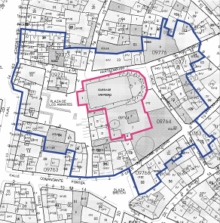
Torre de la iglesia de San Martín (378-003) | Torre de la iglesia del Salvador (378-004)

Property | Cathedral, Alcazar and Archivo de Indias in Seville
Identification | ES-383rev
Date(s) of inscription | 1990
Area of the inscribed property | 12.19 ha
Date of receipt of the clarification | 01/02/2007

Technical Summary:
Serial ID | Name | Area
383-001 | Catedral de Sevilla | 2.02 ha
383-002 | Reales Alcázares | 9.85 ha
383-003 | Archivo de Indias | 0.31 ha
The State Party has clarified the surface in hectares of the three components of this serial site.

Property | La Lonja de la Seda de Valencia
Identification | ES-782
Date(s) of inscription | 1996
Area of the inscribed property | 0.20 ha
Date of receipt of the clarification | 01/02/2007

Technical Summary:
The State Party has clarified the surface in hectares of the inscribed property.

Property | San Millán Yuso and Suso Monasteries
Identification | ES-805
Date(s) of inscription | 1997
Area of the inscribed property | 19.01 ha
Area of the buffer zone | 266.24 ha
Date of receipt of the clarification | 01/02/2007

Technical Summary:
The State Party has clarified the surface in hectares of the two components of this serial property.

Serial ID | Name | Area | Buffer zone
805-001 | Monasterio de Yuso y huertas dentro de los tapiales históricos | 18.90 ha | 104.26 ha
805-002 | Monasterio de Suso y yacimientos arqueológicos | 0.11 ha | 161.98 ha

Property | University and Historic Precinct of Alcalá de Henares
Identification | ES-876
Date(s) of inscription | 1998
Area of the inscribed property | 75.15 ha
Area of the buffer zone | 109.89 ha
Date of receipt of the clarification | 01/02/2007

Technical Summary:
The State Party has clarified the surface in hectares of the inscribed property and its buffer zone.

Approved by the 7th Extraordinary Session, Decision 7 EXT.COM 7.1 (UNESCO, 2004)

