REPORT ON THE IMPACT OF CLIMATE CHANGE ON THE MOSI-OA-TUNYA WORLD HERITAGE SITE

- State party: Zambia
- Name of World Heritage Property: Mosi-oa-tunya waterfalls
- Geographical coordinates to the nearest second: 17°56”S and 25°55”E
- Date of inscription on the World Heritage List: 15th December 1989.
- Organisation or entity responsible for the preparation of the Report: National Heritage Conservation Commission.
- Date of the Report. 2nd January, 2007
- Signature on behalf of the State Party……………………….
THE IMPACT OF CLIMATE CHANGE ON THE MOSI-OA-TUNYA WORLD HERITAGE SITE

Introduction
Climate change has been a topic of major debate for over a decade as a result of observable changes in various environmental areas such as loss or extinction of certain species, changes in the hydrological regimes and rainfall patterns resulting severe droughts in some areas and severe floods in others. Climate change is an alteration of long standing weather patterns-as opposed to daily fluctuations-above and beyond natural climate variability observed over comparable time periods; climate changes are changes in the composition of the global atmosphere that can be attributed directly or indirectly to human activity

It has been predicted that there will be a rise of about 1.4˚-5.8˚C by the year 2100 and that the mean sea level is expected to rise 9-88 centimeters by the same year. Such radical changes are likely to have fundamental impacts on the global environment. In general, the faster the climate changes, the greater the risk will be to sustainable living conditions.

Temperature increases could result in increases in global precipitation and changes in the severity or frequency of extreme events, such as hurricanes, droughts, and tornadoes. Changes could result in shift in climatic zones displacing current locations of forests, deserts, rangelands, and wetlands and causing a decline in the health of some ecosystems, as well as accelerated species extinction.

Human societies will face new risks and pressures. Some regions are likely to experience food shortages and hunger. Water resources will be affected as precipitation and evaporation patterns change around the global. The consequences to the physical and economic health and welfare of humankind could be disastrous.

The impacts of climate change and the response by human societies will vary from one region to another. For Africa the impact may be very severe considering the already existing vulnerability and poverty levels in many countries.

The United Nations Framework Convention on Climate Change
All attempts to improve the situation will require dramatic changes in the way we use energy, as well as in our general understanding of ecological systems. The international community is tackling this challenge through the UNFCCC. Adopted in 1992 and with more than 185 member nations, the Convention seeks to stabilize atmospheric concentrations of greenhouse gases at safe levels. It commits all countries to find ways to limit their emissions, gather relevant information, develop strategies for adapting to climate change, and cooperate with each other. It also requires developed countries to take measures aimed at returning their emissions of greenhouse gases to 1990 levels.

The Kyoto protocol (an extension of convention agreements, which outline ways to proceed) requires governments to take even stronger action. In 1997, the Parties to the Convention agreed by consensus that developed countries should accept a legally binding commitment to reduce their collective emissions of six green house gases by at least 5 percent compared to 1990 levels by the period 2008-2012. The protocol also establishes an emission trading regime and a “clean development mechanism”.

Zambia signed the UNFCCC on the 11th June 1992 in Rio de Janeiro during the UNCED and ratified it in March 1993.

Mosi-oa-tunya world heritage site and climate change
A number of concerns as regards the impact of climate change on the natural property and the entire Zambezi basin have been raised, however there have been no focused studies done on the property with respect to the world heritage site. If any were done we have not come across such studies within the time period given. As an institution i.e. national heritage conservation we have not undertaken any such studies and with the rising concerns there will be need to put in place a monitoring programme for particular environmental parameters. With no focused studies on the property, effort is made to highlight concerns on climate change observed in the Zambezi basin in which the world heritage site is situated.

The Zambezi basin has been experiencing a spate of floods and droughts in the past years. In 2005 from December to March 2006, the basin experienced floods which caused considerable damage, destroying schools, crops, telecommunications and roads while in some places whole villages were flooded prompting the relocation of people and livestock to higher ground. According to Chagutah (2006) at least 22 people were killed Mozambique while 1,500 families were left homeless and up to 9000 people affected, and in Sofala province alone, about 4000 hectares of maize were destroyed.

Furthermore, at least 45 houses and 50 hectares of cropland were destroyed in Huila town and neighbouring town of Benguela in Angola. The flooding also disrupted the power supply in Zambia’s main hydroelectric power station at Kafue Gorge (Chagutah, 2006).

Though there are no direct studies done on the world heritage site on the Zambian side, it worthy mentioning that climate change will have significant implications on the site’s natural integrity. Significant changes in water flows on the falls will affect the plants that have adapted to the spray from the falls. If the dry spells are prolonged or become too short, this may result in the loss of certain species in the ‘rain forest’.

The lack of water on the falls will not only affect the flora and fauna, but also the visual aspects of the world heritage site which in turn has a negative effect on the tourist visitation. Reduced flow in the Zambezi can have serious implication on power generation at the power station.
Analysis of rainfall patterns and river flow on the Zambezi River and Livingstone area.
Climate change scenarios generally indicate higher temperatures for most of Africa, although precipitation trends vary from slight increases in West Africa to slight decreases in Southern Africa (Washington et al. 2004). There is a general consensus about a higher climate variability, which will lead to an increase in drought (both inter and intra seasonal) and flood events, and more uncertainty about the onset of the rainy seasons. This impacts on the social as well as cultural and economic development of rural poor communities.

The greatest development challenge facing our increasingly globalized world is the long-term sustainable development of Africa’s rural poor. Since 2000(UN 2000), the energies of development partners worldwide have focused on achieving measurable targets through the time bound (2000-2015) Millennium Development Goals (MDGs). Whilst significant progress has been made towards these goals in the less developed regions of the America’s and Asia, the dryland regions of sub-Saharan Africa are not (UN 2005). This is principally because they have not been able to generate sustained economic growth of the type that now characterizes much of Asia. Indeed for much of Africa the situation is actually getting worse.

Unfortunately, efforts to develop African economies and achieve the MDGs must contend with the increasing challenge of climate variability (see for example, Stern, 2006; UNDP, 2006). Most scientists now agree that global warming is inevitable, and that it will have major impacts on the climate worldwide and agricultural productivity, particularly in sub-Saharan Africa (Box 1).
Box 1 Anticipated Impacts of Climate Change in sub-Saharan Africa

- Decreased rainfall, increased temperature and evaporation in dry areas
• Frequent drought spells leading to severe water shortage and increased risk of crop failure
• Change in planting dates of annual crops
• Increased fungal outbreaks and insect infestations due to changes in temperature and humidity
• Decrease in forest area and area under cultivation
• Decline in crop and livestock production
• Increased risk of food shortage and famine
• Reduction in ecosystem integrity and resilience, and decline in biodiversity
• Increased potential of malaria transmission and burden on the country’s health care system
• Sea level rise

Various sources such as UNEP 2003; Cooper et al., 2007; Stern Report, 2006; IRI, 2006; UNDP,2006

Drought is a re-current feature of the southern African agricultural climate both between and within seasons (Twomlow et al., 2006). In fact, it is increasingly unusual for drought not to occur somewhere in southern Africa each year (UNEP 2002), and it is universally accepted that climate influences development and must be integrated into the African development agenda (NEPAD, 2002; 2004).

Climate Highlights For Livingstone From 1950-2005

Rainfall performance.

Fig 1 shows the calculated ten-year moving averages for rainfall for Livingstone Meteorological Station. The data is from 1960 to 2000. The pattern indicates a reduction in annual rainfall. The trend is the same for monthly and daily data not included in this report. The seasonal rainfall pattern has however remained the same. Climate variability has been observed from season to season. The variability includes the start of the season, duration of the season and dry spells. A lot can still be done jointly to carry out these investigations.

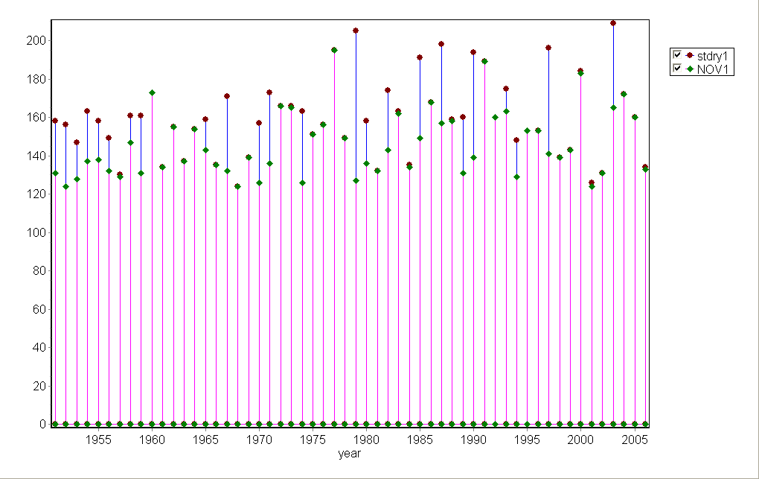
Fig 2 -15 days dry spell

Dry spell at the start of the season.
The average start of the season or planting window of the growing period for rain fed agriculture in Livingstone is 18th November. A brief look at the presence of the 15 days dry spells indicate that it occurs at the start of the season 11 years out of 28 years which is 39 %. The frequency of long dry spells appears to be more from the 80s to date in the years from 1950 to 2005.

Deforestation: There is rampant deforestation going on around the Livingstone area. The Forest Department in Livingstone put the rate of deforestation at 5% and believes it has a bearing on local temperature and rainfall.

This also is likely to affect our Mosi-oa-tunya World Heritage Site. The Falls are in an area experiencing notable impacts of climate change and variability. The 2005/2006-rainfall season recorded a notable recent flood disaster over Kazungula district, a district upstream the Victoria Falls where thousands of families had to be evacuated to higher grounds. The analyses of the Zambezi River water levels over a long time at a given point (Sashi, Durton, 2006 ) indicate the trends are showing a slight decrease.

This then is therefore correct to say the Victoria Falls Heritage is also being affected by some impacts of climate change and variability, which requires constant monitoring as to certainly know their direct and extent of impacts on the Victoria Falls.

Other factors
There are other factors identified affecting the Victoria Falls other than those of climate change and variability. Identified are the negative human attitudes of rampant deforestation, poor land management practice, Poor environment conservation practices, increased silt deposits into the Zambezi River etc whose effects require investigation in order to come up with appropriate and mitigation.

Recommended options
Mitigation and adaptation are the two strands to any strategy for tackling the threat posed by climate change. Mitigation is about minimizing future climate change by weakening the link between economic growth and carbon emissions. Adaptation is about-facing up to the fact that climate change is inevitable and that many of the most threatened countries have the least capacity to adapt. There is to

- Build institutional capacity to monitor, manage and integrate Rio conventions and climate change considerations in decisions making and operations.
- Build institutional and individual level management capacity of institutions responsible and mandated to manage the world heritage property.
- Promote and facilitate multisectoral and integrated coordination of environmental policies, legislation and regulations.
- Establishment of a regular research system on the world heritage property’s biodiversity in order to form a basis for management decisions.

Produced by
National Heritage Conservation Commission
Box 60124; Livingstone, Zambia.
Email: nhccswr@zamnet.zm; ndiyoi@yahoo.co.uk;
Tel: 260-3-323662; Cell: 260 95-832 433;

And
The Provincial Meteorological Office – Livingstone. Zambia
Email: dnanja@yahoo.com
Meteorological Office, P.O Box 60004, Livingstone, Zambia
Tel 260 3 321 256 mobile 260 97 499 502

Falconer A and Foresman J (2002) A system for survival: GIS and sustainable development.
Falconer A and Foresman J (2002) A system for survival: GIS and sustainable development.
Environmental Council of Zambia (2001) State of Environment in Zambia 2000. ECZ, Lusaka-Zambia.
Chagutah T (2006) Recent floods in the Zambezi basin –a result of climate Change? In the Zambezi, p1,7; vol 6 no 3. SARDC.

