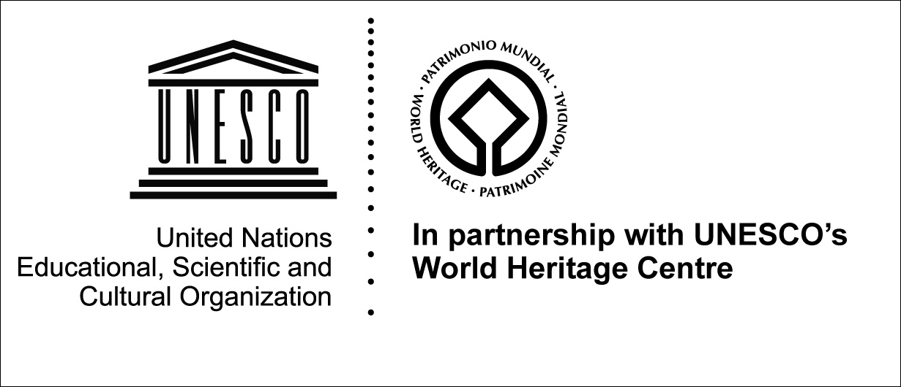

THE UNESCO-VOCATIONS PATRIMOINE FELLOWSHIPS FOR WORLD HERITAGE SITE MANAGERS

2007 APPLICATION GUIDE

Introduction

The United Nations Educational, Scientific and Cultural Organization seeks to encourage the identification, protection and preservation of cultural and natural heritage around the world considered to be of outstanding universal value to humanity. This is embodied in the Convention concerning the Protection of the World Cultural and Natural Heritage, adopted by UNESCO in 1972.

Cultural heritage refers to monuments, groups of building and properties with historical, aesthetic, archaeological, scientific, ethnological or anthropological value. Natural heritage refers to outstanding physical, biological and geological formations, habitats of threatened species of animals and plants and areas with scientific, conservation or aesthetic value.

As of July 2006, there are 830 properties on the World Heritage List. But inscription on the List is only the first stage in an on-going process of conservation. Many of these properties face a variety of threats. Their preservation requires exemplary management in order to preserve them for existing and future generations.

The Programme

The UNESCO-VOCATIONS PATRIMOINE Fellowships for World Heritage Site Managers Programme aims to reinforce the capacity of professionals currently working or intending to work in the near future, in the management, conservation and development of a World Heritage property. It is an important tool in UNESCO’s efforts to conserve and promote the outstanding universal value that justified the properties’ inscription on the World Heritage List. Launched in January 2006, the Fellowships are made possible as a result of an innovative public-private partnership between UNESCO and its World Heritage Centre and a French non-governmental organization, Association Vocations Patrimoine, with the support of the multinational groups AXA and MAZARS.

The Programme supports the World Heritage Committee’s Capacity Building objectives by providing Fellowships for up to two years to facilitate access to advanced level interdisciplinary training in World Heritage studies. Fellowships, for graduate studies of a Master of Arts or of Science level in fields related to the management of cultural and natural heritage properties will be awarded.

At present, the Fellowships are only offered in connection with the Master of Arts in World Heritage Studies at Brandenburg Technical University, Cottbus, Germany (http://www.tu-cottbus.de/whs), and with the Master of Science in World Heritage Management at University College Dublin, Ireland (http://www.ucd.ie/bioenvsci/postgrad/masters_world_heritage.htm). Applicants should therefore either be in receipt of an offer of a place or in the process of applying to one of these courses. It is anticipated that other Universities will participate in the programme in future years.

In addition to proven academic excellence, candidates will be required to submit an innovative proposal for research on a management issue at a World Heritage property to be carried out as part of the Fellowship. These proposals should explicitly support the objectives and priorities of the World Heritage Committee in the field of World Heritage management. (The Committee’s Decisions in respect of individual World Heritage properties can be found on the respective property pages on http://whc.unesco.org. Special attention will be given to candidates who wish to focus their research on the management of a property on the List of World Heritage in Danger.

A balanced geographical representation will be ensured, with fellowships being awarded to the extent possible in each of the 5 geo-cultural regions of UNESCO (i.e. Africa, the Arab States, Asia and the Pacific, Europe and North America, Latin America and the Caribbean). Priority will be given to applicants from low income and lower middle income countries and to professionals already working at a World Heritage property.

What do the Fellowships cover?

The Fellowships cover: tuition fees, one round trip air ticket between the Fellow’s home and the university plus one round trip air ticket to the World Heritage property where the field work will take place; a monthly stipend of Euro 1300 to cover living expenses (accommodation, utilities, food, books, local transport and other out of pocket expenses); and mandatory health insurance. Applicants should note that no provision to finance or lodge family members or other dependents can be made, nor can UNESCO cover any maintenance, insurance or travel expenses for persons accompanying awardees.
UNESCO will also provide support to the Fellows in the form of access to research material held at the World Heritage Centre and facilitating access to the properties.
The programme operates as follows:

- Candidates submit their application to the official national liaison body for UNESCO of the country of which they are a citizen (usually the National Commission for UNESCO). For the 2007 programme, they should simultaneously be in receipt of an offer from or be applying for a place at the Master of Arts in World Heritage Studies at BTU Cottbus, Germany, or the Master of Science at University College Dublin, Ireland.

- The national body may submit a maximum of two completed applications to UNESCO, one of which must be from a professional already working at a World Heritage property. The national body is also required to provide a statement of support for each application and a commitment to facilitate the applicant’s participation if it is successful, for example by releasing the applicant from their duties if they are an employee of the State and guaranteeing a return to post after completion of the studies.

- A jury made up of representatives of UNESCO, the World Heritage Committee and its Advisory Bodies, the Universities, and the donor selects the successful candidates, subject to confirmation of acceptance at one of the host Universities. An exchange of letters setting out the amount and terms of the award constitutes a contract between UNESCO and the applicant.

- An official announcement and awards ceremony will take place in Paris (Fellows’ travel and accommodation costs for their participation in the ceremony will be covered.)

- UNESCO transfers Fellowship Funds to the host universities providing for tuition, international travel, a monthly stipend to cover living expenses (accommodation, utilities, food, books, local transport and other out of pocket expenses) and mandatory health insurance. The host institution manages these funds on behalf of UNESCO.

The 2007 Competition

In 2007, 5 Fellowships will be awarded following an international competition. Each Fellowship is for up to 2 years to cover taught coursework and an extended period of research at a World Heritage property. It is expected that this research will form the core of the Fellow’s Masters thesis.

Eligibility

Specific rules of eligibility have been established.

- The Programme is open to citizens of States Parties to the 1972 World Heritage Convention, aged 45 or under.

- Priority will be given to applicants from developing countries and to those who are currently working at a World Heritage property. http://propertyresources.worldbank.org/DATASTATISTICS/Resources/CLASS.XLS.

- Candidates must have a Bachelor of Arts or a Bachelor of Science Degree (or equivalent) in fields related to the management, conservation and development of World Heritage properties. Applicants can come from fields such as anthropology, architecture, archaeology, geography, ethnology, museum sciences, visual arts, landscape, sociology, history, history of art, environment, urban planning and management, ecology, forestry, marine and coastal sciences, natural resource management, and civil engineering.

- Applicants should not be in receipt of actual or apply for financial assistance from any other grant making body or government during the period of the award.

- Applicants must have the written support of the official national liaison body for UNESCO of the country of which they are a citizen.

Application instructions

Applicants should send a complete application package, available from http://whc.unesco.org in English or French as appropriate, to the official national liaison body for UNESCO of the country of which they are a citizen, requesting their support for the application. It is the responsibility of the applicant to ensure that the package arrives in good time for country level assessments to be made.

- Application form. This is available as a pdf file at http://whc.unesco.org. It must be completed in full.
- A language certificate issued by an official authority (e.g. British Council).
- Certified copies of university degrees or diplomas.
- A personal statement of no more than 200 words explaining why the Fellowship is being sought and how the applicant and his/her country would benefit from it.
- A succinct description of the field research proposed by the applicant which should be limited to 500 words and include:
  - the name of the World Heritage property to be studied;
  - the duration of the project – which should be no more than one year;
  - a description of the management challenge to be addressed and how the project would reinforce management capacities at the property;
  - how the project would involve or positively impact on the communities living in or around the property;
  - the contribution to raising awareness about the World Heritage Convention

Given the requirement for home country support, applicants are responsible for ensuring that they submit their application package in good time for the necessary checks to be made. Once the decision to support an applicant has been confirmed, the national liaison body completes the relevant section of the application and forwards the package to UNESCO.

Only applications submitted via the official national liaison body for UNESCO (usually the National Commission) will be considered. Applications must by received by UNESCO’s World Heritage Centre on or before 31 March 2007.

