Assessing Management Effectiveness of
Natural World Heritage Sites

Sue Stolton and Nigel Dudley, Equilibrium Consultants

Equilibrium is an environmental research and policy consultancy established in 1991. Our work has encompassed over fifty countries, working with non-governmental organisations, academic Institutions and international bodies. Equilibrium has been working with the University of Queensland, Australia to implement the Enhancing our Heritage project.

Abstract
Monitoring and evaluation are increasing viewed as critical components of protected area management. The assessment of management effectiveness has three major applications: adaptive management – to improve performance within protected areas; accountability – to assist reporting by site and system managers, and improved project planning – to review approaches and apply lessons learned.

This paper describes the Enhancing our Heritage (EOH) project, which aims to develop a framework for assessing the management effectiveness of natural World Heritage (WH) sites in pilot sites across three continents. It describes the project and the relationship between the project’s objectives and the monitoring requirements contained within the WH Convention, discusses lessons learned to date and finally asks some questions regarding the application of management effectiveness systems in both natural and cultural World Heritage sites.

Introduction
Monitoring and evaluation are increasing viewed as critical components of protected area management. As a result a range of systems and methodologies have been developed to improve approaches to monitoring conservation effectiveness. To date, however, these efforts have tended to focus on assessing biodiversity interactions, i.e. ecological monitoring, rather than assessing the effectiveness of natural resource management interventions, i.e. performance monitoring.

More recently, ecological monitoring and performance monitoring have been used to increase the overall effectiveness of protected area planning and management. The assessment of management effectiveness has three major applications:
- Adaptive management – to improve performance within protected areas.
- Accountability – to assist reporting by site and system managers.
- Improved project planning – to review approaches and apply lessons learned.

EoH project aims
The Enhancing our Heritage: monitoring and managing for success in Natural World Heritage sites, is a four-year project of UNESCO and IUCN – the World Conservation Union, funded by the United Nations Foundation and carried out in co-operation with the University of Queensland, The Nature Conservancy, World Wide Fund for Nature and other organisations. The project started in 2001, and is working in ten WH sites in southern Asia, Latin America and southern and eastern Africa.

The EoH Project aims to improve the management of WH sites through the development of better monitoring and reporting systems and through using the application of the results of these assessments to enhance site management. Based on the results, IUCN will provide recommendations to the WH Committee on a consistent approach to monitoring and reporting on the state of conservation and management effectiveness of all natural WH sites and on improving the effectiveness of management of WH sites.

The project should also result in improved management of the ten pilot WH sites, by providing:
- an established assessment, monitoring and reporting programme for evaluating management effectiveness and the state of conservation of World Heritage values;
- site managers and others will be trained in the application of assessment and monitoring techniques;
- established or improved communication and co-operation between site managers, local communities and NGOs, regional training institutions and other key experts and stakeholders to ensure continuation of assessment and monitoring beyond the life of the project;
- improved management in areas of identified deficiency resulting from training programmes and small-scale support provided through the project;
- integration of assessment and monitoring practices into management; and
- project proposals prepared and funding sought for large-scale projects required to address any identified deficiencies.

The EoH Project design
The EoH project is using the six elements outlined in IUCN’s World Commission on Protected Areas (WCPA) Framework for Assessing Management Effectiveness (context, planning, inputs, processes, outputs and outcomes) to build assessment systems suitable for WH sites, and testing these in the pilot sites.
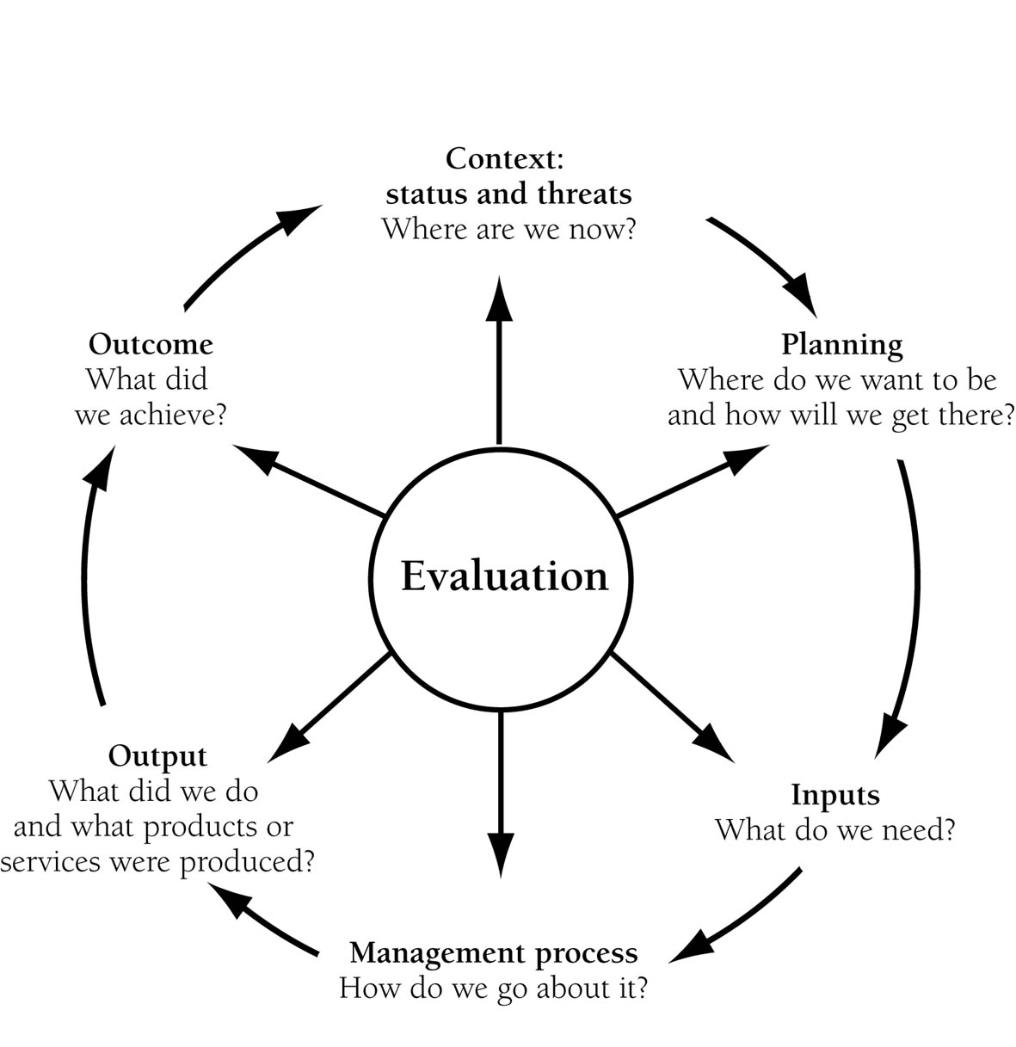

Figure 1: The WCPA Framework

To do this the project is providing technical expertise and financial assistance, to complete an initial and second assessment, towards the end of the project, of the management effectiveness of the site. The initial assessment provides baseline data on the site, to identify both gaps to be filled in the monitoring systems and also steps to address any possible management deficiencies that are identified.

Figure 2 describes the main project steps in diagrammatic form.

Document World Heritage values and attributes
↓
Develop and undertake an initial assessment (context, planning, inputs, processes,
outputs and outcomes)
↓

Establish a long term assessment and monitoring programme
↓

Report on initial assessment and analyse results
↓  Develop training and small-scale response programmes in response to assessment findings | ↓  Develop larger project proposals and seek funding
↓

Repeat assessment at regular intervals

Figure 2: Setting up management effectiveness systems – the EoH project steps

Three steps (not necessarily consecutive) will likely be involved in developing this assessment process.
- Data collection: including from site records, any other relevant literature sources and interviews with key stakeholders.
- Managers’ workshop/s: combining the data collected with the knowledge and experience of managers and key staff members/stakeholders to complete a draft assessment framework for the site.
- Site workshop/s: including representatives of a wide range of stakeholders, where the draft assessment framework will be discussed and finalised.

The project has just completed its first year – some of the lessons learned will be discussed below. The completion of the initial assessment provides the basis for the continuation of the project. Year two will concentrate on acting on the results of the assessment by working with managers and staff on adaptive management and on filling remaining gaps in knowledge of the site’s function through the development of monitoring systems. The information gathered in the initial assessment should also be useful for sites to fulfil any reporting requirements, i.e. to funders, stakeholders, governments etc.

It is expected that changes to management (adaptive management) may produce recommendations for: straightforward changes in management practices; small-scale projects that could enhance capacity; and/or the need for larger-scale projects. There is limited funding in the EoH project to assist in developing small-scale projects – e.g. training, equipment purchase etc. and the project can also help plan, write and facilitate larger-scale project proposals to address challenges identified in the assessment.

The initial assessment will also provide the information needed to develop any long-term monitoring systems required to fill existing gaps in information; and to set up regular assessments of management effectiveness. In year two therefore, monitoring programmes will be established in cooperation with site managers, regional training institution staff, local and regional experts and local communities, as appropriate. Requirements for generic training for site staff will be identified and undertaken as necessary.

Developing systems to assess management effectiveness
The WCPA Framework for assessing management effectiveness of protected areas identifies different levels of monitoring and evaluation - depending on resources and needs. The EoH project aims to introduce to WH sites the most comprehensive level of assessment, as it places greatest emphasis on monitoring the extent of achievement of management objectives through focussing on outputs (the products of management) and outcomes (the impacts of management) while still measuring the other elements of management defined by WCPA (context, planning, inputs and processes).

Clearly, it is impossible to monitor and assess everything that happens within a WH site. For each element of the WCPA Framework therefore key indicators are suggested which should together help build an overall picture of management effectiveness. Because WH sites vary in their management and objectives, capacity for assessment and monitoring, and resources, the EoH project is providing a variety of different approaches – in effect an assessment toolkit – to help evaluate these indicators. Assessments can be carried out in two ways – through the collection of descriptive information and by the application of specific methodologies. In many cases WH sites will already have a range of systems in place to monitor management actions. The toolkit thus provides suggestions to fill gaps in monitoring and assessment, and does not suggest bringing in new systems to replace established practice: assessment systems will be tailored to the needs and resources of individual sites.

The Enhancing our Heritage Toolkit for Assessing Management Effectiveness of World Heritage Sites, consists of a Manual (Book 1) and Workbook (Book 2) and a CD containing both publications along with explanatory PowerPoint presentations. The Manual provides an introduction to the project, a guide to project implementation and a brief explanation of the WCPA Framework for assessing management effectiveness of protected areas. Each of the six elements of assessment identified by WCPA is then explained in more detail, explaining why each element is important, suggesting indicators for each element and a list of assessment methods. The Workbook summarises a variety of different assessment systems, with examples of their use, which can either supplement existing approaches to ensure all the elements of the WCPA Framework are assessed or can be used to build a management effectiveness system. The Workbook, and to some extent the Manual, will be ‘living documents’ throughout the project, to be amended and updated in response to experience gained by the test sites and by those developing and refining assessment systems.

Linking monitoring and assessing management with WH Convention requirements
All States Parties to the WH Convention are required to protect and conserve the values for which a site has been granted WH status. In 1998, the WH Committee adopted guidelines defining two types of monitoring regimes: 1) reactive monitoring and 2) periodic reporting.

Reactive monitoring consists of reports prepared by the WH Centre or Advisory Bodies on WH properties that are under threat. State Parties are requested to support reactive monitoring by submitting reports and impacts studies whenever significant impacts on the state of conservation of a site are detected. Reactive reporting is envisaged as part of the process that may lead to a site being included on the List of WH in Danger, which creates political pressure on member states to address the threats, or in an extreme case could lead to the deletion of a site from the WH List. Most reactive reports on natural sites to date have been prepared by IUCN working with the UNESCO World Heritage Centre.

Periodic reporting is intended to serve four main purposes:
- to assess the application of the WH Convention by the State Party;
- to assess whether the WH values of the sites inscribed on the WH List are being maintained over time;
- to provide up-dated information about the WH sites, including records of changing circumstances and state of conservation; and
- to foster regional co-operation and exchange of information and experiences between State Parties concerning the implementation of the Convention and WH conservation.

Reporting by State Parties has in the past been intermittent and lacking in consistent form and content. Discussion within the WH Committee on the nature of periodic reporting began in 1982 but it was not until 1997 that a consensus was reached on its format, content and timeframe. Guidelines were adopted by the WH Committee at its twenty-second session in December 1998. Periodic reporting is intended to improve site management, advanced planning and reduce emergency and ad-hoc interventions. The guidelines require the State Party to put appropriate monitoring arrangements in place, in co-operation with site managers.

This process reflects a desire to shift the emphasis from reactive to periodic reporting. The latter makes it easier for emerging threats and problems to be identified and rectified before a serious degradation of WH values occurs. However, the process has been constrained by lack of:
- human and financial resources;
- a participatory approach that involves all relevant stakeholders; and
- consistent methodologies and approaches.

The EoH project aims to demonstrate a more consistent and reliable mechanism for meeting WH Convention reporting requirements. IUCN will use the results of the project to demonstrate how these assessment and monitoring mechanisms can be used to establish priorities for international assistance and other management interventions.

The EoH project should also help to develop more consistent, transparent and objective decision making processes for the listing and de-listing of sites on the WH in Danger list. At present, the links between threats to specific WH values and the decisions of the Committee to place them in the List of WH in Danger are not always explicit and it is hoped that the development of regular monitoring systems can address this problem.

Some lessons learnt
Although the EoH project is only just entering into its second year of four, it is already possible to identify some lessons arising from the implementation of the project. As the results of the initial assessments are reviewed and monitoring and assessment activities implemented further more detailed lessons will clearly become apparent.

- Building a team is vital
The underlying premise of the EoH Project is that WH sites undertake the assessment of their own management effectiveness. For the self-assessment process to be rigorous it is essential that site managers develop a team of stakeholder representatives to work with them to develop or further develop and agree the monitoring and assessment process.

Although all sites were already engaged in some form of stakeholder dialogue, in most cases this tended to be a one way conversation used to provide or elicit information rather than working with stakeholders to ensure effective site management. The requirement of the project to develop site implementation teams to undertake the project, who then work with a wider group of stakeholders to develop and ratify the initial assessment, has reinforced this need to build strong and coherent local teams to work together to assess management. Two examples from Latin America highlight this clearly.

In Canaima National Park, Venezuela, the project has been perceived as an opportunity to combine the separate efforts of civil society, government, local governments and indigenous groups. The local team has demonstrated capacity and commitment to implement the project and quickly identified themselves as a team, ensuring all stakeholders involved in the project are actively engaged in project implementation.

However, at the Río Plátano Biosphere Reserve in Honduras it became clear during the introductory and planning workshop that those involved in the reserve had little experience of working together as a team. It is also evident that unsolved issues between the various organisations involved have affected the implementation of the initial assessment. In particular, the participation of stakeholders and the integration of existing information has been limited. Despite these problems there has been a positive reaction to the project from all the stakeholders involved with reserve management. In year two it will be important to overcome these organisational difficulties and build a strong team.

- Identifying management objectives
The first step in assessment is the definition of site values and associated management objectives. These values are the key attributes that underlie nomination as a World Heritage site. For sites important to biodiversity and nominated for their global biological assets, these values should ideally reflect not only unique or threatened/endangered species or ecosystems, but all the biological diversity (including terrestrial, freshwater and marine diversity) to ensure sustained ecological function. Site values should also reflect other natural values such as geologic or representative ecological processes, as well as any cultural or social values that are locally, nationally or globally important to stakeholders.

In several of the test sites the agreement of management objectives has proved a challenge, particularly for the areas that did not have agreed management plans. The description of the process in South Africa provides an example of the difficulties that can arise when stakeholders involved in the management of a WH site disagree on first principles – the values for which the site should be managed.

The EoH project is being implemented in Greater St Lucia Wetland Park (GSLWP) in South Africa, during the set-up period of the Park. The declaration of WH status in 1999 has led to major management changes. The Greater St Lucia Wetland Park Authority (GSLWPA) has been set up as the overall management authority with a mandate to enter into co-operative agreements with other institutions to fulfil its core functions. KZN Wildlife, which has been involved in the management of areas within the WH site for many years, will continue to carry out the day to day conservation management of the area, but now GSLWPA is responsible for overall policy and regulation, leading to tensions between conservation, tourism and development. Within the EoH project this has been particularly apparent in the process of agreeing the management objectives, with debate arising over the relative importance of the conservation values detailed in the WH nomination, and the wider conservation, development and ecotourism objectives contained in the national legislation setting up the park. One major area of concern for KZN Wildlife is that tourism and sustainable development interests could compromise the natural values of the site. The implementation process of the EoH project has thus been dominated by the need to address, define and harmonise the differing management objectives of the GSLWPA and KZN Wildlife. Although at times this has been difficult, all the parties involved in management feel that the process will lead to increased transparency between the two managing partners and in turn to better management in the future.

Conclusions ….. or rather questions
Given that the EoH project is still in its infancy and that many of the issues relating to the successful monitoring and assessment of management effectiveness will take longer to resolve than the life of a four year project, it seems a little early to be drawing conclusions from project implementation to date. Instead it is probably more useful to conclude this paper with a number of questions that can help further the debate and discussion on the monitoring and assessment of management effectiveness of WH sites and, more specifically, that can be addressed by the EoH project over the next three years.

- How to determine base-line data?
For the sites taking part in the EoH project the first stage has been to undertake the initial assessment, which aims to identify the gaps in monitoring, highlight adaptive management requirements and provide sites with the information needed to fulfil a variety of reporting requirements. Initial assessments are only just being completed so it is too early to say whether these aims have been completed. It is however clear that the initial assessment has proved time consuming and has in some cases only had minimal stakeholder involvement.

This raises a number of questions:
- Is more time needed to train people in undertaking and develop initial assessment?
- Should the initial assessment be simplified?

- How do you ensure that sites adapt methodologies to specific conditions?
It is the strong belief of the EoH project team, and a clear recommendation from the WCPA Framework, that a one-system-fits-all approach could not adequately reflect the management effectiveness of WH sites, or any other protected sites. There is too much diversity in habitat and management needs, resources and style. On the other hand the project does propose assessing all the elements of the management cycle and associated key indicators as defined by the WCPA Framework. The EoH team has therefore produced a toolkit that contains suggestions of how these elements can be assessed. It has stressed that in the first place these tools should be used to fill gaps in information not covered by existing monitoring and assessment regimes and secondly that the tools should always be adapted to reflect local realities. Despite the team’s best efforts it seems that some sites did not attempt to make these adaptations. For instance, the initial assessment from Aldabra Atoll in the Seychelles notes that…”there were initial difficulties with the fact that Aldabra is not a ‘typical’ World Heritage Site with an indigenous human population who depend on the site..[thus].. many of the data tables didn’t seem to fit”.

This raises the questions:
- How do you ensure that sites use the monitoring systems already in place as a foundation for developing the comprehensive monitoring and assessment system advocated by the EoH project?
- How do we ensure people see the systems in workbook as a template and adapt them to fit their own site’s realities?

- How can we ensure that the EoH system not only becomes institutionalised in the ten test sites, but in other WH sites (natural and cultural) and other protected areas?
Management effectiveness of protected areas has grown to be a prominent issue over the past decade, and there has been considerable interest in developing methodologies. The initial workshop to introduce the EoH project in Ecuador, for example, created such interest that it resulted in the development of (and subsequent seed funding for) a larger project to assess all Latin American WH sites.

Much of this work however is not yet reflected on the ground – with most protected areas taking part in management effectiveness projects being involved in an outsider driven process rather than the need for monitoring and assessment systems being identified by managers and/or stakeholders. However, we should also recognise that policy almost invariably takes time to develop into practice, and at least in this case the policy developments are firmly based in field experience.

- Could the experience in natural WH sites be applicable to cultural or historical sites?

The six elements identified in the WCPA protected area assessment framework (context, planning, inputs, processes, outputs and outcomes) could in theory also be used to assess the effectiveness of management of cultural sites, although the indicators and assessment toolbox would differ. The match might be quite precise for those cultural sites managed as a single entity (for example Angkor Watt in Cambodia) but would inevitably be more complex when cultural WH status is given to a city centre or larger area of land with multiple management authorities. Questions of what to assess in cultural sites are also perhaps more complicated: for example should assessment be purely of the built environment or include human and cultural values; and if the latter then how would we agree baselines and trends? One way to build on the experience and resources of the EoH project would be to adapt and apply the methodology to other WH sites, perhaps starting with those nominated for both natural and cultural values and progressing to some purely cultural sites, to test out how the approaches ‘travel’ from natural to cultural sites.

Acknowledgments
This paper has drawn from material prepared for the EoH project by the project manager Marc Hockings and project team members, in particular Jose Courrau and Jeff Parrish.

Further information, project documents, workshop reports and the project manual and workbook, are available for downloading from www.enhancingheritage.net/docs_public.asp
The sites are: Aldabra Atoll: Seychelles; Bwindi Impenetrable National Park: Uganda; Greater St Lucia Wetland Park: South Africa; Serengeti National Park: Tanzania; Keoladeo National Park: India; Kaziranga National Park: India; Royal Chitwan National Park: Nepal; Río Plátano Biosphere Reserve: Honduras; Sangay National Park: Ecuador; and Canaima National Park: Venezuela.
Hockings, Marc with Sue Stolton and Nigel Dudley (2000); Assessing Effectiveness – A Framework for Assessing Management Effectiveness of Protected Areas; University of Cardiff and IUCN, Switzerland. For more details on the Framework see Marc Hockings paper.

