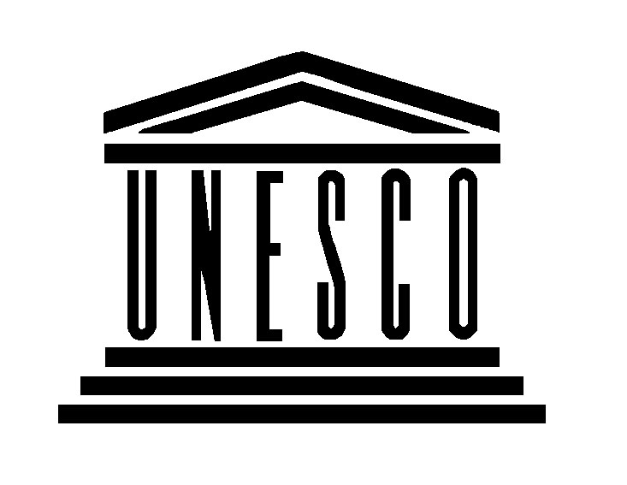


Training Workshop on Sustainable Tourism Planning and Management
at World Heritage Sites in China

15 – 19 May 2006

Lushan National Park and World Heritage site, China

Organized by the UNESCO World Heritage Centre in collaboration with the Chinese National Commission for UNESCO and the Ministry of Construction, and with financial support from the Netherlands Funds-in-Trust

Background:

Tourism is one of the World’s largest industries. It has an estimated US$ 3 trillion in annual revenues. The industry is expanding at four to five percent annually. Tourist travel over the next fifteen years is expected to double. Increases are both associated with international arrivals and in countries such as China, a rapidly expanding domestic tourism market. Governments note an economic value in World Heritage listing and many times encourage tourism development at World Heritage sites.

Tourism is an industry with well-known costs but also has potential for aiding protection efforts. Well-managed, sustainable tourism has been recognized as integral part of the protection and management of World Heritage properties. Such tourism can serve both to transmit World Heritage values and to generate revenue for their protection.

The over-riding importance of tourism to World Heritage, both as an opportunity and if poorly managed as a threat, was recognized by the World Heritage Committee when it authorized the Centre, in 2001, to develop a World Heritage Sustainable Tourism Programme. The mission of the Tourism Programme is to aid the WH Committee and site management using tourism as a positive force to retain WH site values and to help mitigate site threats.

The results of the Periodic Reporting exercise as well as the World Heritage Committee’s decisions on the State of Conservation clearly indicate that tourism is a major management concern. Two themes that strongly emerged from the 2003 Asia-Pacific Region report were the opportunities generated by heritage tourism and the challenges of ensuring its sustainability.

The regional report identified the need to generate resources and develop training materials to respond to the challenges of heritage tourism as a regional World Heritage priority. Management faces a growing tourism demand and the duel and contradictory missions of ensuring site integrity and conservation and providing opportunities for visitors to experience site values. Building management capacity, working with local stakeholder, including local communities and governments, site managers and engaging with the tourism industry has been shown to be the key ingredients to effective management for safeguarding of the World’s natural and cultural heritage.

WHC’s China Tourism Initiative:

China has 31 World Heritage sites inscribed on the World Heritage List. Catering to the volume of mass tourism in China has been a major challenge for site management. To help address this challenge, as a first initiative the WH Tourism Programme developed a manual on tourism management for World Heritage site managers entitled, Managing Tourism at World Heritage sites: a practical manual for World Heritage site managers. The manual provides information to guide World Heritage site managers on tourism management issues. The UNESCO World Heritage Centre and China’s Tsinghua University produced and distributed the Chinese version manual.

A second initiative, and a follow-up to the recommendations of the Periodic Reporting exercise, is this Training Workshop on Sustainable Tourism Planning and Management at the World Heritage Sites in China. This current workshop will be the first of a series of training activities for tourism management in China. It will provide a broad overview of sustainable tourism issues and techniques. From this it will identify the needs of management and an action plan that sets the stage for future training interventions. The workshop will be structured in the following manner. Morning presentations and group discussions will be followed by afternoon working sessions to develop the site management priorities and necessary future actions. Case studies and practical examples will be used to present the different themes. A collection on literature, case studies and other training materials will be supplied. A field trip to a WH property will take place.

Workshop Goal:

To develop a participatory action plan for a Chinese World Heritage site managers training scheme.

Workshop Objectives

- Inform Chinese site managers on sustainable tourism issues including the notion of Outstanding Universal Value and the principals of authenticity and integrity under the World Heritage Convention, the WH Sustainable Tourism Programme, and the tourism activities of the WH advisory bodies IUCN and ICOMOS;
- Provide an overview of selected methods and tools for sustainable tourism planning and management;
- Assess the needs of Chinese site managers in heritage tourism management;
- Determine the mechanisms most appropriate to establish and maintain a useful training network;
- Formulate an Action Plan for follow-up workshops and training on tourism management for the site managers.

Expected outputs:

- Chinese site managers are better informed of WH and advisory bodies tourism activities as well as tourism issues in China and internationally; (objectives 1 and 2)
- A better understanding within the WH Sustainable Tourism programme of the practical realities of site management in China; (objective 3)
- A list of training needs and priorities of all Chinese site managers; (objective 3)
- A written action plan with recommendation of training needs and mechanisms most appropriate to establish and maintain a useful training network; (objectives 4 and 5)
- Commitment to collaborate with WHC in pursuing the idea of future training and a learning network among Chinese site managers. (objective 5)

Participating agencies

In addition to experts on heritage conservation, tourism development and public policy, the workshop will unit a network of Chinese World Heritage site managers, representatives from central and local governments, NGO’s, and experts on heritage conservation, tourism and public policy. The Chinese National Commission for UNESCO, the focal point for the implementation of the World Heritage Convention in China, will ensure overall coordination for the workshop.

Workshop Agenda

Day 1:

Date | Activities
Monday  15 May | Arrival and registration of workshop participants  Welcome dinner reception and cultural performance (informal)

Day 2:

Date | Activities
Tuesday  16 May | Opening/ Registration  8.30-12.30  Session 1:  Purpose: To present an overview of the workshop process and provide information on the World Heritage Tourism programme, the tourism related activities of the WH advisory bodies IUCN and ICOMOS and an overview of Chinese tourism issues.  Moderator: Mr. Feng Jing, Programme Officer, World Heritage Centre  Introduction of Participants  Presentation of the Workshop Agenda and Review Goals for the Workshop  Mr. Feng Jing, Programme Officer, World Heritage Centre  Presentation on Tourism Management and the World Heritage Sustainable Tourism Programme  Mr. Art Pedersen, Specialist on Heritage and Tourism, World Heritage Centre  Presentation on the ICOMOS Charter on Cultural Tourism  Dr Graham Brooks, Chairman, ICOMOS Tourism Committee, Australia  Presentation on IUCN tourism management policies and activities for Natural Heritage sites  Professor Steven McCool IUCN/WCPA Tourism Taskforce  Presentation – Issues on Managing International and National Tourism at World Heritage sites  Prof. LU Zhou, Tsinghua University, Beijing, China  Discussion and questions  13.30-17.30  Session 2:  Purpose: To develop a list of training and information needs related to tourism and visitor management at Chinese World Heritage sites.  13.30 -15.30  Working groups: Divide into working groups to develop preliminary lists of training and information needs. A half an hour will be dedicated for each the following suggested themes, tourism planning, visitor management and interpretation, and involving local communities. Additional themes would be added if deemed necessary by site managers.  15.30 – 16.00 Tea and coffee break  16.00 – 17.30 Presentations by the working groups and discussion

Day 3:

Date | Activities
Wednesday  17 May | 8.30-12.30  Session 3:  Purpose: To present an overview of planning, visitor management and interpretation techniques.  Moderator: Prof. LU Zhou, Tsinghua University, Beijing, China  Presentation on Public Use Planning  Professor Steven McCool IUCN/WCPA Tourism Taskforce  Presentation on Tourism Management Planning in China  Professor Yang Rui, Director, Associate Professor Institute of Resource Protection and Tourism Tsinghua University Beijing, China  Presentation on Visitor Experience & Resource Protection (VERP)  Mr. Mike Tollefson, Superintendent of Yosemite National Park, US Park Service  Presentation on Ideas for Site Interpretation and Awareness Building  Dr. Tim Merriman and Ms. Lisa Brochu, National Association of Interpreters  Presentation on Techniques for Managing Congestion at WH sites  Dr Graham Brooks, Chairman, ICOMOS Tourism Committee, Australia  Discussion and questions  13.30-17.30  Session 4:  Purpose: To develop a list of recommendations from site managers site on specific information and training needs for planning, visitor management and interpretation and a list of the key actions that need to be carried out, with timeframes, budgets and suggestions on financing, for an action plan to meet those needs.  13.30 -15.30  Working groups: Divide into working groups to develop lists of training and information needs and a proposed action plan for planning, visitor management and interpretation.  15.30 – 16.00 Tea and coffee break  16.00 – 17.30 Presentations by the working groups and discussion

Day 4:

Date | Activities
Thursday  18 May | 8.30-12.30  Session 5:  Purpose: To present an overview of techniques and experiences for community development and working with stakeholders.  Moderator: Professor Yang Rui, Director, Associate Professor Institute of Resource Protection and Tourism Tsinghua University Beijing, China  Presentation on the National Geographic Society’s Geotourism Concept: Involving and Catalyzing local communities through the production of a National Geographic Map Guides  Mr. Jonathan B. Tourtellot, Director, Center for Sustainable Destinations, National Geographic Society and Geotourism Editor, National Geographic Traveler  Presentation on Involving local communities in Ecotourism Enterprises  Andy Drumm, Senior Ecotourism Specialist & Desk Officer, External Affairs, South America Conservation Region, The Nature Conservancy, Worldwide Office, USA  Presentation on Developing Local Products and Training Local People in Micro Enterprise development  TNC Yunnan representative;  Presentation on Cultural Heritage Management and Tourism: Lijiang Models of Cooperation Among Stakeholders  Ms. Beatrice Kaldun, Programme Officer, UNESCO Beijing  Presentation on Ideas for Awareness Building in Local Communities  Dr. Tim Merriman and Ms. Lisa Brochu, National Association of Interpreters  Discussion and questions  13.30-17.30  Session 6:  Purpose: To develop a list of recommendations from site managers on specific information and training needs for involving local communities and for promoting local goods and services that link to site conservation and a list of the key actions that need to be carried out, with timeframes, budgets and suggestions on financing, for an action plan to meet those needs.  13.30 -15.30  Working groups: Divide into working groups to develop lists of training and information needs and a proposed action plan for involving local communities and for promoting local goods and services that link to site conservation .  15.30 – 16.00 Tea and coffee break  16.00 – 17.30 Presentations by the working groups and discussion  Afternoon Session:
Day 5: Field Trip???

National agency responsible for the organization of training workshop

Mr Tian Xiaogang
Secretary-General
Chinese National Commission for UNESCO
37, Damucang Hutong
Beijing Xidan, 100835

Tel: 86-10 6609 7596
Fax: 86-10 6601 7912
E-mail: yuxp@moe.edu.cn;

