First
"World Heritage Site Managers”
Fellowships awarded
A new way forward in preserving and managing sites

Paris, 16 March 2006

Assistant Director-General of UNESCO Françoise Rivière, representing the Director-General of UNESCO, Koïchiro Matsuura, and the President of the Association VOCATIONS PATRIMOINE, Yves Coppens, joined by Michel Clément, Director of Architecture and Heritage at the French Ministry of Culture and Communication; Patrick de Cambourg, Chairman of the MAZARS Group; and Henri de Castries, Chairman of the Board of the AXA Group, today awarded certificates to the first fellows of the new university level training programme for World Heritage Site Managers during an official ceremony held at UNESCO. Five successful candidates were rewarded for their exemplary academic performance and innovative study proposals, which bring together research and management in order to define planning and management concepts that will ensure better conservation of World Heritage sites.

"This new UNESCO – VOCATIONS PATRIMOINE Fellowships programme, supported by AXA and MAZARS, meets a genuine need for training and will allow students and professionals from around the world to study World Heritage site management at recognized institutions and thus learn how to contribute to World Heritage site conservation. I would like to congratulate and thank Association VOCATIONS PATRIMOINE, AXA and MAZARS for their collaboration, which has enabled us to launch this programme today." Koïchiro Matsuura.

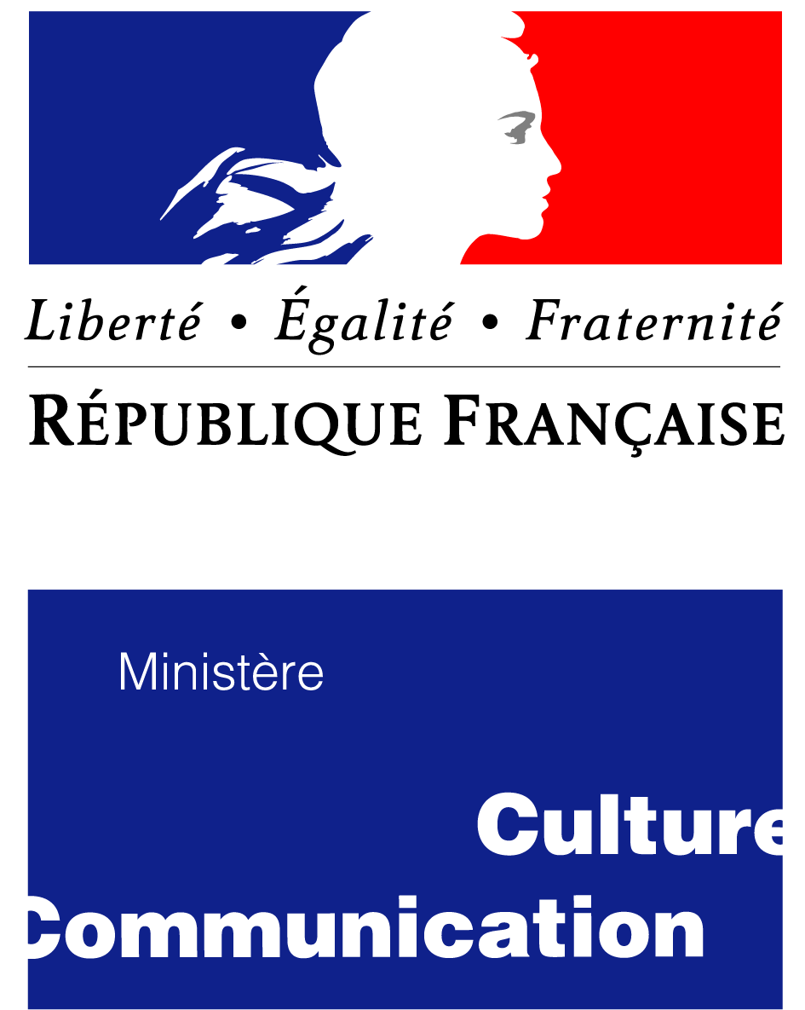

The successful candidates…

Sandra Flavin, Irish
Sandra will undertake a preparatory analysis of the natural values of the Island of Iriomote, often described as the “Galapagos of Asia” and “the last wilderness of Japan”, and examine the scope for a possible enlargement of the Gusuku Sites and Related Properties of the Kingdom of Ryukyu (Japan). She will also examine the need for an integrated management plan reconciling tourism and conservation of the island.

Samuel Janse, Dutch
Samuel will assess the increased involvement of local communities in the conservation of the Sundarbans National Park (India). The site, which was inscribed on the World Heritage List in 1987, is located in the Ganges estuary. The main issue is the need to preserve a large number of protected species, including the tiger, in an extremely fragile environment.

Iryna Kravets, Ukrainian
Iryna will carry out a comparative study of cultural policies and World Heritage management practices in Western and Eastern Europe in order to identify new management guidelines that could be applied to World Heritage sites in post Soviet countries. She will focus in particular on the Old and New Towns of Edinburgh (United Kingdom) and Kiev: Saint-Sophia Cathedral and Related Monastic Buildings, Kiev-Petchersk Lavra (Ukraine).

Julian Machange, Tanzanian
Julian will study the impact of the reintroduction of livestock - a recommendation made to reduce poverty - on the socio-economic life of peoples who rely on grazing animals for their survival and its impact on the ecological integrity of the Ngorongoro Conservation Area (United Republic of Tanzania), inscribed on the World Heritage List in 1979.

Yujie Zhu, Chinese
Yujie will work on a project that aims to further improve the management strategies used in the Old Town of Lijiang (China), with particular emphasis on the new pressures on the town caused by increased tourism, and its repercussions for the local indigenous population and the conservation of the site.

A special training programme
Brandenburg Technical University Cottbus in Germany (BTU) and University College Dublin in Ireland (UCD) are the first universities to contribute to this programme through their interdisciplinary courses, which combine appropriate conservation techniques, socio-economic aspects, planning and management. The BTU course focuses more on the cultural sector, while UCD emphasizes biodiversity. Each involves a two year programme comprising theory, technique and training in situ. UNESCO and Association Vocations Patrimoine will work together to expand the programme, encourage the creation of other courses and thus increase the training opportunities at international level. The French Government, at the initiative of its Ministry of Culture, has pledged to create an appropriate training programme.

An original public-private partnership
The university fellowship programme for future World Heritage site managers and practicing professionals was launched in October 2005. It was conceived as a partnership by Association VOCATIONS PATRIMOINE, led by Yves Coppens, and UNESCO, with the support of the French Ministry of Culture and Communication and the international groups AXA and MAZARS. The concept behind the programme and the development of the project is that of public-private co-operation, as the fellowships can be jointly financed by several entities. The first partners, AXA and MAZARS, to have joined VOCATIONS PATRIMOINE, are thus helping to improve conservation of World Heritage sites over the long term.

"We are proud to support this programme, which combines various aspects of AXA’s sponsorship plan – notably education, and the conservation and transmission of our heritage – as a natural development of our business, Financial Protection," said Henri de Castries, Chairman of the Board of the AXA Group.

"This international sponsorship programme is ground-breaking in its content: cultural diversity and the preservation of our heritage will be given a boost by young people with a broad range of high-level skills, who have been specially trained to ensure that this rich heritage is transmitted to future generations and that it can be enjoyed by the greatest possible number of people," explains Patrick de Cambourg, Chairman of the MAZARS Group.

"Our goal for this European programme is to open up a new co-operation opportunity and to be able to offer 10 to 15 scholarships a year," said Béatrice de Foucauld, Secretary General of VOCATIONS PATRIMOINE.

"Training the future custodians of World Heritage sites will be a key factor in reconciling responsible tourism and the preservation of masterpieces for the good of our future generations," concluded VOCATIONS PATRIMOINE President, Yves Coppens.

This programme of university fellowships is intended to expand significantly and to contribute to the training of an entire new generation of professionals in a field which is essential to the protection of heritage sites worldwide.

Press contacts:

UNESCO World Heritage Centre:
Gina Doubleday – +33 (0)1 45 68 16 60 – g.doubleday@unesco.org

VOCATIONS PATRIMOINE :
Ericka Rolin - +33 (0)1 75 06 75 72 – erika@rolin.fr

French Ministry of Culture / Department for Architecture and Heritage:
Christine Andre - +33 (0)1 40 15 75 22 - andre.ext@culture.gouv.fr

AXA:
Clara Rodrigo – +33 (0)1 40 75 47 22 - clara.rodrigo@axa.com

MAZARS:
Sandrine Verdelhan - +33 (0)6 61 54 10 69- sandrine.verdelhan@mazars.fr

