


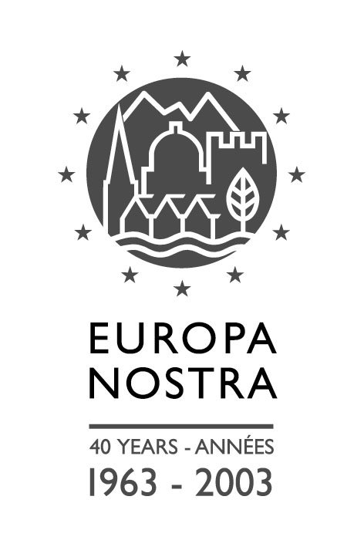

EUROPEAN CULTURAL HERITAGE FORUM

“CULTURAL HERITAGE COUNTS FOR EUROPE”

“CULTURAL HERITAGE COUNTS FOR EUROPE”

7 DECEMBER 2005, BRUSSELS, BELGIUM
Venue: European Economic and Social Committee, 99, rue Belliard, B-1040 Brussels

Registration Form

Name: ……………………………... Surname: ……………………………..

Organisation: ……………………………… Function: ……………………………..

Address: ……………………………… Telephone: ……………………………..

……………………………… Fax: ……………………………..

……………………………… E-mail: ……………………………..

Payment: The registration fee (Euro 65 per person – Euro 50 for Europa Nostra members) will be settled by:

□ Credit Card □ American Express □ Visa

□ MasterCard □ Diners Club

Cardholder

Card number

Expiry date Card validation code (MasterCard/VISA)
(on the back of credit card, last 3 digits)

□ Bank transfer

Date Signature

Send the completed registration form no later than 30 November 2005 to:

Europa Nostra (Att. Ms Tamara van Kessel)
Lange Voorhout 35, NL – 2514 EC The Hague
Fax: +31 70 361 78 65 or E-mail: meo@europanostra.org




