World Heritage | 7 EXT.COM
Distribution limited | WHC-04/7 EXT.COM/14.Corr  Paris, 08 December 2004  Original: English/French

UNITED NATIONS EDUCATIONAL, SCIENTIFIC AND CULTURAL
ORGANIZATION

CONVENTION CONCERNING THE PROTECTION OF THE WORLD
CULTURAL AND NATURAL HERITAGE

WORLD HERITAGE COMMITTEE

Seventh Extraordinary Session

Paris, UNESCO Headquarters, Room II
6 – 11 December 2004

Item 14 of the Provisional Agenda: Report on the use of the World Heritage Emblem

Annex 3

Annex 3
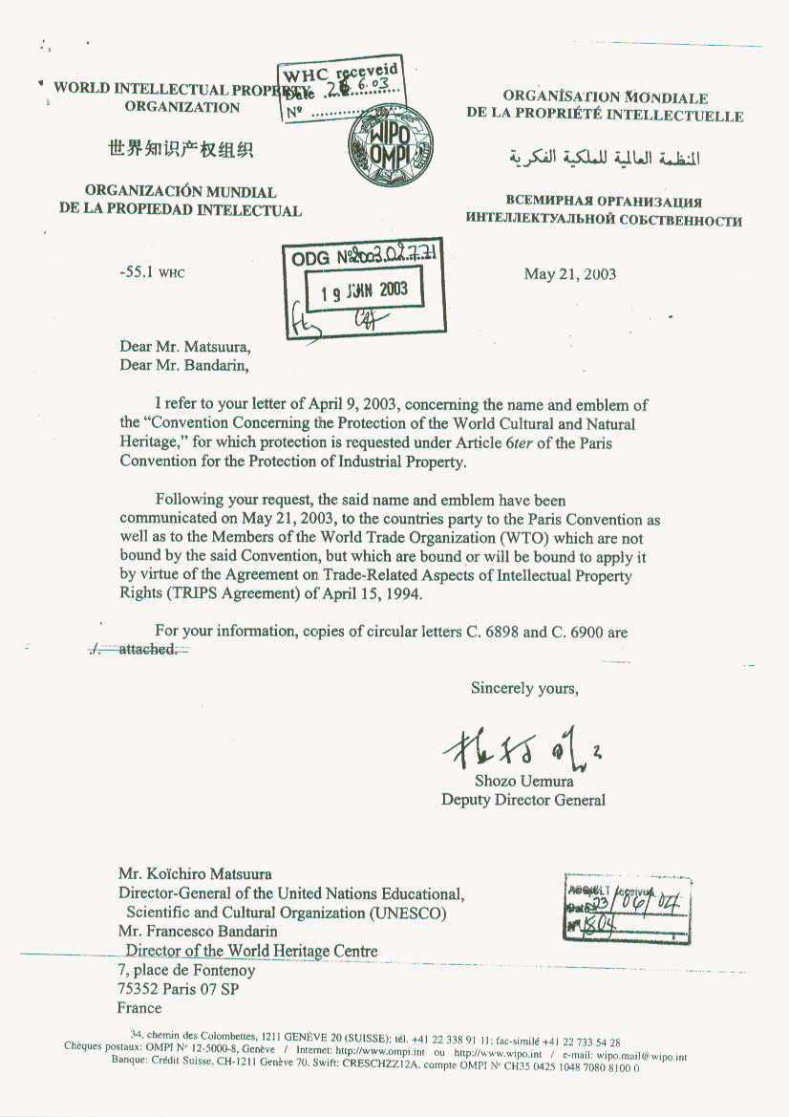
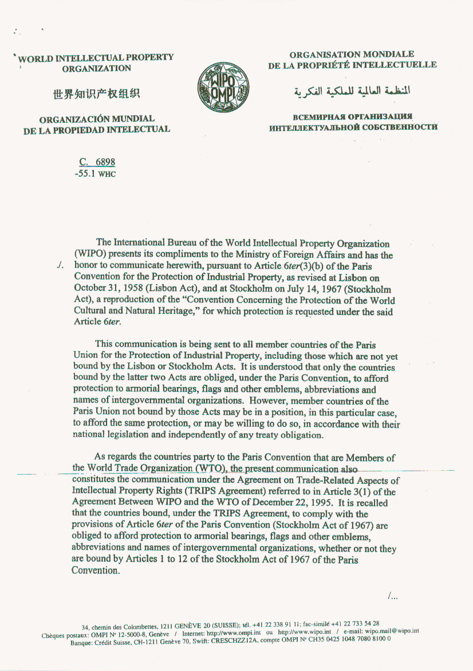
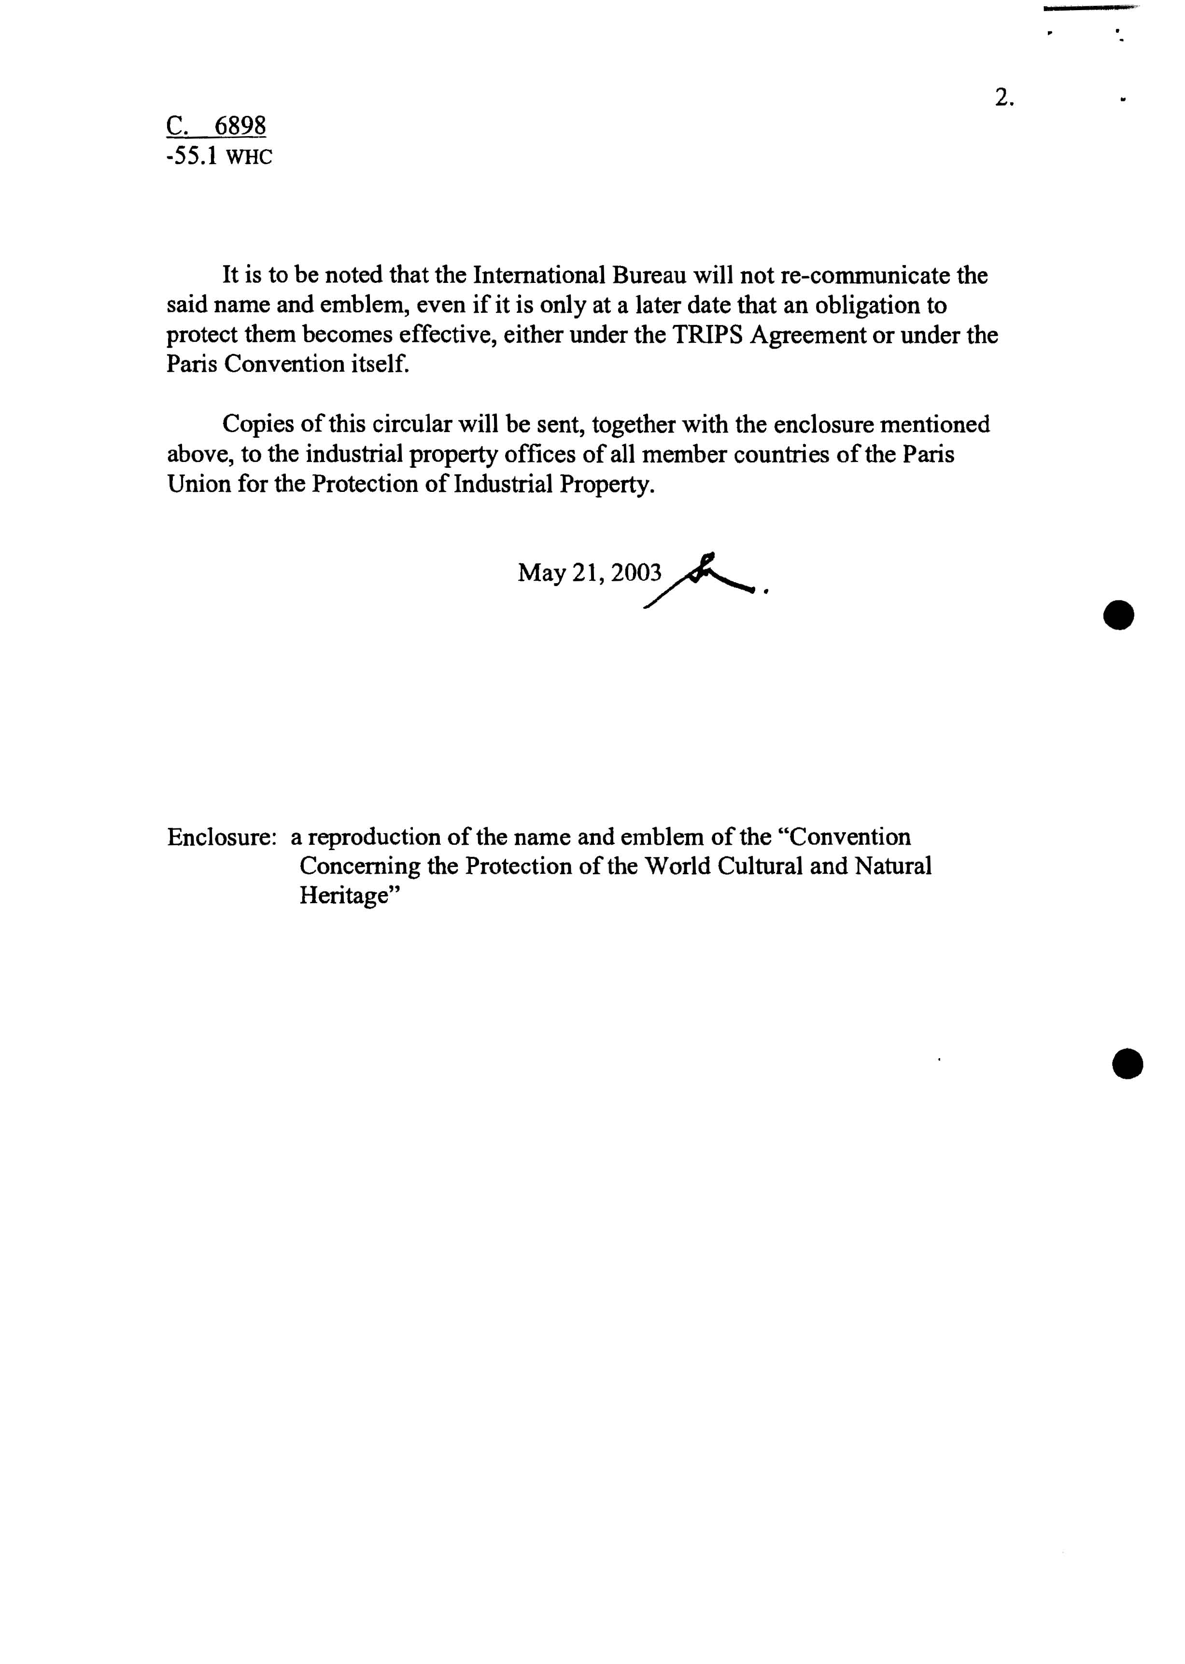
NAMES, ABBREVIATIONS AND EMBLEM OF THE CONVENTION CONCERNING THE PROTECTION OF THE WORLD CULTURAL AND NATURAL HERITAGE

DENOMINATIONS, SIGLES ET EMBLEME DE LA CONVENTION CONCERNANT LA PROTECTION DU PATRIMOINE MONDIAL, CULTUREL ET NATUREL

- Names in English, French and Spanish:
Dénominations en anglais, français, et espagnol:

Convention concerning the Protection of the World Cultural and Natural Heritage

Convention concernant la protection du patrimoine mondial, culturel et naturel

Convención sobre la protección del patrimonio mundial, cultural y natural

2. Abbreviations in English, French and Spanish:
Sigles en anglais, français et espagnol:

N/A

- Emblem:
Emblème:

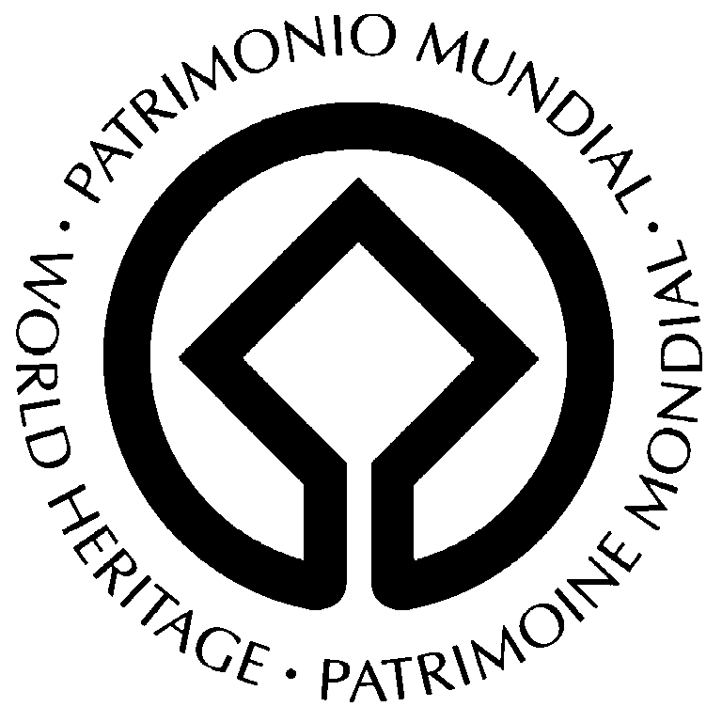

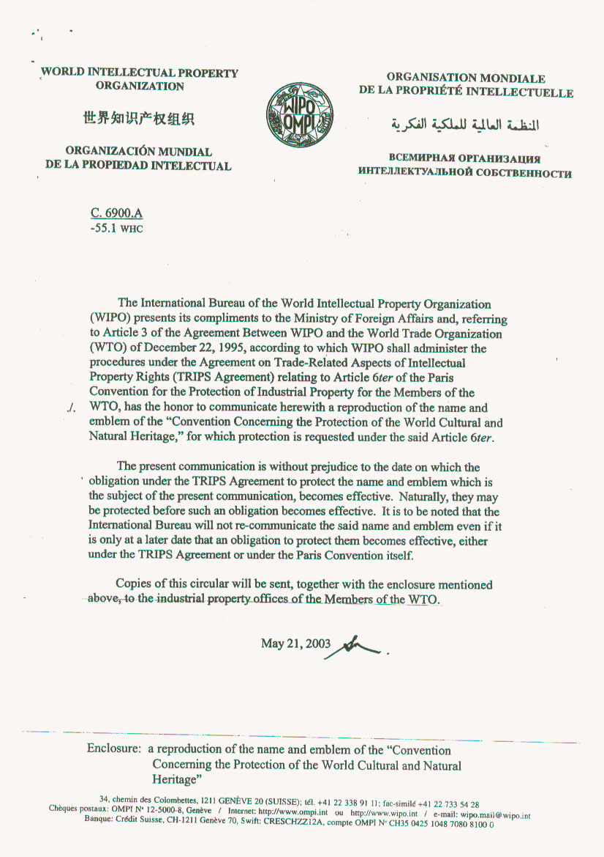

NAMES, ABBREVIATIONS AND EMBLEM OF THE CONVENTION CONCERNING THE PROTECTION OF THE WORLD CULTURAL AND NATURAL HERITAGE

DENOMINATIONS, SIGLES ET EMBLEME DE LA CONVENTION CONCERNANT LA PROTECTION DU PATRIMOINE MONDIAL, CULTUREL ET NATUREL

- Names in English, French and Spanish:
Dénominations en anglais, français, et espagnol:

Convention concerning the Protection of the World Cultural and Natural Heritage

Convention concernant la protection du patrimoine mondial, culturel et naturel

Convención sobre la protección del patrimonio mundial, cultural y natural

2. Abbreviations in English, French and Spanish:
Sigles en anglais, français et espagnol:

N/A

- Emblem:
Emblème:

