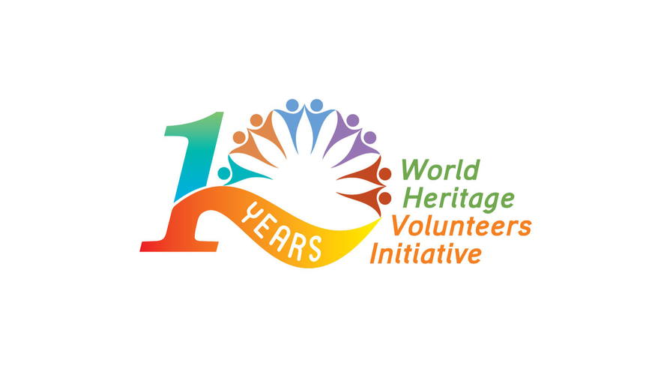

World Heritage Volunteers 2018
Empowering the Commitment to World Heritage


Application Form

*Patrimonito tip: The more detailed, concrete and precise your project description is, the more chances your project will have to be selected.
**Starting from this year, a call for projects of WHV Initiative will go out every year with the options of the one-year cycle and the two-year cycle.

1. Action camp information

Title of the action camp: WHV –  Please add WHV before the title of your project | WHV -
Name of the World Heritage Site:
- For Cultural/Natural/Mixed property inscribed on the World Heritage List please refer to: http://whc.unesco.org/en/list
-For Cultural/Natural/Mixed property inscribed on the List of World Heritage in danger please refer to: http://whc.unesco.org/en/danger/
-For the site inscribed on a Tentative List
please refer to: http://whc.unesco.org/en/tentativelists
Type of World Heritage site (Cultural, Natural, Mixed, List of World Heritage in Danger, Tentative List)
Project location (Town, Country, Region)
Are you applying for a two-year cycle? YES/NO
If yes, once your application is approved, your project should be implemented in 2018 and 2019. After the implementation of the project in the first year, selected organisations will be asked to submit a pre-filled form by January 2019 to confirm the implementation of the project in the second year. Please refer to more details in the CALL.
Provisional Project dates dd/mm/yyyy – dd/mm/yyyy
(Minimum 10 full days of activities, consecutive or not, excluding arrival and departure of participants)
Please note that projects should ideally start after 15 June 2018 and finish before 15 December 2018
Participation fee (Please specify the amount and currency of the participation fee required from the volunteers to join your action camp and what this amount corresponds to)
Expected number of volunteers: (participating in least 80% of the duration of the action camp)
- Local volunteers
- International volunteers

2. Organisation information

Name of the organisation

Name of the project coordinator
(Title, first name and last name)
Complete postal address
(n°, street name, postal code, city, country, region)

E-mail address

Phone number (+ country code - city code - phone number)
Previous World Heritage Volunteers participation: Have you already participated in the WHV initiative? Yes/No
  If the answer is Yes, please specify the year(s) | If the answer is No, please take into account the point “7. Support documents” of this application

3. Objectives of the action camp
What motivates your organisation to join the World Heritage Volunteers campaign 2018?

Specify the objectives of the action camp.

Explain why your organisation has chosen this particular World Heritage site.

4. Activities planned
Please provide us with as much detailed information as possible on the activities you plan to implement during the action camp.

Awareness Raising Activities

 | Activity 1 | Activity 2 | Activity 3 | Activity 4
Name
Awareness Raising activities
Details
Skills learnt by the volunteers
Involvement of international volunteers

 | Activity 1 | Activity 2 | Activity 3 | Activity 4
Involvement of the site-management and local authorities in the implementation
Involvement of the community
Share best practices / use of non-formal education
State of conservation on the site
Expected results
*Please refer to the Annex of the World Heritage Volunteers 2018 Call for Projects for definitions of awareness-raising, hands-on activities, skills and the state of conservation of the site.
Please provide us with as much detailed information as possible on the activities you plan to implement during the action camp.

Hands-on Activities
 | Activity 1 | Activity 2 | Activity 3 | Activity 4
Name
Hands-on activities
Details
Skills learnt by the volunteers
Involvement of international volunteers

 | Activity 1 | Activity 2 | Activity 3 | Activity 4
Involvement of the site-management and local authorities in the implementation
Involvement of the community
Share best practices / use of non-formal education
State of conservation on the site
Expected results
*Please refer to the Annex of the World Heritage Volunteers 2018 Call for Projects for definitions of awareness-raising, hands-on activities, skills and the state of conservation of the site
5. Partners

Major partners  Name and  Area of activity (e.g environment, youth club, government)  Principal function | Involvement  What is their role in the project and the nature of the partnership? (e.g financial support, materials, infrastructure, institutional support) | Added value  In what way is this partnership valuable for the implementation of your project?

6. Development and sustainability (Applicable only to the organisations that have already participated in the World Heritage Volunteers initiative)

If your action camp was already part of the campaign in the past, please summarise in few sentences what the objectives were for the previous project(s), how they have evolved and which of them you plan to achieve this year.

7. Support documents (Applicable only for first time applicant organisations)
First time applicants should submit with this application:
- Two letters of support from recognised organisations and/or institutions recommending the applicant on the basis of past or current proven cooperation;
- A copy of their Constitution / Bylaws and of their most recent activity report in one of the UN official languages.
We, name of organisation, submit this proposal for the World Heritage Volunteers Campaign 2018. We have read and undertake to comply with the attached criteria for selection.

Title First Name Last Name

Checklist for first time applicant organisations
I have submitted two letters of support from recognised organisations and/or institutions recommending the applicant on the basis of past or current proven cooperation;
I have submitted a copy of their Constitution / Bylaws and of their most recent activity report in one of the UN official languages.

Please submit your application at the latest by 14 January 2018 at MIDNIGHT (Paris Time)
by e-mail to:
- CCIVS (secretariat@ccivs.org) for projects in Africa, Arab States and The Americas
- European Heritage Volunteers (info@heritagevolunteers.eu) for projects in Europe
- Better World (whv@betterworld.asia) for projects in Asia
with a copy to the World Heritage Centre (i.yousfi@unesco.org).
Once you have completed this form you will receive an e-mail confirmation. If you have not received this e-mail your application has not been completed. Thank you very much!

