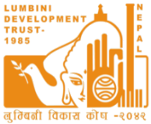
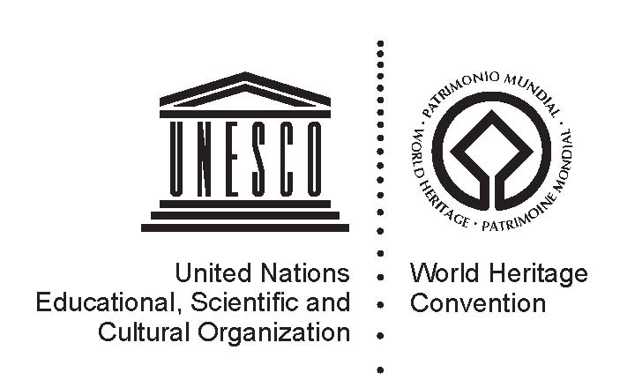

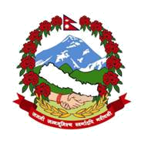

Agenda
International Scientific Committee
UNESCO/Japanese Funds-in-Trust for Strengthening the Conservation and Management of Lumbini, the birthplace of Lord Buddha
Lumbini, Nepal, 17 to 19 February 2017

17 February 2017
- Opening
9:00 - 9:05 | Welcome Remarks  Mr Christian Manhart  UNESCO Representative to Nepal
9:05 - 9:10 | Remarks  Mr Kiyohiko Hamada  First Secretary, Embassy of Japan in Nepal
9:10 - 9:15 | Remarks  Mr Bharat Mani Subedi  Joint Secretary, Ministry of Culture, Tourism and Civil Aviation
9:15 - 9:20 | Remarks  Mr Bhesh Narayan Dahal  Director General, Department of Archaeology
9:20 - 9:25 | Remarks  Venerable Nigrodha  Vice Chair, Lumbini Development Trust
ISC meeting chaired by Prof Yukio Nishimura, Team Leader, Advisor on Planning
- Adoption of agenda
9:25 – 9:30 | Adoption of agenda
- Reports by the Department of Archaeology and the Lumbini Development Trust
9:30 – 9:45 | Research, protection and conservation of the archaeological sites and monument in Greater Lumbini Area  Department of Archaeology
9:45 – 10:00 | Recent development in the Greater Lumbini Area  Lumbini Development Trust
10:00 – 10:15 | Q & A
- Reports by UNESCO
10.15 – 10.30 | World Heritage Committee recent decisions for Lumbini  Dr Roland Lin Chih-Hung, UNESCO World Heritage Centre
10:30 - 10:45 | Report on project implementation  Ms Nabha Basnyat Thapa, Project Coordinator, UNESCO Office in Kathmandu
10:45 - 11:00 | Q & A
11:00 – 11:15 | Tea
- Review of activities and Implementation Plan for 2016 – 2017
11:15 - 12:00 | Review of the activities related to the archaeological investigation in Tilaurakot  Prof Robin Coningham, Durham University, UK, Advisor for Archaeology
12:00 - 12:15 | Q & A
12:15 - 13:00 | Review of the activities related to mapping heritage sites in the Greater Lumbini Area and planning of Tilaurakot  Prof Yukio Nishimura, Tokyo University, Japan, Advisor on Planning
13:00 – 13:15 | Q & A
13:15 – 14:15 | Lunch
14:15 - 15:00 | Review of the activities related to the conservation of archaeological remains in Lumbini and Tilaurakot  Mr Claudio Margottini and Mr Paolo Pagnin, Advisors for Conservation
15:00 - 15:15 | Q & A
- Various Lumbini-related efforts by the Government of Nepal
15:15 – 15:30 | Ministry of Urban Development
15:30 – 15:45 | Department of Environment
15:45 – 16:00 | Kapilvastu Municipality
16:00 – 16:15 | Tea
16:15 – 16:30 | Lumbini Cultural Municipality
16:30 – 16:45 | Local Development Officer, Rupandehi
16:45 – 17:00 | Local Development Officer, Kapilvastu
17:00 – 17:15 | Q & A
17:15 – 18:30 | Site Visit to the Sacred Garden of Lumbini (Optional)
18 February 2017
- Needs of religious community
9:00 – 9:15 | Bhikkhu Thubten Jikdol, President, Nepal Bauddha Association
9:15 – 9:30 | Padma Jyoti, Vice President, Dharmodaya Sabha
9:30 – 9:45 | Activities by the Chinese Monastery
9:45 – 10:00 | Activities by the Royal Thai Monastery
10:00 – 10:15 | Venerable Metteyya
10:15 – 10:30 | Q & A
- Other initiatives
10:30 – 10:45 | Initiatives in the Greater Lumbini Area under the South Asian Tourism Infrastructure Development Project  Asian Development Bank
10:45 – 11:00 | Lumbini Museum Improvement Project  Mr Thomas Schrom
11:00 – 11:15 | Tea
11:15 – 11:30 | H.E Ms Swarna Perera  Ambassador of Sri Lanka in Nepal
11:30 – 11:45 | H.E Mr Vutti Vuttisant  Ambassador of Royal Thai Embassy in Nepal
11:45 – 12:00 | Arts and crafts in the Terai  Ms Claire Burkert
12:00 – 12:15 | Air quality observatory in Lumbini  Arnico Panday, Senior Atmospheric Scientist, Atmosphere Initiative, ICIMOD
12:15 – 12:30 | Venerable Vivekananda, Lumbini Meditation Centre
12:30 – 12:45 | Projects and activities in Lumbini area  Mr Rajendra N Suwal, Deputy Director, WWF Nepal
12:45 – 13:00 | Arts & Humanities Research Council sponsored project ‘Promoting the Protection of Heritage Sites in Nepal’s Southern Terai in the Face of Accelerated Development’  Prof Robin Coningham, UNESCO Chair in Archaeological Ethics and Practice in Cultural Heritage, Durham University
13:00 – 13:30 | Q & A
13:30 – 14:30 | Lunch
- Discussion on third phase of the project
14:30 – 14:45 | Concept note of the third phase of the project  UNESCO Kathmandu Office
14:45 – 15:30 | Discussion
- Closure
15:30 – 15:35 | Closure by Prof Yukio Nishimura, ISC Chair
15:35 – 16:00 | Tea
16:00 – 17:30 | Project Steering Committee Meeting
 | Participants: Ministry of Culture, Tourism and Civil Aviation, Department of Archaeology, Lumbini Development Trust and UNESCO
19 February 2017
8:00 - 12:00 | Site Visits to Lumbini Museum and Tilaurakot (tour guided by Prof Robin Coningham, Durham University)
12:00 – 13:00 | Lunch
13:00 – 14:00 | Stakeholder debriefing at Tilaurakot site

