World Heritage Volunteers 2017
“Heritage in our hands”

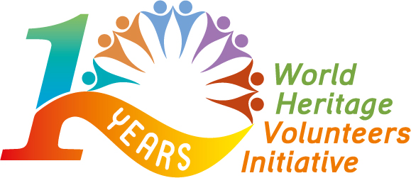

APPLICATION FORM

*Patrimonito tip: The more detailed, concrete and precise your project description is, the more chances your project will have to be selected.

1. Action camp information

Title of the action camp: WHV –  Please add WHV before the title of your project | WHV -
Name of the World Heritage Site:
- For Cultural/Natural/Mixed property inscribed on the World Heritage List please refer to: http://whc.unesco.org/en/list
-For Cultural/Natural/Mixed property inscribed on the List of World Heritage in danger please refer to: http://whc.unesco.org/en/danger/
-For the site inscribed on a Tentative List
please refer to: http://whc.unesco.org/en/tentativelists
Type of World Heritage site (Cultural, Natural, Mixed, List of World Heritage in Danger, Tentative List)
Project location (Town, Country, Region)
Project dates dd/mm/yyyy – dd/mm/yyyy
(Minimum 10 full days of activities, consecutive or not, excluding arrival and departure of participants)

Participation fee (Please specify the amount and currency of the participation fee required from the volunteers to join your action camp and what this amount corresponds to)
Expected number of volunteers: (participating in least 80% of the duration of the action camp)
- Local volunteers
- International volunteers

2. Organisation information

Name of the organisation

Name of the project coordinator
(Title, first name and last name)
Complete postal address
(n°, street name, postal code, city, country, region)

Email address

Phone number (+ country code - city code - phone number)
Previous World Heritage Volunteers participation: Have you already participated in the WHV initiative? Yes/No
  If the answer is Yes, please specify the year(s) | If the answer is No, please take into account the point “7. Support documents” of this application

3. Objectives of the action camp

What motivates your organisation to join the World Heritage Volunteers campaign 2017?

Specify the objectives of the action camp.

Explain why your organisation has chosen this particular World Heritage site?

4. Activities planned
Please provide us with as much detailed information as possible on the activities you plan to implement during the action camp (double click on the tables to modify them).

Awareness Raising Activities

*Please refer to the Annex of the World Heritage Volunteers 2017 Call for Projects for definitions of awareness-raising, hands-on activities, skills and the state of conservation of the site.

Please provide us with as much detailed information as possible on the activities you plan to implement during the action camp (double click on the tables to modify them).

Hands-on Activities

*Please refer to the Annex of the World Heritage Volunteers 2017 Call for Projects for definitions of awareness-raising, hands-on activities, skills and the state of conservation of the site.
5. Partners

(Double click on the table to modify it)

6. Development and sustainability (Applicable only to the organisations which have already participated in the World Heritage Volunteers initiative)

If your action camp was already part of the campaign in the past, please summarise in few sentences what the objectives were for the previous project(s), how they have evolved and which of them you plan to achieve this year.

7. Support documents (Applicable only for first time applicant organisations)
First time applicants should submit with this application:
- Two letters of support from recognised organisations and/or institutions recommending the applicant on the basis of past or current proven cooperation;
- A copy of their Constitution / Bylaws and of their most recent activity report in one of the UN official languages.
We, name of organisation, submit this proposal for the World Heritage Volunteers campaign 2017. We have read and undertake to comply with the attached criteria for selection.

Title First Name Last Name

Please submit your application at the latest by 30 November 2016 at MIDNIGHT (Paris Time)
by email to:
- CCIVS (secretariat@ccivs.org) for projects in Africa, Arab States and The Americas
- European Heritage Volunteers (info@heritagevolunteers.eu) for projects in Europe
- Better World (whv@betterworld.asia) for projects in Asia
with a copy to the World Heritage Centre (i.yousfi@unesco.org).

Once you have completed this form you will receive an email confirmation. If you have not received this email your application has not been completed.

Thank you very much!

