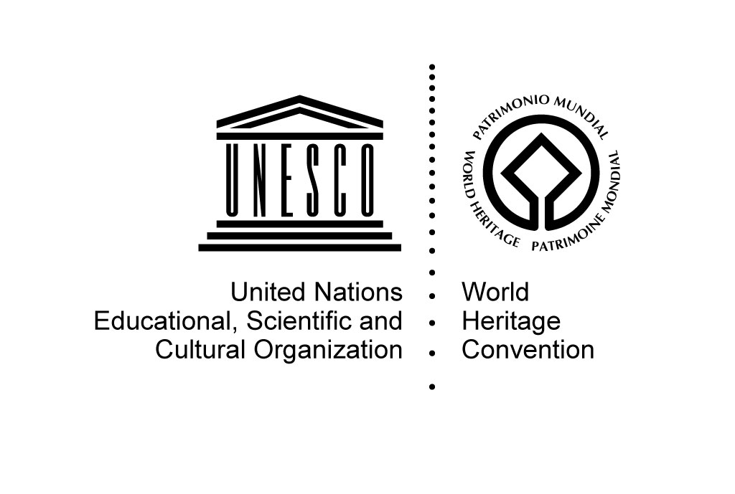

Post-conflict reconstruction in the Middle East context
and in Aleppo in particular

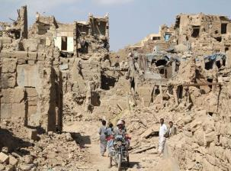
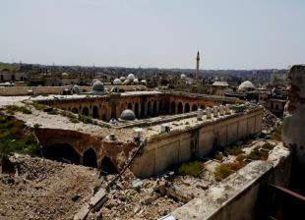

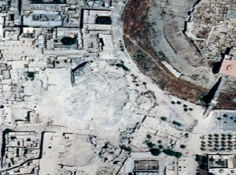
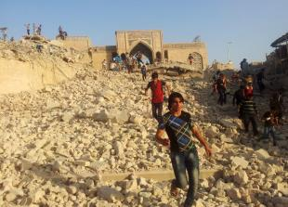

18-19 June 2015
UNESCO Headquarters
Paris, France

Room VIII

PROGRAMME

Thursday, 18 June 2015
9.30 – 10.00 am |  |  | Registration – Entrance to UNESCO Headquarters, 7 place de Fontenoy, Paris
10.00 – 10:30 am |  |  | WELCOME AND OPENING REMARKS  Alfredo Pérez de Armiñán, UNESCO Assistant Director-General for Culture
10.30 – 11.30 |  |  | INTRODUCTION  Nada Al Hassan, Chief, Arab States Unit, World Heritage Centre  Tour de Table: Presentation of participants & short overview of their experience in the field of post-conflict reconstruction.  Discussion on the expectations and objectives of the meeting (30 mn)
11.30 am –1 pm |  |  | FIRST SESSION: CULTURAL HERITAGE AND CONFLICTS, LESSONS FROM HISTORY  Moderator: Nada Al Hassan, Chief, Arab States Unit, World Heritage Centre  Nicolas Detry: Challenges and critical analysis of post-WW II reconstruction in Europe  Amra Hadźimuhamedović: Heritage, War and Peace : a view on the reconstruction in Bosnia-Herzegovina  Amir Pasic: Operational challenges of post-war reconstruction: the case of Mostar  Discussion (30mn)
1 – 2.30 pm |  |  | Lunch Break
2.30 – 4.00 pm |  |  | Presentations (continued)  Moderator: Giovanni Boccardi, Head, Emergency Preparedness and Response Unit,  Culture Sector  Wendy Pullan: Rebuilding/Reconstructing a city  Simone Ricca: Reconstructing a symbolic monument : the Hurva Synagogue  Marie Louise Stig Sørensen: Reconstructing cultural heritage after conflict  Discussion (30mn)
4 – 4.15 pm |  |  | Coffee break
4.15- 5:30 pm |  |  | Presentations (continued)  Assaad Seif: Opportunities revealed by the post-conflict reconstruction of Beirut city centre  Jad Tabet: Reconstruction organized by the private sector: the case of Solidere in Beirut  Discussion and conclusions of the day (30mn)
 | Friday, 19 June 2015
 | 10.00 – 11.15 am | SECOND SESSION: GUIDANCE ON RECONSTRUCTION  Moderator: Mechtild Rössler, Deputy Director, Division for Heritage, Culture Sector  Presentations  Mustapha Khanoussi: International charters and recommendations in the area of conservation: Is there a need for a document dedicated to post-war reconstruction?  Edmond Moukala/Bandiougou Diawara: UNESCO’s project for the rehabilitation of cultural heritage in Timbuktu  Feng Jing: The controversy about the reconstruction of the Buddhas of Bamiyan  Discussion (25mn)
 | 11.15 -11.30 am | Coffee break
 | 11.30 am – 1 pm | THIRD SESSION: PERSPECTIVES FOR THE ANCIENT CITY OF ALEPPPO  Moderator: Stefano Bianca, Director Emeritus, Aga Khan Historic Cities Programme  Presentations  Anas Soufan: Reconstruction in the Syrian context  Thierry Grandin: The condition of the urban fabric and cultural heritage in the Ancient city of Aleppo  Kheireddin Al Rifai, Sarab Atassi-Khattab, Diana Miznazi and Luna Rajab will present an overview of ongoing initiatives and/or recommendations related to recovery and reconstruction plans (5-7mn per participant)  Discussion (30mn)
 | 1 – 2.30 pm | Lunch Break
 | 2.30 – 3.15 pm | FOURTH SESSION : WORKSHOP, CONCLUSIONS AND RECOMMENDATIONS  Ancient city of Aleppo  Moderator: Stefano Bianca, Director Emeritus, Aga Khan Historic Cities Programme  Discussions and proposals
 | 3.15 -3.30 pm | Coffee Break
 | 3.30 – 5.30 | (session continued)  Conclusions of the meeting and the way forward  Moderator: Shadia Touqan, Expert of Architectural Preservation and Revitalisation of Historic Cities  Discussions et propositions  Nada Al Hassan: Closing remarks

