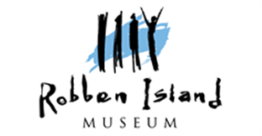

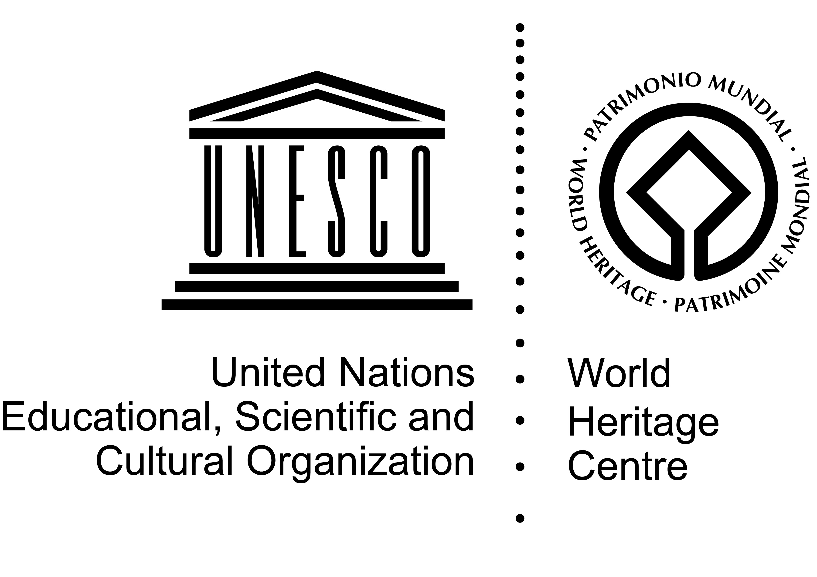


African World Heritage Youth Forum
DATE: 28th April – 4th May 2016
VENUE: Robben Island World Heritage Site, South Africa

APPLICATION FORM

A- Identity of applicant
Surname: |  |  |  |  |  |  | Other name(s):
Sex : Male □ Female □ |  |  | Age : |  |  |  | Nationality:
Physical Address: [please state country]

Telephone: |  |  |  | Email (mandatory):
Passport Number: |  |  |  | Passport Expiry Date:
Special needs:
B- Current status of applicant
Present occupation:

From: |  |  |  |  |  | To:
Name of employer/university (if self-employed, please state):

Address of institution/organisation/work place:

Telephone : |  |  | Email:
Description of Responsibilities/Role:

C- Academic background of applicant
Discipline:

Academic/professional Qualification:

D- Experience of applicant
- Briefly describe the link between your current responsibilities/role/experience and the youth forum

E- English language proficiency -Please tick your proficiency in English
Languages | fluent |  |  |  | Moderate |  |  |  | Low
Speak
Read
Write
F- Recommendation from a university, organisation or administrative supervisor/authority
I, the undersigned, recommend. ……………………………………for the Youth Forum to be held from 28th April to the 4th May 2016.
Position and name:

Institution/Organisation (Name and contact details):

Signature/Stamp:

Date:
G- Verification by the applicant
I, the undersigned, certify that the information above is true, complete and correct to the best of my knowledge.

Date: Signature

The complete application package (letter of motivation, curriculum vitae, letter of recommendation, completed application form and video) should be sent at the latest on the 31st January 2016 via electronic email to: awhfyouthforum@gmail.com.

