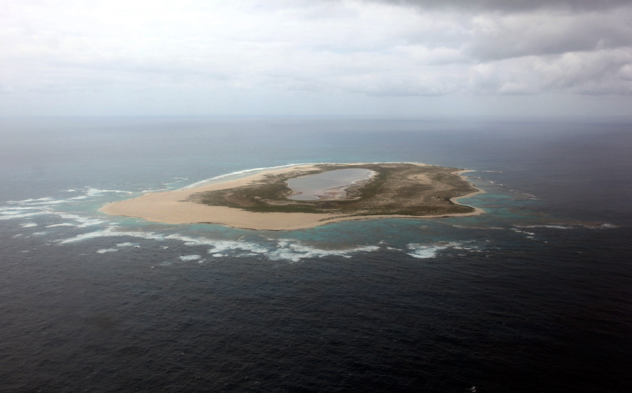

COP21 Thematic Day at UNESCO Pavilion

UNESCO Sites: A Climate Change Observatory

Saturday, 5 December 2015
Climate Generations Areas

© NOAA / Andy Collins / Papahānaumokuākea

A series of events is organised at the UNESCO Pavilion during COP21 on 5 December that invite expert speakers and audience to explore how the impacts of climate change are being evidenced and managed at UNESCO designated World Heritage sites, Biosphere Reserves and Global Geoparks.
11.00-11.15
WELCOME AND INTRODUCTION TO UNESCO SITES
11.15-12.00
UNESCO SITES AS EXPERIMENTAL AREAS FOR GREEN GROWTH AND LOW CARBON DEVELOPMENT
In partnership with the International Centre on Space Technologies for Natural and Cultural Heritage under the auspices of UNESCO in Beijing, China (HIST)
Prof. Natarajan Ishwaran – Visiting Professor and State Recruited Expert of the International Centre on Space Technologies for Natural and Cultural Heritage under the auspices of UNESCO in Beijing, China
Mr Andrew Bell – Vice-Chair for International Programmes of the UK MaB Programme and the Director of the North Devon UNESCO Biosphere Reserve in Devon, UK
Dr Le Van Chinh – Official, Department of Social and Natural Sciences Ministry of Science and Technology of Vietnam
13.00-14.00
UNESCO SITES AS CLIMATE CHANGE OBSERVATORIES: THE CONTRIBUTIONS OF WORLD HERITAGE SITES, BIOSPHERE RESERVES AND GLOBAL GEOPARKS FOR CLIMATE KNOWLEDGE AND ACTION
Prof. Brendan Mackey – Director, Griffith Climate Change Response Program, Griffith University, IUCN Council, Regional Councilor for Oceania, Chair, Climate Change Task Force
Dr Qunli Han – Director, Division of Ecological and Earth Sciences, Secretary, Man and the Biosphere (MAB) Programme
Dr Mechtild Rössler – Director of the Division for Heritage and the UNESCO World Heritage Centre

Prof. Patrick McKeever – Chief of Section, Earth Sciences and Geohazard Risk Reduction, Secretary of the International Geoscience and Geoparks Programme
Prof. Lee White – CBE, Secrétaire Exécutif, Agence Nationale des Parcs Nationaux, Parcs Gabon
Mr Richard Kapere – Acting Planning Coordinator / Climate Change Focal Point, Uganda Wildlife Authority
14.15-15.00
UNESCO WORLD HERITAGE MARINE PROGRAMME: THE IMPACTS OF CLIMATE CHANGE ON OUR COMMON OCEAN HERITAGE
Dr Russell Reichelt – CEO Great Barrier Reef Marine Park Authority, Australia
Dr Fanny Douvere – Project Officer, UNESCO World Heritage Marine Programme
15.15-16.00
CULTURAL HERITAGE & AR6: IMPROVING THE TREATMENT OF CULTURAL HERITAGE IN THE NEXT IPCC ASSESSMENT REPORT
In partnership with the U.S. National Committee of the International Council on Monuments and Sites (US/ICOMOS) and the International National Trusts Organisation (INTO)
Mr Andrew Potts – JD, Executive Director, US/ICOMOS
Mr Oliver Maurice – Director, INTO
Dr Katharine J. Mach – Director, Science, IPCC Working Group II Technical Support Unit
Dr Mechtild Rössler – Director of the Division for Heritage and the UNESCO World Heritage Centre
16.00-16.45
RENEWABLE ENERGY AND UNESCO SITES
17.00-17.45
ARCTIC AND CLIMATE CHANGE
In partnership with the 'Association Pôles Action' and the Cousteau Society.

