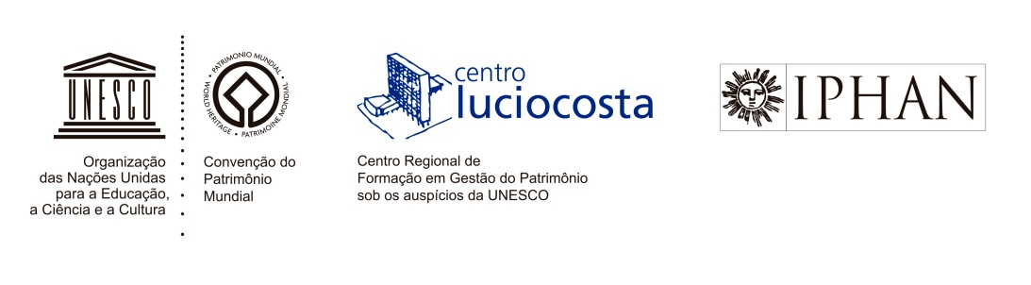

**MEETING FOR THE ESTABLISHMENT OF THE GOVERNANCE OFFICES OF THE REGIONAL CENTER FOR CAPACITY-BUILDING IN HERITAGE MANAGEMENT - LUCIO COSTA CENTER/IPHAN**

**26-27 NOVEMBER 2015**

**PLACE:** PAÇO IMPERIAL - RIO DE JANEIRO - BRASIL

**NOVEMBER 25:** ARRIVAL OF BRAZILIAN AND FOREIGN PARTICIPANTS

**NOVEMBER 26**

**Morning**

10am: **OPENING SESSION**

**Jurema de Souza Machado** - President of IPHAN

**Patrícia Reis** - Representative of the UNESCO General Director

10:30am - 11am: **Presentation of focal points for the countries that joined the CLC**

11am - 12pm: **Presentation of activity reports from 2010 to 2015**

12pm - 2pm: **Lunch**

**Afternoon**

2pm - 3pm: **Composition and establishment of the Director Council**

3pm - 4pm: **Composition and establishment of the Executive Committee**

4pm - 4:30pm:  **Appointment of the Director of Lucio Costa Center**

8 pm: **Dinner**

**NOVEMBER 27**

**Morning**

10am - 11am: **Planning 2016/2017**

11am - 12am: **Debates**

12pm - 2pm: **Lunch**

**Afternoon**

2pm - 5pm: **Debates on the operation of the CLC governance offices**

5pm: **Closing session**

**NOVEMBER 28:** DEPARTURE OF BRAZILIAN AND FOREIGN PARTICIPANTS