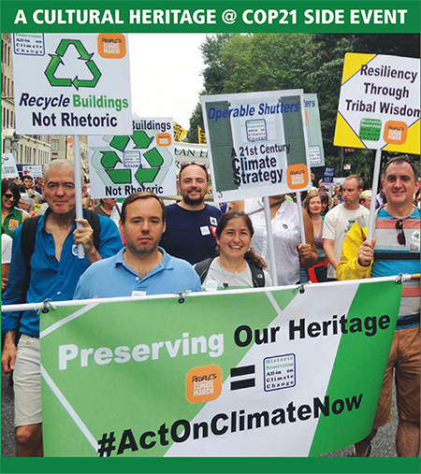

**Cultural Heritage & AR6: Improving the Treatment of Cultural Heritage in the Next IPCC Assessment Report**

**TUESDAY, 1 DECEMBER 2015**

**Roundtable and Discussion • 16h30 – 18h30**

**Reception and Networking Event • 18h30​– 19h30**

**La Maison Champs-Elysees**

**8 rue Jean Goujon, 75008 Paris (near the Grand Palais)**

*Directions from Le Bourget: Take RER B to Châtelet-Les Halles, transfer to Paris Métro Line 1 in the direction of La Défense–Grande Arche. Exit at Champs-Élysées-Clemenceau.*

**Culture Heritage is both impacted by Climate Change and a source of Resiliency, but the relationships are not well understood.**The IPCC Fifth Assessment Report (AR5), for example states that “impacts, such as loss of... cultural heritage, and ecosystem services, are difficult to value and monetize, and thus they are poorly reflected in estimates of losses.” We will examine how to improve the treatment of cultural heritage in the AR6 through new collaboration among interested organizations within the framework of expanding engagement by heritage of climate issues.

Inline image 2

**Dr. David Harvey**

Professor of Historical Cultural Geography, University of Exeter

**Mr. Keith Jones**

Environmental Adviser, National Trust Wales

**Dr. Katharine J. Mach**

Director, Science, IPCC Working Group II Technical Support Unit

**Mr. Oliver Maurice • *Co-Rapporteur***

Director, International National Trusts Organisation (INTO)

**Ms. Anika Molesworth**

Coordinator, Sustainable Farms Initiative,

International National Trusts Organisation (INTO)

**Ms. Anna Sidorenko**

World Heritage Centre, UNESCO

**Dr. Youba Sokona**IPCC Vice Chair, Special Advisor on Sustainable Development, South Centre

**Andrew Potts, JD • *Moderator and Co-Rapporteur***

Executive Director, US/ICOMOS

The Reception/Networking Event is designed to bring together in one place all the folks attending COP21 working at the intersection of Climate Change and Heritage.   
RSVPs appreciated but not required. Direct questions or RSVPs to [**cbanahan@usicomos.org**](mailto:tocbanahan@usicomos.org)

