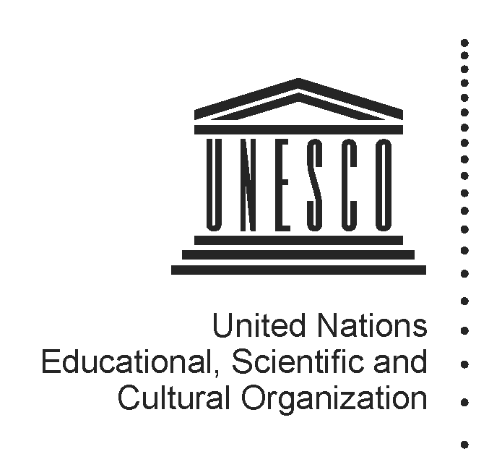 2014-2015
Mapping factsheet
Institutes and centres under the auspices of UNESCO
(Category 2)

Reference documents pertaining to the integrated comprehensive strategy for category 2 institutes and centres:

- 37 C/Resolution 93 (adopted on 19 November 2013)
- 37 C/18 Part I and its attachments
- 37 C/4 (Medium-Term Strategy) and 37 C/5 (Programme and Budget)

Full name of institute/centre and its acronym, if any | Nordic World Heritage Foundation
Name of the host Member State and city | Norway, Oslo
Name of other participating/sponsoring Member State(s) | Denmark, Finland, Iceland, Sweden
Date of approval for the creation by the General Conference and relevant resolution | 32nd session of the GC (2003, 32 C/Resolution 36)
Date of entry into force of the signed agreement with UNESCO | 01/10/2008
Date(s) of the renewal of the agreement and relevant Executive Board decision(s) | 179th session (179 EX/Decision 12)
Is the present agreement in compliance with the integrated comprehensive strategy (37 C/18 Part I)? | No, since the agreement was signed before 2013.
Duration of the agreement | 6 years
Thematic specialization | NWHF has the following purposes:  (a) it acts as a focal point bringing Nordic  countries together in their collective attempt to fulfil the intentions and requirements of the Convention;  (b) it supports the World Heritage Centre by  facilitating technical expertise, disseminating information and contributing to innovative projects, all in support of the Convention and the Global Strategy; and  (c) it mobilizes funds from bilateral, multilateral and private sources and facilitates assistance for natural and cultural World Heritage conservation efforts in developing countries.  In 2010 the NWHF’s Board of Directors adopted a new Strategy for 2010-2014 and a Results Based Management System and indicators in line with UNESCO’s working methods. The new Strategy focuses on three main objectives:  a) SO1: Promote Sustainable Development through Tourism;  b) SO2: Strengthen the Periodic Reporting (PR) tool;  c) SO3: Implementation of the integrated comprehensive strategy for Category 2 centres under the auspices of UNESCO approved by the General Conference of UNESCO (35C/22).
Contribution to which UNESCO strategic objectives (37 C/4) and expected results at the main lines of action (MLA) level (37 C/5) | Contribution to the Strategic Objectives:  The NWHF contributes to the Strategic Objectives 6 (“Supporting inclusive social development and promoting intercultural dialogue and the rapprochement of cultures”) and 7 (“Protecting, promoting and transmitting heritage”) of the 37 C/4 Medium-Term Strategy.  Expected Results at 37 C/5 MLA level:  Europe and North America ER 1: Tangible heritage is identified, protected, monitored and sustainably managed by Member States, in particular through the effective implementation of the 1972 Convention
Contribution to the two global priorities of UNESCO – Africa and Gender Equality | The NWHF ensure that African heritage is better safeguarded and promoted in Member States.
Contribution to the implementation of sector-specific strategy of interaction with category 2 institutes/centres | The NWHF participated in the Second Cycle of Periodic Reporting in Europe (2012-2015), in particular through preparing and updating Quantitative Summaries of National Periodic Reports (country-based and site-based) concerning a cluster of 20 countries. NWHF was also involved in several sub-regional meetings focused on Periodic Reporting, and undertook capacity-building activities for site managers in the Nordic and Baltic sub-region. In this context, NWHF contributed in the development and design of the Handbook for Site Managers.  NWHF cooperates with other Category 2 Centres in the field of World Heritage. It has MOUs (or Letters of Intent) with the African World Heritage Fund (AWHF), World Heritage WHITR-AP and the Arab Regional Centre for World Heritage (ARC-WH).
Implementation strategy (200 words), should come from the agreement | The NWHF acts as a focal point bringing Nordic countries together in their collective attempt to fulfil the requirements of the Convention and its implementation. It also supports the Secretariat of the 1972 Convention by facilitating technical expertise, disseminating information and contributing to innovative projects, all in support of the Convention and the World Heritage Committee’s Global Strategy. Finally, it mobilises funds from bilateral and multilateral sources and private sources in a coordinated and transparent way, and facilitates assistance for natural and cultural World Heritage conservation efforts in developing countries in support of the Convention.
Geographic coverage | Global
Best practices in promoting South-South, North-South and triangular cooperation | The Foundation provides technical and financial support to the African World Heritage Fund (AWHF) and continued support for natural heritage nominations; feasibility study for staff exchange with AWHF through FK Norway (the Norwegian Peace Corps); partnership development with AWHF and WHITR-AP (World Heritage Institute of Training and Research - Asia and Pacific); establishment of partnerships for concept development of tourism as a driver for sustainable development; participation as key partner in the UNESCO World Heritage Tourism Programme.  The NWHF has furthermore, and in close cooperation with the World Heritage Centre, contributed to enhancing capacities with regards to PR in Africa and Asia-Pacific through the provision of technical assistance to regional workshops and meetings in Africa and Asia-Pacific (see Document WHC-10/34.COM/10B.1).  On the institutional side, NWHF has established Memoranda of Understanding with the African World Heritage Fund (AWHF) and with the World Heritage Institute of Training and Research for Asia and the Pacific Region (WHITRAP). NWHF expanded its network also through its observer role on the Board of Directors of the African World Heritage Fund and of the Arab Regional Centre for World Heritage (ARC-WH).
Governing Board | The NWHF is guided and supervised by a Governing Board renewed every four years and composed of:  (a) an observer representative from the Norwegian Ministry of the Environment;  (b) representatives from the Nordic countries, including Norway. Those are appointed by the Norwegian Ministry of the Environment, which also appoints the Chairperson. The seat of the Deputy Chairperson is rotated each year between these countries.  (c) a representative of the Director-General of UNESCO (e.g. the Director of the World Heritage Centre)  UNESCO is not legally responsible for the Foundation and bears no liabilities of any kind, be it managerial, financial or otherwise, but may  contribute to the Foundation activities.
Financial contributions of UNESCO if the agreement of institute/centre entered into force before 2013 when the General Conference approved the current integrated comprehensive strategy in its 37 C/Resolution 93 | Resources provided under Regular programme for:  (i) feasibility study  (ii) activities, implemented through contractual arrangements  (iii) participation in governing board meetings  (iv) renewal review assessment  (v) others (pls. specify) | (i) N/A  (ii) None  (iii) None  (iv) N/A  (v) Calculation of staff time spent engaging with the Category 2 Institute over the biennium: 32,365 US$
 | Extra-budgetary | N/A
 | Total | 32,365 US$
 | Centre’s budget and sources of financing | Regular Budget:  2012-13: 9,252,13 NOK  2014: 5,312,000 NOK  Funding sources:  Norwegian Government (2012: NOK 4 million; 2013: NOK 5 million)
Has the institute/centre been providing biennial self-assessment progress report(s) to UNESCO?  If so, indicate the date of the last submission and provide the web link | Yes. Annual reports have been provided to the World Heritage Committee, outlining the activities of the Category 2 Centre.  The latest report can be found at http://whc.unesco.org/document/128229
Has the institute/centre been evaluated and/or audited?  If so, when and by whom? | Yes.  Evaluation by IOS in June 2011.  Evaluation by Vista Analyse (Karin Ibenholt, Rasmus Reinvang, Hanne Toftdahl, Philip Swanson), 16 October 2013.  Note: Following the 2013 evaluation, the Norwegian authorities decided not to renew the Category 2 Centre as is stands, and to work towards a proposal for a new Category II Centre.
Is the institute/centre considered as non-operational due to the absence of an agreement signed between UNESCO and a host country? | No
Responsible UNESCO Programme Sector and its implementing unit(s) | Culture Sector – World Heritage Centre
Name and title of responsible officer(s) | Mr Kishore Rao, Director, World Heritage Centre
Name and title of sectoral focal point(s) for category 2 institutes and centres | Frank Proschan, Programme Specialist, Section of Intangible Heritage (Culture Sector)
UNESCO field office in contact with institute/centre | N/A
Name and title of field office focal point(s) | N/A
Name and title of UNESCO staff seconded to institute/centre, if any | N/A
Relevant web-links for :  (i) UNESCO sector-specific web-page  (ii) Institute/centre dedicated web-page  (iii) Agreement with UNESCO  (iv) other | (i) http://whc.unesco.org/en/category2centres/  - (ii) http://www.nwhf.no/  - (iii) http://www.nwhf.no/files/File/Agreement_UNESCO_Norway_September_2008.pdf  (iv) Acknowledgement of the in-kind contribution by the Executive Board (194 EX/4.INF.2): http://unesdoc.unesco.org/images/0022/002269/226974e.pdf

