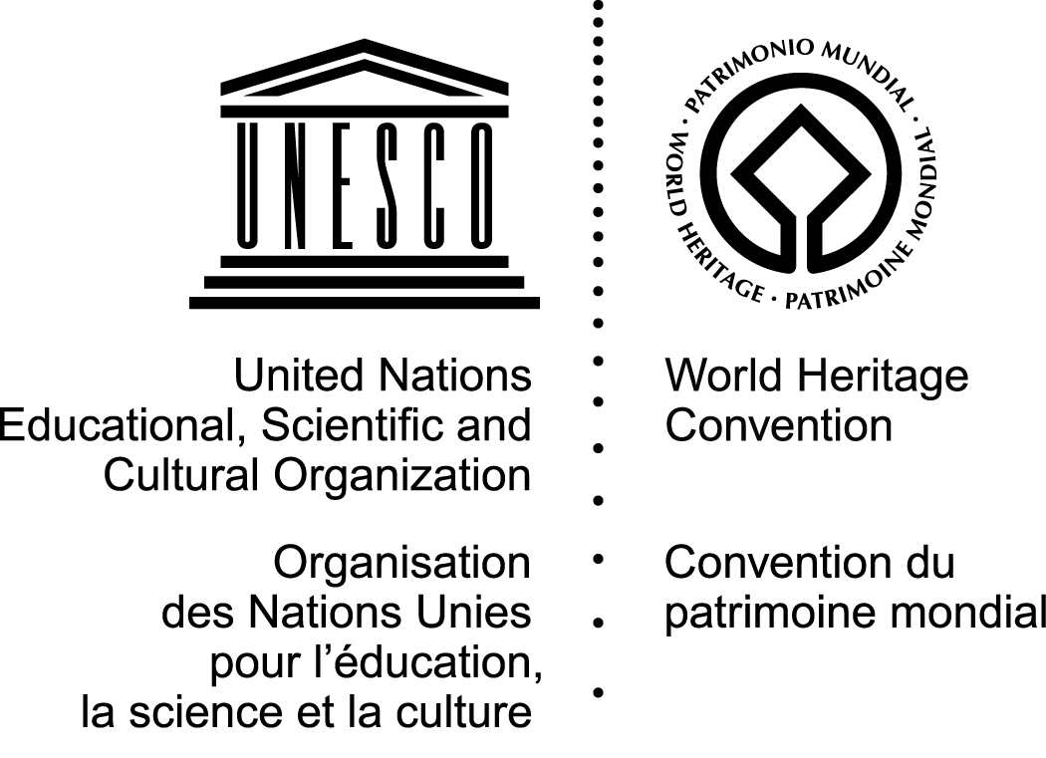
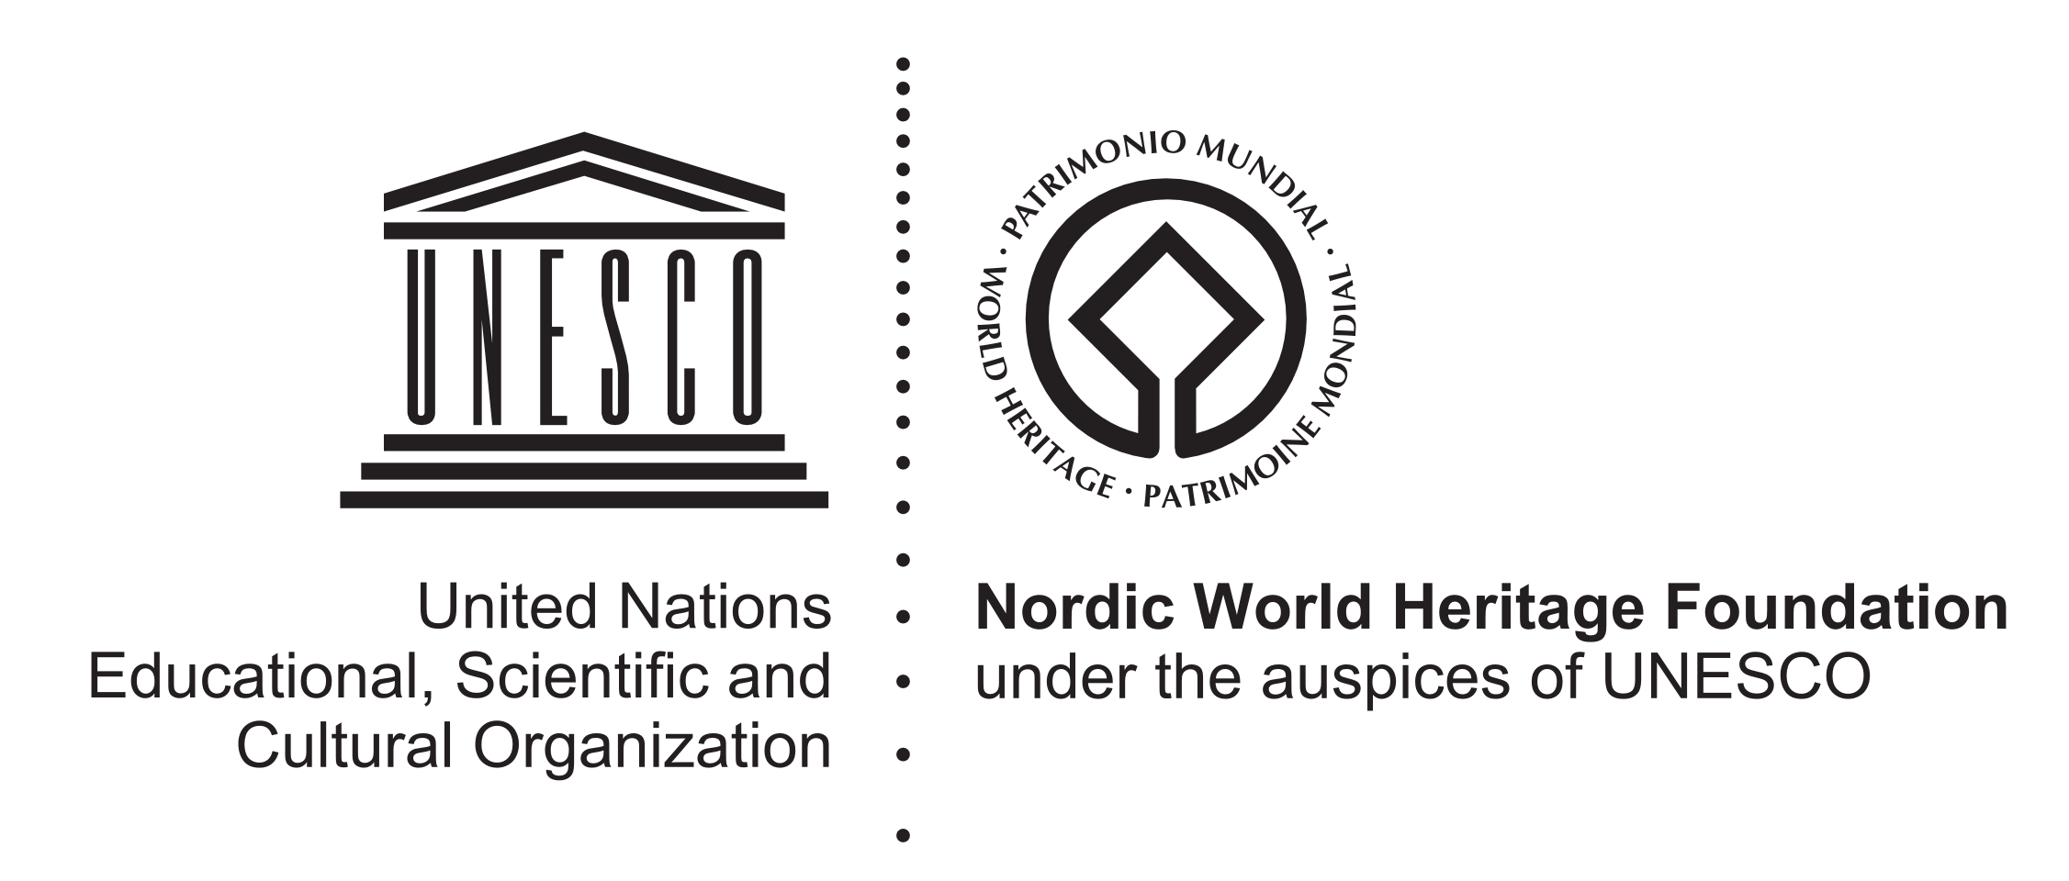

3rd African Ministers Roundtable on World Heritage in Africa
on the occasion of the 38th session of the World Heritage Committee
21 June 2014, Doha, Qatar

1:15 p.m. – 3 p.m.
QNCC - Auditorium 1

DRAFT AGENDA

1:15pm Light lunch available outside the auditorium
1:45pm Welcoming remarks by the UNESCO Director-General, Ms. Irina Bokova
1:55pm Interventions by various Ministers responsible for World Heritage in Africa
2:55pm Closing remarks by the Director of the African World Heritage Fund, Mr. Webber Ndoro
3pm End of event

