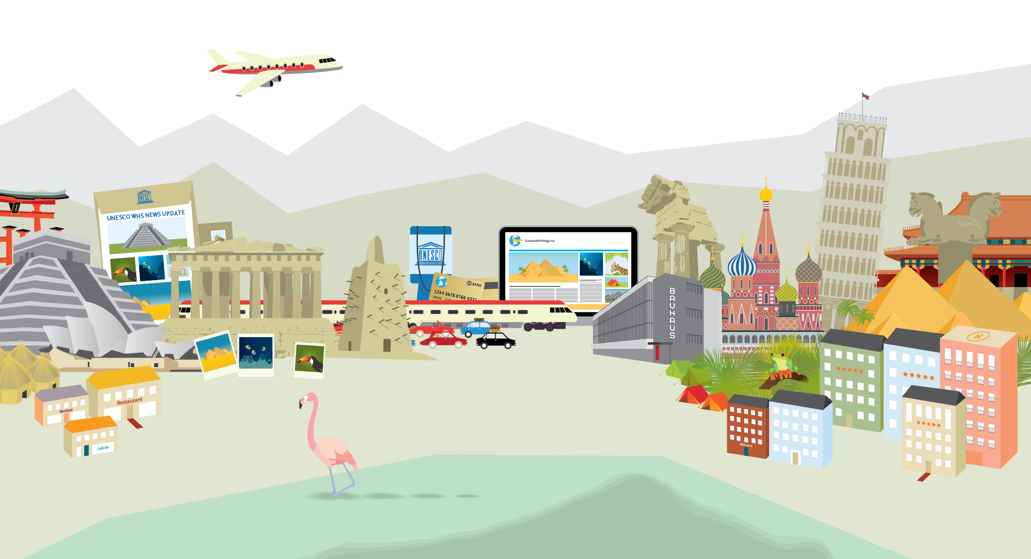
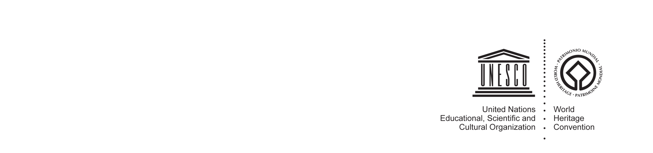
UNESCO/Zhongkun Group Workshop

STRENGHTENING SOUTH-SOUTH COLLABORATION
ON WORLD HERITAGE AND SUSTAINABLE TOURISM

Hongcun Village, Anhui Province, PRC
23 – 24 May 2014

World Heritage sites are unique treasures of humanity. These natural and cultural wonders have Outstanding Universal Value, represent our past and present, and belong to all. These sites are also important travel destinations with huge potential impact for local economic development and long-term sustainability.

With millions of tourists visiting World Heritage sites each year, tourism has become an important cross cutting issue and management concern at most World Heritage sites. However, many sites lack trained personnel and local communities and policy makers sometimes lack the experience necessary to use tourism as a tool to contribute to biodiversity and cultural diversity conservation.

This international workshop will focus on the power of tourism for local economic development and the conservation of heritage values through international cooperation.

It is expected that the outcomes emanating from this meeting will be of value to participating countries aiming to develop sustainable tourism potentials at World Heritage properties.

AIM OF THE WORKSHOP:

- Showcase and share international good practice approaches and other capacity-building tools to promote, recognize and incentivize sustainable tourism practices and products at and around World Heritage sites with a special focus on China and Africa.

- Explore new ideas and trends in terms of visitation, connectivity, and interpretation.

- Encourage World Heritage stakeholders to consider the benefits & impact of new technologies and travel and visitor trends could have for their own sites and allow them to investigate those further.

- Identify priority areas of intervention in order to address unsustainable trends in tourism development.

- Identify potential areas for international cooperation and partnerships.

AGENDA

OPENING SESSION: INTRODUCTORY OVERVIEW AND KEYNOTE PRESENTATIONS
- Challenges and opportunities for sustainable tourism at World Heritage sites
- South-South cooperation - a vehicle for cross-cultural dialogue and peace

SESSION 1: MARKETING, PROMOTION AND INTERPRETATION OF WORLD HERITAGE FOR TOURISM
- Marketing World Heritage as a destination
- Interpreting and communicating the Outstanding Universal Value
- Role of innovative technology in marketing promotion and interpretation

SESSION 2: CAPACITY BUILDING TOOLS AND STRATEGIES FOR SUSTAINABLE TOURISM PLANNING AND MANAGEMENT TO INCREASE SOCIO-ECONOMIC BENEFITS AND SUSTAINABLE DEVELOPMENT OPPORTUNITIES
- Local community empowerment: strategies and linkages
- Conservation management and tourism management integration

- Stakeholder engagement and destination planning
- Visitor management strategies: models and trends
- Methods and models for assessing socio-economic benefits of tourism
- Introduction to the UNESCO How To guides for World Heritage site managers

SESSION 3: PARTNERSHIPS FOR INTERNATIONAL COOPERATION
- Mentoring and exchange mechanisms
- Regional and transboundary cooperation in sustainable tourism at World Heritage sites
- Effective multi-stakeholder cooperation and partnerships

CLOSING SESSION: CONCLUSIONS AND RECOMMENDATIONS FOR FUTURE COLLABORATION
TECHNICAL VISIT TO HONGCUN VILLAGE
- Unveiling of UNESCO/Zhongkun Group “South-South capacity building training facility on World Heritage and Sustainable Tourism”

