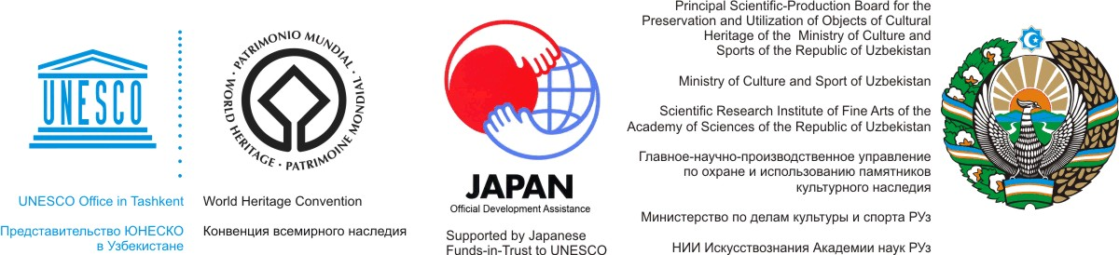

SUB-REGIONAL CLOSING MEETING of the UNESCO/JAPAN FUNDS-IN-TRUST PROJECT
“SUPPORT FOR DOCUMENTATION STANDARDS AND PROCEDURES OF THE SILK ROADS WORLD HERITAGE SERIAL TRANSNATIONAL NOMINATION IN CENTRAL ASIA”
Tashkent, Uzbekistan
4 - 5 December 2013
Within the framework of the UNESCO/Japanese Funds-in-Trust project ‘Support for documentation standards and procedures of the Silk Roads World Heritage serial and transnational nomination in Central Asia’, the final meeting will be held in Tashkent, Uzbekistan on 4 - 5 December 2013. Organized by the World Heritage Centre and the UNESCO Office in Tashkent in close cooperation with the Principal Department for the Preservation and Utilization of Cultural Objects of the Ministry of Culture and Sports of Uzbekistan and the Institute of Fine Arts of the Academy of Sciences of Uzbekistan, this meeting will present/review the documentation procedures, cooperative approaches, and World Heritage nomination initiatives that have been undertaken by the States Parties in the region for the Silk Roads heritage corridors within their territories, evaluate the progress of current national and interstate/international developments relevant to the nomination and conservation processes for the proposed sites within the heritage corridors, and determine the best ways for all the concerned parties to move all ongoing and future initiatives forward as the current phase of the project comes to a close and in view of its next phase.

P R O V I S I O N A L P R O G R A M M E

4 December 2013 (Wednesday)
Morning

Welcoming remarks by:
- Head of the Board of Monuments under the Ministry of Culture and Sport of the Republic of Uzbekistan
- Representative from the Embassy of Japan in Uzbekistan
- Mr. Karomatullo Olimov, Vice- President, Academy of Sciences of the Republic of Tajikistan
- Meeting objectives by Mr Roland Lin, UNESCO World Heritage Centre
- Group photo
09:30 – 10:25 Opening session
Chairpersons: Mr. Abdusafikhon Rakhmanov (Board of Monuments, Uzbekistan) and, Co-chair Silk Roads Coordination Committee
10:25 – 10:45 Coffee/tea break

10:45 – 12:30 Session I Review Results of Japan FIT Central Asia Silk Roads project
Chairpersons: Mr Roland Lin, UNESCO World Heritage Centre and the Republic of Kazakhstan

- Presentation of Mr. Kazuya Yamauchi, NRICP Tokyo, Japan (20 min)
- Presentation of Prof. Tim Williams, UCL, UK (20 min)
- Presentation of Prof. Karl Baipakov on behalf of Central Asian experts (20 min)
- Discussion (45 min)

12:30 – 14:00 Lunch break

Afternoon

14:00 – 15:30 Session II States Parties Presentations: Review of national activities and assessment of results
Chairpersons: Mrs. Ona Vileikis, RLICC, Belgium and the Republic of Turkmenistan

- Presentation of Kazakhstan (30 min)
- Discussion (15 min)
- Presentation of Kyrgyzstan (30 min)
- Discussion (15 min)

15:30 – 16:00 Coffee/tea break

16:00 – 17:30 Session III States Parties Presentation (continued): Review of national activities and assessment of results
Chairpersons: Mr. Dmitriy Voyakin, Regional Facilitator, Kazakhstan and the Kyrgyz Republic

- Presentation of China (30 min)
- Discussion (15 min)
- Presentation of Tajikistan (30 min)
- Discussion (15 min)

5 December 2013 (Thursday)
Morning

09:00 – 10:30 Session IV States Parties Presentation (continued): Review of national activities and assessment of results
Chairpersons: IICC Xi’an and the Republic of Tajikistan

- Presentation of Uzbekistan(30 min)
- Discussion (15 min)
- Presentation of Turkmenistan (30 min)
- Discussion (15 min)

10:30 – 11:00 Coffee/tea break

11:00 – 12:30 Session V Two Submitted Nominations Presentation
Chairpersons: Prof. Tim Williams, UCL, UK and the People’s Republic of China

- “Silk Roads: Initial Section of the Silk Roads, the Routes network of Tian-shan
Corridor,” jointly prepared by China, Kazakhstan, and Kyrgyzstan (20 min)
- Discussion (10 min)
- “Silk Roads: Penjikent-Samarkand-Poykent Corridor,” jointly prepared by Tajikistan
and Uzbekistan (20 min)
- Discussion (10 min)

12:30 – 14:00 Lunch break

Afternoon

14:00 – 15:00 Session VI International Supporting Presentation
Chairpersons: Mr. Sanjarbek Allayarov, UNESCO Tashkent office, and the Republic of Uzbekistan

- Presentation of IICC Xi’an (20 min)
- Discussion (10 min)
- Presentation of Ona Vileikis, RLICC, Belgium (20 min)
- Discussion (10 min)
15:00 – 15:30 Coffee/tea break
15:30 – 17:00 Session VII The Way Forward : Potential issues and needs assessment for next phase
Chairpersons: Mr. Yamauchi, NRICP Tokyo, and Yuri Peshkov, UNESCO Almaty office

- Goal orientation for the next phase, presentation by Mr. Roland Lin, UNESCO World Heritage Centre (20 min)
- Discussion about the issues and needs for the next phase (20 min)
- Activities’ assessment for the next phase (20 min)
- Discussion and approval of the plan of action for the next phase (30 min)

17:00 – 17:30 Closing Session Closing Remarks
Chairpersons: Mr. Abdusafikhon Rakhmanov (Board of Monuments, Uzbekistan), Co-chair Silk Roads Coordination Committee

- Closing speech by Japan representative
- Closing speech by Uzbekistan representative
- Closing remarks by UNESCO representative

- End of Meeting –

