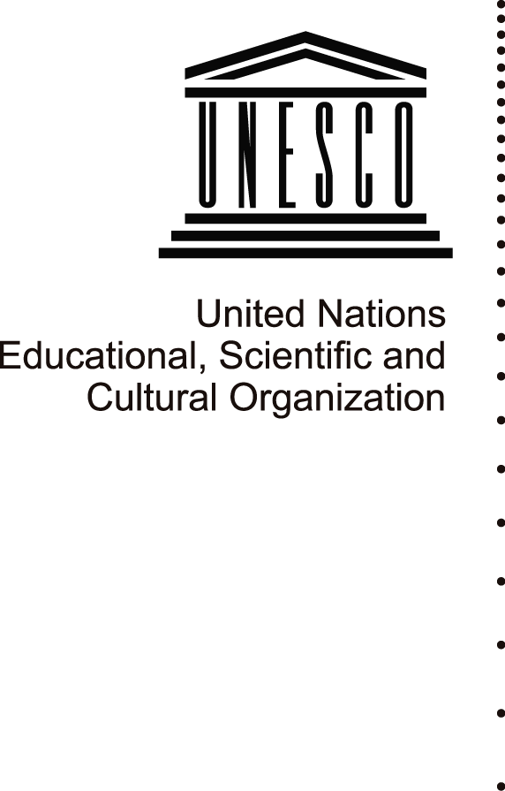15 July 2013

**FACT SHEET**

**Safeguarding Mali’s cultural heritage**

1. Since May 2012, cultural heritage and expressions in Northern Mali, notably in Timbuktu and Gao, have been the subject of repeated attacks and suffered heavy damages **14 of the 16 mausoleums of the property of Timbuktu were destroyed** including 2 of the Djingareyber Mosque, the largest mosque in the city, and the El Farouk monument. The Tomb of Askia is also at high risk for lack of maintenance during the occupation of Gao by the armed groups. **4203 manuscripts have been burned** and concerns remain regarding high risks of physical deterioration and illicit trafficking of some 300,000 estimated manuscripts ex-filtrated from Timbuktu to Bamako. Community members have been repeatedly prevented from using the mausoleums or from observing important cultural expressions.
2. On 28 June 2012, Timbuktu and the Tomb of Askia were inscribed on the **List of World Heritage in Danger** at the 36th session of the World Heritage Committee in order to mobilize the international community to help Mali in its efforts to safeguard these sites and to prevent illicit trafficking of cultural property.
3. The adoption of resolutions 2056, 2071, 2085 and 2100 by the **UN Security Council** strongly condemn the destruction of cultural and religious sites and urge all parties to take appropriate measures to ensure the protection of the World Heritage properties in Mali. Resolution 2100 established MINUSMA, and includes “support for cultural preservation” in its mandate, specifying that this is to be done in collaboration with UNESCO.
4. In the framework of humanitarian international law, Mali has acceded to the 1999 Second Protocol to the **1954 Convention Protection of Cultural Property in the Event of Armed Conflict** on 15 November 2012. This accession allows Mali to benefit from international mechanisms for the protection of its cultural heritage.
5. UNESCO established a **Special Fund to support Mali** in safeguarding its cultural heritage affected by the armed conflict. UNESCO Director-General also allocated seed-funding for immediate actions in support to Mali’s efforts, notably to develop and distribute **maps and “heritage passports”** with the geographical coordinates of the cultural properties, libraries and museums in the northern region as well as relevant information on intangible cultural heritage to facilitate their protection during military operations, and to initiate activities of inventorying, documentation and safeguarding of cultural objects.
6. UNESCO is cooperating with the **International Criminal Court (ICC)** with respect to the investigation into the situation in Mali undertaken by the Office of the Prosecutor, in conformity with Article 8(2)(e)(iv) of its Statutes which qualified as war crimes *“intentionally directing attacks against buildings dedicated to religion, education, art, science or charitable purposes, historic monuments, …”*.
7. In January 2013, upon request from the transitional national authorities in Mali, France led an international military coalition to intervene in Mali (MISMA).
8. **UNESCO Director-General visited Mali** together with French President François Hollande on 2 February 2013, and confirmed UNESCO’s commitment to do everything possible to safeguard and rebuild Mali’s extraordinary cultural heritage, which she described as *“a vital part of the country’s identity and history and fundamental for its future. Its restoration and reconstruction will give the people of Mali the strength and the confidence to rebuild national unity and look to the future.”*
9. An **international experts meeting on the safeguarding of Mali’s cultural heritage** was held at UNESCO Headquarters on 18 February 2013. Attended by over 200 participants including managers of cultural sites in Mali, ministers, experts, and representatives from UNESCO Member States and international technical organizations, the meeting resulted in the adoption of an Action Plan with 3 main objectives: rehabilitating cultural heritage with the active participation of local communities; putting in place measures to protect the ancient manuscripts; providing training in conservation and management.
10. UNESCO is actively searching funds for the implementation of the **Action Plan,** and participated in the International Conference for the Support and Development of Mali, which was co-chaired by the European Union and France on 15 May 2013 in Brussels, and aimed to determine priority actions and coordinate support for development in Mali in 2013-2014.
11. **A joint UNESCO-Mali Expert Mission** to evaluate the status of Mali’s cultural heritage and ancient manuscripts took place in Bamako and Timbuktu, 31 May to 8 June 2013. It resulted in a technical evaluation and determined priority actions for rehabilitation and conservation in cooperation with the Government of Mali.
12. **UNESCO is partnering with MINUSMA,** the United Nations Multidimensional Integrated Stabilization Mission in Mali (MINUSMA), to offer support for cultural preservation in Mali

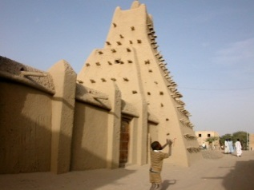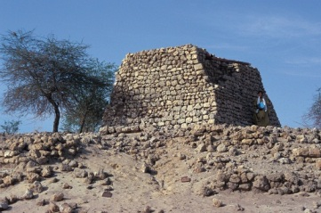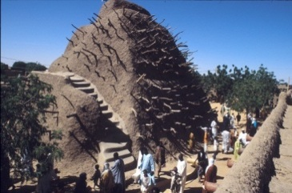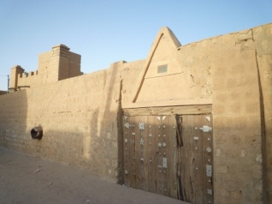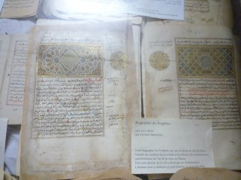

*Contact: Lazare Eloundou Assomo, Chief of Africa Unit, World Heritage Centre (l.eloundou-assomo@unesco.org)*