Aztec Ruins News Release

Aztec Ruins
National Monument
84 County Road 2900
Aztec, New Mexico 87410

505 334-6174 phone
505 334 6372 fax
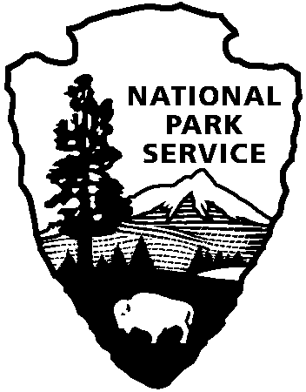
National Park Service
U.S. Department of the Interior

Release date:
Contact(s):
Phone number:
Date:
Release code:
Aztec Ruins Hosts UNESCO World Heritage Celebration

February days in most parks—Aztec Ruins included—are the slowest of the year. Front-line rangers count visitors on one hand. Friday, February 24, 2012 was a notable exception for Aztec Ruins National Monument, with 167 visitors turning out over the course of the day to join in a celebration of World Heritage. Superintendent Larry Turk was already pacing in front of the Visitor Center when the gates opened at 8:00am that day, wondering what kind of support the unique event would garner. The first visitors arrived minutes later.

In 1987 Aztec Ruins National Monument became a UNESCO World Heritage site as part of the Chaco Culture designation to recognize the uniqueness of the archeological sites protected in the park. Today there are still only twenty-one World Heritage sites in the United States, which puts the 394-acre Aztec Ruins in the elite company of Yellowstone, the Statue of Liberty, and the Everglades.

Throughout the years, the Monument has increased awareness of its auspicious designation, culminating in the celebration of the 25th anniversary of its inscription on February 24. Working with the NPS Office of International Affairs, the Monument hammered out the day’s activities for months. Even so, Harpers Ferry Center delivered a brand-new three-minute film on World Heritage just days before the event. Aztec Ruins was proud to be the first park to show it.

Immediate
Park Ranger Lauren Blacik or Superintendent Larry Turk
505 334-6174 ext.228
March 5, 2012
A8215

page 2
The park had commemorative coins made for the celebration so visitors got to take home a reminder of the day. Many families carefully studied the World Heritage symbol featured on one side and the detailed outline of West Ruin on the other.

All entrance fees were waived to encourage the community to join in the celebration. In addition to a large local showing, park employees from Canyon de Chelly, Navajo National Monument, Chaco Culture, and Mesa Verde attended. International students from the organization Up with People painted an eye-popping mural that welcomed visitors as they arrived.

The biggest surprise of the day was the number of Junior Rangers who came to earn a special badge. The Monument developed a World Heritage activity sheet for the event, and the kids tackled it with gusto, commenting on their wishes to visit Paris, the Pyramids, or the Statue of Liberty some day.
They promised to visit another World Heritage site during their Junior Ranger pledge. The Monument actually ran out of badges, awarding over 30 that day.

The highlight of the evening was guest speaker Jonathan Tourtellot, a National Geographic Fellow and the “grandfather” of geotourism. His gave an evening program entitled “World Heritage: A Made in America Achievement” to a full auditorium. He talked convincingly about the underrepresentation of the United States on the World Heritage List and explained how geotourism can benefit the park and the local economy.

Sites across the globe have a reason to celebrate this year. 2012 marks the 40th anniversary of the 1972 UNESCO Convention, the international treaty that created the World Heritage List. As Tourtellot explained, “The United States was the primary force behind creating this List in the first place.” Now almost every country in the world has signed the Convention and has a World Heritage site (or sites) to honor.

