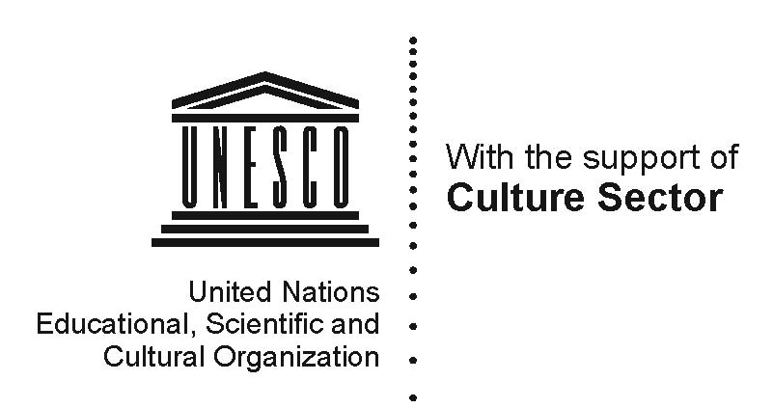

Symposium
Redefining Progress: Architecture for a New Humanism
May 24th 2011 | 17.00 – 20.00
UNESCO (Room XII), 7 Place de Fontenoy, Paris

At the start of the new millennium, the idea of a global village gained ground, thanks to the improvements brought about by the knowledge-society. New definitions of
progress and standards are constantly announced in contemporary architecture. But, can architecture be defined through cold demographic curves, energy rates and high-tech standards?
With countries and peoples in critical economic and political situations, architecture during the twentieth century moved towards defining progress through criteria with an existential, holistic and human dimension. Progress was placed at the service of civicity and the concept of sustainable architecture was introduced – in Europe, for example, via the social urban reforms of the early Moderns. In Africa and India, the works of Hassan Fathy and Laurie Baker highlighted sustainable architecture through cultural references to local societies.
This first UNESCO / LOCUS Symposium presents and discusses ways of redefining progress today, and ways of creating a sustainable architecture for a new humanism – an architecture in which, in the words of Ivan Illich, “ethical values replace technical ones, conviviality replaces productivity”. While UNESCO reveals the urban renewal programme which is currently starting up at Hassan Fathy’s housing settlement in New Gourna, LOCUS invites the five winners of its Global Award for Sustainable Architecture 2011 to present their work and philosophy.

“One’s designs must serve the humble everyday needs of men;
indeed, if these designs are true to their materials, their environment, and their daily job, they must necessarily be beautiful.”
Hassan Fathy, Architecture for the Poor, 1973
“My principle is to use locally-available material. This is not only economical, but the building would also look as though it belongs. Why abandon local materials that cope with terrain, climate and cultural patterns of living for expensive, unsuitable energy-intensive material - merely to look ‘international standard’?”
Laurie Baker, Of architectural truths and lies, 1999

Programme
17.00 Welcome by Francesco Bandarin, UNESCO Assistant Director-General of
Culture
17.10 Welcome by Jana Revedin, Prof. Arch. PhD, Umeå University, Sweden,
LOCUS Foundation President
17.20 Leila El Wakil, Arch. and Prof. Art History, University of Geneva, Switzerland
“Social progress and adequacy in the work of Hassan Fathy”
18.00 Hubert Guillaud, Prof. Arch. ENSAG Grenoble, CRAterre-ENSAG, France
“Building cultures and sustainable development”
18.45 “Redefining Progress: Architecture for a New Humanism”
- Roundtable discussion chaired by Francesco Bandarin and Jana Revedin,
together with John Hurd, B.Sc., President of the ICOMOS Scientific Commission for Earthen Architectural Heritage (ISCEAH)

- Statements of the five laureates of the “Global Award for Sustainable Architecture 2011”
- Shlomo and Barbara Aronson, Israël
- Sigrun Birgisdottir, Olga Gudrun Sigfusdottir, Iceland and Jörn Frenzel,
Germany/Iceland (Vatnavinir)
- Anna Heringer, Germany
- Teddy Cruz, USA
- Carmen Arróspide Poblete, Peru (Q’eswachaka Communidades de Huinchiri)

- Discussion
20.00 Cocktail

