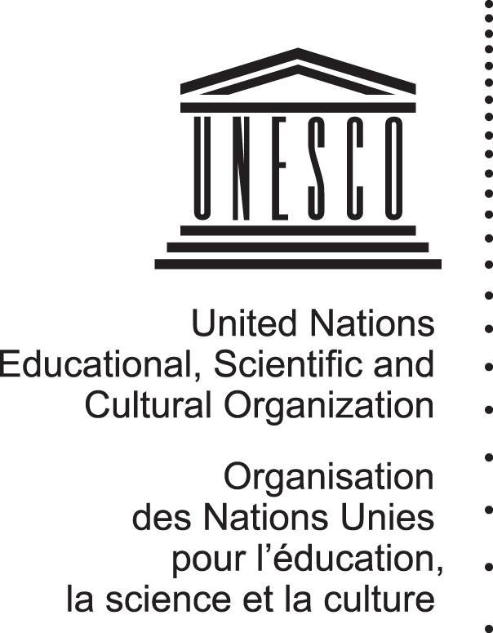
World Heritage 35 COM
Distribution Limited WHC-11/35.COM/INF.1
Paris, 8 April 2011

Original: English/French
UNITED NATIONS EDUCATIONAL, SCIENTIFIC
AND CULTURAL ORGANIZATION
CONVENTION CONCERNING THE PROTECTION OF THE WORLD CULTURAL AND NATURAL HERITAGE
WORLD HERITAGE COMMITTEE

Thirty-fifth session

Paris, UNESCO Headquarters
19 - 29 June 2011

GENERAL INFORMATION

Information on the 35th session is also available on the following Website:

http://whc.unesco.org/en/sessions/35COM

A registration form is contained in Annex A

A media accreditation form is contained in Annex B
PURPOSE

The World Heritage Committee comprises representatives from 21 States Parties to the Convention Concerning the Protection of the World Cultural and Natural Heritage elected by the General Assembly of States Parties to the Convention.

The current composition of the Committee is (see for more information at http://whc.unesco.org/en/comittee#members):

Australia, Bahrain, Barbados, Brazil, Cambodia, China, Egypt, Estonia, Ethiopia, France, Iraq, Jordan, Mali, Mexico, Nigeria, Russian Federation, South Africa, Sweden, Switzerland, Thailand, United Arab Emirates

The essential functions of the Committee are:

- to identify, on the basis of nominations submitted by States Parties, cultural and natural properties of Outstanding Universal Value which are to be protected under the Convention, and to inscribe those properties on the World Heritage List;
- to monitor the state of conservation of properties inscribed on the World Heritage List, in liaison with the States Parties; decide which properties included in the World Heritage List are to be inscribed on or removed from the List of World Heritage in Danger; decide whether a property may be deleted from the World Heritage List; and
- to examine requests for International Assistance from the World Heritage Fund.

SESSION

The 35th session of the World Heritage Committee will be held at UNESCO Headquarters in Paris from 19 to 29 June 2011 (entrance is at 7, place de Fontenoy or 125, avenue de Suffren (from 8am to 7pm). The Plenary meetings will be held in Room I located at the ground floor in the main UNESCO Headquarters building (Fontenoy) from 10am onwards, unless otherwise announced by the Chairperson. When deemed necessary, ad hoc sessional groups will meet in Rooms X, Xbis and/or IV and will be announced by the Chairperson and notified on a board outside Room I.

The official working languages of the World Heritage Committee are English and French. Simultaneous interpretation in these languages will be provided in plenary sessions. Thanks to the generous contributions of the Kingdom of Bahrain and the Kingdom of Spain, simultaneous interpretation of the debates will be also available in Arabic and in Spanish.

DOCUMENTATION

If Members of the Committee wish to obtain a copy of any document, they should request it from the documentation clerks in the meeting room. New documents, as they become available, will be distributed in the delegation pigeonholes inside Room I, or directly to Delegates in the meeting room, if so decided by the Chairperson. For all other participants, all documents will be made available electronically at the following address:

http://whc.unesco.org/en/sessions/35COM

DISTRIBUTION OF UNOFFICIAL DOCUMENTS

Any other documentation that Delegates might wish to have distributed should be referred to the World Heritage Centre or to the reception desk prior to distribution. It is regretted that no copying services can be provided by the Secretariat for such documentation.

CONTACTS

For all information regarding the session, please contact the World Heritage Centre:

Téléphone : + 33 1 45 68 18 76
+ 33 1 45 68 24 96
Fax : + 33 1 45 68 55 70

PARTICIPANTS AND REGISTRATION

Participants

The primary participants of the 35th session of the World Heritage Committee are the 21 members of the Committee.

States Parties to the World Heritage Convention that are not members of the Committee may send representatives to the session as observers.

Non-States Parties to the Convention that are Member States of UNESCO, or of the United Nations, may also be permitted by the Committee, upon written request, to attend the sessions of the Committee as observers.

Representatives of the International Centre for the Study of the Preservation and Restoration of Cultural Property (ICCROM), the International Council on Monuments and Sites (ICOMOS), and the International Union for Conservation of Nature (IUCN) will attend to the sessions of the Committee in an advisory capacity.

The United Nations and bodies of the United Nations system, as well as other international governmental and non-governmental organizations, permanent observer missions to UNESCO and non-profit institutions having activities in the fields covered by the Convention, may upon written request, be authorized to participate in the sessions of the Committee as observers.

Registration

All delegates and those who wish to attend the 35th session as observers are strongly advised to register as soon as possible. This will provide the session organizers with sufficient time to process information and prevent any inconvenience to participants. Please register online on the meeting’s website at:

http://whc.unesco.org/en/sessions/35COM

If you require any assistance or encounter any problems with the online registration, please send an e-mail to:

wh-committee@unesco.org

Please note that all participants to the 35th session (delegates and observers) must be accredited and approved by the UNESCO World Heritage Centre. Registration will therefore take place in two steps. First, the registration form must be completed and submitted for validation online by all those who wish to attend the 35th session. Once accreditation or approval has been given by the organizers, applicants will be notified of the confirmation of their registration.

Registration Desk to the meeting

The Registration Desk will be located in the Hall des Pas Perdus in front of Room I from 19 June morning onwards. All the participants should register before the session of the World Heritage Committee. For the participants who are planning to come after the opening of the Committee, the Registration Desk will be open every morning from 8am onwards.

Badges
Upon registration, an Identification badge will be delivered. We advise that the participants to register as soon as they arrive to allow for sufficient time for the badges to be printed.
The ID badges are not transferable. For security purposes, the badge is required to gain entry to UNESCO and must be visibly worn at all times.

SERVICES

Desktop PCs and Emails

Desktop PCs will be available for Delegates.

Telephone Calls

Local (and within-house calls) may be made by participants themselves from the telephone booths outside Room I. All call within France are dialled as 10 digits. Numbers in Paris begin with 01. For long distance calls, telephone cards may be purchased from the Magazine Kiosque at the entrance of Fontenoy Building.

Coffee/Tea

Coffee and tea will be served daily at approximately 11.30am and 4.30pm.

Cafeteria/ Restaurant (Fontenoy Building)

Restaurant 7th floor. For reservations: Tel. ext.: 81600
Conference Bar Basement level (open from 8.30am to 4pm, lunch from noon to 2.30pm (Tel. ext.: 80307)
Snack-Cafeteria 7th floor. Lunch from 11.45am to 2:30am (Tel. ext.: 81605)
Bar 7th floor. Open from 8.30am to 6pm

Medical Service

A medical service and a nursery are located on the 2nd floor of the Fontenoy Building.

Bank

The Société Générale has a branch on the left of the reception desk at the main entrance, ground floor. Opening hours:
Ordinary banking: Monday to Friday from 9.30am to 12.15pm and 1.15pm to
5.15pm
Exchange operations: Monday to Friday from 9.30am to 12pm and 1.15am to
5pm

This branch also provides a cash point/ATM.

Hotel and Public Transportation

For information on hotels, please refer to: www.parisinfo.com

For information on public transportation, please refer to: www.ratp.fr

Taxis

A taxi can be called at the following numbers: 01 45 66 00 00, 01 49 36 10 10 or 01 47 34 00 00. Indicate the address of the building and the UNESCO telephone number: 01 45 68 10 00.

Airports

For information on flights, you can call directly Orly Airport: 01 49 75 15 15 or Roissy - Charles de Gaulle Airport: 01 48 62 22 80

media

Accreditation

Accreditation is mandatory for media representatives who wish to cover the 35th session of the World Heritage Committee. To become accredited, please apply using the online application form on the meeting website at:

http://whc.unesco.org/en/sessions/35COM

A copy of the application form can be found in Appendix B.

In case of difficulties to register online, please contact:

Lucia Iglesias : +33 1 4568 1702
Email: l.iglesias@unesco.org

Isabelle Le Fournis : +33 1 4568 1748
Email: i.le-fournis@unesco.org

Carole Darmouni : +33 1 4568 1738
Email: c.darmouni@unesco.org

Media Centre

A Media Centre will be provided as a work space for the media to cover the 35th session of the World Heritage Committee. The media centre will be equipped with work stations with Internet access.

Press Conference Room

All the press conferences will take place in a specially designated area dedicated to this purpose to which access will be restricted to only appointed and accredited media.

Materials for the press

Press releases, photos and videos will be available on the web page dedicated to press at the following address: www.unesco.org

Access of the media to the 35th session

Please note that rules of procedures do not allow the presence of the press in the meeting room when the Committee of UNESCO is in session. Only the opening ceremony is open to the press.

FURTHER INFORMATION
For further information on the World Heritage Committee and the World Heritage Convention, please consult the following website of the World Heritage Centre:
http://whc.unesco.org

APPENDIX A – Registration Form

This form is available online at the following address:
http://whc.unesco.org/en/sessions/35COM

You are kindly requested to complete your registration online.

If you require any assistance or encounter any problems with the online registration, please email the session organizers at the following address:
wh-committee@unesco.org

This form is only an information document regarding the details required for the online registration.

35th Session of the World Heritage Committee
Paris, UNESCO Headquarters
19 - 29 June 2011

1 – Registration Form

CATEGORY: | □ Committee member  □ Head of Delegation □ Other  Please specify the head of your delegation:  ______________________________________________  □ Observer of a State Party not member of the Committee  □ Head of Delegation □ Other  Position: ______________________________________________  □ Member of one of the following Advisory Bodies  □ ICCROM □ ICOMOS □ IUCN  □ Observer of a Non-State Party to the World Heritage Convention  Position: ______________________________________________  □ Observer of an entity maintaining a Permanent Observer Mission to UNESCO  Position: ______________________________________________  □ Observer of an NGO/IGO invited by the Director-General of UNESCO  Position: ______________________________________________  □ Observer of an NGO/IGO invited by the Director of the World Heritage Centre  Position: ______________________________________________  □ Individual Observer  Position: ______________________________________________  □ UNESCO/Paris  Position: ______________________________________________
SURNAME/FAMILY NAME: | ______________________________________________  (write your name exactly as it appears on your passport)
FIRST NAME(S): | ______________________________________________
MR / MS / MRS: | ______________________________________________
Please indicate how YOU would like it to appear on your ID badge: | ______________________________________________  ______________________________________________
INSTITUTION/  ORGANIZATION: | ______________________________________________  (write the full name of your institution)
POSITION: | □ Minister  □ Deputy-Minister  □ Other: ______________________________________  (please tick the appropriate box. If you choose "Other", please specify your position)
ADDRESS: | ______________________________________  ___________________________________________
ZIP CODE: | ____________________
CITY: | ______________________________________________
COUNTRY: | ______________________________________________
WORK PHONE NO: | ___________________________________  (country code + area code + phone number)
CELL PHONE NO: | ___________________________________  (country code + area code + phone number)
FAX: | ___________________________________  (country code + area code + phone number)
E-MAIL: | ______________________________________________
EMERGENCY PHONE: | ___________________________________  (country code + area code + phone number)
EMERGENCY CONTACT PERSON: | ______________________________________________

2 – Preferred Language for the 35th session of the World Heritage Committee

□ English
□ French

3 – Future Communication

BY: | □ E-mail  □ Fax  □ Mail  □ Phone

Privacy Statement

All information you will provide on this registration form will be encrypted and will be collected for the purpose of enabling session organizers to register you as a participant to the 35th Session of the World Heritage Committee. It will also help other agencies to facilitate your entry into the country. This information will be safeguarded for your protection.

APPENDIX B – MEDIA ACCREDITATION APPLICATION FORM

This form is only an information document regarding the details required for the online registration.

If you require any assistance or encounter any problems with the online registration, please contact:

Lucia Iglesias: +33 1 4568 1702
Email: l.iglesias@unesco.org

Isabelle Le Fournis +33 1 4568 1748
Email: i.le-fournis@unesco.org

Carole Darmouni ; +33 1 4568 1738
Email: c.darmouni@unesco.org

You are kindly requested to complete your registration online.

Personal Information

First Name(s):
______________________________________________________________________
Last / Family Name:
______________________________________________________________________
Title (Mr, Mrs, Ms, Dr, Hon, President, Prof.):
______________________________________________________________________
Address:
______________________________________________________________________
City / Town:
______________________________________________________________________
Province / State:
______________________________________________________________________
Postal Code / Zip Code:
______________________________________________________________________
Country:
______________________________________________________________________
Office Telephone:
______________________________________________________________________
Office Facsimile:
______________________________________________________________________
Mobile Telephone:
______________________________________________________________________
E-mail Address:
______________________________________________________________________
Name of the media organization you represent:
______________________________________________________________________
In which of the following media do you work?
Print - Please specify:
_________________________________________________
Radio - Please specify:
________________________________________________
Television - Please specify:
____________________________________________
Other - Please specify:
________________________________________________
Please indicate the dates you will require access to the media centre from 19 to 29 June 2011:
______________________________________________________________________

