
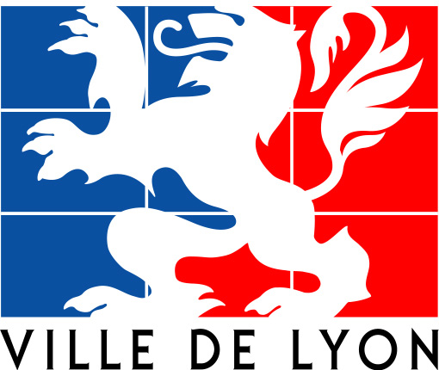


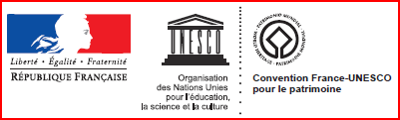
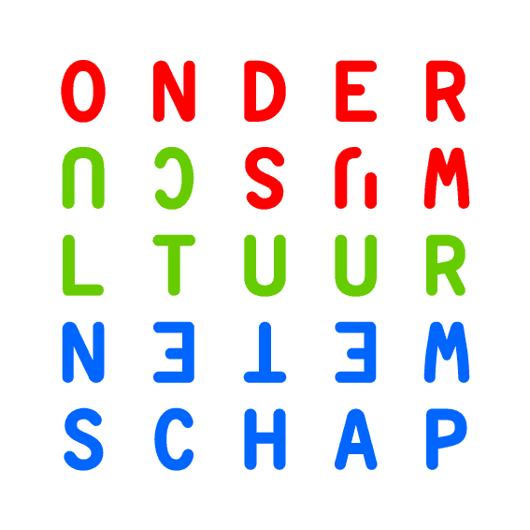
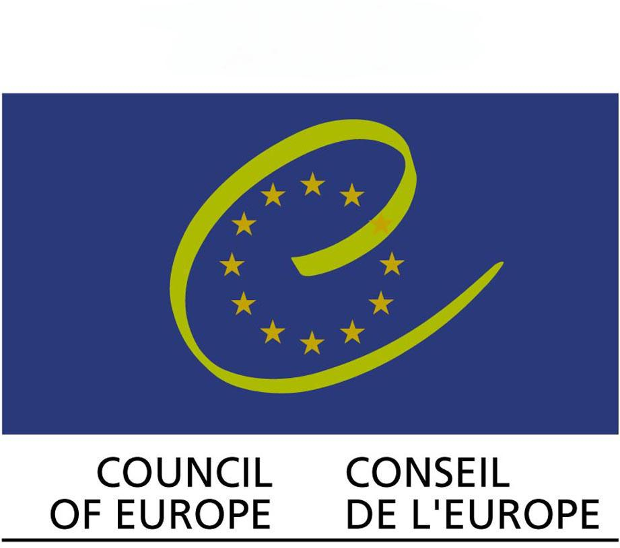
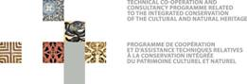



“Historic Cities in Development: Keys for Understanding and Action”
A Compilation of Case Studies
on the Conservation and Management of Historic Cities

The Organization of World Heritage Cities (OWHC) is implementing a project on the collection of case studies on conservation and management in historic cities called “Historic Cities in Development: Keys for Understanding and Acting”.
Each Member City has been invited to contribute by presenting one (or several) urban project(s) so as to understand in detail and describe in a hands-on manner the necessary processes and procedures and, by doing so, instigate a new shared understanding and respect with the respect for heritage, and in particular World Heritage, as part of urban development projects.
The project goes beyond the exchange of know-how in conservation – it aims at introducing a more heritage-centered urban development approach. It aims to create a dynamic within the network of the OWHC’s member cities and thus contribute to the global debate on urban heritage management.
Its results will be presented during the next OWHC World Congress to be held in Sintra (Portugal) in November 2011, with a view to making a contribution to the 40th anniversary of the World Heritage Convention in 2012 and ensuring a large-scale dissemination the details of which remain to be defined (internet, printed publication, workshop).

The City of (in ) represented by its Mayor
proposes a contribution entitled
on the theme

Responsible Officer
Name
Assignment
Address
Tel
Email

To Fill in the questionnaire

- Save the document on your computer
- Reply to the questions by filling in the boxes highlighted in grey.
Depending on each case, you can reply to the questions by:
- drafting a text: the grey boxes are extensible so that you can insert as much text as you wish in order to give a comprehensive reply,
- clicking on the grey box to indicate your choice,
- adding a number to the grey box when you are asked to indicate the hierarchy.

For any questions or clarifications, please contact Ms Kerstin Manz: kmanz@ovpm.org

This questionnaire has been prepared
by the Lyon Town Planning Agency
and Kerstin Manz, geographer - urban planner,
based on the guidance by the Steering Committee.
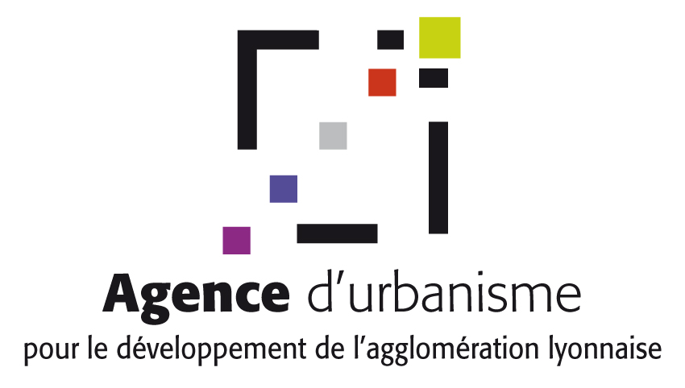

Part 1
identification DATA
ANd General context

  - the city
    - IDENTIFICATION
City Name:
Country:
Number of Inhabitants:
Surface:
Web Address:

    - POLITICAL AUTHORITY : MAYOR
Name and Surname:
Dates and duration of mandate(s):

    - RESPONSIBLE OFFICER
Name and Surname:
Role/Assignment:
Address:
Telephone:
E-Mail:

    - SELECTED HISTORICAL AND GEOGRAPHICAL REFERENCES

Significant historical features
Please briefly indicate some selected dates e.g. by chronological table. Documents can be attached as annexes.

Significant geographical features
Example: Location at river junction, mountain town, seaside town, etc.
Please attach a map indicating the situation of the key geographical features

Main contemporary functions of the City
Example: Administrative centre, National capital, Regional capital, etc.

Main contemporary functions of the City in economic terms
Example: Business city, Harbor activities, Military town, etc.

    - COMMENTS/ specific details on the city’s identification

  - the property inscribed on the world heritage list
    - IDENTIFICATION of the property inscribed on the world heritage list (see : whc.unesco.org/EN/list/)
Name of the Property:
Year of Inscription:
Criteria of Inscription: i ii iii iv v vi
Statement of Outstanding Universal Value / Statement of Significance (as adopted by the World Heritage Committee in its Decision of inscription):

- What category does the Property belong to?
Monument
Group of buildings
Site (neighbourhood)
Cultural Landscape
Area of the Property:
- Area of the inscribed Property:
- Area of the buffer-zone(s):
Location of the Property (inscribed Property and its buffer-zone) within the City
Please attach detailed cartographical document(s)
Function and articulation of the Property within the City
Please address this question according to the following 4 points:

- What are the major functions of the Property in the urban context
Please indicate your choice of priorities by numbers
Administrative function
Residential area
Central Business District (company headquarters)
Retail and/or handicrafts
Touristic and leisure activities
Cultural functions (cultural infrastructure)
Transport hub
Public space
Place of worship and / or pilgrimage
No longer in function/use
Other:

- How is the Property linked to the rest of the City from a spatial point of view?
Example: Centrally located monument, isolated monument, centrally located historic core, integrated neighborhood within urban fabric, spatially isolated neighborhood (by river, ring-road, etc)

- How is the Property linked to the rest of the City from a social point of view?
Example: Religious monument, public space, residential area ; gentrification / pauperisation, mixité etc.

Example: Ensure transition from centre to periphery regulations, host public transport infrastructure, etc.
- Does the Buffer-Zone play a specific role in linking the Property and the entire City? If yes, how?

    - Management of the property
Management Structure of the Property
Is there a specific site-managing entity for the Property? YES NO
If yes:
- Name of the entity:
- Municipal Department it reports to:

Which are the relevant document(s) for the management of the Property?
What are the management mechanisms and documents for planning and implementation affecting the management of the Property?
You have the possibility to attach a synthetic document in electronic format (pdf)
- Title and type of document(s) at the Property level:
Example: World Heritage Management Plan, Preservation Plan, etc.

- Title and type of document(s) at the City’s level:
Example: Urban Development Plan, Local Development Strategy, Thematic Plans (green spaces, illumination, etc)

- Other (please specify):

Role of the Management of Property for the entire City
Example: Creation of pedestrian areas; creation of artisans’ workshops
- Does the Property play a key role as a catalyst in the implementation of and / or innovating urban development trends or urban political decision-making?
No
Yes. Please specify:

- Does the Property play a specific role in the implementation of Sustainable Development Policies?
Example: Awareness-raising measures; rehabilitation of green spaces

No
Yes. Please indicate the goals in social, economic, environmental terms:

- Please specify in case you have encountered any difficulties when implementing the management objectives for the Property in the urban context.
Example: Increase of land / real estate values, speculation; increased tourism flows

    - COMMENTS on the above identification of the World Heritage Property

    - OPERATIONAL FRAMEWORK OF THE CITY AND division OF cOMPETENCES
Organizational structure of the implementing bodies
Please briefly describe the organizational structure of the implementing bodies of the City.
You can also attach supplementary documents, such as an organizational chart of the Municipal Departments

How are the urban and cultural competences divided that apply to the territory?
Please tick the cases to indicate the division of roles for each level of competence.

Basic Urban Services
- Distribution of drinking water / sewage
Local Regional National
- Waste collection and treatment
Local Regional National
- Creation of public transport infrastructure
Local Regional National
- Management of bus stations
Local Regional National
- Creation of road system
Local Regional National
- Management of road system
Local Regional National
- Management of traffic flows
Local Regional National
- Public lighting system
Local Regional National

Land-Use
- Land reserve strategies
Local Regional National
Economy
- Management of markets
Local Regional National
- Subsidies for the creation and maintenance of shops and businesses
Local Regional National
- Subsidies for the creation and maintenance of handicraft businesses/workshops
Local Regional National
- Creation of industrial areas/business parks
Local Regional National
- Research & development (centres of excellence, technology parks etc.)
Local Regional National

Urban Development Planning
- Preparation of master plan(s) / urban development strategies
Local Regional National
- Preparation of building plan(s)
Local Regional National
- Management of land-use rights (decision on construction / demolition permits)
Locale Regional National
Urban Development Planning (cont’d)
- Preparation of thematic planning documents or programmes
Local Regional National
- Housing (creation of residential areas)
Local Regional National
- Social housing
Local Regional National
- Public space (creation and management)
Local Regional National
- Green spaces (creation and management)
Local Regional National
- Urban ecology (e.g. City Department handling all Sustainable Development-related policy issues)
Local Regional National
- Large infrastructure and facilities
Local Regional National
Culture and Heritage
- Creation of heritage protection tools
Local Regional National
- Management of national protection instruments
Local Regional National
- Promotion and enhancement of heritage
Local Regional National
- Preventive archaeological investigation
Local Regional National
- Restoration measures
Local Regional National
- Promotion of traditional festive events
Local Regional National

Part 2
Presentation of Case study project

  - Description of the project (where, when, why)
    - Which project?
Title of the Project
Please present a project that has been implemented after the inscription of the Property on the World Heritage List

Location in relation to the City and the inscribed Property
Please name the project area(s) and indicate it/them on a map within the City and in relation to the inscribed Property

Nature of the Project
Please tick the cases below (multiple choice possible)
- Urban Management
Housing
Mobility / transport / access / parking / traffic plans
Urban restructuring
Improvement of public spaces (e.g. Illumination Scheme)
Water / Sewage / Waste management
Electricity / Communication networks
Energy management
Other:
- Intervention in built fabric
Rehabilitation after emergency situations (natural disasters etc.)
Restoration of monuments
Conversion of buildings and historic fabric
Insertion of contemporary architecture
Environmental protection and adaptation measures (energy-saving tools etc.)
Other:
- Spatial Planning
Rehabilitation / creation of public space(s)
Rehabilitation / creation of green space(s)
Other measures based on a Sustainable Development Strategy of the city
Other:
- Economy, Commerce, Tourism
Commerce / retail
Handicrafts
Tourism promotion
Other:
- Culture and Heritage
Intangible heritage: knowledge, practices, skills
Intangible heritage: traditional festive events, languages, rituals etc.
Performing arts / festivals
Other:
- Knowledge and Communication
Research and studies
Awareness-raising for heritage
Other:
Is the project included in the property’s Management Plan ?
No
Yes
If yes, please specify in chapter 1.2.2
Steps and Progress of the Project (launching, main phases, finalization)
Please choose a project that has been implemented after inscription of the Property on the World Heritage List

Please attach photos illustrating before and after project implementation

    - Why implement this project?
What is at stake: Which specific urban problem does the project address?

Operational targets
Example:
- Maintain residential functions in the area
- Increase the percentage of green space per capita
- Reinforce the public transport network
Please briefly point out the main objectives (Are they quantified/quantifiable?)

Proposed strategy
Example:
- Creation of tax incentives for environmental measures
- Creation of bus lanes for transport public, of tramway lines
Please briefly outline the main operational steps chosen to address the identified problem

  - Implementation Process (who, how, which tools?)
    - The Initiators (urban Project ownership)
Initiator(s) of the project
Please specify which administrative level initiated the project. In case of multiple initiators, please indicate the hierarchy (1, 2, 3…).
Public local level
Public regional level
Public national level
International institution. Specify which:
Private entity. Specify who/which:
Other:

Political support of the project
Please specify which political level of authority gives main support to the project.
Public local level
Public regional level
Public national level
Project driver(s)
Is there a specific structure supporting the project in political and decision-making terms?
Yes. Who are its members? Who is leading it?

No. Please specify who is the political counterpart of the project.

    - The Project Managers
Main project managers (technical coordination)
Is there a specific structure ensuring the technical coordination of the project?
Yes. Which legal/institutional set-up has been chosen for it?

No:
The project is directly implemented by the Municipality. Please specify the department:

The project is implemented by a private entity/a private architect. Please specify the name:

Associated stakeholders: Craftspeople and shop-keepers
Please explain briefly if and how craftspeople are associated to the project implementation and through which type of instruments

Associated stakeholders: Owners and investors
Please explain briefly how owners and investors are associated to the project implementation and through which type of instruments

    - The Citizens
Please explain briefly the process and tools applied for the participation of inhabitants and city users

    - international Expertise
If applicable, please explain briefly which international institutions are associated to the project, how and during which phase(s) (UNESCO, UNDP, ICOMOS etc.)

    - The Funding
Main Funding Sources
Please indicate the type and hierarchy of the main project funding institutions and their financial contributions (1, 2, 3..)
Public local
Public regional
Public national
Public international institutions (inter-governmental)
Private investors
Private owners
Sponsors (private companies etc.)
Foundation / National association
Foundation / International association
Other:

Details on Public Funding
Concerning the financial contribution of the Municipality the funding is provided by:
General budget of the Municipality (investment budget lines)
Specifically attributed budget (through tax creation etc.)
In the latter case, please specify the origin of this specifically attributed budget (taxes etc.):

Details on Private Funding
In case of private funding, please specify the name(s) of the funding partner(s):
- Investors:

- Sponsors (private companies etc.):

- Foundation / National Association:

- Foundation / International Association:

- Other:

Financial Plan
Example: Public-Private Partnership etc.
Please outline the financial set-up. Have any specific tools been created?

    - The Tools
Traditional tools
Please specify which traditional tools have been applied for the project implementation

Creation of new tools?
If applicable, please specify which new tools and/or rules have been created for or during the project implementation.

  - Evaluation
    - The results
- Which project results were immediately identifiable? Which results have been / are being observed in the longer term?

- Based on the targets set and explained above, which ones have been achieved, which ones have not been achieved? Why?

- Have the project tool(s) also been applied more broadly to other areas of the City and beyond?

- Who are the main beneficiaries of the project?
- Did the project help reinforce local know-how?
No
Yes. Why?

- Did the project help reinforce the local economy?
No
Yes. Why?

- Did the project help raise the awareness of the citizens / reinforce the citiznes’ participation?
No
Yes. Why?

    - The Effect of the “World Heritage” status on the project and of the Project on the World Heritage property
- Has the fact of developing a project related to a World Heritage property helped you to implement the project, to find new partners and/or take innovative actions?
No
Yes. Why?

- How do you judge the long-term impact of the project on the City as a whole and/or on the conservation and development of the World Heritage property?

    - Lessons and recommendations
Which are the main lessons and recommendations that you have learned from this project?

Thank you very much for your cooperation !

