Guidelines for the use of the name, acronym and logo of UNESCO and of the World Heritage logo by World Heritage sites in Germany

20th October 2008
I. Introduction:
At its 34th session in November 2007 the General Conference of UNESCO adopted the “Directives concerning the use of the name, acronym, logo and Internet domain names of UNESCO”. They can be downloaded in German (translated by the German Federal Foreign Office in co-operation with the United Nations - German Translation Section) on the website of the German Commission for UNESCO (www.unesco.de) and in English on the website of UNESCO (www.unesco.org).

As for the emblem of the World Heritage Convention, the “Operational guidelines for the implementation of the Word Heritage Convention” are also applicable. They are available in German (translated by the German Federal Foreign Office) on the website of the German Commission for UNESCO (www.unesco.de) and in English on the website of UNESCO (www.unesco.org).

Both documents aim at the worldwide standardization of the use of the name, acronym, logo and Internet domain names of UNESCO in order to prevent misuse.

Both the UNESCO logo and the logo of the World Heritage Convention are internationally protected symbols. In Germany, the German Commission for UNESCO has all exclusive rights to authorize the use of the name and logos.

The use of the name and logo of UNESCO and of the World Heritage logo (see below) by institutions and persons who are not members of UNESCO or of the German Commission for UNESCO, is not allowed without prior authorization by the German Commission for UNESCO.

Therefore the Executive Board of the German Commission for UNESCO has authorized the Secretariat of the German Commission for UNESCO to ensure the implementation of UNESCO’s Directives among the various stakeholders of UNESCO in Germany (World Heritage sites, biosphere reserves, UNESCO Chairs, UNESCO Associated Schools, UNESCO clubs etc.).

These guidelines shall illustrate German World Heritage sites and their associations the principles and general conditions of the use of UNESCO’s name and emblem, of the World Heritage logo and the logo of the UNESCO German World Heritage sites Association. They are meant to harmonize the various forms of utilisation of the logos, to help to prevent improper use and to simplify the procedure regarding the authorization of their use. Finally, the guidelines shall give orientation and provide instructions. In case of doubt the German Commission for UNESCO has to be consulted.

II. The World Heritage logo

The World Heritage logo is composed of the UNESCO logo (temple including the UNESCO acronym; accompanied by an explanatory text in at least one language) and the logo of the World Heritage Convention (central square surrounded by a circle accompanied by a phrase of how the entity in question is linked to UNESCO; on right-hand side of the temple), linked by an accurately defined dotted line in a logarithmic progression. This linked logo must not be altered; the logo of the World Heritage Convention must not be used without the UNESCO logo.

III. For UNESCO World Heritage sites the following applies:
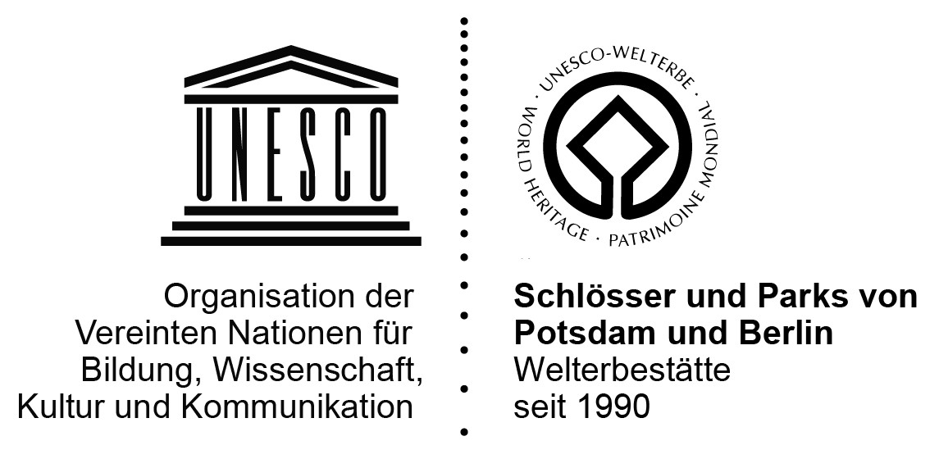
Once a property is included on the World Heritage List, it is authorized to use the World Heritage logo for non-commercial purposes. A specifically adapted World Heritage logo defines the connection between the particular World Heritage site and UNESCO (see the following example):

The German Commission for UNESCO can provide all German World Heritage sites with a specifically customized logo in EPS format. In order to elaborate these specifically adapted logos the German Commission for UNESCO will send a questionnaire to each German World Heritage site. According to the Operational guidelines the agencies responsible for site management have to ensure that the (on-site) transformation into any other electronic format is fulfilled in compliance with the Directives.
The implementation of the newly-drafted UNESCO Directives is carried out in close co-ordination with the local responsible bodies.
Principles for the use of the specifically adapted World Heritage logo:
(i) The coherent, non-commercial use of the respective logo in the external communication of the agency responsible for site management, i.e. by all authorized, responsible authorities of World Heritage sites, is explicitly encouraged not only by the Operational guidelines for the implementation of the World Heritage Convention but also by the UNESCO World Heritage Centre and by the German Commission for UNESCO.
After inscription of a site on the UNESCO World Heritage List the agency responsible for site management of this property is granted by the German Commission for UNESCO the authorization for non-commercial use of the respective World Heritage logo. Authorization to use the logo is inextricably linked to the requirement that the connection between the World Heritage site and UNESCO becomes unmistakeably clear. The agency responsible for site management accepts the responsibility for all legal consequences deriving from the use.
This authorization may be extended to other responsible public authorities and institutions as well as to responsible bodies of the World Heritage sites and to third parties designated with the safeguarding of their interests. As for the choice of these authorities, institutions and responsible bodies the agency responsible of site management may submit a proposal to the German Commission for UNESCO. For this purpose the above-mentioned questionnaire will be utilised. In case of urban architectural monuments these may be, for instance, the responsible body of the World Heritage site, the Cultural Office of the town/city, the monument protection authority, the tourism manager or the mayor. However this authorization does not include institutions like sponsoring associations, other clubs or entities operating for predominantly commercial purposes.
(ii) The commercial use of the (specifically adapted) World Heritage logo – for instance for merchandizing, for sales promotion, for publications sold in bookselling trade or for the sale of merchandizing products or services – is not permitted. In case of doubt the German Commission for UNESCO has to be consulted. Exceptions require the prior conclusion of a separate agreement with UNESCO and the German Commission for UNESCO.
(iii) The transmission of the World Heritage logo by World Heritage sites to any third party, for instance in the framework of co-operation agreements with private partners (such as tour operators, gastronomy or hotel sector) is not permitted.
(iv) Any modification of the logo, for example by integrating it into an own signet, is not permitted.
(v) Any descriptive use of the acronym “UNESCO“(without using the logo) has to be unambiguous and correct (“Our hotel is situated in the UNESCO World Heritage ‘Old town of Regensburg with Stadtamhof’ ”, but not: “UNESCO hotel” or “UNESCO World Heritage hotel”). This also applies to any illegitimate graphical manipulation that may lead to ambiguity (e.g. larger typeface for the word “UNESCO”).
(vi) World Heritage sites shall submit on an annual basis a brief schematic report (quantitative and qualitative) on the extent and intensity of the utilisation of the World Heritage logo to the German Commission for UNESCO.

IV. For Associations/Networks of World Heritage sites (for example within a federal state) the following applies:
Should an association or network of World Heritage sites want to share a joint logo, such a logo has to fulfil all graphical requirements of the newly-drafted Directives – as illustrated under point II above: the UNESCO logo (temple including the UNESCO acronym, accompanied by an explanatory text in at least one language) and the logo of the World Heritage Convention (central square surrounded by a circle with square accompanied by a phrase of how the entity in question is linked to UNESCO; on right-hand side of the temple), linked by an accurately defined dotted line in a logarithmic progression.

The German Commission for UNESCO may elaborate such a logo in co-operation with the responsible divisions of the UNESCO Secretariat in Paris. The same principles as listed under point III would be valid for its use.

