Final report of the Expert meeting on "Upstream Processes to Nominations: Creative Approaches in the Nomination Process", 27-29 April 2010, Phuket, Thailand

Report of the expert meeting on Upstream Processes to nominations:

Creative approaches in the nomination process

Background
- An expert meeting on Upstream Processes to Nominations: Creative approaches in the nomination process (27 – 29 April 2010, Phuket, Thailand) was organized by the UNESCO World Heritage Centre and UNESCO Bangkok Office with support from the Foreign Ministry of Japan and the Australian Government Department of the Environment, Water, Heritage and the Arts in cooperation with the Ministry of Natural Resources and the Environment of Thailand on behalf of the Royal Government of Thailand. This expert meeting provided the opportunity for a broad ranging discussion on creative approaches to reduce the number of properties that experience significant problems in the nomination process. This document provides a summary of the discussions and recommendations from the expert meeting.

Introduction
- The World Heritage Convention is approaching its 40th anniversary in 2012, the potential inscription of the 1000th property to the World Heritage List, and near universal ratification. In view of this, the World Heritage Committee, at its 32nd Session (Quebec 2008), decided to initiate a process of reflection on the future of the World Heritage Convention. Document WHC-10/34.COM/12A outlines the context behind the Futures process, the discussion to date and the next steps in the Futures process.
- As part of this process, at its 17th session (Paris 23-28 October 2009), by its Resolution 17 GA 9, the General Assembly of States Parties to the World Heritage Convention welcomed the offer of Japan and Australia to host an expert meeting on the upstream processes for World Heritage nominations.
- The World Heritage Committee, in Decision 33 COM 14.A2 paragraph 14, recognized that challenges exist in the process for nominating a property to the World Heritage List. States Parties spend considerable time and money developing nominations which may be delayed or unsuccessful. The Advisory Bodies – which, as this expert meeting amply demonstrated, possess a wealth of knowledge and generate constructive and informed ideas – are constrained in their ability to help by the adequacy of resources, and some World Heritage processes could better facilitate opportunities for them to render assistance. International Assistance does not always result in successful nominations and the World Heritage Committee is often faced with difficult, pressured inscription decisions.
- The participants of the expert meeting appreciated the financial support of the governments of Japan and Australia for organizing this important event in collaboration with the UNESCO World Heritage Centre and UNESCO Bangkok field office. The expert meeting also commended the Government of Thailand for its generous hospitality.
- The expert meeting was attended by 52 participants from 21 States Parties, representatives of the Advisory Bodies – IUCN and ICOMOS – as well as representatives from the UNESCO World Heritage Centre and UNESCO Bangkok Field Office and category 2 centres, represented by the Nordic World Heritage Foundation. Participants at the expert meeting came from all regions, representing the Convention’s geographic diversity. A full list of participants is included as Annex I.
- “Upstream processes” were considered by the expert meeting to be any of the processes and practices that occur prior to inscription (or otherwise), by the World Heritage Committee, of a property on the World Heritage List. These processes and practices include activities that take place at the national level before a property is included in the tentative list, those processes associated with the tentative list, the processes of submission of a nomination and its evaluation, and the consideration by the World Heritage Committee of a nomination. The workshop did not consider steps that might take place after inscription by the World Heritage Committee of a property on the World Heritage List, although the expert meeting did note that this could be an area worthy of future consideration, for instance in relation to the monitoring processes of the Convention, and the List of World Heritage in Danger.
- The agenda for the expert meeting is available at Annex II and focused on the following key issues:
  - Mapping the “upstream processes”
  - Identifying the challenges experienced by States Parties, the World Heritage Centre, the Advisory Bodies and the World Heritage Committee during these upstream processes
  - Identifying a range of possible solutions to these challenges within and outside the existing systems
  - Drafting recommendations to the World Heritage Committee for its consideration.

Discussion
- The expert meeting held a rich and productive discussion of current upstream processes, as well as possible improvements thereto.
- Participants at the expert meeting particularly valued the opportunity to analyse a broad range of processes – ranging from national considerations of whether or not to commence preparation of a possible nomination, through tentative listing, to consideration by the World Heritage Committee of a nomination. The expert meeting noted that this broad perspective complemented the more usual emphasis in expert meetings upon more specific issues of policy or practice.
- The expert meeting identified the following longer term trends affecting upstream processes:
  - The increasing creativity of States Parties in developing nominations which present new arguments for Outstanding Universal Value, including the continual emergence of themes which may underpin nominations
  - A growing complexity of properties nominated and the processes needed to evaluate properties – this is particularly evident with the increasing number of nominations for serial properties
  - As a consequence of the greater prominence and recognition accorded World Heritage, the broadening range of interests and motivations behind seeking World Heritage nominations.
Mapping the current situation
- As there is no current overall map, flowchart or diagram of upstream processes, the expert meeting developed some illustrations to help clarify current and possible refined upstream processes. These illustrations are at Annex III and include:
  - An overview of current upstream processes, from initial national considerations through to the range of processes under the Convention
  - A detailed map of the current and possible refined processes under the Convention between the stages of placement on a tentative list and submission of a nomination; indicating options for voluntary steps available to a State Party to receive additional advice and assistance in the development of nominations
  - An indication of other options for protection and recognition of heritage values, aside from World Heritage listing.
Identification of key challenges
- In considering such a broad range of issues, participants at the expert meeting were conscious of the considerable work already undertaken relevant to upstream processes. In particular, the expert meeting noted the results of the expert meeting held in Kazan (Russian Federation 2005) on the Concept of Outstanding Universal Value, and specifically the recommendations concerning the rigorous preparation of tentative lists and their conservation context (attention in this respect is particularly drawn to the report of the workshop at document WHC-05/29 COM/9).
- The expert meeting further recalled the outcome of the expert meeting on Serial Nominations and Properties (Ittingen, Switzerland, 25-27 February 2010 – see WHC-10/34.COM/9B). This expert meeting proposed an additional annex to the Operational Guidelines to cover the submission of tentative lists for transnational/transboundary serial properties. The expert meeting in Switzerland emphasised the requirement for harmonization of tentative lists and recommended an adequate comparative analysis as an essential requirement for a nomination to be accepted as complete. Whilst the expert meeting on upstream processes was aware of these conclusions, it did not discuss them in any detail.
- Participants in the expert meeting were made aware that a joint Advisory Body/UNESCO World Heritage Centre resource manual on nominations is currently under preparation, which will provide guidance on current upstream processes. The meeting noted that additional research was needed to better define the “problems”, such as to understand the different reasons why nominations funded by International Assistance have not led to inscriptions, the trends in the use of Referral and Deferral, the trends in complex nominations, and the degree of use of the Global Strategy in setting priorities in tentative lists.
- Based upon these and other inputs, and discussions that took place, the expert meeting identified a number of key challenges:
  - Too great a focus upon World Heritage above other means to recognise and protect heritage – Articles 5 and 12 of the Convention sets a broad aspiration to protect the world’s heritage – not just World Heritage – and there are international, regional and national options beyond World Heritage to protect and conserve heritage. These may all assist in ensuring a balanced approach to mechanisms to protect the world’s heritage.
  - Complexity of the World Heritage system – underpinning most other challenges is the reality that World Heritage processes are complex and difficult to readily understand. Every effort should be made to simplify/rationalise the system, in a manner that preserves its emphasis upon quality and credibility; there may also be ways to enhance communication about how the system operates; and efforts need to be made to better capture and record institutional knowledge.
  - Role of tentative lists – while tentative lists are an important part of the process required before submission of a nomination, they also play a variety of other separate but mutually compatible roles; processes related to tentative lists could be refined to provide States Parties with opportunities for further guidance particularly by Advisory Bodies and by the World Heritage Centre, and there remain benefits to be derived from harmonisation.
  - Comparative analyses – comparative analyses are one of the most common challenges facing States Parties in preparing nominations, and better guidance may be helpful.
  - Thematic studies – thematic studies may assist in the development of nominations and the undertaking of comparative analyses. The potential number of thematic studies is considerable, and it remains a challenge to produce thematic studies in a context of limited resources, tight timelines, and where priorities for thematic studies remain to be systematically determined including in relation to the Global Strategy.
  - Capacity building – there are options to improve capacity within States Parties at all levels, including in local communities, to best ensure the protection of World Heritage and to develop successful nominations.
  - Managing expectations – while the core aim of the Convention is the protection and conservation of World Heritage, national stakeholders may consider that inscription of a property is the focus. It is important to reiterate that inscription is a means to an end, but does not of itself protect heritage.
Possible solutions
- The expert meeting identified possible options to address each of these challenges. Some of these solutions can be implemented relatively easily; others require more detailed thought; and several would demand additional resources. The expert meeting also identified that some could be implemented by States Parties, individually or regionally, while others required the involvement of the World Heritage Centre, the Advisory Bodies, category 2 centres, and/or other institutions.
- Creative options to improve upstream processes were identified, related to the ability to refine and augment the provision of advice and feedback to States Parties. These options include:
  - Exploring ways to offer, on a voluntary basis, assistance to States Parties by enabling the Advisory Bodies to provide advice upon the prioritisation of possible nominations of properties included on a State Party’s tentative list
  - Draft Nomination
    - Augmenting the annual informal review of nominations (the ‘30 September check’) undertaken by the World Heritage Centre by involving the Advisory Bodies, to ensure more substantive feedback to States Parties. This feedback could, for example, pay particular attention to challenging areas such as comparative analyses
    - Considering the introduction of an option for States Parties to undertake, on a voluntary basis, an early-stage process (perhaps in the form of a ‘draft nomination’ to be considered months or even a year or two before the annual 30 September informal review of nominations) which would enable the provision of detailed advice and feedback from the Advisory Bodies
    - Additional consideration by the World Heritage Committee of draft nominations, perhaps in combination with other reforms to Committee processes (such as the notion of having the Committee consider, in alternate years, nominations and state of conservation issues or of holding the World Heritage Committee twice a year or of determining Outstanding Universal Value, integrity and authenticity first, with other elements determined at a later Committee session).
  - Exploring ways to ensure that the provision of international assistance more frequently results in the successful nomination and protection of properties.
- These ideas can be explored individually or in combination. Refinements to each idea are also possible. The expert meeting felt that while such ideas offer considerable potential to assist States Parties, they also pose procedural, resourcing and other challenges, and so require further consideration. Any assessment of feasibility would need to take into account issues such as cost, timeliness, practicability and net benefit to States Parties.
- The expert meeting considered that the World Heritage Centre should work with the Advisory Bodies to undertake further consideration of these ideas, with a view to identifying the most promising options. These options could then be tested with one or more States Parties, on a voluntary basis, with the World Heritage Centre and Advisory Bodies keeping the Committee informed of their evolving work.
- The expert meeting also considered these ideas could be considered by any consultative group that may be established at the 34th session of the World Heritage Committee to continue the process of reflection on the Future of the World Heritage Convention.
- In addition to these ideas, the expert meeting held a rich discussion on the processes of Referral and Deferral (paras 159 and 160 of the Operational Guidelines).
- The expert meeting considered that Referral and Deferral should be viewed as constructive options that can assist States Parties to develop nominations that can be successfully inscribed. It was noted that a decision to Refer a nomination, in the situation where the nomination may need more time and work and would require additional on-site evaluation, may be a ‘poisoned gift’ which can needlessly limit the options available to a State Party to refine its nomination, including with the assistance of the Advisory Bodies. Further clarity on the Referral and Deferral processes, and their implications, may assist in having the benefits of these options, and the differences between them, more widely appreciated.
- The Operational Guidelines currently permit States Parties to withdraw a nomination at any time prior to the Committee session at which it is scheduled to be examined (para 152).
- In addition, the expert meeting noted that it may be possible to contemplate a further option, which would enable States Parties to put a nomination on hold for a period of time. This possibility could provide additional flexibility for States Parties – but it would need to be carefully evaluated. For example, if changes were to be made to a nomination during the period in which it was on hold, then it may be necessary to determine whether the nomination would need to return to a previous stage in the evaluation process. The expert meeting noted that this option warranted further detailed analysis before it was contemplated for introduction.
- The expert meeting noted that there is currently ambiguity in the Operational Guidelines in relation to when a State Party should submit a property for inclusion on its tentative list. To remove doubt, the expert meeting considered that the word “preferably” in paragraph 65 of the Operational Guidelines be deleted.
- Annex IV contains a table of the possible solutions developed by the expert meeting.

Recommendations
- The expert meeting agreed to the following recommendations for placing before, as appropriate, the World Heritage Committee, the World Heritage Centre and the Advisory Bodies:
  - That actions already underway to improve upstream processes be continued, including further review and definition of challenges to assist better targeting of action
  - That those possible solutions to enhance the provision of advice and feedback to States Parties which entail minimal costs and which can be done within the present system, be agreed by the World Heritage Committee for immediate implementation
  - That other possible solutions with more significant cost implications, and which may require refinements to current processes, be subjected to further analysis and considered by the World Heritage Committee for implementation as appropriate
  - That the World Heritage Centre work with the Advisory Bodies to undertake further work on the feasibility of strengthening of existing approaches to enhance the provision of advice and feedback to States Parties, including through undertaking, subject to funding, a voluntary pilot with one or more States Parties; and the possible consideration of the draft tentative list and/or nominations by the World Heritage Committee, upstream of their formal submission
  - That the World Heritage Centre and the Advisory Bodies keep the World Heritage Committee informed of their work on options and pilot studies to test them
  - That these creative options, and work underway to further consider them, be brought to the attention of any consultative group that may be established at the 34th session of the World Heritage Committee to continue the process of reflection on the Future of the World Heritage Convention
  - That the World Heritage Committee continue reflection upon ways to use the Referral and Deferral processes and the mechanism for State Parties to withdraw nominations from consideration as part of the suite of upstream mechanisms that can contribute to successful inscriptions, possibly augmented by additional options such as the possibility of a State Party to place a nomination on hold
  - That the word “preferably” in paragraph 65 of the Operational Guidelines be deleted.

List of Annexes
Annex I: List of participants
Annex II: Agenda of the expert meeting
Annex III: Illustrations of current upstream processes
Annex IV: Possible solutions
ANNEX I

LIST OF PARTICIPANTS to the expert meeting on "Upstream Processes to Nominations: Creative Approaches in the Nomination Process", Phuket, Thailand, 27-29 April 2010

 | EXPERT | POSITION | COUNTRY | ADDRESS | EMAIL CONTACT
Group I | Mr Michael TURNER | Professor, Unesco Chair in Urban Design and Conservation Studies | ISRAEL | Bezalel Academy of Arts and Design, ISRAEL World Heritage Committee Contact Address:  25 Caspi Street, North Talpiot, Jerusalem, 93554, ISRAEL  Tel No.: +972 (0) 2 671 6492  Fax No.: +972 (0) 2 673 2801 | turnerm@013.net
Group I | M. Johann MÜRNER | Responsible for cultural heritage and historical monuments on Swiss Federal Level - Head of Section - Federal Office of Culture | SWITZERLAND | Federal Office of Culture, Section for cultural Heritageand Historic Monuments, Switzerland Hallwyl Strasse 15, 3003 Berne, Switzerland Tel No.: + 41 31 322 80 59  Fax No.: + 41 31 322 87 39  Mobile No.: + 41 79 277 37 81 | Johann.Muerner@bak.admin.ch
Group II | Ms Ina MARCIULIONYTE | Ambassador at Large, permanent republic of Lithuania to UNESCO | LITHUANIA | Ministry of Foreign affairs of the Republic of LithuaniaTumo-VaiŸyants 2,  VILNIUS LITHUANIA  Tel No.: +370 5 236 2536  Mobile No.: +370 620 177 85 | ina535@hotmail.com
Group II | Dr Tamas FEJERDY | Vice President of the National Office for the Protection of Cultural Heritage, Head of Secretariat of the Hungarian World Heritage Convention | HUNGARY | National Office of Culture Heritage, Hungary H-1014 Budapest, Tancsics Mihály Utca 1, HUNGARY  Tel No.: +36 1 225 48 65  Fax No.: +36 1 225 48 68  Mobile No.: +36 30 941 68 41 | Tamas.Fejerdy@koh.hu Tfejerdy47@gmail.com
Group III | Ms Alissandra CUMMINS | Chairperson, Barbados National Commision for UNESCO and Special Envoy for Cultural Heritage | BARBADOS | Barbados National Commision for UNESCONo. 11 St. Arm’s Gamson, St. Michael, BARBADOS BB 14038 Tel No.: 1 246 427 0201  Fax No.: 1 246 429 5946  Mobile No.: 1 246 231 3260 | director@barbumuse.org.bb
Group III | Mr Oscar ACUÑA | Executive Director of the National Monuments Council of Chile | CHILE | National Monuments Council Av. Vicuña Mackenna 84, Proviosncia, Santa 60, CHILE  Tel No.: 56 2 726 1412  Mobile No.: 56 9 318 9634 | oacuna@monumentos.cl
Group III | Mr Francisco J LOPEZ-MORALES | Expert advisor, Director of World Heritage in the National Institute of Anthropology and History (INAH) | MEXICO | National Council of Arts and Culture. (CONACULTA)Av Insurgentes Sur 421 2nd Floor Col Hipodromo Mexico City DF Cp 06100 MEXICO  Tel No.: 52 (55) 40 40 4300 ext 415591  Mobile No.: 52 1 55 22 69 10 95 | francisco_lopez@inah.gob.mx  panchol08@gmail.com
Group IV | His Excellency San SOR PHORN | Secretary General, Cambodian National Committee for the World Heritage | CAMBODIA | National Committee for the World Heritage 74, Phreah Sihanouk Bluud, Beng Keng Kang 1,Phanom Penh, CAMBODIA  Tel No.: (855) 23 210 842  (855) 23 210 845  Fax No.: (855) 23 211 904  Mobile No.: (855) 12 79 73 72  (855) 15 79 73 72 | sansorphornlaw@yahoo.com sansorphornlaw@gmail.com
Group IV | Dr Roland SILVA | National Trust- Sri Lanka (President) | SRI LANKA | 69/3 Gregory’s Road, Colombo 7, SRI LANKA  Tel No.: 00 94 11 269 3647  Fax No.: 00 94 11 269 3647 | srsilva@silvermillgroup.com
Group Va | Dr George Okello ABUNGU | CEO-Okello Abungu Heritage Consultants | KENYA | Okello Abungu Heritage Consultants P.O. Box 496 Karen, 00502, Nairobi, KENYA  Tel No.: +254 20 204 264,  +254 20 204 264  Mobile No.: +254 724 462 883 | g.abungu@mac.com
Group Va LDC | Dr Yonas Beyene GEBRE-MICHAEL | Director of “ Heritage Collection and Laboratory”, ARCCH | ETHIOPIA | Authority for Research and Cosservation Of Culture Heritage (ARCCH), Ministry of Culture and Tourism,ETHIOPIA P.O. Box 6686, ADDIS ABABA, ETHIOPIA  Tel No.: 25 11 11 2 70 15 27  Mobile No.: 25 19 13 54 45 93 | yonasbeyene.gm@gmail.com
Group Va | Dr Ali OULD SIDI | Chief of the Timbuktu Cultural Mission Expert de l’UNESCO, consultant de ICOMOS international | MALI |  | ouldsidi_ali@hotmail.fr
Group Va | Mr. Fareed CHUTTAN | Principal Assistant Secretary, Ministry of Education, Culture and Human Resources | MAURITIUS | Principal Assistant Secretary, Ministry of Education, Culture and Human ResearcesLevel 7, R seeneevassen Bldg, Cnr. P.Henessy 2 Maillard Streets, Port-Louis, MAURITIOUS  Tel No.: (230) 212 8377  Fax No.: (230) 211 3196  Mobile No.: (230) 259 2166 | fchuttan@mail.gov.mu
Group Va | Mrs. Skumsa Mancotywa | Chief Director: Tran frontier | SOUTH AFRICA | Departments of Environmental Affairs,SOUTH AFRICA P/Bag x447, Pretoria 0001, SOUTH AFRICA  Tel No.: +2712 310 3606  Fax No.: +2712 320 2849  Mobile No.: +2782 413 0166 | smancotywa@deat.gov.za
Group Va | Mr Leonard Khoza | Second Secretary from the South African Permanent Delegation to UNESCO | SOUTH AFRICA | South Africa Embassy 59 Quai d'Orsay, PARIS, Cedex 07, 75343 FRANCE  Tel No.: +33 1 53 59 23 49  Mobile No.: +33 6 37 59 72 39 | KhozaL@dirco.gov.za
Group Vb | Mr Eisa Abbas Hussien Yousif | Supervisor of Archaeological Survey and Excavation, Directorates of Antiquities | UNITED ARAB EMIRATES | Department of Cultural and Information-Government ofSharjah P.O. Box: 1741 Sharjah U.A.E.  Tel No.: 06 566 8001  Fax No.: 06 566 0334  Mobile No.: 050 968 1234 | eisayousif@gmail.com
Group Vb | Mr Moawiyah IBRAHIM | Representative of Jordan to the UNESCO World Heritage Committee, President, the Society of Friends of Archaeology & Heritage | JORDAN | President, Society of Friends of Archaeology andHeritage P.O. Box 815584, 11180 Amman, JORDAN Tel No.: (HOME) +96 26 58 21 855  Mobile No.: +96 27 9 56 77 215 | moawiyah@rocketmail.com
Thai | Dr. Somsuda LEYAVANIJA | Deputy Permanent Secretary, Ministry of Culture | THAILAND | Minister of Culture 666 Borommaratchachonnani Road, Bang Plad, Bang Bamru, Bangkok 10700 THAILAND  Tel No.: +66 (0) 2422 8932  Fax No.: +66 (0) 2422 8931  Mobile No.: +66 (0) 819 201 307 | somsudale@gmail.com
Thai | Ms Orachart SUEBSITH | Deputy Permanent Delegate of the Kingdom of Thailand to UNESCO | THAILAND | Permanent Delegate of the Kingdom of Thailand to UNESCO Maison de l'UNESCO Bureau MS 1.30 1, rue Miollis 75732 Paris Cedex 15 FRANCE  Tel No.: +33.1.45.68.31.23  Fax No.: +33.1.45.68.31.24 | dl.thailande@unesco-delegations.org
Thai | Mrs. MingQuan WICHAYARANGSARIDH | Secretary General, Office of Natural Resources and Environmental Policy and Planning | THAILAND | Office of Natural Resources and Environmental Policy and Planning 60/1 Phibulwattana 7, Rama VI Road, Samsen-nai, Phayatai, Bangkok 10400, THAILAND  Tel No.: +66 (0) 2265-6502  Fax No.: +66 (0) 2265-6503 | minquan@onep.go.th
Thai | Ms. Araya NUNTAPOTIDECH | Deputy Secretary General, Office of Natural Resources and Environmental Policy and Planning | THAILAND | Office of Natural Resources and Environmental Policy and Planning 60/1 Phibulwattana 7, Rama VI Road, Samsen-nai, Phayatai, Bangkok 10400, THAILAND  Tel No.: +66 (0) 2265-6505  Fax No.: +66 (0) 2265-6506 | araya@onep.go.th
Thai | Ms Darunee THAMAPODOL | Director of Multilateral Coopperation group, Office of International Relations | THAILAND | Minister of Culture 666 Borommaratchachonnani Road, Bang Plad, Bang Bamru, Bangkok 10700 THAILAND  Tel No.: +66 (0) 2422 8942  Fax No.: +66 (0) 2446 8347  Mobile No.: +66 (0) 818 119 071 | daruntha@gmail.com
Thai | Mr. Duriya AMATAVIVAT | Expert on International Cooperation | THAILAND | Bureau Of Thai National Commission For UNESCO Ministry of Education Rachadamnoen Nok Avenue, Dusit, Bangkok 10300 THAILAND  Tel No.: +66 (0) 2628 5646 ext 116 Fax No.: +66 (0) 2281 0953  Mobile No.: +66 (0) 8 1459 8988 | duriyaa@hotmail.com
Thai | Mr. Tharapong SRISUCHAT | Director, Office of Archeology | THAILAND | Conservation Research Group, Fine Arts Department 81/1 Sriayuthaya Road, Thewes, Dusit, Bangkok 10230,THAILAND  Tel No.: +66 (0) 2282 2121  Fax No.: +66 (0) 2281 3947
Thai | Mrs. Usa Kiatchipipat | Director, Environmental Conservation of Natural and Cultural Heritage Division | THAILAND | Office of Natural Resources and Environmental Policyand Planning 60/1 Phibulwattana 7, Rama VI Road, Samsen-nai, Phayatai, Bangkok 10400, THAILAND  Tel No.: +66 (0) 2265-6575  Fax No.: +66 (0) 2265-6578 | usa@onep.go.th
Thai | Mrs. Peeranuch Dulkul Kappelle | Acting Director, National Parks Research Division National Parks Office | THAILAND | Department of National Parks, Wildlife and Plant Conservation 61 Pahonyothin, Chatuchak, Bangkok 10900 THAILAND  Tel No.: +66 (0) 2561 0777 ext. 1720  Mobile No.: +66 (0) 819 883 646 | dulkup@hotmail.com
Thai | Ms. Jaratrus CHAMRATRITHIRONG | Second Secretary | THAILAND | Department of Treaties and Legal Affairs, Ministry of foreign Affairs Ministry of Foreign Affairs Sri Ayuttaya Road, Bangkok, 10400 THAILAND  Tel No.: +66 (0) 2643 5000 ext 1106  Fax No.: +66 (0) 2643 5035  Mobile No.: +66 (0) 859 163 510 | jaratrusc@mfa.go.th
AUS | Dr Gregston Terrill | Assistant Secretary, International Heritage and Policy Branch | AUSTRALIA | Department of the Environment, Heritage and the Arts CANBERRA Tel No.: +61 2 62 74 20 44  Mobile No.: +61 4 17 04 82 59 | Greg.Terrill@environment.gov.au
AUS | Dr Katharine Feros | Assistant Director, International Heritage Section | AUSTRALIA | Australian Department of the Environment, Water, Heritage and the Arts GPO Box 787 Canberra, ACT Australia  Tel No.: +61 2 6274 2002 | Kate.Feros@environment.gov.au
JAP | Mr.Tadamichi YAMAMOTO | Ambassador of Japan to UNESCO | JAPAN | Permanent Delegation of Japan to UNESCO 100, avenue de Suffren 75015 PARIS  Tel No.:+33 01 53 59 27 00,  +33 01 45 68 35 43  Fax No.: +33 01 53 59 27 27 | dl.japan@unesco-delegations.org
JAP | Mr. Toshiyuki KONO | Professor of Law, Kynshu University | JAPAN | Kynshu University Faculty of Law, Kunshu University 23, Fukuoka 812-8581  Tel No.: 81 92 642 3207  Fax No.: 81 92 642 3207 | konoto@law.kyushu-u.ac.jp
JAP | Ms Nobuko INABA | Director / Professor, World Heritage Studies | JAPAN | World Heritage Studies Program, Graduate School of Comprehensive Human Sciences, University of TsukubaGraduate School of Comprehensive Human Sciences, University of Tsukuba, Tennodai, Tsukuba, 305-8577 Ibaraki, JAPAN
JAP | Ms. Kumiko YONEDA | Senior Research Scientist, Japan Wildlife Research Center (JWRC) | JAPAN | Japan Wildlife Research Center (Home) 2-1-1-4609 Tsukuda, Chuo-ku, 104-0051,Tokyo, JAPAN (Office) 3-10-10 Shitaya, Taito-ku, 110-8676, Tokyo,JAPAN  Tel No.: +81 3 5824 0963  Fax No.: +813 5824 0964 | kyoneda@jwrc.or.jp
JAP | Mr Tatsuya HORIKIRI | Researcher, Japan Wildlife Research Center | JAPAN | Japan Wildlife Research Center (Home) 1-5-5-508, Shibakubo-cho, Nishitokyo-shi, Tokyo, 188-0014, JAPAN (Address) 3-10-10, Shitaya, Taitou-ku, Tokyo, 110-8676, JAPAN | thorikiri@jwrc.or.jp
JAP | Mr Yukihiro HAISA | Technical official | JAPAN | Ministry of Environment Godochosha No. 5, Kasumigaseki 1-2-2, Chiyoda-ku,Tokyo 100-8975, JAPAN
JAP | Mr Takuya MITANI | Director, Office for World Cultural Heritage Moments and Sites Division, Cultural Properties Department | JAPAN | Agency for Cultural Affairs 3-2-2 Kasumigaseki, Chiyoda-ku , 100-8959, Tokyo, Japan: | mitani@bunka.go.jp
JAP | Ms Maki SAKAMOTO | Unit Chief, Office for World Cultural Heritage Moments and Sites Division, Cultural Properties Department | JAPAN | Agency for Cultural Affairs 3-2-2 Kasumigaseki, Chiyoda-ku, Tokyo, 100-8959, JAPAN | m-sakamo@bunka.go.jp
JAP | Mr Yoshio ANDO | Director, Multilateral Cultural Cooperation Division | JAPAN | Multilateral Cultural Cooperation Division, Cultural Affairs Division, Ministry of Foreign Affairs of Japan 2-2-1, Kasumigaseki, Chiyoda-ku, Tokyo 100-8918, Japan  Tel No.: + 81 (3) 5501 8141  Fax No.: +81 (3) 5501 8140 | yoshio.ando@mofa.go.jp
JAP | Ms Yuka MIYASHITA | Third Secretary, Delegation Japan to UNESCO | JAPAN | Permanent Delegation of Japan to UNESCO 100, avenue de Suffren 75015 PARIS  Tel No.:+33 01 53 59 27 00,  +33 01 45 68 35 43  Fax No.: +33 01 53 59 27 27 | y.miyashita.jp@unesco-delegations.org
NGO | Ms. Synnøve Vinsrygg | International Consulting, Nordic WHF Deputy director in the Nordic World Heritage Foundation International development co-operation and cultural heritage management | NORWAY | Nordic World Heritage Foundation Fridtjof Nansens Plass 4 0160 Oslo, Norway  Tel No.: (47-24) 14-01-02  Fax No.: (47-24) 14-01-01 | synnove.vinsrygg@nwhf.no
EGT | Mr.Mohamed  El ZAHABY | Permanent Delegation of Egypt to UNESCO | EGYPT | 1 Rue Miollis 75732, Paris cadex 15 France  Tel No.: (+33) 1 45 68 33 16  Fax No.: (+33) 1 47 83 41 87  Mobile No.: (+33) 66 00 27 926 | m.el-zahaby@unesco_delegations.org zahabi99@yahoo.com
AB | Ms. Kristal BUCKLEY | Vice-President of ICOMOS | AUSTRALIA | International Council on Monuments and sites (ICOMOS) 49 – 51, rue de la Fédération, 75015 Paris, FRANCE  Tel No.: +61 439 361 793  Fax No.: +61 3 9489 0832 | kristal.buckley@icomos.org
AB | Mr. Guo ZHAN | Vice-President of ICOMOS | CHINE | International Council on Monuments and sites (ICOMOS) 49 – 51, rue de la Fédération, 75015 Paris, FRANCE Tel No.: +33 1 45 67 67 70  Fax No.: +33 1 45 66 06 22  Mobile No.: +86 1 370 1386 673: | zhan.guo@icomos.org
AB | Mr.Tim BADMAN | International Union for Conservation of Nature (IUCN) Institution/Organization | SWITZERLAND | International Union for Conservation of Nature (IUCN) Rue Mauverney 28, 1196 Gland, Switzerland  Tel No.: +41 79 521 89 84 | Tim.Badman@iucn.org
AB | Mr. Peter SHADIE | International Union for Conservation of Nature (IUCN) |  | Regional Protection Areas Programme, Asia Regional Office, IUCN, 63 Sukhumvit Soi 39, Sukhumvit Rd, Wattana, Bangkok, THAILAND 10110  Tel No.: +66 (0) 2 662 4029 ext 302  Fax No.: +66 (0) 2 662 4387  Mobile No.: +66 (0) 8 1373 1020 | Peter.SHADIE@iucn.org
WHC | Mr. Kishore RAO | Deputy Director, World Heritage Centre (DDIR/WHC) | FRANCE | World Heritage Centre 7 Place de Fontenoy, 75007, PARIS  Tel No.: +33 (0) 1 81 55 9  Fax No.: +33 (0) 1 81 55 9 | k.rao@unesco.org
WHC | Ms Mechtild Rossler | Chief of Section Europe and North America (WHC/EUR) | FRANCE | World Heritage Centre, UNESCO 7 Place de Fontenoy, 75007, PARIS Tel No.: + 33 1 45 68 18 91 | M.Rossler@unesco.org
WHC | Mr. Alessandro BALSAMO | Programme Specialist (WHC/POL) | FRANCE | World Heritage Centre, UNESCO7 Place de Fontenoy, 75007, PARIS Tel No.: + 33 1 45 68 11 36  Fax No.: + 33 1 45 68 55 70 | a.balsamo@unesco.org
WHC | Ms Luba JANIKOVA | Super numerary, Policy and Statutory Implementation Unit, Culture Sector (WHC/POL) | FRANCE | Programme Specialist (WHC/POL)World Heritage Centre, UNESCO 7 Place de Fontenoy, 75007, PARIS  Tel No.: +33 (0)1 4568 1824 | l.janikova@unesco.org
UNESCO BKK | Mr. Tim CURTIS | Head of Culture Unit | THAILAND | UNESCO Bangkok, 920 Sukhumvit Road, Prakanong, Bangkok THAILAND  Tel No.: +66 2 391 0577 ext 501  Fax No.: +66 2 391 0866 | t.curtis@unesco.org
UNESCO BKK | Ms Korapat PRAPUTUM | Senior Secretary, UNESCO Bangkok | THAILAND | UNESCO Bangkok 920 Sukhumvit Road, Prakanong, Bangkok THAILAND  Tel No.: +66 2 391 0577 ext 509  Fax No.: +66 2 391 0866 | k.praputum@unesco.org
UNESCO BKK | Mr. Takahiko MAKINO | Project Assistant, UNESCO Bangkok | THAILAND | UNESCO Bangkok, 920 Sukhumvit Road, Prakanong, Bangkok THAILAND  Tel No.: +66 2 391 0577 ext 513  Fax No.: +66 2 391 0866 | t.makino@unesco.org

ANNEX II

As of 26 April 2010

Workshop on “upstream processes to nominations”:
Creative approaches in the nominations process
26-29 April 2010
Phuket, Thailand

Agenda and Timetable

Monday 26 April
Arrival of participants and transport to hotel (Movenpick Resort & Spa Karon Beach, Phuket). For participants who arrive Monday morning, site visits to heritage sites will be organised.
18.00 Meet in foyer
19.00 Reception dinner hosted by HE Mr Suwit Khunkitti, Minister of Natural Resources and Environment

Tuesday 27 April
9.00 – 9.50 Session 1: Opening of the workshop
Moderator: Thailand Permanent Secretary of Ministry of Natural Resources and Environment
Process: Welcome and introductions
Outcomes sought: Participants have a clear understanding of what the workshop is about and how it will happen
Issues for discussion:
    - Welcom to Thailand (Thailand)
    - Outline the objective of the Workshop (Japan)
    - Explanation of the format of the workshop (WHC)
    - Description of how the workshop fits in the Futures process, recall mandate: Decision 33COM14.A2, para 14; explain focus on ‘upstream processes’ (Aust);
9.00 – 10.00 Group photograph
10.00 – 10.30 Coffee break
10.30 – 12.30 Session 2: Map current upstream processes
Moderator: Ms Ina Marciulionyte
Rapporteur: Mr Moawiyah Ibrahim
Process: 10 minute presentations each by Dr Alissandra Cummins (Barbados), Mr Tim Badman (IUCN), Ms Kristal Buckley (ICOMOS), Mr Alessandro Balsamo (WHC), followed by discussion.
Outcomes sought. Participants have a clear understanding of current practices and upstream processes and agree on the current process
Issues for discussion:
  - To chart the current processes used to nominate a property for inclusion in the World Heritage List.
  - Indicate and categorize substantial issues such as description of OUV, comparative analysis, management, etc with some examples of where challenges typically occur both in the processes and in relation to the different components of OUV.

Dress code: Casual for all sessions and meals

12.30 – 14.00 Lunch at Pacifica (Buffet)
14.30– 18.00 Session 3: Conduct analysis: What are the key challenges in upstream processes?
Moderator: Mr Francisco J Lopez-Morales
Presenter: Mr Tim Badman (IUCN) and Ms Kristal Buckley (ICOMOS)
Rapporteur: Mike Turner
Process: 15 minutes presentations each by Kristal Buckley (ICOMOS), Tim Badman (IUCN), followed by discussion
Issues for discussion:
  - indicate and categorize substantial issues such as description of OUV, comparative analysis, management, etc with some examples of where challenges typically occur both in the processes and in relation to the different components of OUV.
  - identify the typical points and sources of challenges or difficulty experienced by States Parties, the secretariat, the Advisory Bodies and the World Heritage Committee during the nomination process
  - thematic studies and other advisory body tools
  - the development of Tentative Lists
  - applications for preparatory assistance
  - provision of advice on compiling the nomination file
  - the completeness check of new nominations (to ensure that all necessary documentation and maps are included)
  - the evaluation of the nomination by the appropriate Advisory Body
  - the AB evaluation process for nominations and supplementary information within it
  - the role of referral and deferral of nominations and how to support follow up to these decisions by States Parties before a resubmitted nomination
  - follow up actions to Committee decisions
  - procedural successes and frustrations
  - assessment of which current processes work best
  - whether there is any need for additional processes, including on a voluntary basis
18.00 End of the session
19.00 – 21.00 Welcome dinner hosted by HE Mr Suwit Khunkitti, Minister of Natural Resources and Environment - Grand Ballroom I and II (Buffet)
21.00 Meeting of moderators and rapporteurs

Wednesday 28 April 2010
19.00 – 21.00 Session 4: Propose solutions to challenges
Moderator: Prof. Nobuko Inaba
Rapporteur: Dr George Abungu
Process: summary of discussion presented by Rapporteur of Session 3 (Mike Turner) Discussion facilitated by moderator
Dress code: Casual for all sessions and meals
Issues for discussion:
  - identifying creative and innovative solutions to the challenges identified in Session 3
  - seeks to improve the upstream processes
  - to reduce the frustrations experienced by all parties
  - build on the successful innovations of the past.
  - re-examination of the roles of the Centre and the Advisory Bodies
  - benefit from the creation of additional processes, including on a voluntary basis reviewing the Tentative Listing process
  - refocusing International Assistance
  - introducing a staged/progressive inscription process
  - revisiting the Global Strategy, gap analyses and thematic studies.
10.30 – 11.00 Coffee break
11.00 – 13.00 Continuation of session
13.00 – 14.30 Lunch at Pacifica (Buffet)
15.00 – 16.30 Drafting group meeting of Secretariat, moderators, rapporteurs
Moderator: Prof Toshiyuki Kono
16.30 – 17.00 coffee break
17.00 – 18.00 Continue drafting work
19.00 Dinner hosted by Japan and Australia at Sand Bar
Thursday 29 April 2010
8.00 – 10.30 Session 5: Discussion of ‘recommendations’ to the World Heritage Committee
Co-Moderators: H.E. Mr Tadamichi Yamamoto (Japan), Dr Greg Terrill (Australia)
Presenters: Professor Kono and Dr Kate Feros (30 minutes)
Issues for discussion:
  - finalise the ‘recommendations’ that will be presented for discussion at the 34th Session of the World Heritage Committee in Brazil in three weeks following the workshop.
10.30 – 11.00 Coffee break
11.00 - 13.00 Continuation of session
13:00 End of the Session
13:30 Lunch at Pacifica (Buffet)
Dress code: Casual for all sessions and meals
ANNEX III
Table a - An overview of current upstream processes, from initial national considerations through to the range of processes under the Convention

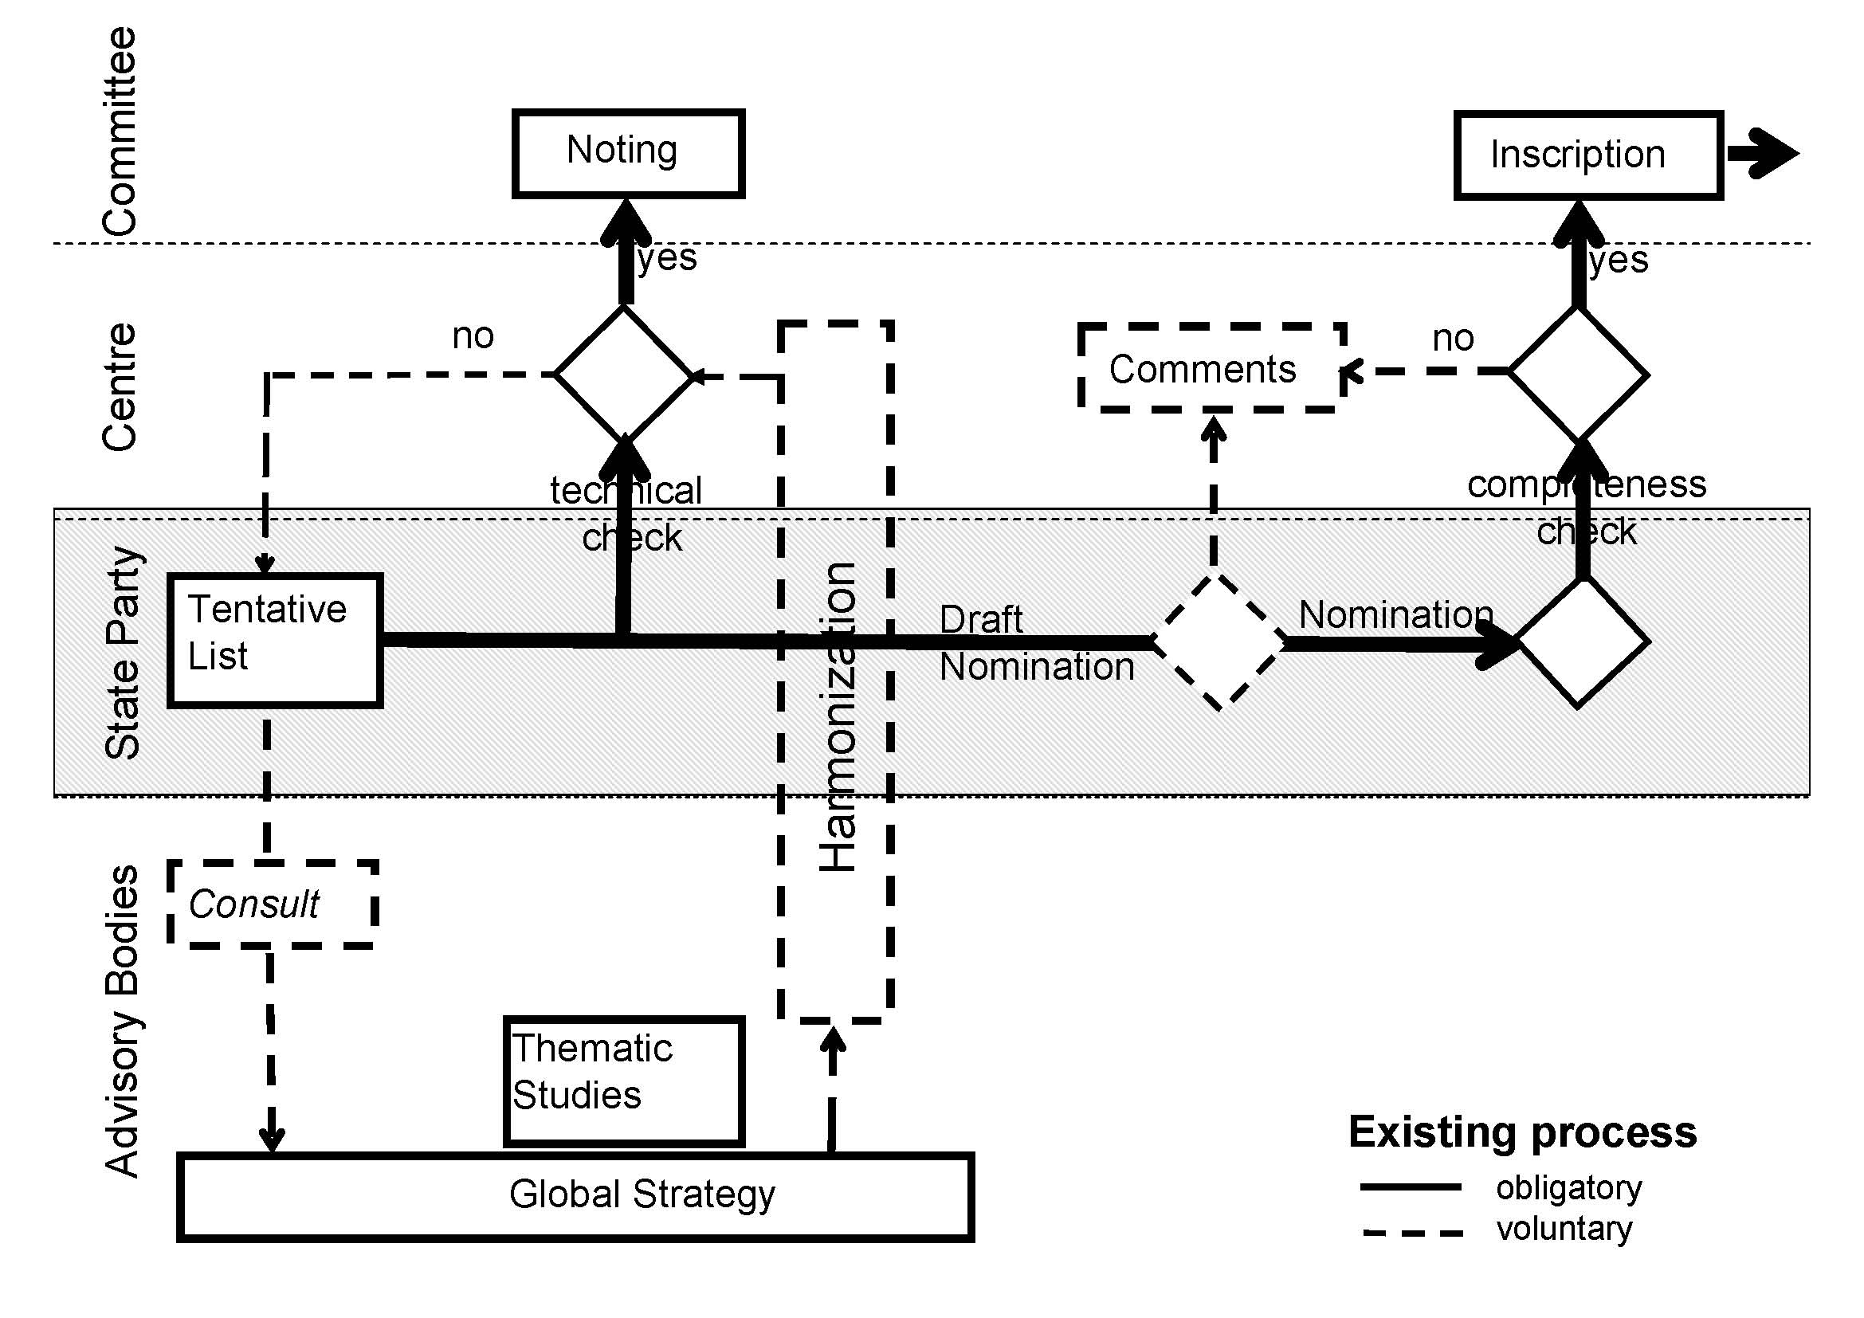
Table b - A detailed map of the current and possible refined processes under the Convention between the stages of placement on a tentative list and submission of a nomination, indicating options for voluntary steps available to a State Party to receive additional advice and assistance in the development of nominations

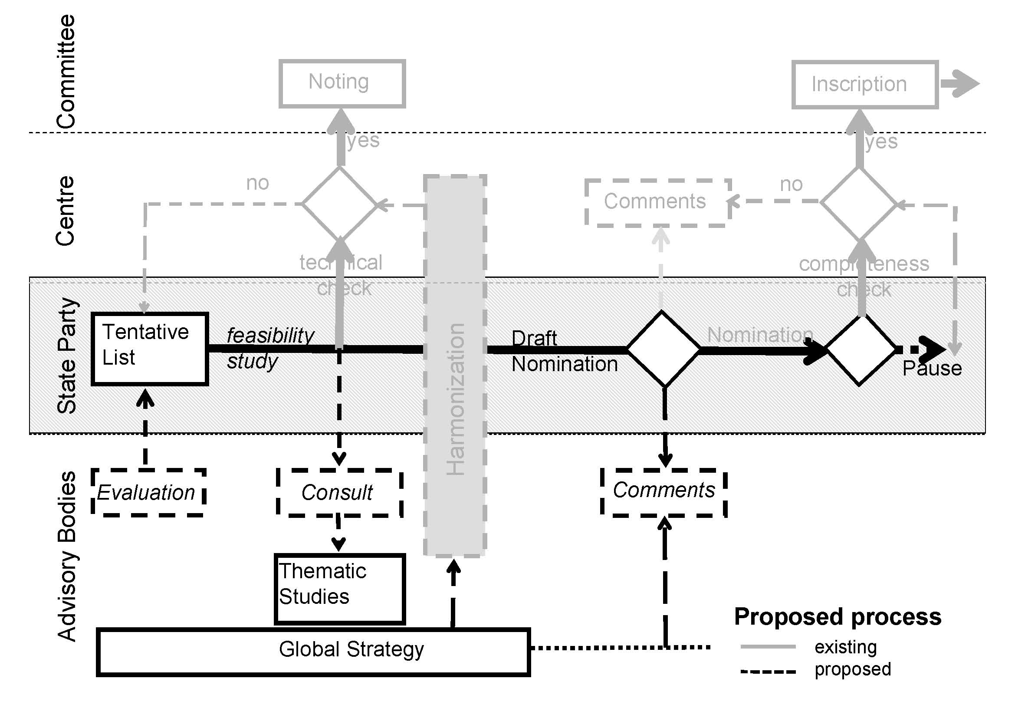
Table c – An indication of other options for protection and recognition of heritage values, aside from World Heritage
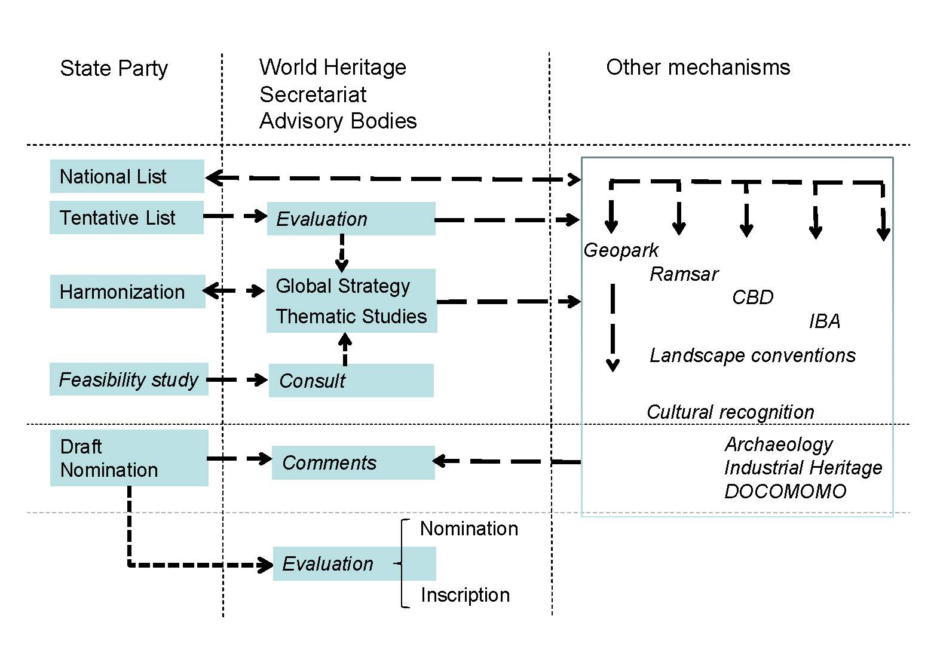

ANNEX IV – Possible solutions
1 Too much focus upon World Heritage above other means to recognise and protect heritage – Article 5 of the Convention sets a broad aspiration to protect the world’s heritage – not just World Heritage – and there are international, regional and national options beyond World Heritage to protect and conserve heritage. These may all assist in ensuring a balanced approach to mechanisms to protect the world’s heritage.
Challenges | Possible solutions | Who? | Resources
1. National stakeholders often focus upon World Heritage as the sole, or most attractive, means to recognise and protect heritage  (Para. 41 to 44 of the Operational Guidelines) | 1.1 Recall Articles 5 and 12 of the Convention which contain a broad aspiration to protect heritage | 1.1 WH Centre with ABs to outline the range of options to recognise and protect heritage, including some good practice national approaches  1.1 Individual States Parties to use these resource materials | 1.1 Minimal
 | 1.2 Promote other international, regional and national mechanisms to recognise and protect heritage | 1.2 WH Centre with ABs to outline the range of options to recognise and protect heritage, including some good practice national approaches  1.2 Individual States Parties to use these resource materials | 1.2 Minimal
 | 1.3 States Parties ensure integrated management approaches to the range of national, regional and international mechanisms are in place to recognise and protect heritage | 1.3 Individual States Parties | 1.3 Variable: some States Parties may already have such systems, others may need to consider introducing them
2 Complexity of the World Heritage system – underpinning most other challenges is the challenge that World Heritage processes are complex and difficult to readily understand. Every effort should be made to simplify the system, in a manner that preserves its emphasis upon quality and credibility; there may also be ways to enhance communication about how the system operates; and efforts need to be made to better capture and record institutional knowledge.
Challenges | Possible solutions | Who? | Resources
2.1 World Heritage processes and requirements are complex by nature and difficult to understand  (Para. 120 to 168 of the Operational Guidelines) | 2.1.1 Develop simple means to illustrate World Heritage processes and requirements, and include on the WH Centre’s website and in other materials | 2.1.1 WH Centre with ABs | 2.1.1 Nil for resources already developed, and Minimal for further materials that could be developed in house by the WH Centre
 | 2.1.2 Simplify processes and documentation wherever possible, retaining quality and function | 2.1.2 WH Committee should take every opportunity to simplify processes | 2.1.2 Nil; the WH Centre needs merely to ensure that advice to the Committee take simplicity into consideration
 | 2.1.3 Develop explanatory note to guide the preparation of tentative lists (Annex 2 of the Operational Guidelines), drawing upon the recommendations of the Kazan expert meeting and other sources | 2.1.3 WH Centre with ABs | 2.1.3 Nil
2.2 Institutional knowledge is often lost and not fully captured | 2.2.1 Continue to develop, as priorities permit, tools to assist, such as compendiums of landmark decisions, toolkits of good practice national approaches and other resource manuals | 2.2.1 WH Centre and ABs | 2.2.1 Moderate, but could be integrated into other work that would take place anyway.
 | 2.2.2 Continue to work with training institutions, including category 2 centres, to develop broader base of knowledge | 2.2.2 States Parties, WH Centre and ABs | 2.2.2 Moderate but could be integrated into other work that would take place anyway
 | 2.2.3 Integrate explanatory materials into ongoing training processes | 2.2.3 WH Centre, ABs, category 2 centres and other regional and national training institutions and providers | 2.2.3 Nil additional if integrated into other work that would take place
 | 2.2.4 Continue to facilitate understanding of States Parties by involvement in Committee expert meetings | 2.2.4 WH Centre | 2.2.4 Nil additional if continue current practices

3 Role of tentative lists – while tentative lists are an important part of the process required before submission of a nomination, they also play a variety of other separate but mutually compatible roles; processes related to tentative lists could be refined to provide States Parties with opportunities for further guidance, and there remain benefits to be derived from harmonisation.
Challenges | Possible solutions | Who? | Resources
3.1 States Parties require assistance and feedback before submitting nominations  (Para. 124 to 127 of the Operational Guidelines) | 3.1.1 Provide on-line self help tools and templates to assist States Parties to formulate and prioritize tentative lists, including elaborating the steps required for submission on the tentative list | 3.1.1 ABs with WH Centre | 3.1.1 Moderate-significant
 | 3.1.2 Prioritise assistance for …. to those States Parties who do not currently have tentative lists | 3.1.2 WH Centre, ABs and individual States Parties through twinning, partnerships and information exchange | 3.1.2 Minimal if continue current practice
 | 3.1.3 Elaborate a new, voluntary option for States Parties to submit a draft tentative list for assessment and feedback. Note: sub-options may have different resourcing implications | 3.1.3 WH Centre and ABs to elaborate possible process and options, including resourcing implications | 3.1.3 Modest to consider and develop new options
 | 3.1.4 Elaborate a new, voluntary option for States Parties to submit a draft nomination for assessment and feedback by WHC and ABs. Note: Sub-options may have different resourcing implications | 3.1.4 WH Centre and ABs to elaborate possible process and options, including resourcing implications | 3.1.4 Modest to consider and develop new options
 | 3.1.5 Include AB participation in the WH Centre informal review of draft nominations (30 September) | 3.1.5 WH Centre with ABs | 3.1.5 Modest-Moderate to include in ABs contracted work
 | 3.1.6 Completeness check (February) to include AB input and regard as “not complete” those requiring further comparative analysis or justification of OUV | 3.1.6 WH Centre with ABs | 3.1.6 Minimal to include in ABs contracted work
 | 3.1.7 States Parties to finalise a feasibility study approved by AB before proceeding with Nomination | 3.1.7 States Parties to develop feasibility study, ABs for approval | 3.1.7 Modest to include in ABs contract for services with the WH Centre
 | 3.1.8 States Parties to finalise a feasibility study approved by Committee before proceeding with Nomination. | 3.1.8 States Parties to develop feasibility study, Committee for approval | 3.1.8 Variable for States Parties, Moderate additional for Committee
 | 3.1.9 Pilot additional options for States Parties to receive advice upon possible World Heritage nominations | 3.1.9 ABs with individual States Parties | 3.1.9 Modest
 | 3.1.10 Introduce minimum two phase nomination process - first phase leading to agreement of OUV and integrity and then inscription at a later Committee session. Note: this may require either additional Committee Sessions or alternate year’s consideration of nominations to allow more time for evaluation. | 3.1.10 Committee | 3.1.10 Moderate-significant, depending on whether additional Committee time required.
3.2 The opportunity to use tentative lists as a planning tool, in accordance with the Global Strategy, is not widely used  (Para. 70 to 72 of the Operational Guidelines) | 3.2.1 Provide a 5 year forecast of intended nominations from tentative list, and provide targeted follow up support to the States Parties on intended nominations early in the process, including on Comparative Analysis, and knowledge of the WH Committee | 3.2.1 States Parties, ABs, and WH Centre | 3.2.1 Nil to fill out questionnaire as already requested. Moderate-significant in relation to follow up, depending on numbers of nominations to be advised.
 | 3.2.2 Augment analysis of contents of current tentative lists in accordance with the Global Strategy | 3.2.2 ABs | 3.2.2 Modest
 | 3.2.3 Offer voluntary assistance by the ABs with prioritization of tentative lists. | 3.2.3 ABs, States Parties | 3.2.3 Modest-significant depending on level of request for assistance.
 | 3.2.4 Provide at least one year’s notice of intent to nominate – remove word “preferably” in para 65 of Operational Guidelines | 3.2.4 States Parties, WH Committee to remove word “preferably” in para 65 of Operational Guidelines | 3.2.4 Nil for both States Parties and WH Committee
3.3 The opportunity to harmonise tentative lists is not widely used  (Para. 73 of the Operational Guidelines) | 3.3.1 Continue to consider options to harmonise tentative lists | 3.3.1 States Parties, ABs and WH Centre | 3.3.1 Minimal if considered as a part of other activities that would take place anyway
 | 3.3.2 Opportunities to harmonise tentative lists be considered as part of other established processes such as Periodic Reporting | 3.3.2 WH Committee and WH Centre in design of process for 3rd cycle of Periodic Reporting | 3.3.2 Minimal if considered as a part of other activities that would take place anyway
4 Comparative analyses – comparative analyses are one of the most common challenges facing States Parties in preparing nominations, and better guidance is needed.
Challenges | Possible solutions | Who? | Resources
4 Comparative analyses are a common area of problem for all States Parties while preparing nominations  (Para. 124 to 127 and Para. 132.3 of the Operational Guidelines) | 4.1 Clearer guidance in a variety of languages on comparative analyses, with broad dissemination, such as through the Nominations Resource Manual under production | 4.1 ABs with WH Centre | 4.1 Moderate, manual in English and French is under production
 | 4.2 Greater help from ABs in advising the scope of CA before preparation of a nomination | 4.2 ABs | 4.2 Modest-Significant depending on number of requests and level of advice.
 | 4.3 Highlight ability to search for other relevant comparative analyses through advanced search tool on WHC website | 4.4 WH Centre with ABs | 4.4 Moderate to significant.
 | 4.4 Develop template for best practice comparative analyses | 4.5 ABs, withWH Centre | 4.5 Moderate to Significant

5 Thematic studies – thematic studies may assist in the development of nominations and the undertaking of comparative analyses. The potential number of thematic studies is considerable, and it remains a challenge to produce thematic studies in a context of limited resources, tight timelines, and where priorities for thematic studies remain to be systematically determined, including in relation to the Global Strategy.
5. Thematic studies may not be available when required by States Parties  (Para. 147 and section III of Annex 3 of the Operational Guidelines) | Prioritise thematic studies, in line with an updated Global Strategy and other regional planning processes underway (regional strategic plans), in order to enable timely preparation to best assist States Parties | ABs to develop costed proposals for additional thematic studies for consideration by WH Committee | Modest-Significant, dependant upon the number and complexity of thematic studies

6 Capacity building – there are options to grow capacity within States Parties at all levels, including in local communities, to best ensure the protection of World Heritage.
Challenges | Possible solutions | Who? | Resources
6. There is a constant challenge to develop capacity, particularly for developing countries  See also: 2.1, 2.2, 3.1, 4  (Para. 26, 74 and 212 to216 of the Operational Guidelines) | 6.1 develop clear materials to explain systems (eg diagrams of upstream and other processes) | 6.1 WH Centre, ABs | 6.1 Modest but partly covered by manual under production
 | 6.2 Ensure inclusion of upstream process issues in the capacity building strategy currently under development | 6.2 Underway, involving WH Centre and ABs | 6.2 Nil additional, as process is underway
 | 6.3 Dedicated capacity building for those identified working on nominations | 6.3 Ongoing, multiple parties (ABs, Centre, training institutions including category 2 centres, regional offices or national committees and scientific committees of ABs, regional offices of UNESCO, individual States Parties and other donors) | 6.3 Modest -Significant though many such processes underway
 | 6.4 Encourage and develop twinning, networks, regional heritage associations, mentors targeted to individuals working on TLs and nominations | 6.4 States Parties | 6.4 Nil as already underway
 | 6.5 Adopt capacity building principles in International Assistance decisions for both tentative lists and nominations decisions | 6.5 WH Centre, ABs, Chair, Committee as appropriate | 6.5 Nil if accommodated in IAR processes.
7 Managing expectations – while the core aim of the Convention is the protection and conservation of World Heritage, national stakeholders may consider that inscription of a property is the focus. It is important to reiterate that inscription is a means to an end, but does not of itself protect heritage.
Challenges | Possible solutions | Who? | Resources
7.1 Aim of the Convention is often assumed to be inscribing of a property on the List  (Article 12 of the World Heritage Convention) | 7.1 In initiating the process, clear and constant reminders of focus on conservation for all stakeholders at various levels, in particular the local community: on website, in documentation, by experts | 7.1 WH Committee, WH Centre, ABs, individual State Party experts | 7.1 Nil, or positive impact if nominations better lead to conservation outcomes and reduce follow up SOC.
7.2 Assumption that property on tentative list will automatically be inscribed  (Para. 62 of the Operational Guidelines, Article 11.1 of the World Heritage Convention) | 7.2 In initiating the process, clear and constant reminders of rigour and stringency of inscription requirements for all stakeholders at various levels, in particular the local community: on website, in documentation, by experts | 7.2 WH Committee, WH Centre, individual State Party experts | 7.2 Nil, or positive impact if resources allocated to nominations with better chances of success, and alternative routes found for recognition of other tentative list sites.

