EUROPA NOSTRA

Tours and Excursions proposed by VIP Turizm

I. PRE-CONGRESS TOUR – 4-7 June 2010

Pergamon – Allianoi – Troy – Gallipoli Tour (PR 1)

4 June 2010
Meeting at İzmir airport with the tour participants at 18:00 and transfer to the hotel.
Dinner at a local restaurant and overnight stay in a 4 star hotel in İzmir.

5 June 2010
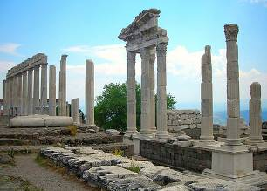
Departure from the hotel and drive to Pergamon. Under the Hellenistic Attalid dynasty, Pergamon became the most powerful city-state in Asia Minor. On a steep-sided hill are remains of palaces, the Altar of Zeus (most of which is now in Berlin), the 2nd century A.D. Temple of Trajan, ruins of the famous Library, known as the second best of the antiquity and rivaling that of Alexandria, and the ‘Temple of Serapis’ (Red Fort), the ancient Egyptian god of the underworld, lying on flat ground below the acropolis.
Allianoi, an ancient spa settlement from the Roman period, which was recently discovered. Apart from the 2nd century Roman orator Aelius Aristides, no other ancient source makes mention of this settlement. The site is inside the projected reservoir of the Yortanli Dam, the construction of which was recently completed. However, the dam has not yet been activated due to the ongoing discussions in Turkey and the international protests to preserve Allianoi. Europa Nostra, under its ‘Heritage at Risk’ scheme, is actively involved in this campaign.
A short drive takes us to impressive Asclepion, the famous healing center of the ancient world. This large complex at Pergamum was originally constructed in the 4th century B.C. Emperor Hadrian further developed the center in 2nd century A.D.
After Asceplion visit, a 2,5 hours’ drive will take us to Çanakkale.
Dinner at a local restaurant and overnight stay in a 4 star hotel in Çanakkale.

6 June 2010
After breakfast we will drive to Troy in Hisarlık, Anatolia, close to the seacoast, in what is now Canakkale province in northwest Turkey, southwest of the Dardanelles under Mount Ida. Troy was a city, both factual and legendary, best known for being the focus of the Trojan Wars as described in the Epic Cycle, and especially in the Iliad, one of the two great poems attributed to Homer. Trojan refers to the inhabitants and culture of Troy, the Troy National Park, famous with the legendary Trojan Horse from the times of Beautiful Helen, Queen of Sparta, and Paris, the Trojan Prince. Lunch in a local restauraurant.
Afternoon visit to Gallipoli, the dramatic World War I battlefield. We will visit the Anzac Cove, the War Cemeteries (Beach Cemetery, Quinn’s Post, The Nek) and the Anzac Memorials (Lone Pine - Australian Memorial, Conk Bair - New Zealand Memorial, Hellespont - English Memorial) of the naval battle (18 March 1915).
Dinner at a local restaurant and overnight stay in Çanakkale.

7 June 2010
Continuation of visiting Gallipoli, and drive to Istanbul (approx. a 5,5 hours’ drive) and arrival time at the main Sultanahmet hotels will be around 17:00 hrs.
Lunch will be taken en route.

Tour Price:
Per Person in DBL Room Euro 580
SGL Supplement Euro 180
Flight ticket * Euro 85

* The ticket price for the flight from Istanbul to Izmir is approximate, and may be revised according to the price in force at time of registration.

II. POST-CONGRESS TOUR – 13-16 June 2010

Ankara & Cappadocia Tour (PS 3)

13 June 2010
Departure from the hotel to the train station for the 22:30 hrs overnight train. Compartment train will used for Istanbul-Ankara transfer.

14 June 2010
Arrival at Ankara at 07.00 hrs. After breakfast, we shall visit the most important museum of Turkey, the Museum of Anatolian Civilizations. The Museum of Anatolian Civilizations, reaching the present time with its historical buildings and its deeply rooted history, was elected the first "European Museum of the Year" in Switzerland on 19 April 1997.
The exhibitions start with the Paleolithic era, and continue chronologically through the Neolithic, Early Bronze, Assyrian trading colonies, Hittite, Phrygian, Urartian, Greek, Hellenistic, Roman, Byzantine, Seljuk and Ottoman periods. There is also an extensive collection of artifacts from the excavations at Karain, Çatalhöyük, Hacılar, Canhasan, Beyce Sultan, Alacahöyük, Kültepe, Acemhöyük, Boğazköy (Gordion), Pazarlı, Altıntepe, Adilcevaz and Patnos, as well as examples of several other periods.The exhibits of gold, silver, glass, marble and bronze works date back as far as the second half of the first millennium BC. The coin collections, with examples ranging from the first minted money to modern times, represent the museum's rarest cultural treasure.

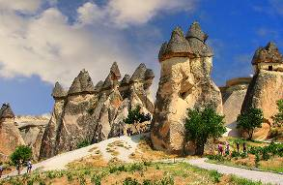
After the museum visit, we will drive to magnificent Cappadocia (4 hrs), with a break for lunch. Cappadocia is a region in central Turkey, largely in Nevşehir Province. The name was traditionally used in Christian sources throughout history and is still widely used as an international tourism concept to define a region of exceptional natural wonders, in particular characterized by fairy chimneys and a unique historical and cultural heritage.
Dinner in a local restaurant and overnight stay at a 4 star hotel in Cappadocia.

15 June 2010
After breakfast, we will visit, Devrent Valley (also known as Camel Valley), Pasabag Valley as "fairy chimneys", where the “voice of wind” mixes with the "songs of fairies", Uçhisar, the Göreme National Park to see the best examples of Byzantine art in Cappadocia in rock-cut churches (Serpent Church, Apple Church, Tokalı Church, St. Basil’s Church, Sandal Church and Monasteries) with frescoes and paintings dating from the 10th to 13th century, and the Zelve Open Air Museum.
Dinner at a local restaurant and overnight stay in Cappadocia.

16 June 2010
Tour to Derinkuyu Underground City, one of the most interesting underground settlements in Cappadocia, and to the dramatic Ihlara Valley Gorge, cut by a small stream (Melendiz Suyu) through the volcanic Cappadocian landscape for 45 km southeast of Aksaray, which area holds about 60 Byzantine churches, chapels, monasteries and hermits' caves dating from the 11th to 13th centuries. Lunch will be taken en route in a local restaurant.

Drive to Kayseri Airport for the return flight to Istanbul at 18:00 hrs with arrival at Istanbul Airport at 19:40 hrs, from where you will be taken to the main Sultanahmet hotels

Tour Price:
Per Person in DBL Room Euro 515
SGL Supplement Euro 160
Flight ticket * Euro 85

* The ticket price for the flight from Kayseri to Istanbul is approximate, and may revised according to the price in force at time of registration.

III. POST-CONGRESS EXCURSIONS on Sunday 13 June 2010

Alternative 1 – Bursa & Iznik Excursion – Full Day (PS 1)

Early departure from the hotel for an approx. 3,5 hrs drive to Bursa, including a 75 min. crossing of 75 min. by ferryboat. Bursa lies in the northwestern part of Turkey near the sea of Marmara. The city was the first capital of the Ottoman Empire and remains one of the greatest treasure houses of Islamic architecture. It is also famous for its peaches, chestnuts and silks.
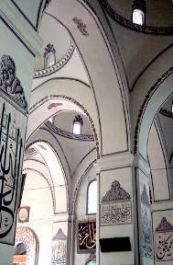
The Green Mosque and the neighboring Green Tomb (Mausoleum), both world-renowned for their superb tiles decoration, as well as the late 14th century “Ulu Camii” (the Great Mosque) and the Koza Han, which was the center of Bursa's flourishing silk trade for centuries, will be visited. After lunch, on the way back to Istanbul, we will visit Iznik (Nicea) with its numerous well-preserved historic monuments, and renowned for its traditional tiles industry. It was in Iznik where the prominent first Ecumenical Council, convened by Constantine, was held, resulting in the condemnation of Arian heresy (adherents of a doctrine which denied the full divinity of Christ) and the promulgation of the Nicene Creed, a formal statement of Christian belief; it was also the initial location for the Seventh Council at which the Iconoclasts were denounced. Lunch will be taken at a local restaurant.
We shall return to the hotels in Istanbul at around 19:30 hrs. approx.
Tour Price: Per Person Euro 200

Alternative 2 – Tekirdağ & Edirne Excursion – Full Day (PS 2)

Early departure from the hotel and a 1,5 hrs drive to Tekirdağ. Then we continue to Tekirdağ and visit the essential Rakocki Museum, dedicated to the most important figure of Hungarian Independence. The history of the city of Tekirdağ dates back to around 4000 BC. In the Ottoman period the city was successively a part of the province of Rumelia, Kaptanpaşa (centered at Gelibolu), Silistre and Edirne. We will visit Rüstem Paşa Camii, built by the Ottoman architect, Mimar Sinan, and then continue to Edirne (ancient Hadrianopolis), is a city in Thrace, the westernmost part of Turkey, close to the borders with Greece and Bulgaria. Edirne served as the capital city of the Ottoman Empire from 1365 to 1457, when Constantinople (Istanbul) became the empire's new capital. Edirne is vibrant, exciting, sensual, hard, European and Oriental at the same time, and carries significant structures from its past history. Lunch will be taken in a local restaurant. After lunch, we shall visit:
Eski Camii (The Old Mosque), built of cut stone and brick in 1402-14, with its fine white marble portal and decorative calligraphy on the interior walls and pillars.
Üç Serefeli Camii, the name of this mosque derived from the three balconies on the southeast minaret. Each balcony is reached by a separate stairway. The decorative tile designs on the minarets are all different. The minarets were the most important development in the structure of the mosque in the fifteenth century.
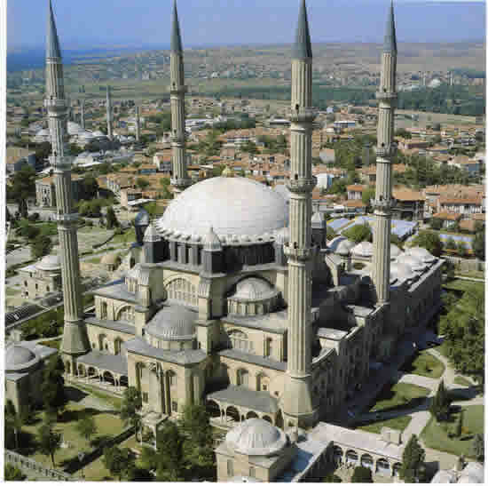
Selimiye Mosque, Edirne's crowning glory, was built for Selim II (1566-74) by Sinan, who was the architect of the Abode of Felicity for 50 years. It is the masterpiece of Sinan's old age. The symmetrical design is strongly emphasised by the four minarets and the soaring rise of the central dome.
Semiz Ali Pasa Arasta is also the work of Sinan. Completed in 1589, it is a long tunnel-like building with shops on both sides. Here you may buy one of Edirne's specialities, soap shaped like fruit or vegetables.
Meric Bridge (New Bridge) constructed at the junction of Meriç and Arda rivers between 1842 - 1847.
Kule Kapisi (the 12th century Tower Gate) is all that remains of the tower, which once protected the principal gate of the citadel. It was rebuilt by the Byzantine emperor John Comnenus II (1118-43) as part of his repais of the Hadrianic defensive system.
Return to your hotel in Istanbul will be at around 19:30 hrs. approx.

Tour Price: Per Person Euro 190

Alternative 3 –
Istanbul: Ancient City Walls & Yenikapı Excavations Excursion – Full Day (PS 3)

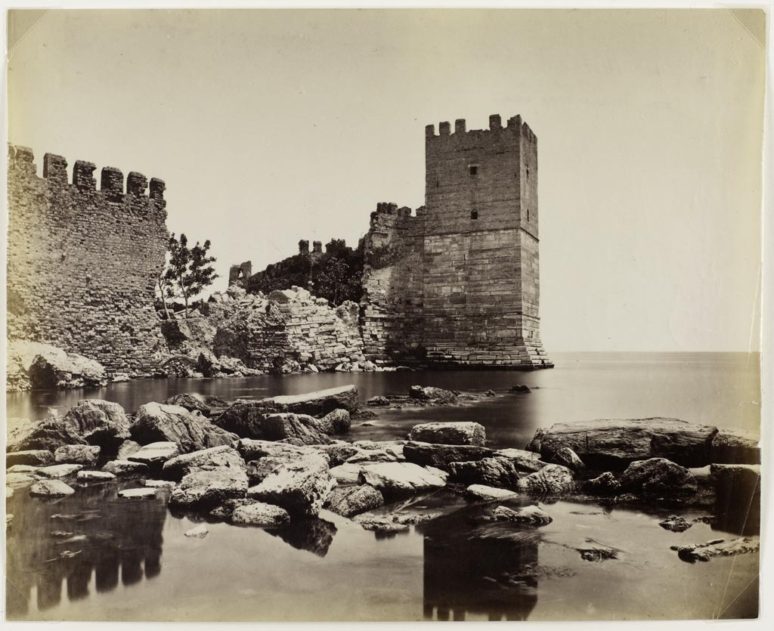
Departure of this tour will be in front of Topkapi Palace entrance, Fountain of Ahmed III, at 09.00 hrs, for a visit of the Ancient City Walls. Theodosius II’s great chain of land walls withstood countless sieges until the Ottoman conquest of the the city in 1453.
From there we shall proceed to the Palace of the Porphyrogenitus, known in Turkish as Tekfur Sarayı (‘Palace of the Sovereign’), which is a 13th century Byzantine palace in the north-western part of the old city of Constantinople (present-day Istanbul). Being an annex of the greater palace complex of Blachernae, it is the only Byzantine palace to survive in the city, and one of the few relatively intact examples of late Byzantine secular architecture in the world.
Thereafter we transfer to the Yenikapı Harbour. Yenikapı is noted for the ongoing excavations of its Byzantine port, discovered in 2004, which became one of the largest and most amazing investigations in Europe by the size and the number of the shipwrecks found since the initial discovery. The commercial harbor, in use between the 5th and 10th centuries, was, as such, an alternative to Constantinople's traditional berths situated along the inlet of the Golden Horn. Finally, we shall visit the important Archaeological Museum, which also includes a display of the excavations of Yenikapı. The excursion will end at 18.00 hrs at the Fountain of Ahmed III.
A light lunch will be taken in a local restaurant

Tour Price: Per Person Euro 35

IMPORTANT NOTE:

All tour and excursion prices are based on a minimum number of 8 participants. If this number is not achieved, the tour/excursion concerned will not take place.
Bookings for the tours and excursions should be made not later than on 8th March, whereupon VIP Turizm will evaluate on what tours and excursions sufficient inscriptions have been made for them to go ahead. So as to enable tour/excursion participants to make their main flight bookings on time, they will be notified latest by 15th March whether the tour/excursion of their choice will take place.

ALL TOURS/EXCURSIONS INCLUDE: TOURS/EXCURSIONS DO NOT INCLUDE:

Current VAT Flight Tickets for tours PR 1 and PS 3
Open buffet breakfast for tours PR 1 and PS 3 Beverages during lunches and dinners
Set menu lunch for the full day excursions Personal expenses
All lunches and dinners on tours PR 1 and PS 3

