EUROPA NOSTRA SELECTED HOTELS
8 – 13 June 2010
Istanbul

(Star ratings according to the Turkish system)

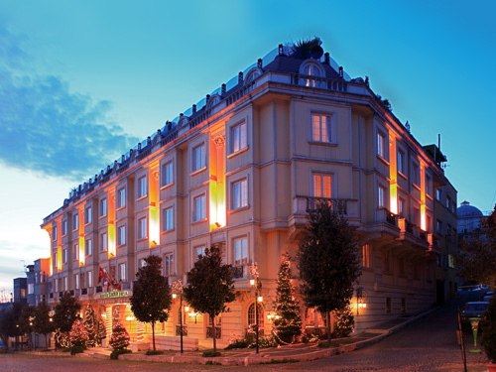
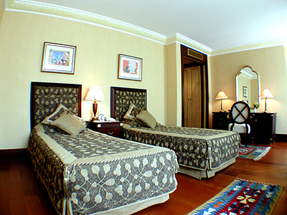
Hotel Name: Eresin Crowne Hotel
Location: Sultanahmet
Category: 5 Stars
Total Room Number: 60

Speciality: All rooms have parquet flooring and Jacuzzi bath tubs, and are equipped with individually controlled air-conditioning, double glazed windows, mini bar, tea & coffee making facilities, hair dryer, telephone by your bedside and in the bathroom, electronically locked safes, electronic key-card locks, color TVs featuring local and international satellite TV channels, radio and music stations, together with in-house multi-video and music systems.

Europa Nostra Special Room rates: Single € 220, Double or Twin € 245
Web Address: http://www.eresincrown.com.tr/index.html

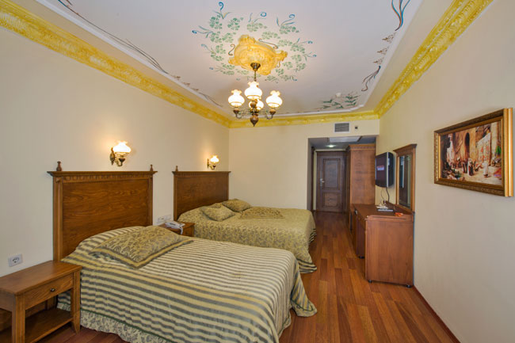
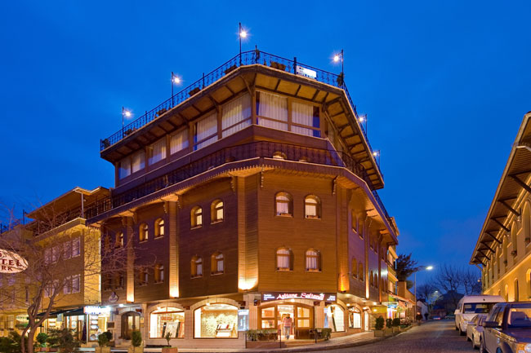
Hotel Name: Seven Hills Hotel

Location: Sultanahmet

Category: 4 Stars

Total Room Number: 20
Speciality: All elegant rooms are equipped with air conditioner, private bathroom with shower and deep bath tub, hair dryer, safety box, direct dial phones in room and bathroom, 32 inch LCD cable / satellite TV, wireless internet, minibar, kettle with hot drink set, wardrobe, daily housekeeping service, electronic room key system, fire alarm.
Europa Nostra Special Room rates: Single € 130, Double or Twin € 150
Web Address: http://www.hotelsevenhills.com/index.asp

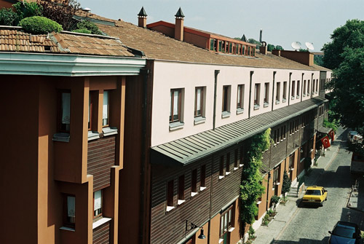
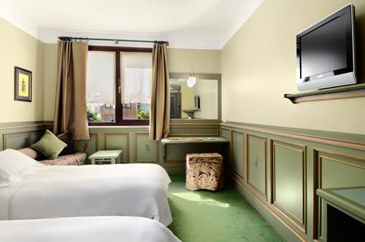
Hotel Name: Armada Hotel
Location: Sultanahmet
Category: 4 Stars
Total Room Number: 108
Speciality: The rooms include personal climatisation, direct-dial telephone service, mini-bar, LCD television, kettle, free wireless internet connection and private safe-deposit box. Along with the traditionally decorated rooms the private bathrooms are modern. They all have a tub and hairdryer, with their natural green and white soaps and specially knitted "Bursa" towels.
Europa Nostra Special Room Rates: Single € 118, Double or Twin € 129
Web Address: http://www.armadahotel.com.tr/pg_en/index.asp

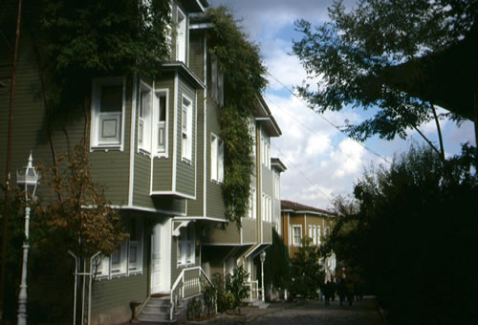
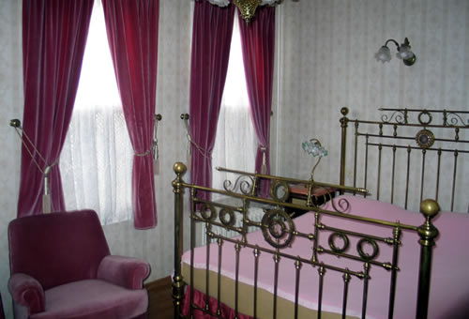
Hotel Name: Ayasofya Konaklari
Location: Sultanahmet
Category: Boutique Hotel (4 *)
Total Room Number: 63
Speciality: This highly original hotel is perfectly located in a very quiet spot behind Aya Sofya and next to Topkapi Palace. The nine hotel buildings consist of a row of guesthouses with a reception office between the cistern and the library. All rooms have individually controlled air conditioning and have private bathrooms with shower/wc, whilst a few have small bathtubs.
Europa Nostra Special Room Rates:
Rear facing : Single € 113, Double or Twin € 155
Front facing: Single € 130, Double or Twin € 181, Suite € 310
Web Address: http://www.ayasofyapensions.com/default.asp

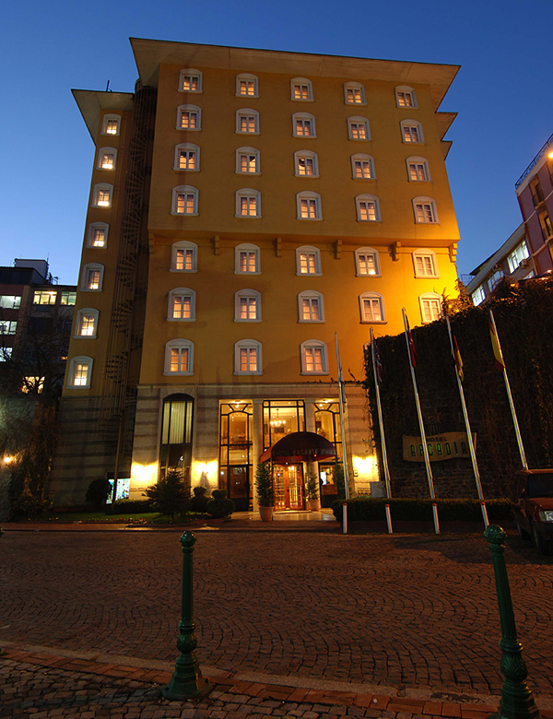
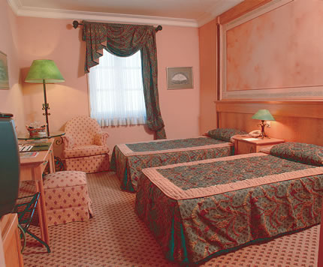
Hotel Name: Hotel Arcadia
Location: Sultanahmet
Category: 4 Stars
Total Room Number: 48
Speciality: Each room is equipped with all items of comfort such as air-conditioning, central heating system, mini bar, satellite TV, direct dialing telephone and wireless internet connection, safe-deposit box, special marble bathroom with bathtub, phone and hair dryer.
Europa Nostra Special Room Rates: Single € 87, Double or Twin € 100
Web Address: http://www.hotelarcadiaistanbul.com/eng/index.html

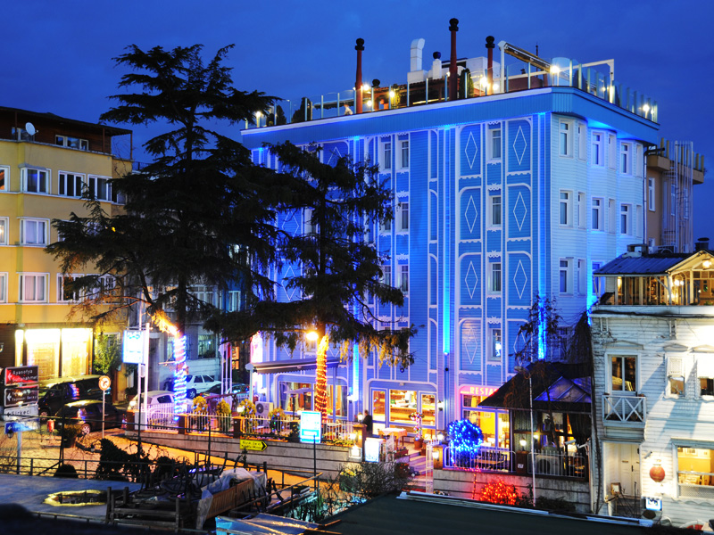
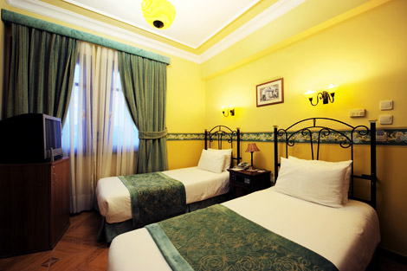
Hotel Name: Blue House Hotel
Location: Sultanahmet
Category: Boutique (3-4 *)
Total Room Number: 26
Speciality: The hotel offers comfortable guest rooms and a suite, facing the Marmara Sea and/or Blue Mosque. All rooms are equipped with airconditioning, minibar, cable TV system, hair dryer, radio / music system, direct dial telephone, shower / toilet and internet connection.
Europa Nostra Special Room Rates: Single € 90, Double or Twin € 110
Web Address: http://www.bluehouse.com.tr/english/

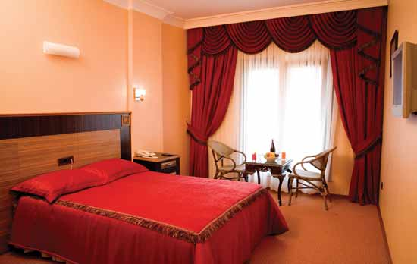
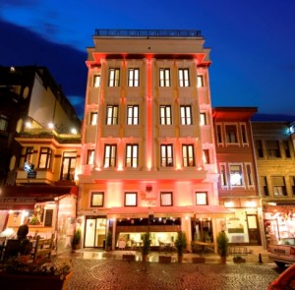
Hotel Name: Byzantium Hotel
Location: Cankurtaran
Category: 3 Stars
Total Room Number: 32
Speciality: The Byzantium Hotel offers stylishly designed rooms, decorated to a high standard with contemporary furniture and with attention paid to every detail. The modern look has been designed to recreate a "Home away from Home" atmosphere. The rooms offer air conditioning, direct dial telephone, minibar, safe box, hair dryer, slippers, wake up service, satellite TV, free wireless internet service.

Europa Nostra Special Room Rate: Single, Double or Twin, all € 84

Web Address: http://www.thebyzantiumhotel.com/index.html

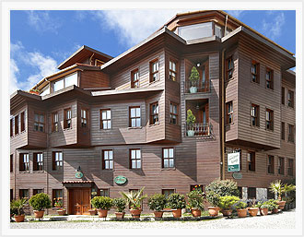
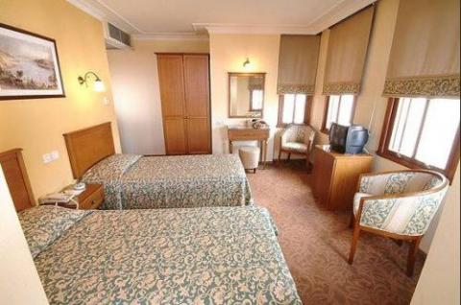
Hotel Name: Yusufpaşa Konağı
Location: Cankurtaran
Category: 3 Stars
Total Room Number: 24
Speciality: All rooms are with private bathroom, hairdryer, direct dial telephone, TV satellite system, internet, music, windows with black out curtains, and are equipped with individually controlled air-conditioning. 24 hours room service, laundry and pressing, safety boxes at reception, terrace cafe-restaurant, free car park.

Europa Nostra Special Room Rates: Single € 60, Double or Twin € 74

Web Address: http://www.yusufpasakonagi.com/

