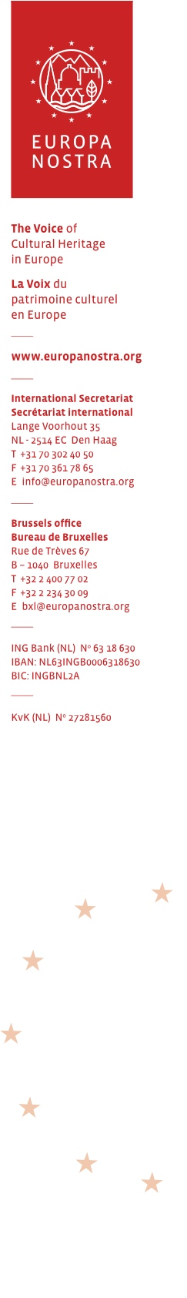
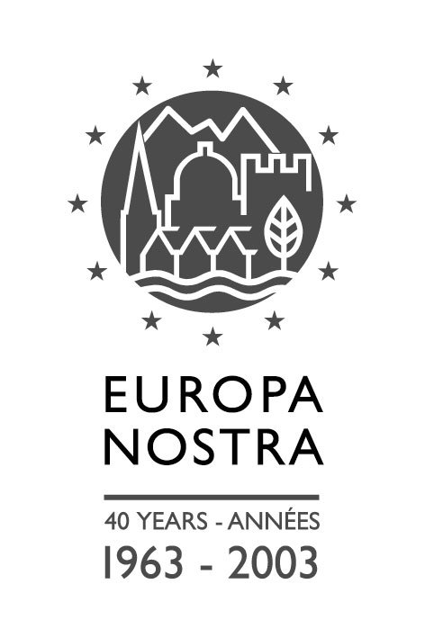EUROPA NOSTRA ANNUAL CONGRESS 2010
Istanbul, 8-12 June 2010

General Information

Contents:

1. The Programme of the Congress
2. A Congress registration form
3. A bookings form for hotels, airport transportation, and the pre and post
congress tours and excursions
4. General Information sheets on the selected hotels and on the tours and
excursions organised before and after the main Congress programme.

We strongly recommend that you carefully read these enclosures, since they
contain important and useful information.

We shall be grateful if your Congress Registration Form is returned to the
Europa Nostra International Secretariat by the hotel reservation deadline of
8 March, but in any case not later than 15 April 2010.

Since the month of June is high tourist season in Istanbul, the more so because of the added attraction of the city being European Capital of Culture, please be advised that hotel accommodation will be scarce, and should be booked as early as possible. At a number of selected hotels block reservations have been made at special rates. However, please note that the deadline for hotel reservations at these special rates is 8 March 2010.

Hotel and airport transportation reservations, as well as bookings for the pre and post congress tours and excursions, should be made directly with the logistics organisation, VIP Turizm at Istanbul, which has been appointed to exclusively handle all accommodation, and other logistic, requirements. Preferably relevant bookings should be made by e-mail (europanostraistanbul2010@vip.com.tr). Information sheets on the selected hotels and the pre and post congress tours and excursions are attached. The hotels are all located in the Sultanahmet area, where some of the main events will take place, and from where all transports to other venues will originate.

Turkish Airlines offer a discount of 10% for Europa Nostra Congress participants booking their flights to and from Istanbul. This discount can be only obtained when bought from a Turkish Airline sales office (not online). The discount code is: BB810.

For more information and any correspondence on the Congress, please contact Mrs Barbara Zander at our Secretariat (direct telephone: +31-70-3024054, by fax: +31-70-3617865, or e-mail: bz@europanostra.org).

