
The Hague, February 2010

TO ALL MEMBERS OF EUROPA NOSTRA
RE: Invitation to the Europa Nostra Annual Congress 2010 in Istanbul
(8-12 June 2010)

Dear Members,
On behalf of our Executive President, we take great pleasure to invite you to this year’s Europa Nostra Annual Congress to be held from 8-12 June in Istanbul, one of the greatest cities not only of Europe but of the world. By holding our Congress in Istanbul, we wish to contribute to the city’s celebrations as having been selected by the EU Member States to be one of the three cities carrying the prestigious title of “European Capital of Culture 2010”. We are proud to inform you that Europa Nostra’s Congress has been included in the “Istanbul 2010 European Capital of Culture” official programme and has received an important financial grant from the “Istanbul 2010 Executive Agency”. We are most grateful for this vital support.
Europa Nostra’s new Board attaches great importance to our Istanbul Congress. On this occasion, our members will have the opportunity to (re)discover the unique multi-cultural and multi-religious heritage of Istanbul. Ensuring a sustainable future for this heritage is of concern to all those who care for the preservation of Europe’s spirit, soul and memory, and who believe that cultural heritage should in future play a stronger role in building bridges and promoting mutual respect and understanding between Turkey and the rest of Europe.
Our Congress should in particular provide us a platform for meeting representatives of a growing civil society movement committed to cultural heritage in Turkey, and for connecting those organisations with the wider European heritage movement. We also hope that the Congress will lead to the launch of Europa Nostra’s country representation in Turkey, the aim of which will be to act as an efficient liaison and coordinating body between Europa Nostra and heritage NGOs in Turkey.
The organisation of our Congress was made possible thanks to the immense commitment and tireless efforts of our Turkish Board member Dr Orhan Silier and his team composed of representatives of Europa Nostra’s members from Turkey, working hand in hand with our International Secretariat in The Hague.
You will find enclosed the programme of our Congress, encompassing a wide variety of events open to both our members and the interested local public. Planned meetings include the Europa Nostra Forum on the topical theme of “Multiple Identities, a Common Heritage”, organised with the kind cooperation of the Mimar Sinan University, with as venue the impressive setting of the Cultural Center Tophane, a true architectural landmark of historic Istanbul, built by the famous Ottoman architect Mimar Sinan. The Annual Colloquium of our Scientific Council is being organised by Prof. Isik Aydemir, Vice-President of Europa Nostra’s Scientific Council, and his colleagues from the Istanbul Technical University and the Kadir Has University. We also very much hope that many members will attend the General Assembly which has been planned for 9 June (draft agenda enclosed).
As in previous years, the highlight of our entire programme will be the European Heritage Awards Ceremony, to be held in the unique setting of a 6th century Byzantine church, Aya Irini (Hagia Eirene), located in the first courtyard of the Topkapi Palace. On this occasion, we will celebrate this year’s laureates of the EU Prize for Cultural Heritage / Europa Nostra Awards together with Mrs Androulla Vassiliou, new European Commissioner responsible for Education, Culture, Multilingualism and Youth, as well as with representatives of the Turkish authorities and a large number of invited guests. For in the morning of the same day, the Awards laureates have been invited to present their winning achievements to the Congress participants at the Kadir Has University, located in the former Cibali tobacco factory whose exemplary conversion won one of our Awards in 2003. As with last year, the European Heritage Awards Ceremony is benefiting from the kind financial support of our partner ACLEU, the Association of Charity Lotteries in the EU.
We are very pleased that we will be joined for our Congress by the European members of the International National Trusts Organisation (INTO), with whom Europa Nostra signed last September a Memorandum of Understanding promoting a mutually beneficial partnership.
The World Heritage City of Istanbul itself, and the entire programme of meetings and cultural discoveries during Europa Nostra’s Annual Congress 2010 in “Istanbul, ville monde” certainly “vaut le voyage”. We therefore invite you to register as soon as possible! Let us gather in Istanbul in great numbers, strongly demonstrating the power and the spread of representation of our European heritage movement. Let our “European Cultural Heritage Summit” in Istanbul also fully confirm Europa Nostra’s willingness to reach out to Turkish heritage professionals and volunteers and to welcome them as active and creative contributors to our shared ambition and our common endeavours.

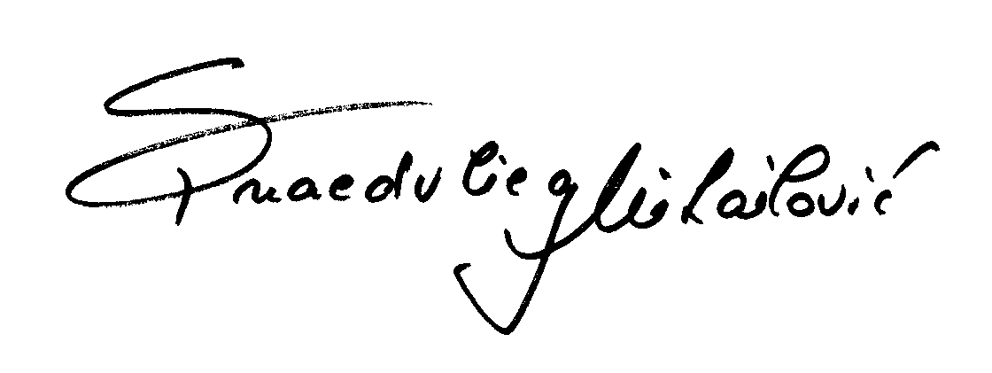
With our very best regards,

Sneška Quaedvlieg-Mihailović
Secretary General

ENCLOSURES

