UNESCO Project: “The Reinstallation of the Aksum Obelisk”

The scale of the operation to reinstall the Aksum Stele 2 in its original location has been one of ambitious dimensions. Commonly known as the Aksum Obelisk, Stele 2 weighs 152 tons and is 23.4 metres high including the foundation. Three massive blocks of carved granite, each weighing from 37.6 to 57.5 tons, were flown on an Antonov aircraft from Rome to Ethiopia in April 2005. Once the aircraft landed in Aksum, the granite blocks were transported by truck - amid joyful citizens - to the Aksum Stelae field, where they were deposited close to their original location in the Aksum World Heritage site.

Survey of the Aksum Obelisk/ Stele 2 in Rome

The preliminary studies
In October 2005, the Italian and Ethiopian governments sought the involvement of UNESCO to lead the difficult task of reinstalling the stele in situ. In 2006, UNESCO contracted La Sapienza University to undertake non-destructive archaeological investigations in the Aksum Stelae field (remote sensing through electric tomography and geo-radar techniques) over all the areas concerned by the reinstallation works, and carried out an Impact Assessment Study for the planned works.
The Engineering Project
In January 2006, UNESCO employed the Engineering firm Croci Associati to carry out a detailed engineering project for the reinstallation of Stele 2. Ethiopian experts including archaeologist Tecle Hagos and engineer Messele Haile Mariam (MH Engineering) took part in the feasibility study and provided great input to the project design.

The engineering project took into consideration the results of the remote sensing investigations and the risk assessment study. The engineers designed a temporary embankment, or platform, with rails on which to slide the granite blocks, and a foundation with a cantilever to support a provisional 30-metre steel tower to lift and position them, in a way that would not exert any weight on the archaeological remains. On top of the steel structure, a traveling crane was mounted to maneuver the stele blocks horizontally and lift them.

The Foundation (plan and profiles) A plan of the foundation (upper left) and the s embankment (right)

The design of the reinstallation project has taken into account the fact that the Aksum Stele 2 was no longer monolithic and the three blocks had to be placed separately one over the other. Traditional techniques used for the erection of obelisks were no longer appropriate.

The protection of Stele 3

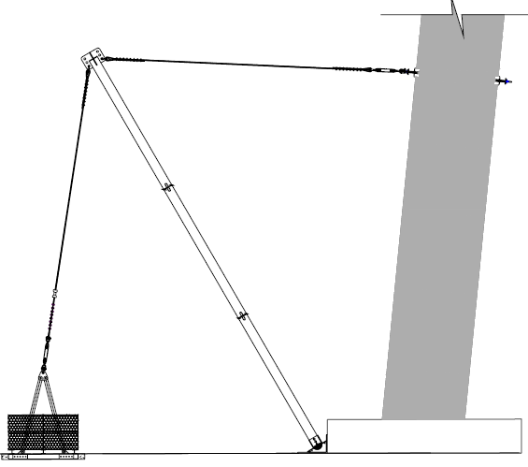

Profile of the Stele 3 Temporary Consolidation Structure

Having noted that Stele 3 - the only remaining decorated stele still standing in situ and approximately 1 metre shorter than Stele 2 - leaned dangerously from its original position due to an inadequate foundation and the effects of several earthquakes, the engineers decided to protect it from any potential negative effects of the reinstallation work by designing a provisional system to prevent it from leaning further. This system consisted of two inclined rafters fixed at the base of the stele which support two cables anchored on the ground and on the stele. The tension on the cable could be regulated and a monitoring system allowed any movement in the standing stele to be controlled.

The reinstallation works
In June 2007, UNESCO signed a contract with the Construction Company Lattanzi S.r.l. to begin the work for the reinstallation of the Aksum Obelisk/ Stele 2.

The first segment of the work started in July 2007 and focused on the organization of the site. The three blocks were moved to a new location to allow the replacement of the provisional metallic reinforcements used during the transportation. New reinforcements were installed to lift the blocks to their final position. During this segment, four longitudinal holes were drilled in each block in order to insert longitudinal synthetic fiber bars (in Kevlar) that guarantee the future structural continuity between the blocks and, therefore, the improved the seismic resistance of the reinstalled stele.
During this segment, the provisional consolidation system was installed on Stele 3.

The second segment of the work which concerned the lifting and positioning of the stele blocks took place in June and July 2008 according to the following sequence of operations:
The first block with its base was placed on a hemispheric hinge already installed in the recently built foundation. By means of adequate topographic measuring, the vertical and transversal position of the block was defined and a system of jacks was installed to allow for the required corrections. On the 10th of June 2008 the first block was fixed in the reinforced concrete foundation. It took approximately 15 days for the concrete to dry.
The second block was lifted and, through a series of movements, placed vertically on the first one. While the second block approached the first one, the Kevlar fiber bars were inserted in the holes drilled in the first block. When the surfaces of the two blocks were aligned, the holes were injected, and the surfaces sealed with a special resin-based mortar. At this point, verification of final positioning and possible corrections were carried out.
The same procedure was followed for the third block.
The lifting and positioning of the Stele 2 second block was completed on 25 July 2008 and the third block on 31 July 2008.

The third segment of the work which concerned the removal of the traveling crane, the supporting steel structure and the provisional protection of the blocks’ surfaces in order to prepare for the final restoration of the stele, was completed in December 2008.
Additional studies are on-going to ensure a sustainable solution for the consolidation of Stele 3 and the removal of the temporary safety devices.

Lifting-up and positioning the Stele 2 blocks
The total budget for the project implemented by UNESCO (studies and works) is US$ 5 million, and is entirely funded by the Italian government, which also financed the dismantling of Stele 2 in Rome and its transportation to Aksum. The goal throughout the operation was to protect this exceptional monument and minimize risk at all levels.

The inauguration ceremony took place in Aksum in the presence of the UNESCO Assistant Director-General for Culture and high level guests on the 4th of September 2008 to celebrate the re-erection of the Aksum Obelisk and mark the end of the Ethiopian year 2000 celebrations.

Communication activities
An information campaign entitled “Home Coming and Re-erection of the Aksum Obelisk, Celebrating Ethiopia’s Cultural Heritage and Cultural Diversity” was held in Ethiopia from December 2005 to July 2006 and included the display of giant banners in the airports of Addis Ababa and Aksum, and regular communication with the press and other activities with the media in the town of Aksum.

UNESCO has worked on several communication activities which include a traveling exhibition that started at UNESCO Headquarters in Paris (13 April to 29 May 2009). The exhibition will take place in Rome, (25 November to 4 December 2009), before going to Addis Ababa.

A photographic and video coverage of the works was undertaken, and a book on the project will be published in January 2010.

Capacity-building activities

Ethiopian restorers have been trained on-the-job during the restoration of the stele surfaces and in Tower of Pisa restoration site by the Central Institute of Restoration (Italian Ministry of Culture).

Following UNESCO experts’ assessment of the capacity building needs in Aksum, UNESCO’s World Heritage Centre held a national workshop on the management of the Aksum World Heritage site aiming at setting guidelines for the site’s management plan. The workshop took place from 31 May to 5 June 2008 and involved site managers of all the Ethiopian cultural sites inscribed on the World Heritage List.
To improve the visiting conditions and contribute to the development of sustainable tourism, UNESCO also organized training for 15 tourism guides in Aksum, in collaboration with the World Federation of Tourism Guides.

