World Heritage 33 COM

Distribution Limited WHC-09/33.COM/INF.13

Paris, 29 May 2009

Original: English/French

UNITED NATIONS EDUCATIONAL, SCIENTIFIC
AND CULTURAL ORGANIZATION

CONVENTION CONCERNING THE PROTECTION OF
THE WORLD CULTURAL AND NATURAL HERITAGE

WORLD HERITAGE COMMITTEE

Thirty-third Session

Seville, Spain

22-30 June 2009

Item 13 of the Provisional Agenda: Revision of the Operational Guidelines

INF.13: Working group on the World Heritage emblem and contributions to Revisions of the Operational Guidelines

SUMMARY

Decision 32 COM 13 refers to the establishment of an informal working group to examine and propose revisions to Chapter VIII of the Operational Guidelines for the Implementation of the World Heritage Convention to include new procedures and tools allowing for consistent and appropriate use of the World Heritage emblem.

This document is proposed to inform the World Heritage Committee on the progress made by the Working group. It includes background, summary reports of meetings held, a summary analysis between existing guidelines and directives, a proposed revision to the text of the Operational Guidelines and recommendations for the future.

This document should guide the work of the Committee in formulating a decision on action to take on the issue of the harmonization of guiding texts on the use of the emblem within UNESCO and on possible measures that could be undertaken in the meantime.

Draft Decision: 33 COM 13Rev, see document WHC-09/33.COM/13

BACKGROUND

- In 1996, at its twentieth session, the Committee requested a Financial Audit of the World Heritage Fund for the year ending 31 December 1996 and a Management Review of the World Heritage Convention. Furthermore, the Committee established a Consultative Body "to take action on the proposal adopted by the Committee, to undertake a review of the way in which the World Heritage Centre has assisted the Committee in implementing the World Heritage Convention".

- At its twenty-first session in December 1997, the Committee requested that the Consultative Body examine the following four issues:

1. Technical issues

2. Communications and Promotion

3. Management Review and Financial Audit

4. Use of the World Heritage Emblem and Fund-Raising Guidelines

- In 1998, during the twenty second session (Kyoto), the Committee adopted a new section of the Operational Guidelines, embodied as Chapter VIII of the existing text in which the Committee reflected guiding principles and authorization procedures. In essence, the guidelines encouraged States Parties to use the emblem and ensure its management within their country by developing policies and exerting adequate quality control at the national level. The Director of the World Heritage Centre was authorized to grant the use of the emblem in cases involving quality control of content in more than one country and thus performed an important coordination task among concerned parties.

- Since the adoption of the revised emblem Guidelines in 1998, revisions were limited to the protection of the emblem, as an official seal of the World Heritage Convention, following a request to increase protection of the emblem itself.

- The Directives for the use of the name, acronym, logo and internet domain names of UNESCO (adopted in 2007 by the General Conference of UNESCO at its thirty-fourth session) and the text contained in chapter VIII of the Operational Guidelines concerning the use of the World Heritage emblem could be maintained as two separate sets of guiding principles: one that recognizes the central role of UNESCO and its Members States in coordinating and ensuring appropriate protection of its name and logo, offering increased visibility through a well managed image and the other, complementary to the first, providing specific guidelines to States Parties to the World Heritage Convention for the application of the World Heritage emblem.

- It should be noted nonetheless that two separate documents can create confusion especially as pertains to the authorization procedures (National Commissions for UNESCO vs World Heritage emblem focal points, cf. Circular Letter of 14 April 1999, http://whc.unesco.org/circs/circ99-4e.pdf), visual applications and the guidance provided to users. Greater consistency in guidance provided about the usage of the World Heritage emblem would facilitate the work of all involved and maximize the potential of the World Heritage brand image.

- In addition, consolidated guidance, in line with the strategic objective of the World Heritage Committee on Communication (Budapest Declaration, 22 June 2002), would certainly benefit site management and national authorities, who would be able to convey the concept of Outstanding Universal Value embodied by the inscribed sites to the public at large. Moreover, the current Operational Guidelines text provides insufficient guidance to site managers/management as per the use of the World Heritage emblem at the site (plaques, information materials, other non-commercial products) and gives a rather old fashioned approach to the use of the emblem notably as pertains to its use in the context of partnerships with the private sector, thus limiting outreach capacity.

- The new text proposed aims to provide a set of revised principles, clearer guidance to States Parties so that they may embrace their role at the national level and provide appropriate advice and tools to site managers/management as well as revised procedures and quality control mechanisms. Furthermore, in light of the Committee’s wish to promote and reinforce the development of partnerships as well as promotional and educational activities on global, national and local scales, it would be useful to formulate appropriate revisions that will take the commercial character of some requests to use the emblem into consideration.

- Moreover, the present exercise and ensuing text revisions must convey and demonstrate existing advantages and necessary links between the desired use and the best use. While the benefits derived from increased promotion of the values of the World Heritage image through improved use of the emblem have been clearly established in the past, the scope and conditions under which the brand or image can be administered and encouraged must yet be better defined.

- A comparative analysis of the UNESCO Directives and the Operational Guidelines was prepared and examined by the Working group on the World Heritage emblem. This revealed discrepancies including:

i. Applicability: The Directives for the use of the name, acronym, logo and internet domain names of UNESCO foresee rights to use the logo only by Governing Bodies, the Secretariat and National Commissions. The applicability is wider in par. 266 of the Operational Guidelines.
ii. Authorization by national authorities: there is recognition of the role of National Commissions for UNESCO in the Directives as opposed to States Parties and national authorities/agencies in the Operational Guidelines. According to the Directives, the National Commissions are the principal point of contact for authorization procedures while specific World Heritage focal points have been established for that purpose in several countries (following par. 277 of the Operational Guidelines and subsequent Circular Letter CL/WHC.4/99 sent to States Parties in April 1999).
iii. Quality control procedures (par. 278 of the Operational Guidelines) involve the Director of the Centre, the Chair and the Committee in rare cases and the States Parties concerned. States Parties can only approve content and/or requests formulated about the sites in their respective country, whether the project is of national or international dimension. The Directives foresee consultation with the National Commissions but there is no specific item referring to quality control.
iv. Commercial value, contractual conditions for the use of and the fund-raising potential of the Emblem are referred to in par. 264, 266 and 275 of the Operational Guidelines, which, according to the Directives is the prerogative of the Governing Bodies or the Director-General on their behalf. The text of the Operational Guidelines is not specific about the conditions or authority needed for such use of the emblem.
v. Third party use (non specific) of the emblem is acknowledged in par. 274 of the Operational Guidelines.

WORKING GROUP

- The informal Working group established by the Committee (Québec, Canada) met on 24 February 2009, on the eve of the workshop about the ‘Future of the World Heritage Convention’. It established a tighter group composed of Brazil, Israel, Kenya, and Morocco that subsequently met on 18 May 2009, joined by several Committee Delegations (Australia, Bahrain, Canada, Jordan, Madagascar, Spain, and United States of America) and representatives of the Advisory Bodies. Full reports and supporting documents are available on the World Heritage website: http://whc.unesco.org/en/events/577.

- Discussion at these meetings focused on the following principal points:

  - Procedures

While the Directives triggered a process and may have forced the Committee to look closely at these issues, it was noted that the Committee remains sovereign over the use of the World Heritage emblem and could decide to keep separate guidelines. Nonetheless, participants agreed that a standardized process, less ambiguous than the Operational Guidelines, would help give greater clearer visibility to the World Heritage Convention.

Distinction was made between the right to use the emblem, notably by sites, and the right to authorize its use, notably by national and local authorities as well as other user groups. Clarification was brought by the representative of the Bureau of Public Information as regards the guidelines of the UNESCO Directives that allow National Commissions for UNESCO the right both to use and authorize the use of the linked logo provided the use of the logo is not foreseen in a commercial, contractual or patronage related context. There was consensus on the suitability of identifying a national entity within each country responsible for the emblem which should ideally work with the National Commission, if the National Commission could not ensure this role. This would ensure a more decentralized approach, allowing local authorities to embrace the emblem and work towards its increased use in all suitable contexts.

Flexibility was also flagged as an important component of the process to help ensure that all stakeholders (from local partners, municipalities, regional entities and communities) could take part fully in promoting the World Heritage message. This was closely linked to the need to keep any future graphic guidance open enough to allow for such associations to be made, notably in cases where States Parties to the Convention but not Member to UNESCO would not be prevented from using the World Heritage emblem.

Concerning interim arrangements, it was explained that the current practice is to follow the instructions provided by the Directives within UNESCO, and thus to promote the use of the linked logo (UNESCO + WH). Several examples of linked logo use currently being promoted were shown and have been annexed to this information document. The existing text in the Operational Guidelines remains valid nonetheless until modified. The World Heritage Committee, empowered to make modifications to the Operational Guidelines, may wish to decide on interim measures in the event that chapter VIII of the Operational Guidelines is not amended in the near future.

b. Protection measures

All participants agreed that protection measures were an essential part of the discussion and that steps to protect the emblem at the international level through the World Intellectual Property Organization to register and communicate the World Heritage emblem should ideally be complemented through other mechanisms such as trade-marking. While this could have a positive effect on how the emblem is used, acting as a deterrent for misguided or illegal users of the emblem, it would most certainly have to be accompanied by strict quality control measures and surveillance modalities which would require an additional investment to any protection measure adopted. Participants generally agreed that trade-marking offered interesting perspectives but that it was also a complicated process requiring technical expertise. Additional clarification was provided as regards the trade-marking process, but the relationship between branding and trade-marking remained to be more fully explored. To clarify this complex issue further it was suggested that a study focusing on the advantages of trade-marking the World Heritage name be undertaken by the Centre, in collaboration with expert legal advice. This study, should the Committee decide to ask the Centre to carry it out, should also include information on modalities of execution and maintenance.

Participants called for a comparison of conditions of protection of logos of other similar programmes and quoted UNEP, UNDP, UNICEF or even WWF. Attention was also called to discussions held by the Intangible Heritage Committee about its emblem and several participants asked for a summary analysis of the two processes. The document of the Intangible Heritage Committee has, for now and with other information documents, been posted on the page of the World Heritage website dedicated to the Working group on the emblem: http://whc.unesco.org/en/activities/572/.

c. Graphic Standards

The issue of graphic guidance was referred to throughout the discussion as closely intertwined with procedures, quality control and protection measures. The need to give clear and easy to use guidelines was considered essential and a proposal to create a user’s manual containing practical guidance to allow for greater consistency in use by all stakeholders was welcomed. Some participants again called for flexibility noting the need to make use of UNESCO guidelines all the while making sure the World Heritage emblem could be used in specific cases without reference to UNESCO. Suggestions were made to develop appropriate reproduction criteria, including reference to language adaptations that were deemed essential, to ensure greater diffusion of the emblem and showcase best practices where policies and graphic guidance have helped to promote the Convention effectively.

d. Use of the emblem and its relation to outreach

It was duly noted that policy work developed in some countries could be used to orient the work of the group and help formulate acceptable proposals to the World Heritage Committee. The need for a revised text was, as recalled, voiced on a number of occasions by the Secretariat. The Director of the World Heritage Centre called for vision, and suggested that this exercise could serve to identify objectives for the Convention’s overall communication and outreach function. In addition, a study, as proposed by some participants, conducted in line with work done on branding and co-branding as a result of the workshop on the ‘Future of the World Heritage Convention’ could provide the Committee with useful insight as to the possible achievable results in the mid to long terms.

A cost, risks and benefits analysis was called for as a part of the study that could be undertaken, if funding was to be identified for this purpose, to determine what could be gained or potentially lost through a wide dissemination process of the emblem which would inevitably require more work and greater control not currently foreseen.

- In addition, the participants of the Working group meeting reiterated the need to focus on possible links to be made with the issue of branding discussed during the Experts’ workshop ‘Future of the World Heritage Convention’.

- Reference was also made again to the need for clearer guidelines about delegation of authority and the specific role of local authorities and National Commissions in authorizing the use of the emblem. A request was placed by IUCN to give thought to the role of the Advisory Bodies and to the authorization they should be granted in using the emblem notably in reports and work done at the request of the Committee. Mention was made of the resource manuals under development, and the suitability of integrating information about the emblem, its governance and practical management, in the manuals.

- It was suggested that possible solutions to the perceived problem of insufficient flexibility in the use of the emblem by local stakeholders could be identified by providing examples of emblem use (whether linked or not) to the Committee. Several of these proposals have thus been annexed to this document to feed the reflection process. In addition, a recommendation was formulated for the Centre to undertake an in-house study with the support of a hired consultant for that purpose, to gather existing examples of policy guidelines and graphic practice at sites. This work should be done in cooperation with the Advisory Bodies. It was also noted that any further work undertaken in the future on graphic guidelines would require prior approval of the revised Operational Guidelines by the World Heritage Committee.

- Other studies, in addition to those mentioned in paragraphs 12b and 15 above, could be undertaken, funding allowing, analyzing and comparing different UN guidelines with UNESCO’s Directives and that proposed for World Heritage using specific and pertinent criteria such as involvement of local stakeholders. Information gathered by UNESCO in designing the Directives would certainly prove useful in this regard and could be provided to the Working group by the Bureau of Public Information for future reference.

- In thanking the Chairperson for having convened the meetings of the Working group it was said that the format of the group gave rise to quality debate and it was recognized as a very positive and constructive exchange model. The Working group could continue to work through the World Heritage website, via a secure page, by exchanging contributions, comments and sharing documents: http://whc.unesco.org/en/activities/572/.

- RECOMMENDATIONS

- Steps need to be taken towards the harmonization of the text of the Operational Guidelines with the text of the UNESCO Directives on the use of the name and logo. Further discussion on this topic is required which could take place during the forthcoming General Assembly of States Parties in October 2009. In the meantime, the Working group has made a number of recommendations that could be adopted by the Committee at its 33rd Session. They are:
  - The need to reinforce links between the emblem governance and graphic guidance issue and World Heritage branding, one of the main points of discussions during the Experts’ workshop “Future of the World Heritage Convention” held in UNESCO Headquarters in February 2009. The Delegate of Australia present during the meeting of the Working group in May stated her country’s wish to be associated to work on World Heritage Branding through the formulation of Terms of Reference for a study that could be undertaken in 2010.
  - Moving towards the development of a user’s manual: before a complete manual can be developed, it would be necessary to gather information pertaining to World Heritage emblem policies and graphic guidelines developed by States Parties and study them for a comprehensive approach to site needs as identified by national authorities.
  - The option to trademark the World Heritage name and emblem. This should be studied further with the help of specialized legal advisors in order to fully grasp the modalities and advantages of trade-marking.

- PROPOSED AMENDMENTS TO THE OPERATIONAL GUIDELINES

- The proposed amendments to the Operational Guidelines were elaborated by the Secretariat to facilitate the discussions of the Working group. While the text herein was not adopted formally by the Working group, the Secretariat was congratulated for work achieved in assisting the Working group and providing a solid base from which discussions and comments could be formulated. It was deemed necessary by the Working group to communicate this text to the World Heritage Committee as a part of an information document so that the Committee could refer to it in taking efforts on this issue further.

- Participants noted the importance of this subject and called for a more consultative process which could involve the General Assembly of States Parties, notably as pertains to the examination of proposed amendments to Chapter VIII on the use of the emblem in the Operational Guidelines.

- As recommended by the Working group, the text below was formulated on the basis of the existing text of the Operational Guidelines, striking out the text no longer required in the context of the harmonization of this text with that of the UNESCO Directives and highlighting the proposed new text for easier reading and comparison.

[Chapter] VIII.A Preamble Definition

258. At its second session (Washington, 1978), the Committee adopted the World Heritage Emblem which had been designed by Mr. Michel Olyff.

Insertion of the emblem

This Emblem symbolizes the interdependence of cultural and natural properties: the central square is a form created by man and the circle represents nature, the two being intimately linked. The Eemblem is round, like the world, but at the same time it is a symbol of protection. It symbolizes the Convention, signifies the adherence of States Parties to the Convention, and serves to identify properties inscribed in the World Heritage List. It is associated wit h public knowledge about the Convention and is the imprimatur of the Convention's credibility and prestige. Above all, it is a representation of the universal values for which the Convention stands.

259. The Committee decided that the Emblem proposed by the artist could be used, in any colour or size, depending on the use, the technical possibilities and considerations of an artistic nature. The Emblem should always carry the text "WORLD HERITAGE . PATRIMOINE MONDIAL". The space occupied by "PATRIMONIO MUNDIAL" can be used for its translation into the national language of the country where the Emblem is to be used.

260. In order to ensure the Emblem benefits from as much visibility as possible while preventing improper uses, the Committee at its twenty-second session (Kyoto, 1998) adopted "Guidelines and Principles for the Use of the World Heritage Emblem" as set out in the following paragraphs.

261. Although there is no mention of the Eemblem in the Convention, its use has been promoted by the Committee to identify properties protected by the Convention and inscribed on the World Heritage List since its adoption in 1978.

VIII.B Governance

262. The World Heritage Committee is responsible for determining the use of the World Heritage Eemblem and for making policy prescriptions regarding how it may be used.

The provisions of the present Guidelines apply only to the use of the emblem of the World Heritage Convention.

The use of UNESCO’s emblem or logo which accompanies the emblem of the Convention is governed by the Directives concerning the Use of the Name, Acronym, Logo and Internet Domain Names of UNESCO, as adopted by the General Conference of UNESCO*.

* The most recent version of the Directives concerning the Use of the Name, Acronym, Logo and Internet Domain Names of UNESCO is found in the annex to Resolution 86 of the 34th session of the General Conference (34C/Resolution 86) or at http://unesdoc.unesco.org/images/0015/001560/156046e.pdf

The use of the World Heritage emblem linked to the UNESCO logo, shall be governed by the present guidelines and the Directives concerning the Use of the Name, Acronym, Logo and Internet Domain Names of UNESCO (for the part of UNESCO’s logo) in accordance with the respective procedures provided under each of these Directives.

VIII.C Rights of use

Primary right of use: Only the Statutory Organs of the World Heritage Convention, i.e. the General Assembly and the Committee, as well as the Secretariat have the right to use the World Heritage emblem without prior authorization, subject to the rules set out by the present Guidelines.

Derivative right of use: National Commissions for UNESCO or other bodies as identified by the National Commission for UNESCO of a State Party to the World Heritage Convention may use the World Heritage emblem to designate and promote the inscription on the World Heritage List of one or several World Heritage properties in its country. The use of the emblem in this context must be done in accordance with graphical standards elaborated by the Secretariat.

National Commissions for UNESCO or other bodies as identified by the National Commission for UNESCO of a State Party to the World Heritage Convention shall coordinate and report on the use of the emblem in their countries, as may be requested by the General Assembly and Committee.

World Heritage properties may use the World Heritage emblem to designate and promote their own inscription on the World Heritage List. The use of the emblem in this context must be done in accordance with graphical standards elaborated by the Secretariat.

VIII.D Authorization

Authorizing the use of the World Heritage emblem is the prerogative of the Statutory Organs of the Convention, i.e. the General Assembly and the Committee. In specific cases as set out by the present Guidelines, the statutory organs empower, by delegation, the Director-General of UNESCO or his/her representative to authorize such use to other bodies. The power to authorize the use of the World Heritage emblem cannot be granted to other bodies.

The General Assembly and the Committee authorize the use of the World Heritage emblem by means of resolutions and decisions, notably in the case of official partners, global or regional prizes, and special events in the States Parties.

The General Assembly and the Committee should ensure that their resolutions and decisions stipulate the terms of the authorization granted, in accordance with the present Guidelines.

The Director-General or his/her representative is empowered to authorize the use of the World Heritage emblem in connection with patronage and contractual arrangements and partnerships, as well as specific promotional activities.

Any decision authorizing the use of the World Heritage emblem shall be based on the following criteria: (i) relevance of the proposed association to the World Heritage Convention and (ii) compliance with the values and principles of the World Heritage Convention.

The General Assembly and the Committee may ask the Director-General to put specific cases of authorization before them and/or submit to them an occasional or regular report on specific cases of use and/or of authorization, notably concerning the granting of patronage, partnerships and commercial use.

The Director-General may decide to put specific cases of authorization before the Governing bodies.

VIII.E Principles

Criteria and conditions for the granting of use of the emblem

Patronage, UNESCO’s highest form of support, is granted to show the Organization’s moral endorsement of an exceptional activity for which it is neither financially or legally responsible. It may be granted to various kinds of activities, for a specific duration, such as cinematographic works and other audiovisual productions, publications, congresses, meetings and conferences, the awarding of prizes, and other national and international events.

The procedures for requesting patronage and use of the World Heritage emblem shall be provided by the Secretariat, in line with the following criteria and conditions:
- Criteria:
- Impact: use may be granted to exceptional activities likely to have a real impact on promoting and/or safeguarding World Heritage and to enhance significantly the Convention’s visibility.

- Reliability: adequate assurance should be obtained concerning those in charge (professional experience and reputation, references and recommendations, legal and financial guarantees) and the activities concerned (political, legal, financial and technical feasibility).
- Conditions:
- The patronage and use of the World Heritage emblem must be requested from the Secretariat at least three months prior to the first day of the period intended; the patronage and the use of the emblem are granted in writing, and exclusively by the Director-General, or his/her representative, as appropriate.
- In the case of national activities, the decision regarding the granting of the Convention’s patronage is made on the basis of obligatory consultations with the State Party in which the activity is held.
- The World Heritage Convention must be afforded an appropriate degree of visibility, notably through the use of its emblem.
Patronage may be granted to individual activities or to activities which take place regularly. In the latter case, the duration must be fixed and the authorization renewed periodically.

Contractual arrangements

Any contractual arrangement between the Secretariat and outside organizations involving commercial use of the World Heritage emblem by those organizations (for example, in the framework of partnerships with the private sector or civil society, co-publication or co-production agreements, or contracts with professionals and personalities supporting the Convention) must include a standard clause stipulating that any use of the World Heritage emblem must be requested and approved previously in writing.
Authorizations accorded under such contractual arrangements must be limited to the context of the designated activity.
Commercial use

The sale of goods or services bearing the World Heritage emblem chiefly for profit shall be regarded as “commercial use” for the purpose of these Guidelines. Any commercial use of the World Heritage emblem shall be expressly authorized by the Director-General, under a specific contractual arrangement.

When commercial benefits are anticipated, the Director-General should ensure that the World Heritage Fund receives a fair share of the revenues and conclude a contract concerning the project and the arrangements for provision of income to the Fund. Such contributions to the Fund shall be governed in accordance with paragraphs 223 – 224 of the Operational Guidelines.

Graphical standards

The World Heritage emblem should be reproduced according to the graphical standards** elaborated by the Secretariat, and should not be altered. These standards, aimed to facilitate the work of the target users, notably those responsible for managing the World Heritage site, should integrate as many different situations as possible. The graphic standards will include a linked logo, as shown in annex 11, as prescribed by the UNESCO Directives as well as graphic modalities including, but not limited, to the linked logo.

** UNESCO graphic standards can be found under the News services section of the UNESCO website: http://portal.unesco.org/en/ev.php-URL_ID=38146&URL_DO=DO_TOPIC&URL_SECTION=201.html

The emblem should be accompanied by UNESCO’s logo and may not be used in isolation, it being understood that each of them is governed by a separate set of rules and that any use must have been authorized in accordance with each of the respective sets of rules.

263. As requested by the Committee at its 26th session (Budapest, 2002), the World Heritage Emblem, the “World Heritage” name and its derivatives are currently being registered under Article 6ter of the Paris Convention for the Protection of Industrial Property and are therefore protected.

264. The Emblem also has fund-raising potential that can be used to enhance the marketing value of products with which it is associated. A balance is needed between the Emblem's use to further the aims of the Convention and optimize knowledge of the Convention worldwide and the need to prevent its abuse for inaccurate, inappropriate, and unauthorized commercial or other purposes.

265. The Guidelines and Principles for the Use of the Emblem and modalities for quality control should not become an obstacle to co-operation for promotional activities. Authorities responsible for reviewing and deciding on uses of the Emblem (see below) need parameters on which to base their decisions.

VIII.B Applicability

266. The Guidelines and Principles proposed herein cover all proposed uses of the Emblem by:

a. The World Heritage Centre;

b. The UNESCO Publishing Office and other UNESCO offices;

c. Agencies or National Commissions, responsible for implementing the Convention in each State Party;

d. World Heritage properties;

e. Other contracting parties, especially those operating for predominantly commercial purposes.

VIII.C Responsibilities of States Parties

267. States Parties to the Convention should take all possible measures to prevent the use of the Emblem in their respective countries by any group or for any purpose not explicitly recognized by the Committee. States Parties are encouraged to make full use of national legislation including Trade Mark Laws.

VIII.D Increasing proper uses of the World Heritage Emblem

268. Properties inscribed on the World Heritage List should be marked with the emblem jointly with the UNESCO logo, which should, however, be placed in such a way that they do not visually impair the property in question.

Production of plaques to commemorate the inscription of properties on the World Heritage List

269. Once a property is inscribed on the World Heritage List, the State Party should place a plaque, whenever possible, to commemorate this inscription. These plaques are designed to inform the public of the country concerned and foreign visitors that the property visited has a particular value Outstanding Universal Value which has been recognized by the international community. In other words, the property is exceptional, of interest not only to one nation, but also to the whole world. However, these plaques have an additional function which is to inform the general public about the World Heritage Convention or at least about the World Heritage concept and the World Heritage List.

Properties inscribed on the World Heritage List should be marked according to the graphical standards elaborated by the Secretariat. These marks or plaques should be placed in such a way that they do not visually impair the property in question.

Protection

To the extent that the emblem of the World Heritage Convention, with and without its surrounding text, has been notified and accepted by the Paris Union Member States under Article 6ter of the Paris Convention for the Protection of Industrial Property, adopted in 1883 and revised at Stockholm in 1967, UNESCO has recourse to Paris Convention Member States’ domestic systems to prevent the use of the World Heritage emblem where such use falsely suggests a connection with UNESCO or the World Heritage Convention.

In specific cases, the World Heritage Committee may ask the Director-General of UNESCO to monitor the proper use of the World Heritage emblem, and to initiate proceedings against abusive use where appropriate.

States Parties to the Convention should take all possible measures to prevent the use of the emblem in their respective countries by any group or for any purpose not explicitly recognized by the Committee. Furthermore, States Parties shall make full use of national legislation including Trade Mark Laws to fight illegal use of the World Heritage emblem on their territories and report on any relevant cases pertaining to misuse or illegal use of the emblem to the Committee through the Secretariat.

The Director-General is responsible for instituting proceedings in the case of unauthorized use at the international level of the World Heritage emblem. At the national level this shall be the responsibility of the relevant national authorities.

The Secretariat and the States Parties should closely cooperate in order to prevent any unauthorized use of the World Heritage emblem at the national level, in liaison with competent national bodies and in line with the present Guidelines.

270. The Committee has adopted the following Guidelines for the production of these plaques:

a) the plaque should be so placed that it can easily be seen by visitors, without disfiguring the property;

b) the World Heritage Emblem should appear on the plaque;

c) the text should mention the property's outstanding universal value; in this regard it might be useful to give a short description of the property's outstanding characteristics. States Parties may, if they wish, use the descriptions appearing in the various World Heritage publications or in the World Heritage exhibit, and which may be obtained from the Secretariat;

d) the text should make reference to the World Heritage Convention and particularly to the World Heritage List and to the international recognition conferred by inscription on this List (however, it is not necessary to mention at which session of the Committee the property was inscribed); it may be appropriate to produce the text in several languages for properties which receive many foreign visitors.

271. The Committee proposes the following text as an example:

"(Name of property) has been inscribed upon the World Heritage List of the Convention concerning the Protection of the World Cultural and Natural Heritage. Inscription on this List confirms the outstanding universal value of a cultural or natural property which deserves protection for the benefit of all humanity."

272. This text could be then followed by a brief description of the property concerned.

273. Furthermore, the national authorities should encourage World Heritage properties to make a broad use of the Emblem such as on their letterheads, brochures and staff

uniforms.

274. Third parties which have received the right to produce communication products related to the World HeritageConvention and World Heritage properties must give the

Emblem proper visibility. They should avoid creating a different Emblem or logo for that particular product.

VIII.E Principles on the use of the World Heritage Emblem

275. The responsible authorities are henceforth requested to use the following principles in making decisions on the use of the Emblem:

a) The Emblem should be utilized for all projects substantially associated with the work of the Convention, including, to the maximum extent technically and legally possible, those already approved and adopted, in order to promote the Convention.

b) A decision to approve use of the Emblem should be linked strongly to the quality and content of the product with which it is to be associated, not on the volume of products to be marketed or the financial return expected. The main criterion for approval should be the educational, scientific, cultural, or artistic value of the proposed product related to World Heritage principles and values. Approval should not routinely be granted to place the Emblem on products that have no, or extremely little, educational value, such as cups, T-shirts, pins, and other tourist souvenirs. Exceptions to this policy will be considered for special events, such as meetings of the Committee and ceremonies at which plaques are unveiled.

c) Any decision with respect to authorizing the use of the Emblem must be completely unambiguous and in keeping with the explicit and implicit goals and values of the World Heritage Convention.

d) Except when authorized in accordance with these principles it is not legitimate for commercial entities to use the Emblem directly on their own material to show their support for World Heritage. The Committee recognizes, however, that any individual, organization, or company is free to publish or produce whatever they consider to be appropriate regarding World Heritage properties, but official authorization to do so under the World Heritage Emblem remains the exclusive prerogative of the Committee, to be exercised as prescribed in these Guidelines and Principles.

e) Use of the Emblem by other contracting parties should normally only be authorized when the proposed use deals directly with World Heritage properties. Such uses may be granted after approval by the national authorities of the countries concerned.

f) In cases where no specific World Heritage properties are involved or are not the principal focus of the proposed use, such as general seminars and/or workshops on scientific issues or conservation techniques, use may be granted only upon express approval in accordance with these Guidelines and Principles. Requests for such uses should specifically document the manner in which the proposed use is expected to enhance the work of the Convention.

g) Permission to use the Emblem should not be granted to travel agencies, airlines, or to any other type of business operating for predominantly commercial purposes, except under exceptional circumstances and when manifest benefit to the World Heritage generally or particular World Heritage properties can be demonstrated. Requests for such use should require approval in accordance with these Guidelines and Principles and the concurrence of the national authorities of countries specifically concerned.

The Secretariat is not to accept any advertising, travel, or other promotional considerations from travel agencies or other, similar companies in exchange or in lieu of financial remuneration for use of the Emblem.

h) When commercial benefits are anticipated, the Secretariat should ensure that the World Heritage Fund receives a fair share of the revenues and conclude a contract or other agreement that documents the nature of the understandings that govern the project and the arrangements for provision of income to the Fund. In all cases of commercial use, any staff

time and related costs for personnel assigned by the Secretariat or other reviewers, as appropriate, to any initiative, beyond the nominal, must be fully covered by the party requesting authorization to use the Emblem.

National authorities are also called upon to ensure that their properties or the World Heritage Fund receive a fair share of the revenues and to document the nature of the understandings that govern the project and the distribution of any proceeds.

i) If sponsors are sought for manufacturing products whose distribution the Secretariat considers necessary, the choice of partner or partners should be consistent, at a minimum, with the criteria set forth in the "Directives concerning UNESCO's co-operation with private extra-budgetary funding sources" and "Guidelines for mobilizing private funds and criteria for selecting potential partners" and with such further fund-raising guidance as the Committee may prescribe. The necessity for such products should be clarified and justified in written presentations that will require approval in such manner as the Committee may prescribe.

"Directives concerning

UNESCO's co-operation with

private extra-budgetary

funding sources" (Annex to

the Decision 149 EX/Dec. 7.5)

and "Guidelines for

mobilizing private funds and

criteria for selecting potential

partners" (Annex to the

Decision 156 EX/Dec. 9.4)

VIII.F Authorization procedure for the use of the World Heritage Emblem

Simple agreement of the national authorities

276. National authorities may grant the use of the Emblem to a national entity, provided that the project, whether national or international, involves only World Heritage properties located on the same national territory. National authorities’ decision should be guided by the Guidelines and Principles.

277. States Parties are invited to provide the Secretariat with the names and addresses of the authorities in charge of managing the use of the Emblem.

Circular letter dated 14 April

1999

http://whc.unesco.org/circs/circ

99-4e.pdf

Agreement requiring quality control of content

278. Any other request for authorization to use the Emblem should adopt the following procedure:

a) A request indicating the objective of the use of the Emblem, its duration and territorial validity, should be addressed to the Director of the World Heritage Centre.

b) The Director of the World Heritage Centre has the authority to grant the use of the Emblem in accordance with the Guidelines and Principles. For cases not covered, or not sufficiently covered, by the Guidelines and Principles, the Director refers the matter to the Chairperson who, in the most difficult cases, might wish to refer the matter to the Committee for final decision. A yearly report on the authorized uses of the Emblem will be submitted to the World Heritage Committee.

c) Authorization to use the Emblem in major products to be widely distributed over an undetermined period of time is conditional upon obtaining the manufacturer’s commitment to consult with countries concerned and secure their endorsement of texts and images illustrating properties situated in their territory, at no cost to the Secretariat, together with the proof that this has been done. The text to be approved should be provided in either one of the official languages of the Committee or in the language of the country concerned. A draft model to be used by States Parties to authorize the use of the Emblem to third parties appears below.

Content Approval Form:

[Name of responsible national body], officially identified as the body responsible for approving the content of the texts and photos relating to the World Heritage properties located in the territory of [name of country], hereby confirms to [name of producer] that the text and the images that it has submitted for the [name of properties] World Heritage property(ies) are [approved] [approved subject to the following changes requested] [are not approved]

(delete whatever entry does not apply, and provide, as needed, a corrected copy of the text or a signed list of corrections).

Notes:

It is recommended that the initials of the responsible national official be affixed to each page of text.

The National Authorities are given one month from their acknowledged receipt in which to authorize the content, following which the producers may consider that the content has been tacitly approved, unless the responsible National Authorities request in writing a longer period.

Texts should be supplied to the National Authorities in one of the two official languages of the Committee, or in the official language (or in one of the official languages) of the country in which the properties are located, at the convenience of both parties.

d) After having examined the request and considered it as acceptable, the Secretariat may establish an agreement with the partner.

e) If the Director of the World Heritage Centre judges that a proposed use of the Emblem is not acceptable, the Secretariat informs the requesting party of the decision in writing.

VIII.G Right of States Parties to exert quality control

279. Authorization to use the Emblem is inextricably linked to the requirement that the national authorities may exert quality control over the products with which it is associated.

a) The States Parties to the Convention are the only parties authorized to approve the content (images and text) of any distributed product appearing under the World Heritage Emblem with regard to the properties located in their territories.

b) States Parties that protect the Emblem legally must review these uses.

c) Other States Parties may elect to review proposed uses or refer such proposals to the Secretariat. States Parties are responsible for identifying an appropriate national authority and for informing the Secretariat whether they wish to review proposed uses or to identify uses that are inappropriate. The Secretariat maintains a list of responsible national authorities.

ANNEX to WHC-09/33.COM/INF.13

Models of logos developed since the adoption of the Directives for the use of the name, acronym, logo and internet domain names of UNESCO for use in the World Heritage context:

1. Linked logo used by the World Heritage Centre

Adaptations to official languages are possible

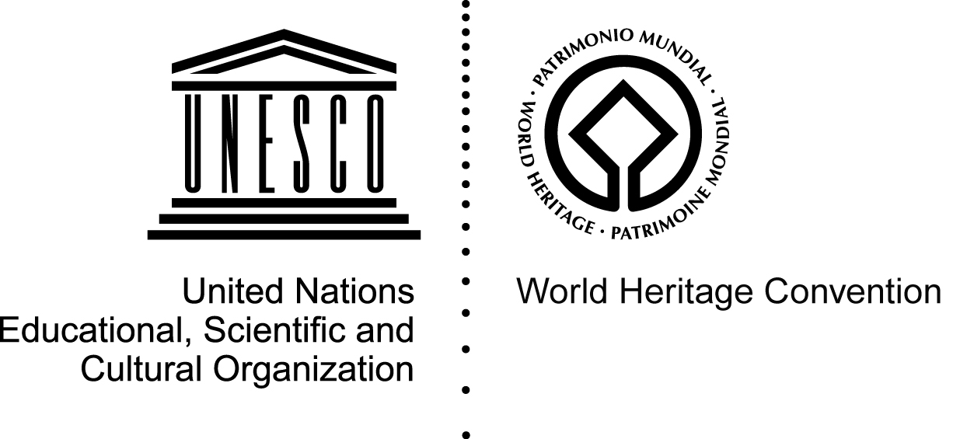

2. Examples of site specific linked logo designed for use by site authorities

Designed as a bilingual logo upon the State Party’s request:

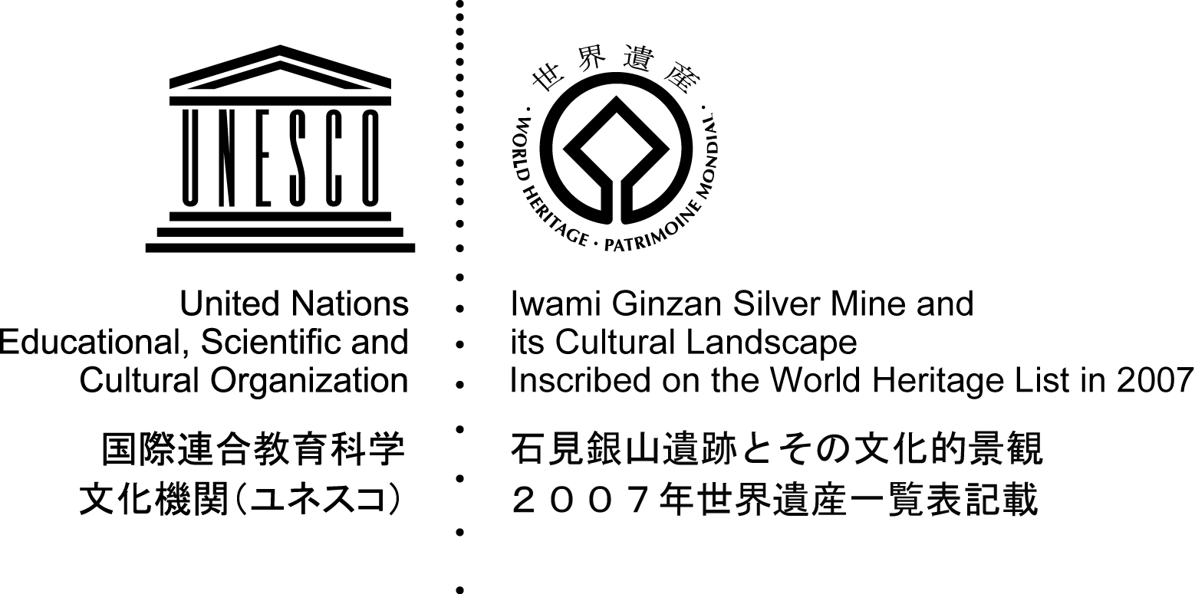

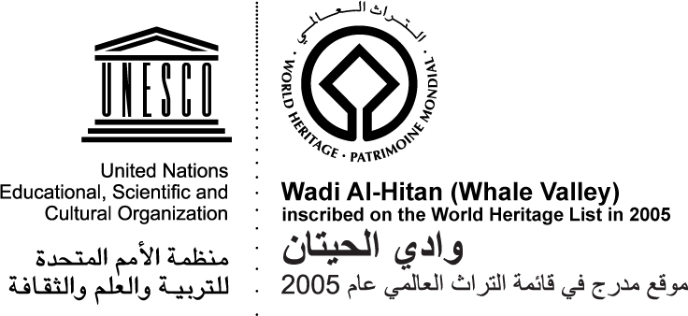

Simple one-language version:

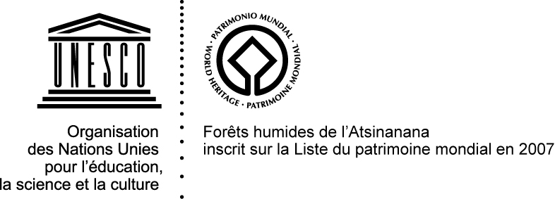



3. Example of linked logo for use at the national level

Can be associated to local partner organizations

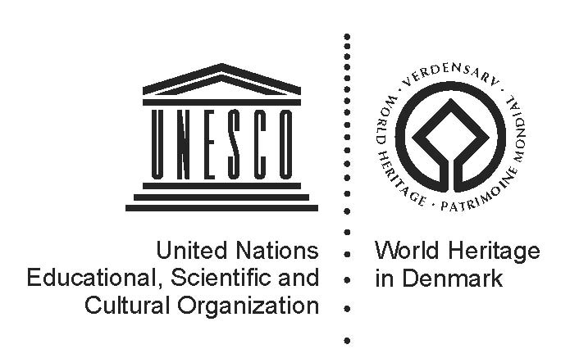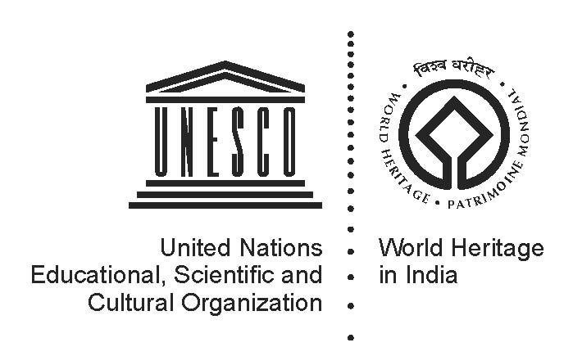

4. Example of linked logo designed for Category 2 centers

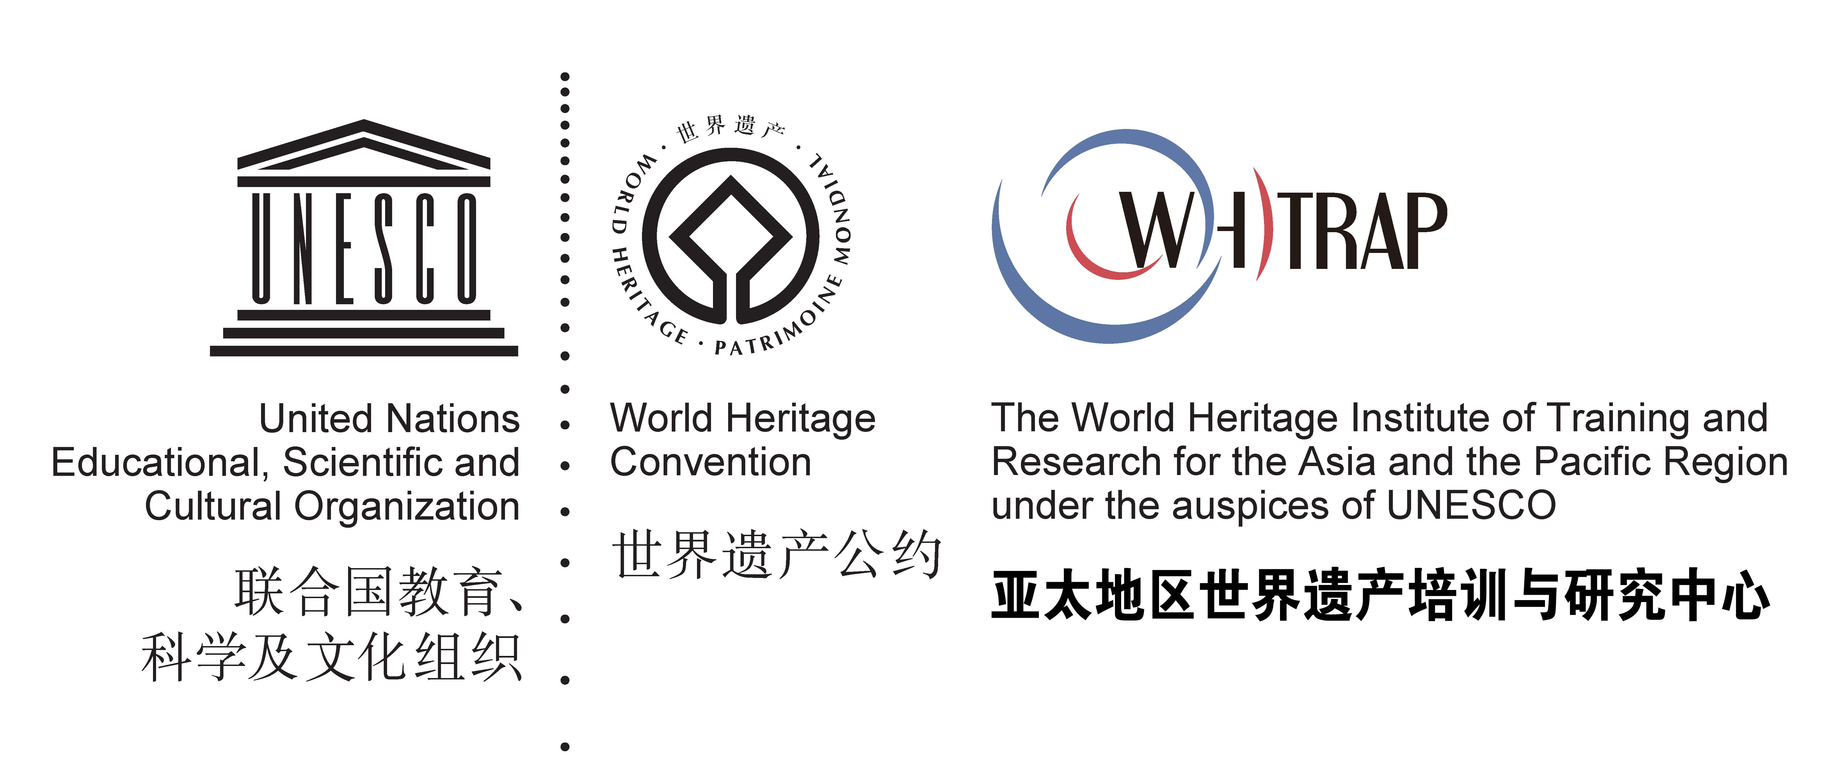

5. Example of World Heritage emblem used alone

Used in iconic form on maps, road signs and other items where the linked logo can be considered too heavy

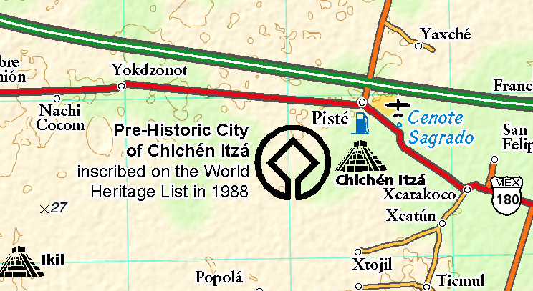

The Government of Australia is considering committing funding to a meeting and consultancy work on the issue of Branding as a result of the meeting on the ‘Future of the World Heritage Convention’. This was confirmed during the meeting of the Working group in May 2009.

