


Rise of Fort Liedot
Ile d’Aix, France – 8-29 June 2009

Cultural site

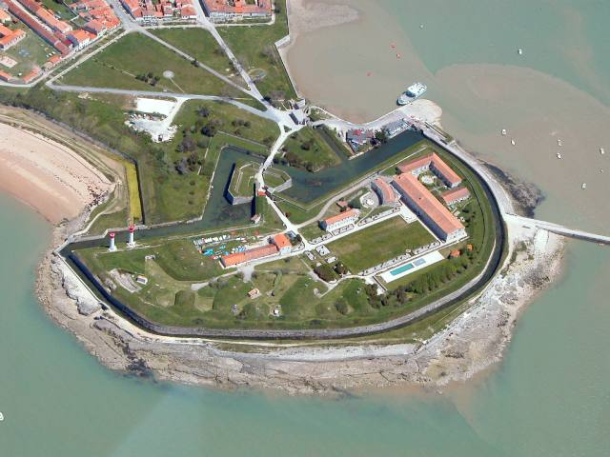
The site: Vauban fortification represents the finest examples of the work of Sébastien Le Prestre de Vauban (1633-1707), a military engineer of King Louis XIV. The work of Vauban constitutes a major contribution to universal military architecture. It bears witness to the evolution of European fortification in the 17th century and produced models used all over the world up to the mid-19th century, thereby illustrating a significant period of history. The Arsenal de Rochefort et fortifications de l’estuaire de la Charente – the second site in the region of Ile d’Aix, proposed in 2002 - is an ensemble of fortified constructions built in the XVII century and representing the unique style of military engineering in this period

The project and its objectives: Ile d’Aix has a long and animated marine and naval history. As a happy consequence the island plays host to many historical sites, notably Fort Liédot. Constructed in the early 19th century to defend the island from naval attacks, it later came to be used as a prison. Today it is a center for artistic and cultural activities. The fort needs regular maintenance as well as restoration work, and for this reason it has already hosted many international camps: last summer a workcamp was held to restore and improve the paths in and around the stronghold, in the frame of the first World Heritage Volunteers campaign. This year, a group of 15 international volunteers will continue this work..
The project will also be an occasion for the volunteers and the local residents to interact with and learn from each other. World Heritage and sustainable development will be the main topics of discussion, and educational activities will be organized to help raise the local awareness on these issues. Volunteers will also have the chance to learn traditional renovation methods while working on the site. The realization of this project will not only mean the enhancement of the fort, but that a large group of people will better understand the importance of protecting our World Heritage.

The activities: Over the course of 3 weeks, volunteers will learn traditional renovation methods, and use them to restore Fort Liédot and preserve it for future generations. Activities such as international meals, exhibitions and tours – in particular to the local schools – will also be planned, using informal and non-formal spaces to promote the discussion and planning education activities on World Heritage, with both the international participants and the local community learning from each other’s experiences the importance of World Heritage in the different countries.

Expected results: The project will have contributed to the protection, promotion and preservation of historical and cultural heritage sites through the renovation of Fort Liédot. The promotion of exchanges on World Heritage within the volunteers’ group and between the volunteers and local residents will have created an environment of intercultural learning and improved the understanding of World Heritage preservation. Having learnt new practical skills (i.e. traditional restoration techniques, masonry, etc.) the reflections of the volunteers will also have been nourished by a hands-on approach, thus complementing with non-formal education activities the tools developed by experts at the WHC and UNESCO.
Organisation responsible for the project:

Solidarités Jeunesses, France
10, rue du 8 Mai 1945
75010 PARIS
workcamp@solidaritesjeunesses.org
www.solidaritesjeunesses.org

Partners: The Ministry for Youth and Sports, the Ministry of Culture and the Ministry of Environment and Sustainable Development will all be involved in the project, together with the Conservatoire du Littoral and several regional councils and local and national NGOs. Numerous schools, the Mission Locale pour les Jeunes de Rochefort-Oléron, the Commune de l’Ile d’Aix, the Regional newspaper « SUD-OUEST » and the Regional Television MaTivi will also be among the local partners for this action.

