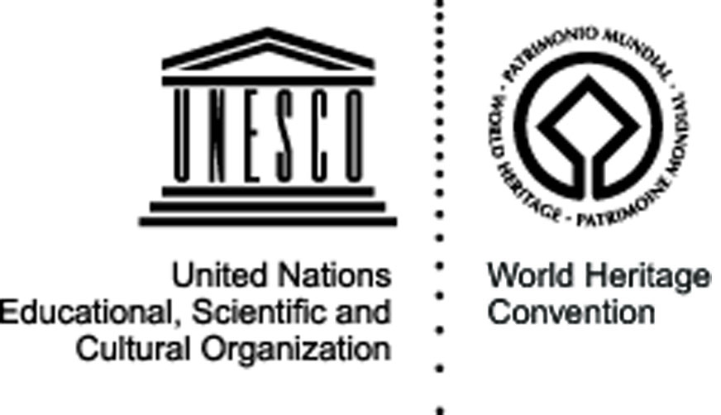


Mosi-oa-Tunya – Victoria Falls
Victoria Falls, Livingstone District, Zambia – 1-14 July 2009

Natural site

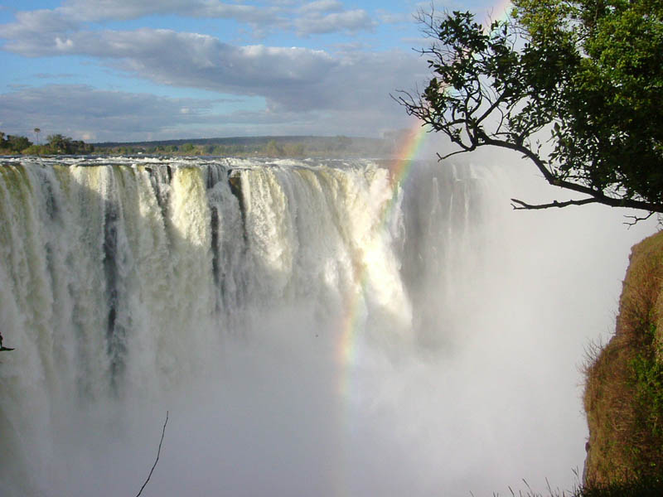
The site: The Victoria Falls are among the most spectacular waterfalls in the world. The Zambezi River, which is more than 2 km wide at this point, plunges noisily down a series of basalt gorges and raises an iridescent mist that can be seen more than 20 km away. Below the falls the river enters a narrow series of basaltic gorges. The fragile ecosystem of the riverine rainforest within the waterfalls splash zone is also of particular interest.

The project and its objectives: The workcamp will look at the preservation of Victoria Falls as one of the most important natural heritage sites. With the main aim of involving young people in the preservation and protection of the ecological system of the falls, the project will focus on awareness raising activities to stimulate community ownership and participation in conserving natural heritage. Through the implementation of concrete activities like the renovation of the foot paths around the site, the international volunteers will establish a bridge with the local community and the tourists to discuss World Heritage issues, while contributing to the material preservation and valorisation of the site.

The activities: Volunteers will be involved in the renovation of the foot paths around Victoria Falls as well as in removing the lantana weed that threatens the very existence of the site. Taking the opportunity of the traditional ceremonies that will take place between 4th and 6th July, volunteers will also run World Heritage education and awareness activities, to discuss with the local communities and tourists about the importance of conserving and protecting the site and the surrounding areas. This will also represent a chance for the young volunteers themselves to discover and appreciate the cultural heritage of the region – in particular of the Mkhanya chiefdom hosting the camp – and learn how traditional knowledge and values can contribute to the protection of World Heritage sites.

Expected results: The first visible outcome of the project will be the renovated foot paths which will guarantee improved accessibility to the site for both the tourists and the members of the local communities. The awareness raising activities will also provide the young people involved – in particular children and young adults from the schools in the region – concrete knowledge and skills on heritage preservation and protection, privileging a hands-on approach that will facilitate youth understanding and ownership. The stimulation of active participation from the local youth will result in a visible change in attitudes, promoting voluntary efforts at local level for the sustainability of the site. The important work on the history of Victoria Falls and of the Toka Leya tribe will also have promoted the use of traditional knowledge as a key agent in preserving natural sites.

Partners: The project will see the involvement of the National Youth Development Council, the Ministry of Youth, Sport and Child Development, and a number of national and international partner Youth NGOs active in Zambia, as well as of the Danish cooperation through MS Zambia. The Mkhanya chiefdom and its community based youth organisations will guarantee the participation of the local population in both the preparation and implementation of the project, ensuring long-term involvement and commitment for the follow-up activities.
Organisation responsible for the project:

YAZ (Youth Association of Zambia)
P.O box 31852, Lusaka
yazinfor@yahoo.com
musonda5@yahoo.com

