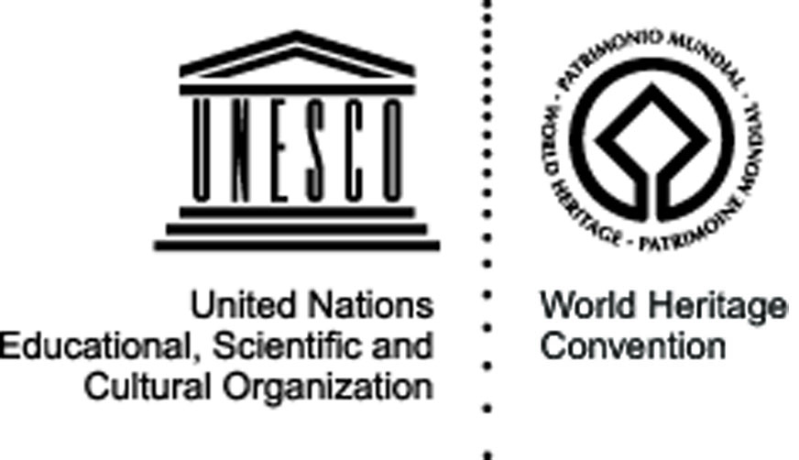


Cajamarca
The Historic Centre of Cajamarca, Peru – 6-26 June 2009

Cultural site - submitted to the Tentative List in 2002

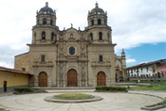
The site: Cajamarca is the setting of the encounter between the culture of Spain and the Andean world. The layout of the city and its buildings, both civil and religious, built of adobe and volcanic stone within the Historic Centre of Cajamarca, offer an exceptional testimony of Spanish-Andean culture. The architecture, which is unique and covers every century from the 16th to the 19th, makes the city centre of Cajamarca a monument of great cultural value. In the fifteenth century the city of Cajamarca became part of the Tawantinsuyo (Inca Empire) when the Kingdom of Cuismanco was conquered by the Inca Pachacutec. Cajamarca retained its importance since for the conquering Incas it was considered to be "head of a province". It was here that Atahualpa was held prisoner and also where he offered his Spanish captors the famous ransom of gold and silver in order to obtain his freedom. In the area around the Historic Centre of Cajamarca there are a number of archaeological monuments of exceptional historic importance.

The project and its objectives: Raising awareness and sensitizing the local population about the problems faced by the historical center of Cajamarca, the volunteers will work on the documentation of the city’s patrimony and propose alternative solutions for its preservation - in particular through the production of audio-visual supports targeting and speaking the language of the youth - so to place higher in the civil agenda of Cajamarca the conservation of cultural resources in the historical center.

The activities: Volunteers will work to identify and document the main points of damage to the infrastructure and the attractiveness of the historic center of the city (Deterioration of facades, plazas, litter, graffiti, poor street lighting, illegal entertainment, etc.). After analysing the situation and giving priority to two main problems, the volunteers will deepen their analysis of the possible causes and consequences of such deterioration and raise possible solutions. A document prepared by the volunteers on the basis of their work will then distributed to the main stakeholders in the city, inviting them to participate in a public campaign on the issue involving radio, TV and written press.

Expected results: The local population and especially the youth of Cajamarca will be able to identify and evaluate the state of the cultural resources of its historic center, as well as its potential as a touristic site. Concrete proposals to solve the problems identified during the research phase of the project will be documented and distributed to the main stakeholders. Audiovisual products (spots, articles, interviews) will have been developed by the volunteers and a number of public debates organised, and new partnerships will have been established with the local and national institutions for the continued development of such products aiming at the valorisation of the city’s social and cultural assets.
Organisation responsible for the project:

Brigada de Voluntarios Bolivarianos del Perù
Jr. Lucanas No. 332 – A
Lima 01
bolivarianosd@hotmail.com
www.voluntariosbvbperu.org

Partners: The project will see the active involvement of local and national media and institutions like Channel 21 TV Cajamarca, Panamericana TV, Radio Layzón, the Mesa de concertación de lucha contra la pobreza, AGUIPTUR, CARETUR, the Municipality of Cajamarca, the National Institute of Culture of Peru and the National Volunteer Center of Peru.

