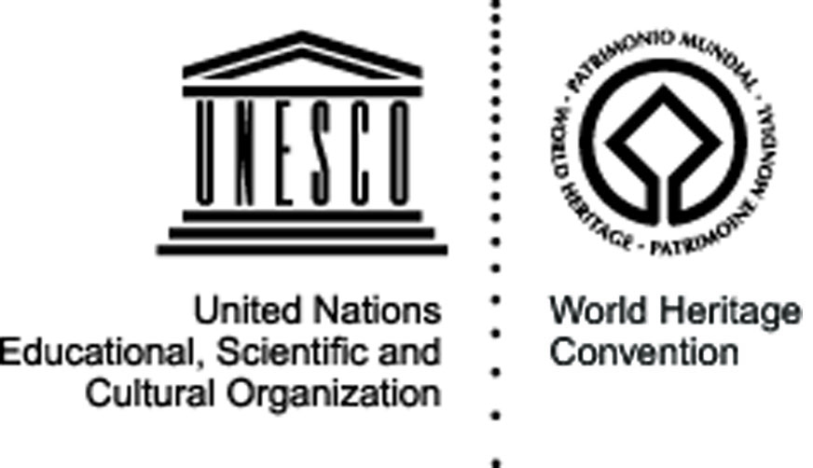


Geomunoreum

Jeju Island, Republic of Korea – 27 July – 8 August 2009

Natural site

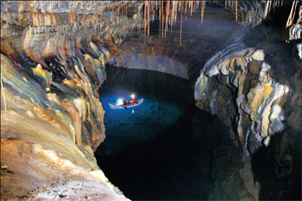
The site: Jeju Volcanic Island and Lava Tubes together comprise three sites that make up 18,846 ha. It includes Geomunoreum, regarded as the finest lava tube system of caves anywhere, with its multicoloured carbonate roofs and floors, and dark-coloured lava walls; the fortress-like Seongsan Ilchulbong tuff cone, rising out of the ocean, a dramatic landscape; and Mount Hallasan, the highest in Korea, with its waterfalls, multi-shaped rock formations, and lake-filled crater. The site, of outstanding aesthetic beauty, also bears testimony to the history of the planet, its features and processes.
The Geomunoreum lava tube system, which is regarded as the finest such cave system in the world, has an outstanding visual impact even for those experienced with such phenomena.

The project and its objectives: Of the three World Heritage sites in Jeju Island – Geomunorem, Mt.Halla and Seongsan Ilchulbong (Sunrise Peak) – the Geomunorem is still relatively unknown to the non-specialists, despite its indubitable attractions. The main objective of the project will therefore be to promote the site towards a wider public through the presence and work of the international volunteers. While running awareness-raising actions with the local population about the interest and necessity to protect Geomunorem unique natural heritage site, the volunteers will also help demonstrating the value of non-formal education to the local and national authorities involved in the preservation of the site.

The activities: During the two weeks of the camp, the international volunteers will run several activities for the promotion and conservation of Geomunoreum site. In particular, they will organise debates and discussions with the local community about the importance of natural world heritage and the knowledge and techniques needed for its preservation. In order to increase the visibility of the site, the volunteers will work in close cooperation with the organisers of the International Tracking Race taking place around the site, organising specific workshops to share with the participants and local community information on world heritage sites in their own countries.

Expected results: The project will contribute to the recognition of Geomunorem natural site among the local community and youth in particular, increasing the interest and the number of visitors and the same time bringing World Heritage education at grassroots level.

Partners: The main partner for the project will be the World Natural Heritage JEJU site management, while JSPSEP (Jeju Solidarity for Participatory Self-government and Environmental Preservation) will ensure the cooperation with and participation of the local community.
Organisation responsible for the project:

IWO (International Workcamp Organisation), Korea
331-15 Sogyo-Dong
121-836, Seoul
korea@workcamp.org
www.1.or.kr

