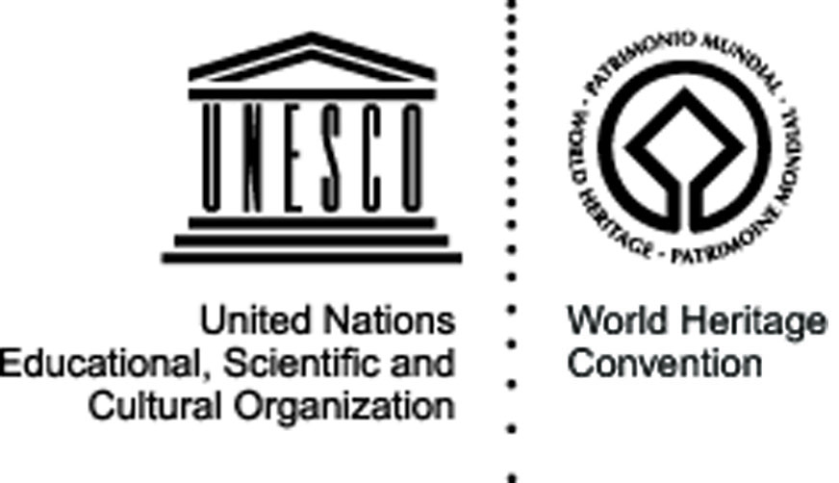


Prambanan
Prambanan, Indonesia – 8-22 August 2009

Cultural site

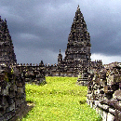
The site: Built in the 10th century, this is the largest temple compound dedicated to Shiva in Indonesia. Rising above the centre of concentric squares are three temples decorated with reliefs illustrating the epic of the Ramayana, dedicated to the three great Hindu divinities (Shiva, Vishnu and Brahma) and three temples dedicated to the animals who serve them.

The project and its objectives: The project will be the continuation of the first camp held in the frame of the 2008 World Heritage Volunteers campaign. The volunteers will be introduced to the World Heritage Centre’s activities and campaigns and to the history and dynamics of World Heritage sites worldwide. Guided visits to Prambanan (which was recently highly damaged by an earthquake), will be organised in cooperation with the site management. The project aims at rendering its symbolic dimension to World Heritage through debates and reflections, while concretely contributing to the restoration and preservation of the site and improving accessibility and availability of information, raising the awareness of the local population and creating a sense of ownership and identification.

The activities: The 2008 camp started the work on the 20 Perwara (stupa ornaments) which are still buried underground. Four were already found, cleaned and restored, and volunteers will continue working together with the local stakeholders as well as the archaeologists involved in the restoration programme aiming at recovering the remaining stupas. On the second week the volunteers will also focus their activities in the primary school of SD Kemudo 1, running classroom programmes related to the promotion and preservation of World Heritage with the students. The local and international volunteers will introduce to the students the World Heritage sites in Indonesia and their own countries and talk about heritage preservation, and launch a school drawing contest on the issue of World Heritage.

Expected results: By holding this project again in 2009, Dejawato expects an amplified impact of the actions toward the students, local community as well as the stakeholders, who will be empowered with both the knowledge and skills to become the main actors in World Heritage preservation and promotion. Targeted primary school students will in particular have been sensitised and will have acquired important knowledge and information about Indonesian World Heritage, with an increased sense of ownership and responsibility towards the sites. On the practical level, several stupas will also have been cleaned and restored thanks to the work of the volunteers.

Partners: The Indonesian Ministry of Culture and Tourism and its Department of Archaeology, as well as UNESCO cluster office in Jakarta will be among the main partners for this project, which will also see an important work of the Archeological department of Central Java Province and Yogyakarta Province, of the PT. Taman Candi Borobudur Prambanan dan Ratu Boko (World Heritage Site Management), the Government of Klaten Regency, IndoWYN (Youth Heritage Club), the Kemudo village and several schools in the area surrounding the temples.
Organisation responsible for the project:

Dejavato Foundation, Indonesia
Jl. Bukit Panjangan Asri Blok M
7 Semarang 50147
Central Java
dejavato@yahoo.com
www.dejavato.org

