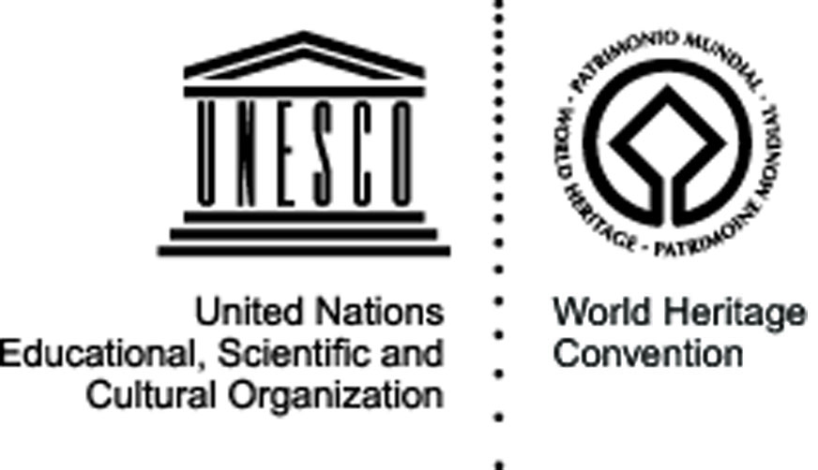


Young Guardians in Action
Borobudur, Indonesia – 14-27 July 2009

Cultural site


The site: This famous Buddhist temple, dating from the 8th and 9th centuries, is located in central Java. It was built in three tiers: a pyramidal base with five concentric square terraces, the trunk of a cone with three circular platforms and, at the top, a monumental stupa. The walls and balustrades are decorated with fine low reliefs, covering a total surface area of 2,500 m². Around the circular platforms are 72 openwork stupas, each containing a statue of the Buddha. The monument was restored with UNESCO’s help in the 1970s.

The project and its objectives: Based on the research conducted by the Directorate General for History and Archeology Department of Culture and Tourism of Central Java and Jogjakarta provinces in 2007-2008, the project will address the problems of climate and weathering processes and intense development of the areas surrounding the site, with important changes in land use (e.g. from traditional farming to housing and concrete buildings). The active involvement of the local population is considered a potential solution to these challenges and a key factor in the preservation and promotion of the site: thus the Young Guardians in Action will aim at promoting and highlighting the importance of the World Heritage education to the local people and local students, in particular those enrolled in tourism management courses.

The activities: Among the different activities, particular importance will be given to the training of “Young Guardians” on World Heritage sites management and the risks and opportunities of tourism, involving the Tourism department of Central Java and PT Taman Candi Borobudur (the private sector of Borobudur Temple park). Senior high school students coming from the surrounding area of the temple, the tour guides working for the tourism department for Borobudur temple, the NGOs working for the eco tourism around Borobudur temple are the target groups of the training, which will be run in cooperation with the Ministry of Culture and Tourism. Apart from supporting the organisation of the training, the volunteers will also campaign to raise the awareness of the visitors during the peak season for tourism in Borobudur, and run a demonstrative action on world heritage education with the theme “I am aware”.

Expected results: The cooperation between the universities students and the local authorities and site managers will contribute establishing community based activities and mechanisms for the preservation of Borobudur and other World Heritage sites, challenging the perception from the local people that the responsibility of preserving the world heritage site only relies on the government. Through the training and awareness raising campaigns, local youth will be empowered to act as Young WH Guardians, while hundreds of tourists visiting Borobudur site will be sensitized to World Heritage preservation and sustainable tourism.
Organisation responsible for the project:

Indonesia International Work Camp (IIWC)
Jalan Jembawan Raya no 8 Semarang Central Java Indonesia 50145
iiwc1@yahoo.com
www.iiwcindonesia.org

Partners: The project will be run in cooperation with the Directorate General for History and Archeology, Department of Culture and Tourism of Central Java, Indonesia, and the Ministry of Culture and Tourism. UNESCO cluster office in Jakarta will also play an important role, as will the PT Taman Candi Borobudur (Borobudur Park), the Jogjakarta and Central Java World Heritage Society, the Archeology Department of Gajah Mada University and several senior high schools in Magelang Regency.

