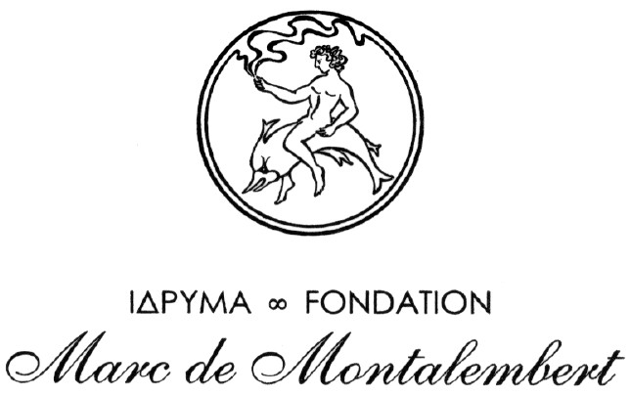

A 7000 EURO GRANT FOR THE REALIZATION OF A CULTURAL PROJECT CONCERNING THE MEDITERRANEAN WORLD

You are a native of a Mediterranean country.
Born after 31 December 1979 you will be under 30 years of age in 2009.

You wish to develop a project furthering the knowledge and understanding of Mediterranean cultures.

Every year the Marc de Montalembert Foundation offers a grant of 7000 euro to enable the implementation of such projects.

To apply for the 2008 Marc de Montalembert grant candidates should send a project outline along with a request for an application form to :

- the following e-mail address: montalembert@fondationmdm.com

- or postal address: Fondation Marc de Montalembert, Fondation de France, 40, Avenue Hoche, Paris 75008.

All these informations are available at: www.fondationmdm.com
Deadline for submission of the full application: December 31, 2008

The grant is meant to incite research and appreciation of the region’s cultural diversities. Candidates will be required to travel outside their native country to pursue their research on a subject of their choice. The Foundation expects concrete results from the project. Whatever form of expression chosen by the candidate – written, oral, visual, … – the outcome must be an original piece of work which, if it deems it worthwhile, the Foundation can consider helping to promote. Should the candidate so desire, the elaboration of the final result of the project can be carried out while in residence at the Marc de Montalembert Foundation on the island of Rhodes.

The subjects treated by grant beneficiaries between 1994 and 2008 come under the headings of: “Sculpture”, “Literature”, “Music”, “Painting”, “Architecture”, “Sociology”, “Photography”, “Ethnography”, “Art History”.

