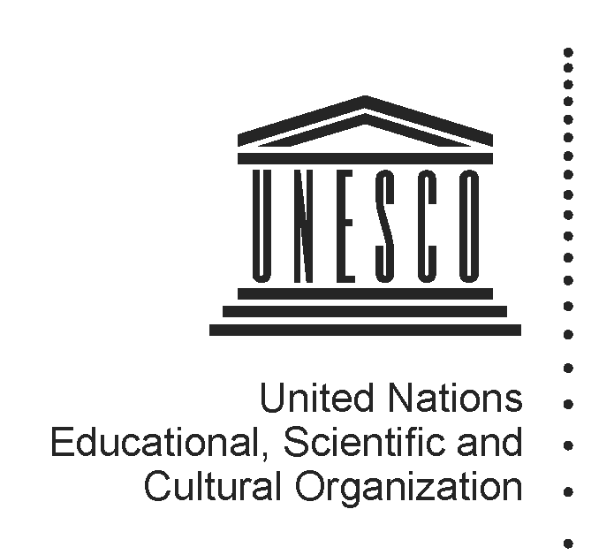 2014-2015
Mapping factsheet
Institutes and centres under the auspices of UNESCO
(Category 2)

Reference documents pertaining to the integrated comprehensive strategy for category 2 institutes and centres:

- 37 C/Resolution 93 (adopted on 19 November 2013)
- 37 C/18 Part I and its attachments
- 37 C/4 (Medium-Term Strategy) and 37 C/5 (Programme and Budget)

Full name of institute/centre and its acronym, if any | the World Heritage Training and Research Institute for the Asia and the Pacific Region (WHITR-AP)
Name of the host Member State and city | China (Beijing, Shanghai and Suzhou)
Name of other participating/sponsoring Member State(s)
Date of approval for the creation by the General Conference and relevant resolution | 2 November 2007, 34 C/Resolution 41
Date of entry into force of the signed agreement with UNESCO | 10 April 2008
Date(s) of the renewal of the agreement and relevant Executive Board decision(s) | N/A
Is the present agreement in compliance with the integrated comprehensive strategy (37 C/18 Part I)? | N/A
Duration of the agreement | 6 years
Thematic specialization | execute short-term and long-term education and training activities for site managers, local government officials, educators and technicians in China and in the Asia and the Pacific region, for the conservation of both cultural and natural heritage;  undertake research on important regional World Heritage issues, and investigations of particular heritage resources in cooperation with relevant conservation training and research centres in the region;  hold scientific symposia, conferences and workshops (regional and international) in all areas relating to World Heritage.
Contribution to which UNESCO strategic objectives (37 C/4) and expected results at the main lines of action (MLA) level (37 C/5) | SPO 7: Protecting, promoting and transmitting tangible heritage  MLA 1- Protecting, conserving, promoting and transmitting culture, heritage and history for dialogue and development.
Contribution to the two global priorities of UNESCO – Africa and Gender Equality | Beneficiaries of training activities to ensure equal gender representation.
Contribution to the implementation of sector-specific strategy of interaction with category 2 institutes/centres | World Heritage Capacity Building Strategy (2011) ; Culture Sector Strategy for category 2 Centres (2012)
Implementation strategy (200 words), should come from the agreement | execute short-term and long-term education and training activities for site managers, local government officials, educators and technicians in China and in the Asia and the Pacific region, for the conservation of both cultural and natural heritage, including those directed at the preparation of World Heritage nomination files, strengthening of conservation and management approaches for World Heritage properties, the monitoring of the state of conservation of World Heritage properties and the drafting of periodic reports;  undertake research on important regional World Heritage issues, and investigations of particular heritage resources in cooperation with relevant conservation training and research centres in the region;  hold scientific symposia, conferences and workshops (regional and international) in all areas relating to World Heritage;  collect available information in order to set up an accessible, secure and reliable database for World Heritage in the region;  collect and disseminate relevant knowledge and information, and the outcomes of research activities in Asia-Pacific countries through the Internet, and the publication of books, articles and other media;  promote collaborative programmes in specific areas of World Heritage conservation and the exchange of conservation practitioners at the regional level in this context;  encourage the development of a World Heritage site manager’s regional network to exchange information, experience and best practices;  facilitate the introduction of disciplines relating to World Heritage conservation and other academic activities in universities and colleges in China and in the Asia and the Pacific region.
Geographic coverage | Regional
Best practices in promoting South-South, North-South and triangular cooperation | Improved regional cooperation and site-site interaction.
Governing Board | Yes, meeting annually since 2008.
Financial contributions of UNESCO if the agreement of institute/centre entered into force before 2013 when the General Conference approved the current integrated comprehensive strategy in its 37 C/Resolution 93 | Resources provided under Regular programme for:  (i) feasibility study  (ii) activities, implemented through contractual arrangements  (iii) participation in governing board meetings  (iv) renewal review assessment  (v) others (pls. specify) | N/A
 | Extra-budgetary | N/A
 | Total
 | Centre’s budget and sources of financing | Regular Budget:  Not available  Funding sources: public
Has the institute/centre been providing biennial self-assessment progress report(s) to UNESCO?  If so, indicate the date of the last submission and provide the web link | Yes, March 2014.  http://whc.unesco.org/en/category2centres/
Has the institute/centre been evaluated and/or audited?  If so, when and by whom? | Yes, May 2014. Michael Turner (Consultant) and Martha McGuire (Evaluator).
Is the institute/centre considered as non-operational due to the absence of an agreement signed between UNESCO and a host country? | No.
Responsible UNESCO Programme Sector and its implementing unit(s) | World Heritage Centre  Asia and the Pacific Unit
Name and title of responsible officer(s) | Feng JING (Mr)
Name and title of sectoral focal point(s) for category 2 institutes and centres | Mr Giovanni Boccardi and Mr Frank Proschan
UNESCO field office in contact with institute/centre | Beijing Office
Name and title of field office focal point(s) | Beatrice Kaldun (Ms)
Name and title of UNESCO staff seconded to institute/centre, if any | N/A
Relevant web-links for :  (i) UNESCO sector-specific web-page  (ii) Institute/centre dedicated web-page  (iii) Agreement with UNESCO  (iv) other | http://www.whitr-ap.org/

